Task 1

Part 1
My final choices:
context window = 7
learning rate = 0.05
epochs/ iterations = 30
x_max = 100
alpha = 0.75

When d= 200

I’ve tested the embeddings with various configurations { learning rate = 0.01, 0.05, 0.1, 0.2 }
{ context window = 3, 5, 7, 10, 15 }, { x_max = 100,50 }, { alpha = 0.5,0.75}

Learning rate 0.01 was too slow, 0.1 was fast but didn’t give the right embeddings based on my observations of similar words. 0.05 was the good spot

Context window = 3, 5, 10 gave less similar results than 7, 15.
On further testing on 7, 15.
Context window = 7 gave better results
Dimension = 200 gave better results than other dimensions for some of the words I have tested

Part 2

Training losses weren’t unstable for Learning Rate less than 0.1. When used 0.2 the loss grew for the second epoch but continued to go down but a lesser speed than 0.1

The dataset showed best results for embeddings only when the learning rate was 0.05.
The graphs show a steep drop at the start and a flat line at the end. This is a property of Adagrad and also the GloVe training, it gives high gradients for frequently occurring words at the start which makes a huge difference.

The average latency for an epoch for different dimensions:
D = 50 : 45 s
D = 100 : 45s
D = 200 : 45s
D = 300 : 45s
There is no significant change in the latency between the average epoch training time in Google Colab. Usually it should show a change linearly because for higher dimensions it should calculate more values but as the GPU power of the Google Colab is higher there is no significant change in the latency.
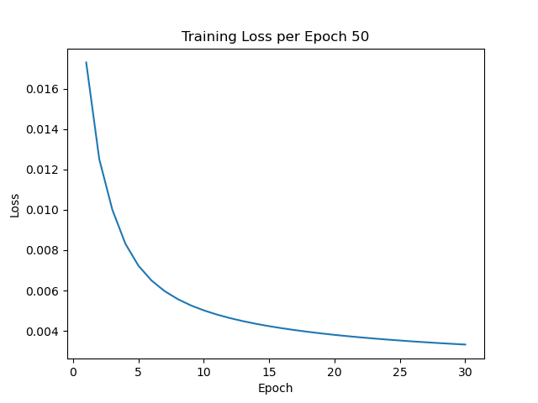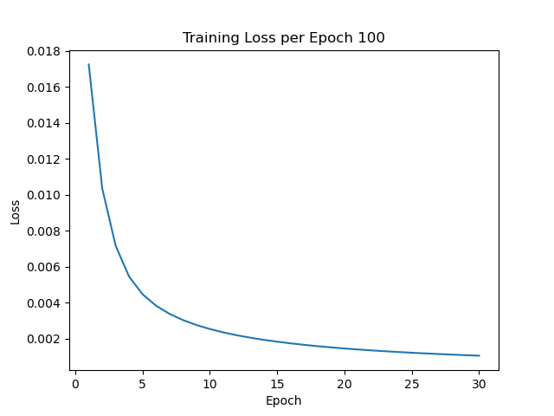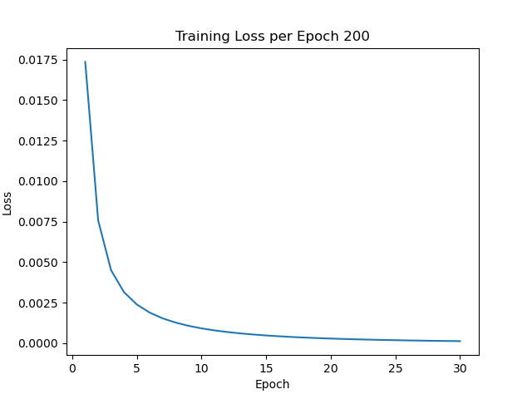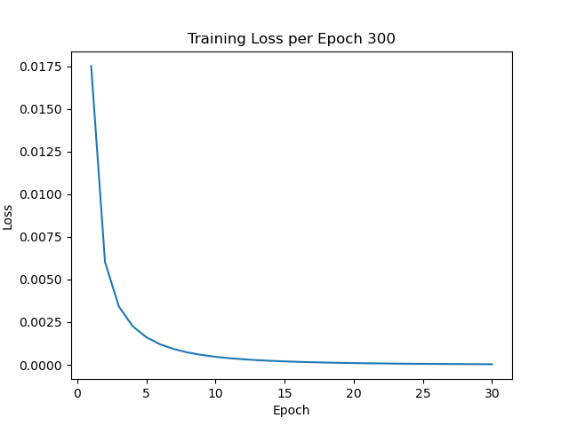

Part 3
Selected words = Bank, oil, City

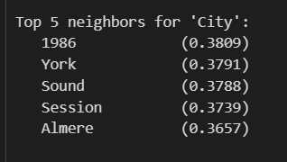
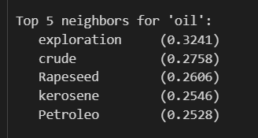

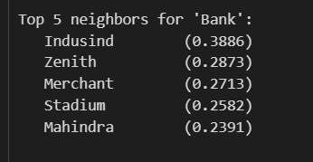

Usage of AI and LLMs :
Understanding of GloVe embeddings with examples. Loading the data.json file. For troubleshooting and code restructuring. Saving mechanisms which I don’t know for models, and co-occurrence matrices.
ChatGPT link - https://chatgpt.com/share/6990bebf-a768-8013-95fe-2c3741c3db6f

Task 2. SVD pipeline

I need to choose same 3 words that are chosen in task 1, the chosen words are:
1.oil
2.bank
3.city
Then the top5 nearest neighbours that I got for these 3 words are :
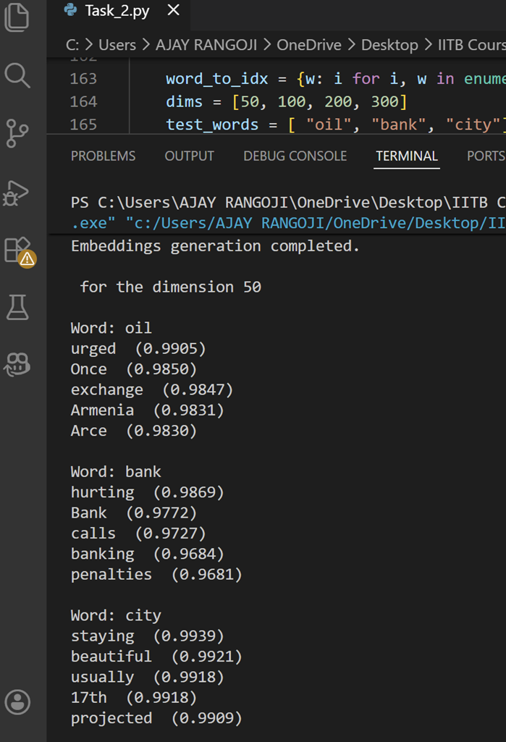
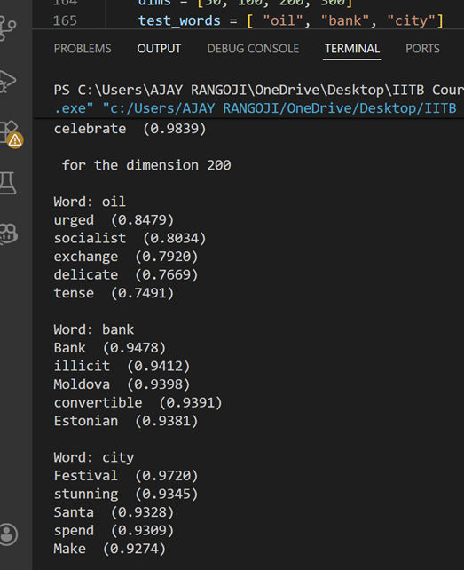
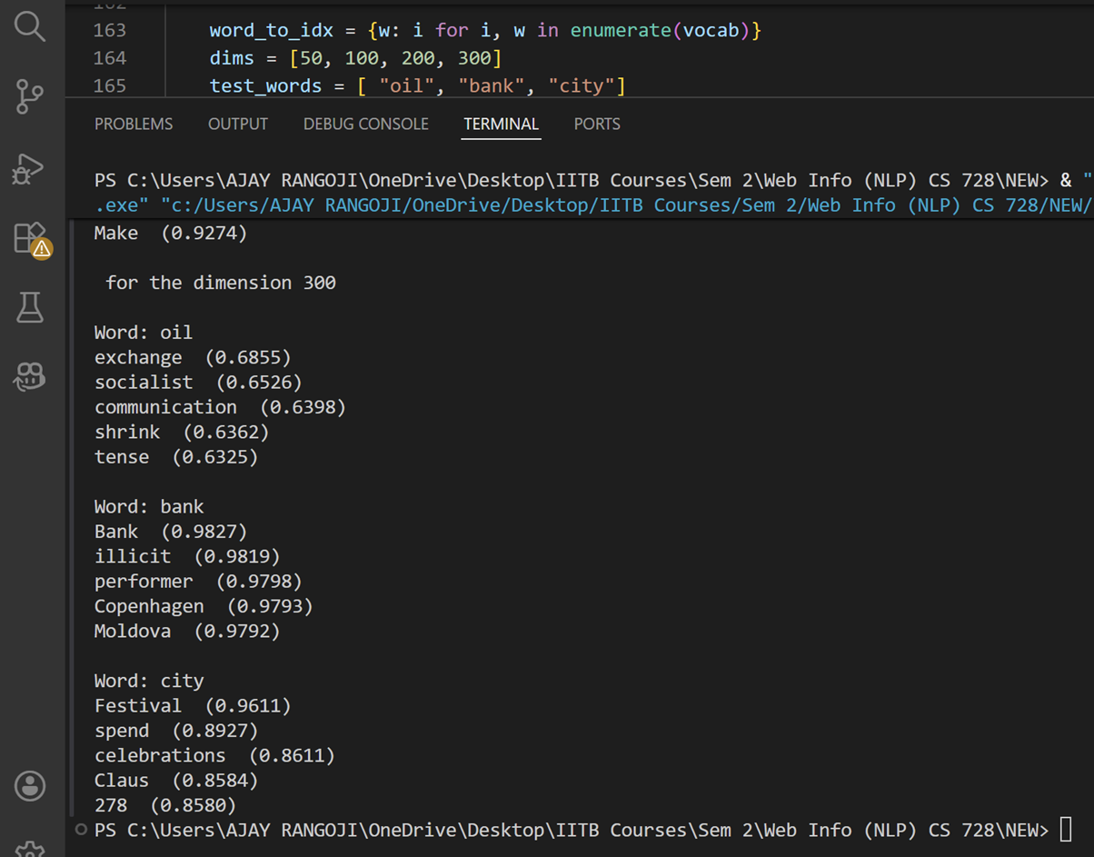

Usage of LLM :
https://chatgpt.com/share/6990a0d9-9930-800d-8fc5-39f393538642
I used Chatgpt, (Not used any other AI tools for this Task 2), at first I learned about SVD from chatgpt and then from youtube videos for better understanding of the SVD functioning, the youtube links are here :
https://youtu.be/wciU07gPqUE?si=JwEhAmFj4Pwuk_RS
https://youtu.be/7Gtxd-ew4lk?si=uLhTA08Tqzl0O_EE
https://youtu.be/mhy-ZKSARxI?si=VX2wOaYzdX_I0a54
https://youtu.be/vSczTbgc8Rc?si=WhFFg2NfnqicT_0h
· For what I have used chatgpt:
To learn about libraries.
· To Solve errors.
· To link the locations for dataset and outputs.
· For the in-built methods in the libraries and their usage.
Understaning the flow of SVD.
· Matrix building.

Task 3: NER using CRF
I trained a CRF model on the CoNLL-2003 dataset and I manually designed features for each word.
Features I have used in my code:
1. Bias constant feature for every word
2.lower lowercase of the word
3.upper check if the word is in capital letters
4.title check if first letter is capital
5. digit check if the word is only numbers
6.hasnum check if word has any digit inside
7.dash check if word has '-'
8. pre2 first 2 letters of word
9. pre3 first 3 letters of word
10. suf2 last 2 letters of word
11. suf3 last 3 letters of word
12. p_lower lowercase of previous word
13. p_title previous word capital check
14. p_upper previous word uppercase
15 .n_lower lowercase of next word
16. n_title next word capital check
17. n_upper next word uppercase
18. start beginning of sentence
19 end end of sentence

Here I have hand crafted all the features with make_feat() function call for each sentence and I will get features for each word and I will train the model crf in the library sklearn_crfsuite
For the train of my model I have used various paramenter for C1 and C2 in CRF model I have used c1 with values 0.01,0.3,0.5 and for c2 with value 0.01,0.10.5 and used all permutation and got all the f1 score each and found that for C1 0.01 and C2 0.1 it got maximum f1 score

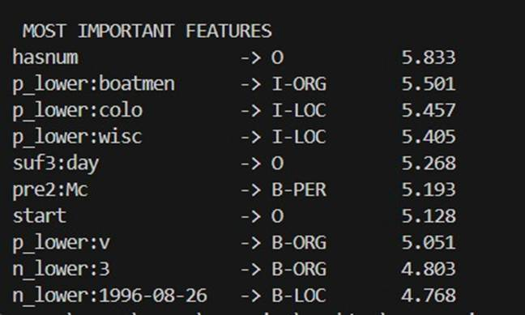
Fig: above fig Representing the most important features hasum is most important

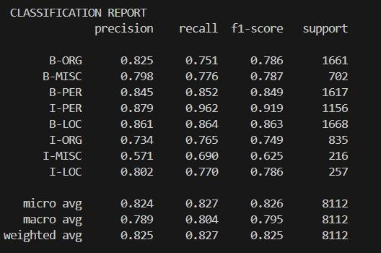
Fig: above figure representing the f1 score for each NER tags
Usage of LLM’s:
https://chatgpt.com/share/6990a8fc-7d5c-8003-85e4-2a8cafd10c1e
I have used chat GPT to understand the CRF and understanding the how to handle the document CoNLL 2003 and there was situation where model got over fit there I have used Chat GPT how to calculate F1 score using modules

Task 4 : NER using feature learning
I implemented a Multi-Layer Perceptron (MLP) model for Named Entity Recognition using word embeddings generated by task 1 and task 2 code
The goal of the model is to classify each token into one of the NER labels such as PER, LOC, ORG, MISC
MLP Architecture:
1.Input layer:
Embeddings used are SVD embeddings and GloVe embeddings with d = {50, 100, 200, 300}
If a word was not found in the embedding vocabulary, a zero vector of size d was used.
2. Pre-processing:
Label Encoding NER tags were converted to numeric labels using LabelEncoder
Feature Scaling Embedding vectors were normalized using StandardScaler
3. Class Balancing:
We will remove the “O” This reduces class imbalance and improves learning.
4. Hidden Layer
One hidden layer with Number of neurons = 200 with relu activation
5. Output Layer
Fully connected output layer Softmax activation over all NER classes

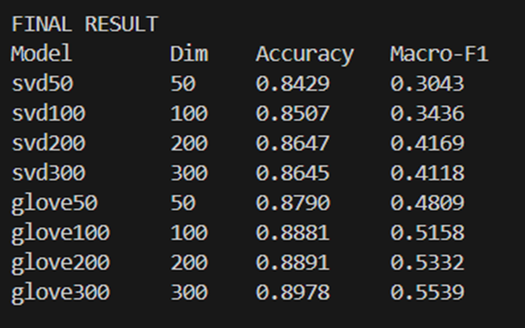
Fig: Accuracy and Macro-F1 Score for every version of MLP: GloVe-MLP and SVD-MLP Task
Fig: accuracy and Macro and F1 score score task 3
Best overall configuration
Clear the max F1 score is 0.55 gor glove 300 and accuracy 0.89 for task 4 but task 3 has outperformed where accuracy is 0.96 and f1 score is 0.79
The CRF model outperformed the MLP model because CRF uses contextual and word-shape features that are very important for NER, while the MLP model used only word embeddings without sequence information. Therefore CRF achieved higher accuracy and F1 score on the CoNLL-2003 dataset.
Use of LLM’s:
https://chatgpt.com/share/6990ba2e-be00-8002-8ba1-82e892cd2faf
I have used Chat gept to understand and debug the errors and understand how commands should be written

Task 5. [Extra Credit] SVD Performance Boost

The output for Task 5 : Quality check 1 is pasted below for the same words : Island, adopts, irony, series, uphill
This is for TF-IDP

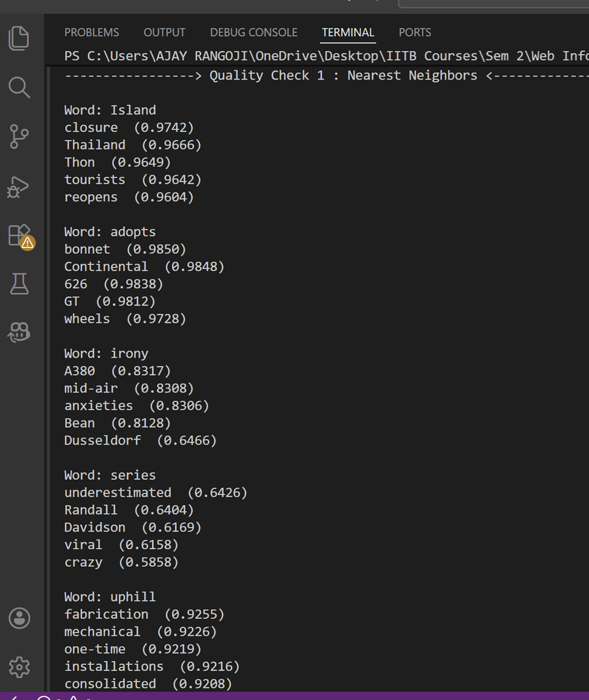
The ouput for Raw SVD is :

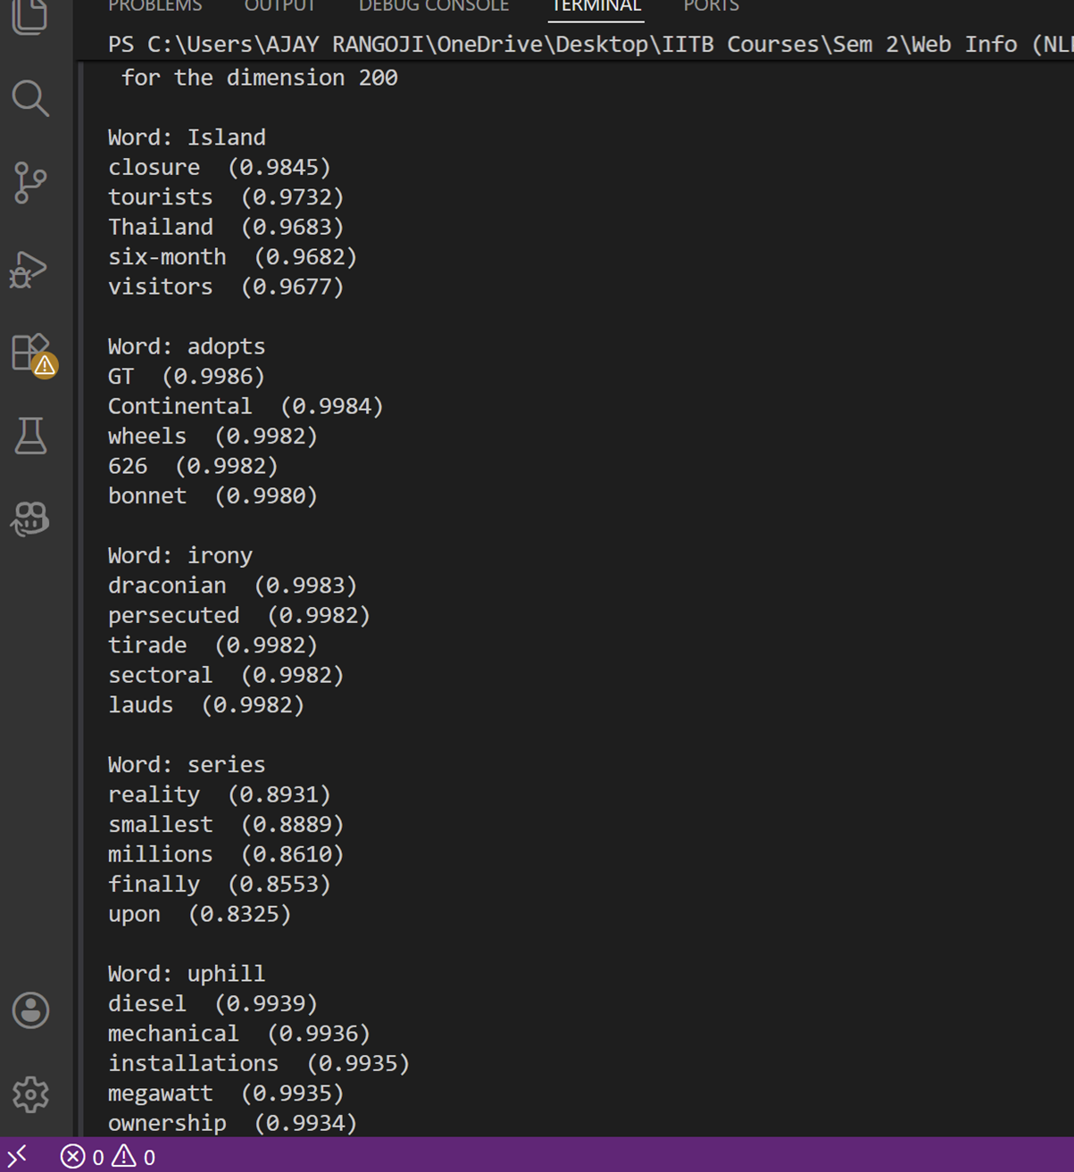
The differences I have observed :
In word 1: 2 words differ.
In word 2: 0 words differ.
In word 3 : All 5 neighbours are different.
In word 4 : All 5 neighbours are different.
In word 5 : 3 words differ.

Comparision : I observed that TF-IDF is giving more semantically meaningful neighbours than Raw SVD.(in word 4)
Chatgpt link :
https://chatgpt.com/share/6990b8ca-0394-800d-b4f9-6cfc26cac82f

Quality check -2 :
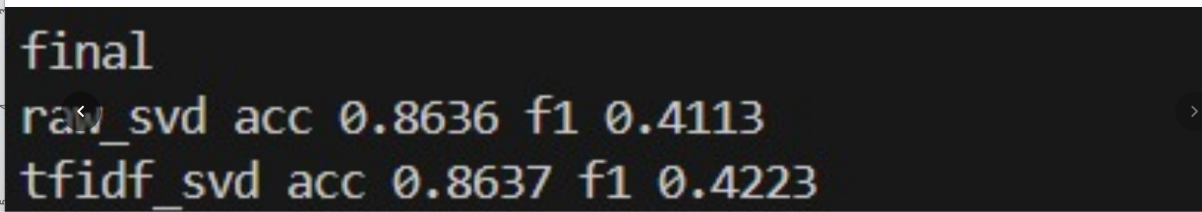
Comparatively TF-IDF has better accuracy and f1 score than raw svd. But almost performed same, as mentioned above TF-IDF is giving more semantic meaningful words.

