Online Complaint Registration and Management System
Project Documentation

1. Technical Architecture
Frontend (React + Bootstrap + Axios) communicates with Backend (Node.js + Express.js REST APIs). Backend uses JWT authentication, Mongoose ODM, MongoDB database and Socket.IO for real-time notifications.

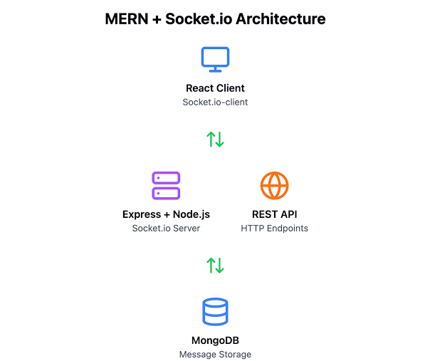

2. ENTITY RELATIONSHIP (ER) DIAGRAM

Description
The Entity Relationship (ER) Diagram illustrates the relationship among the major entities in the Complaint Management System.
The User submits complaints through the system. Every complaint belongs to one user and can be assigned to one agent by the administrator. The assigned agent updates the complaint status and resolution details.
Notifications are generated whenever complaint status changes or important events occur. Feedback can also be submitted after complaint resolution.
The ER diagram helps visualize the database structure and relationships among different collections.

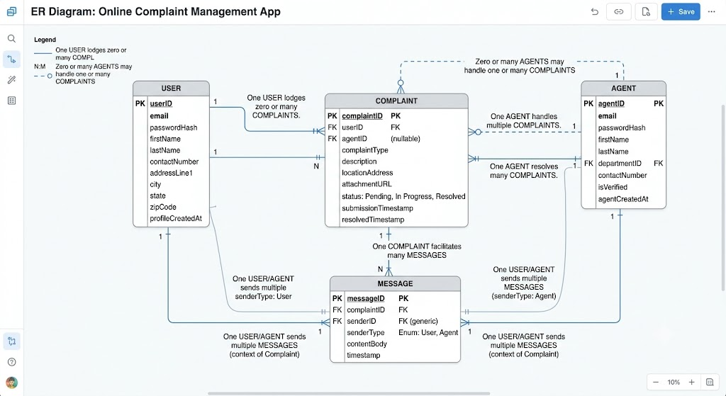

3. Features
- User Registration/Login
- Role-based Access (Admin, Agent, User)
- Complaint Registration
- Complaint Tracking
- Complaint Assignment
- Status Updates
- Notifications
- Feedback
- Search/Filter/Pagination
- Excel/PDF Export

4. Roles and Responsibilities
User: Submit and track complaints.
Agent: Handle assigned complaints.
Admin: Manage users, agents and complaints.


5. User Flow
Login/Register -> Dashboard -> Submit Complaint -> Admin Assigns Agent -> Agent Updates Status -> User Receives Notification -> Complaint Resolved -> Feedback.
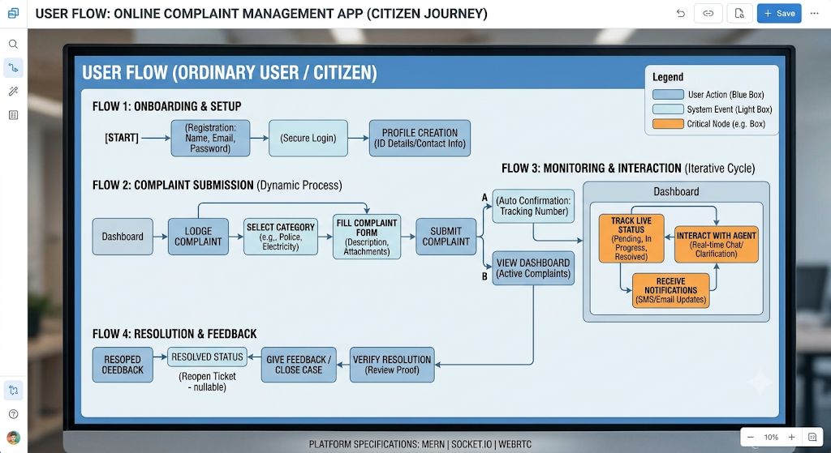

6. MVC Pattern
Models: User, Complaint, Notification, Feedback.
Views: React Components.
Controllers: Auth, Complaint, Notification, Feedback.

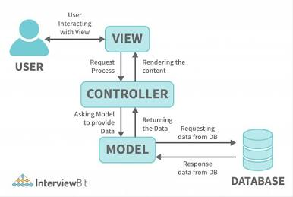

7. Project Setup
Frontend: npm install, npm start.
Backend: npm install, npm run dev.
MongoDB: Start service and configure .env.

8. Backend Folder Structure
controllers/
models/
routes/
middleware/
config/
services/
server.js

9. Database
MongoDB with Mongoose. Collections: Users, Complaints, Notifications, Feedback.

10. Frontend
React, React Router, Bootstrap, Axios, SweetAlert2, Chart.js, Socket.IO Client.

11. Execution Steps
1. Start MongoDB
2. Start Backend
3. Start Frontend
4. Login
5. Submit Complaint
6. Assign Agent
7. Update Status
8. View Notifications

12. Conclusion
The system provides secure complaint management with real-time notifications, dashboards, reporting and role-based access.

