# **Program which repeatedly reads numbers until the user enters “stop”**

Once “stop” is entered, print out the total, count and average of the numbers. If the user enters anything other than a number, detect their mistake using try and except and print an error message and skip the next number.

## **License**

Python license

## **Prerequisite**

Python3 loops, exceptions handling, break and continue

## **Description about the program**

For an infinite loop we used while True:

We used break to come out of the infinite loop

We used continue to go back to the starting of the loop

If the expression the the try gets an error it goes to except and prints us an Invalid number

## **Testing**

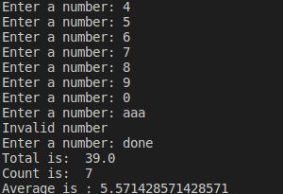

## **Common issues:**

The variables tot is a floating type and count is an integer type, as we generally count of numbers is always in integer and as inputs can be floating types, tot variable is made as a floating type

Since we are find total sum, count and average we raised an exception for data types other than int and float

## **Reference Links**

<https://www.freecodecamp.org/learn/scientific-computing-with-python/python-for-everybody/iterations-more-patterns>