# **Program to extract a portion of a string and convert the extracted string into a floating point number**

Str = ‘X-DSPAM-Confidence: 0.8475 ’

Use find and string slicing to extract the portion of the string after the colon character and then use the float function to convert the extracted string into a floating point number

## **License**

Python license

## **Prerequisite**

Python3-strings and string slicing

## **Description about the code**

Here we used find() method to find the position of a particular character

s[20:-1] this is used to slice the string from position 20 to last before character

float() method to convert an object into float data type

## **Testing**

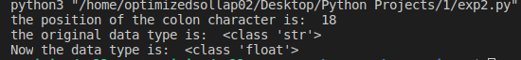

## **Common issues:**

float() method ignores the white space and converts the numbers in the string into float data type

S[20: ] and s[20:-1] and s[20:40] and s[20:100] gives the same output in python3

## **Reference Links**

<https://www.youtube.com/watch?v=1bSqHot-KwE>

<https://www.freecodecamp.org/learn/scientific-computing-with-python/python-for-everybody/reading-files>