C02-AT2-SCENARIO BASED-EXECUTION
Q12
A telecom network evaluates distances between towers to optimize connectivity using brute-force closest pair computation.
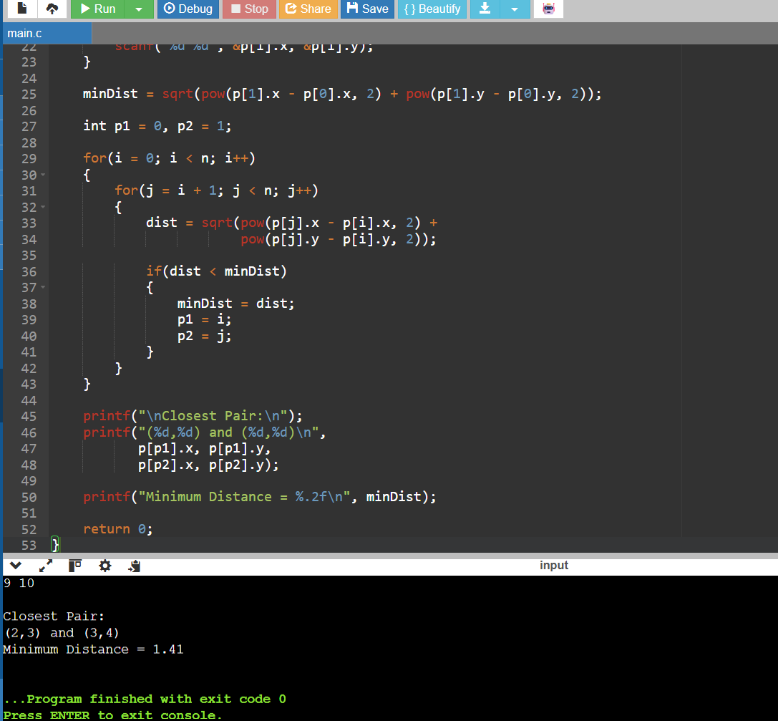

Q60
A drone surveillance system detects the outer boundary of objects using brute-force convex hull computation.


