CO2-AT3-DEBUGGING
Q122 – Debugging Bubble Sort Code
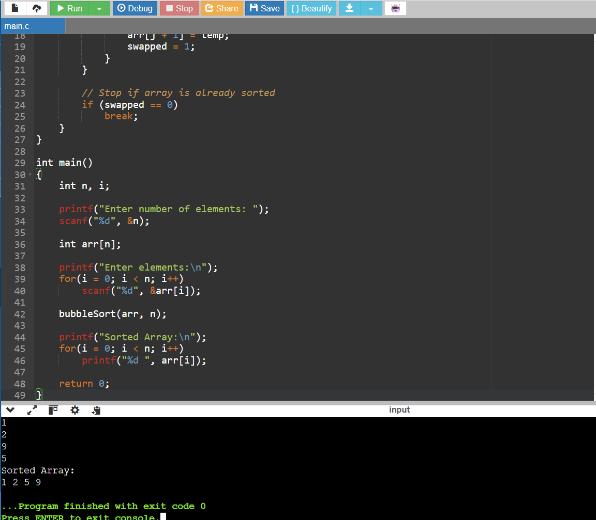

Q95 – Debugging Closest Pair Code
