CMPE 283 – Assignment 2: KVM VM-Exit Statistics Patch
By: Jaya Vyas
GitHub Repository

1) Team Contribution
This lab was completed individually by me, Jaya Vyas. I researched how KVM handles VM-exits, implemented the per-exit counters and periodic printk in the Intel VMX path, resolved kernel build issues, built and installed the modified kernel/module on the outer VM, enabled nested virtualization, and validated the output by booting and exercising the inner VM.

2) Detailed Steps to Complete the Assignment
The process is organized into three stages. Each step below includes the commands with a relevant screenshot.
Also, Pl find required steps in a nutshell
- Clone the Linux repository into the outer VM.
- Install build dependencies and configure the kernel using the current config.
- Add swap space to ensure smooth kernel build.
- Fix build errors related to trusted keys and recompile.
- Modify arch/x86/kvm/vmx/vmx.c to add exit statistics counters and printing logic.
- Build and install the modified KVM modules.
- Reboot and verify the patch with dmesg and nested VM testing.

Step 1 Kernel Build Test on the Outer VM
a) Clone your GitHub fork onto the outer VM and prepare dependencies:
git clone https://github.com/jayavyas07/linux.git
cd linux
sudo apt update && sudo apt install -y build-essential bc flex bison libssl-dev libelf-dev libncurses-dev dwarves ccache
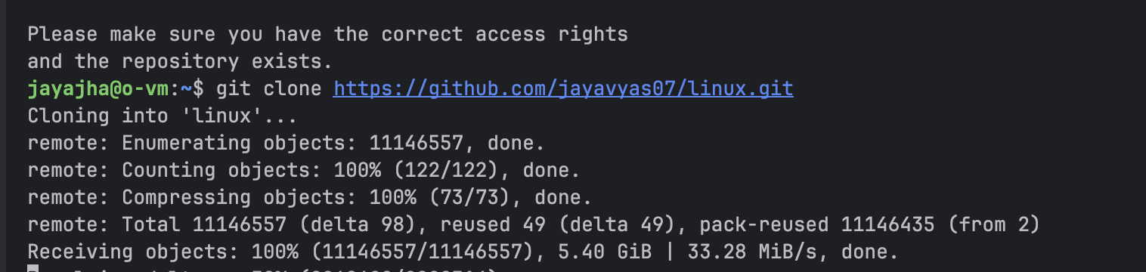
b) Seed the config from the running kernel and accept defaults:
cp -v /boot/config-$(uname -r) .config
yes "" | make olddefconfig

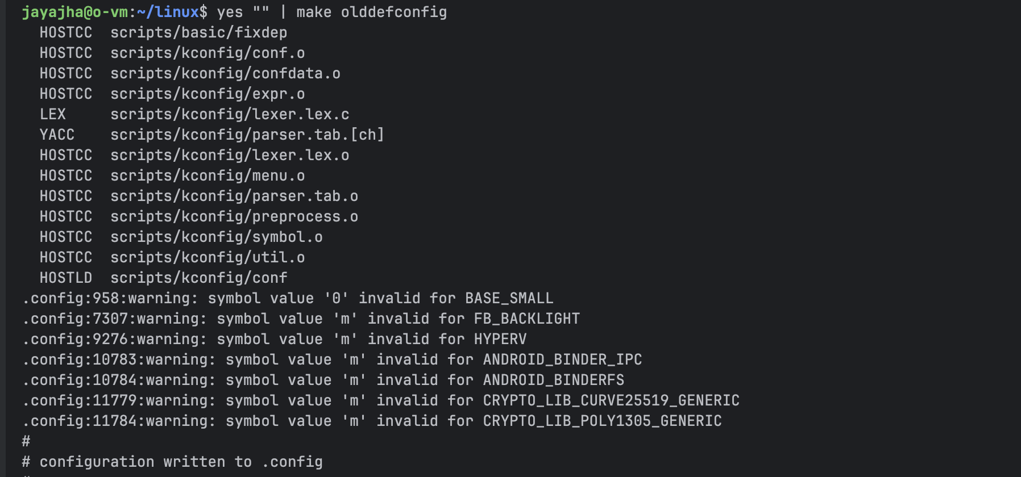
c) (If needed) add swap to avoid OOM during build:
sudo fallocate -l 4G /swapfile && sudo chmod 600 /swapfile && sudo mkswap /swapfile && sudo swapon /swapfile
echo '/swapfile none swap sw 0 0' | sudo tee -a /etc/fstab
free -h
Figure 1 System memory after enabling swap (pre-build).
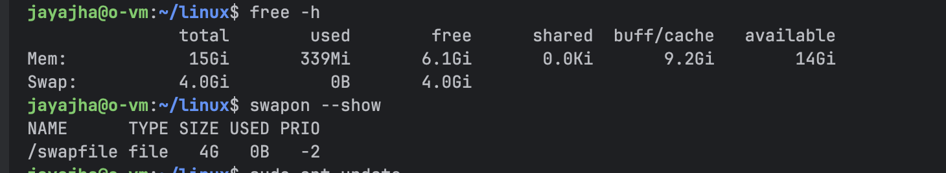

d) Build the kernel and modules:
make -j"$(nproc)" 2>&1 | tee build.log
Figure 2 — Kernel build in progress / bzImage generation.
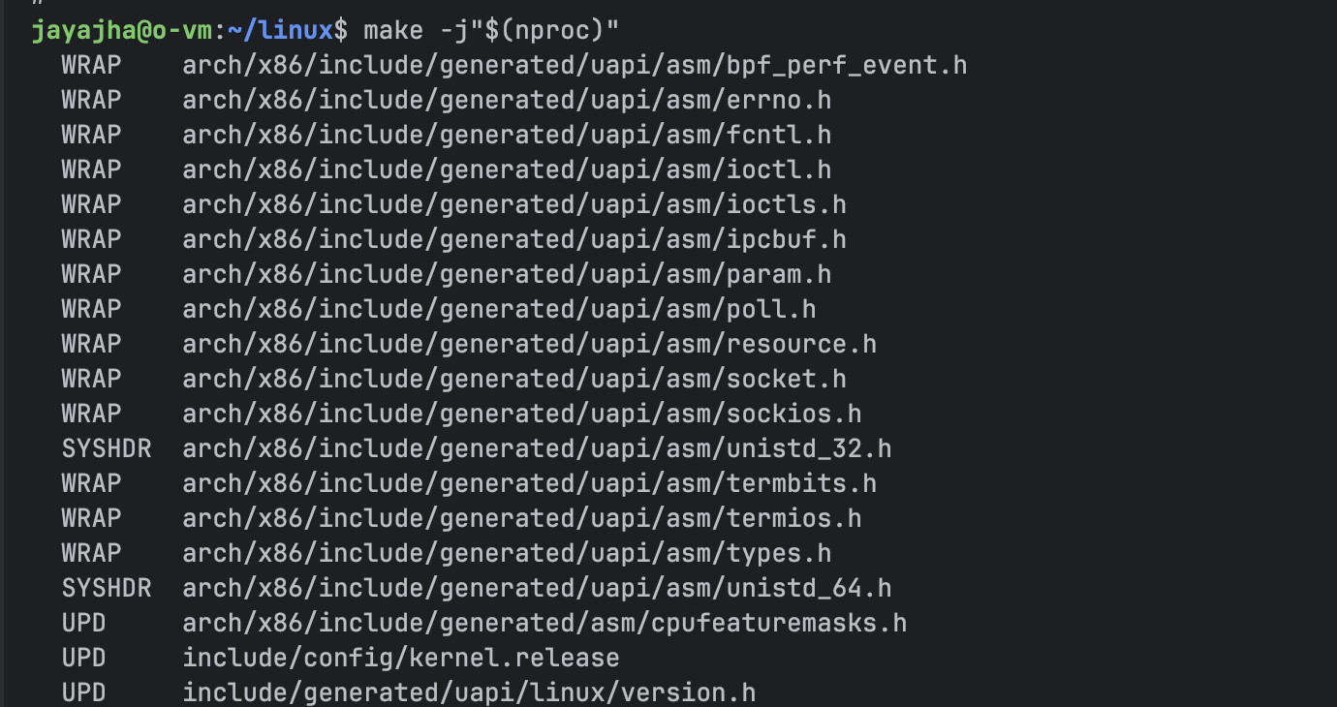

e) Install and boot the test kernel to confirm it runs:
sudo make modules_install
sudo make install
sudo update-initramfs -c -k $(make kernelrelease)
sudo update-grub
sudo reboot
Figure 3 — Post-reboot verification and environment checks.
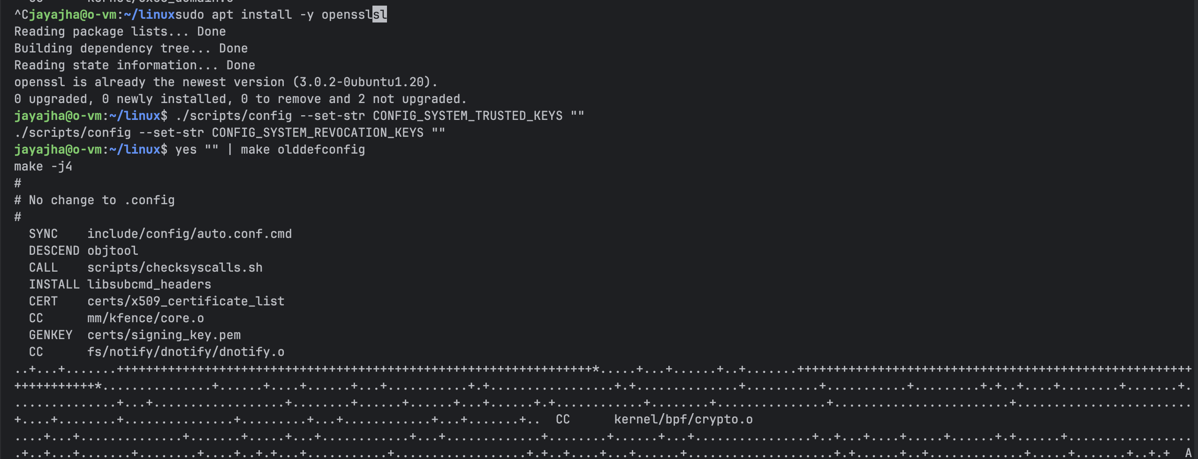
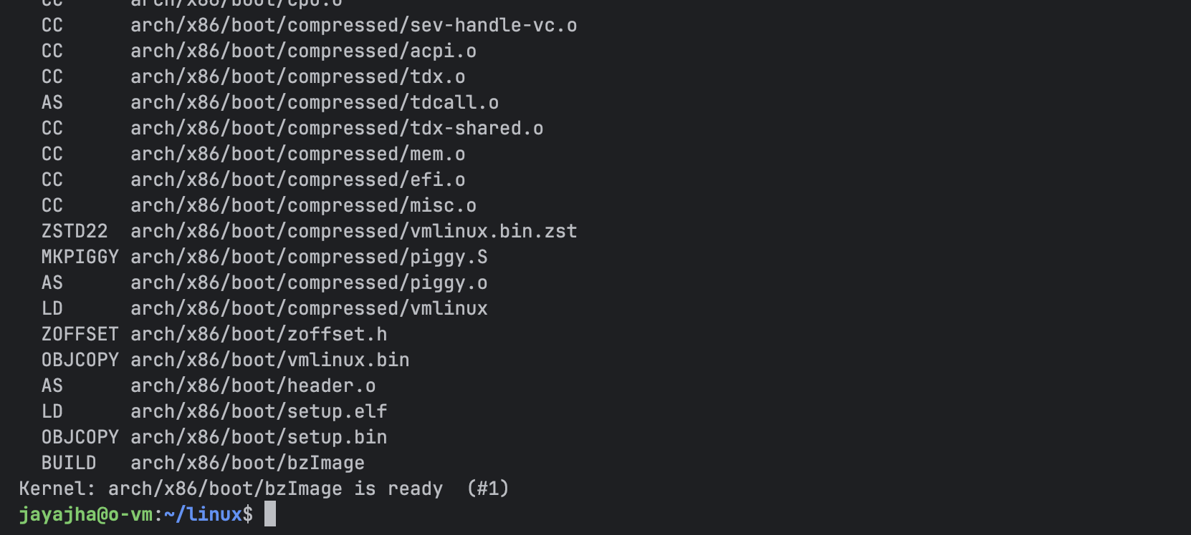
Step 2 Edit KVM (VMX) to Add Exit Counters & Periodic Prints
a) Modify the Intel VMX path:
File: arch/x86/kvm/vmx/vmx.c
Add the counters and helpers near the top:
#include <linux/atomic.h>
#define KVM_VMX_MAX_EXIT_REASONS 128
#define KVM_VMX_PRINT_INTERVAL 10000 // prints every 10k total exits
static atomic64_t kvm_vmx_exit_total = ATOMIC64_INIT(0);
static atomic64_t kvm_vmx_exit_counts[KVM_VMX_MAX_EXIT_REASONS];
static const char *vmx_exit_reason_name(unsigned int r) { /* switch with names */ }
static void kvm_vmx_maybe_dump_counts(void) { /* printk header + per-exit lines */ }

Hook in at the start of the VM-exit handler:
static int __vmx_handle_exit(struct kvm_vcpu *vcpu, fastpath_t exit_fastpath)
{
union vmx_exit_reason exit_reason = vmx_get_exit_reason(vcpu);
u32 basic = exit_reason.basic;
if (basic < KVM_VMX_MAX_EXIT_REASONS)
atomic64_inc(&kvm_vmx_exit_counts[basic]);
atomic64_inc(&kvm_vmx_exit_total);
kvm_vmx_maybe_dump_counts();
/* ... rest of handler ... */
}
Figure 5 Insertion point inside __vmx_handle_exit() (top of handler).
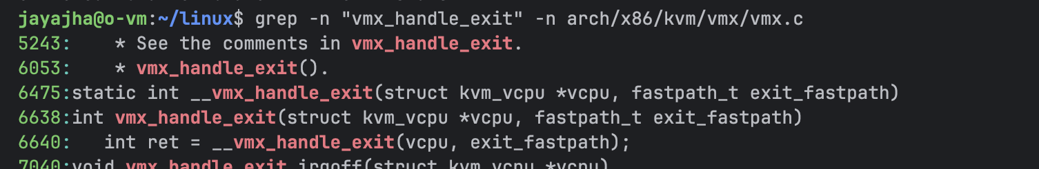
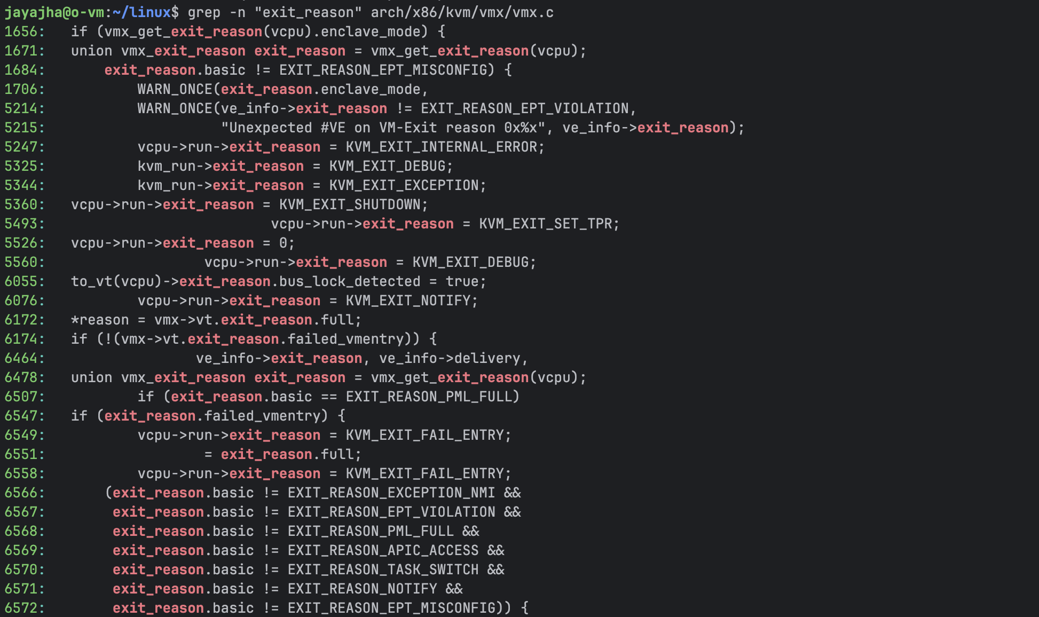Optional beacon on module init (helps verify module load):

int __init vmx_init(void)
{
pr_info("KVM/VMX: stats patch loaded (vmx_init beacon)\n");
/* ... */
}

b) Rebuild and install only the KVM modules for this running kernel:
make M=arch/x86/kvm -j"$(nproc)" modules
sudo make M=arch/x86/kvm modules_install INSTALL_MOD_DIR=kernel
sudo depmod -a "$(uname -r)"
sudo cp -v arch/x86/kvm/kvm-intel.ko "$(modinfo -n kvm_intel)"
sudo depmod -a "$(uname -r)"
Also after patching the code in vmx.c, git push and then git fetch to O-vm and finally check through grep if we have our source code.
grep -n "stats patch loaded" ~/linux/arch/x86/kvm/vmx/vmx.c
grep -n "VM-Exit stats" ~/linux/arch/x86/kvm/vmx/vmx.c
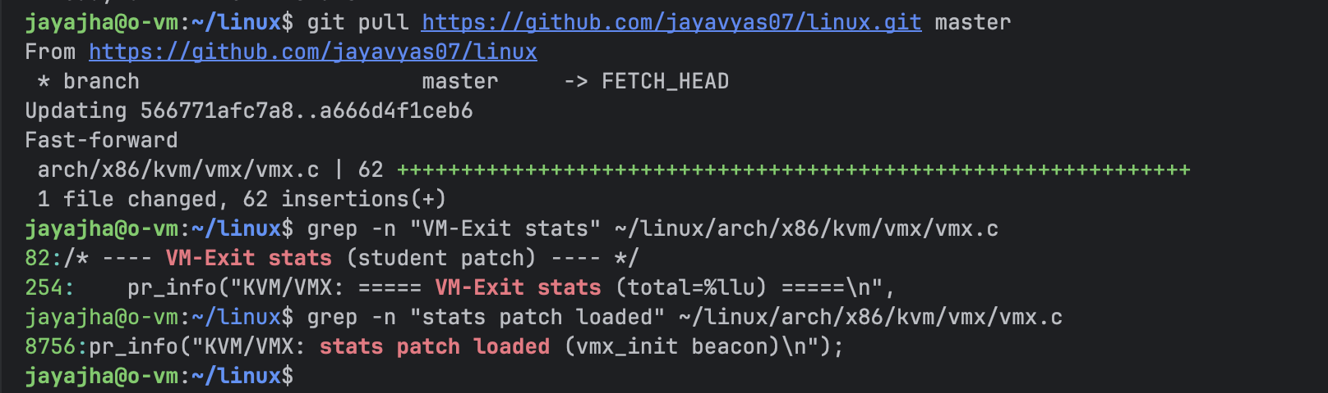
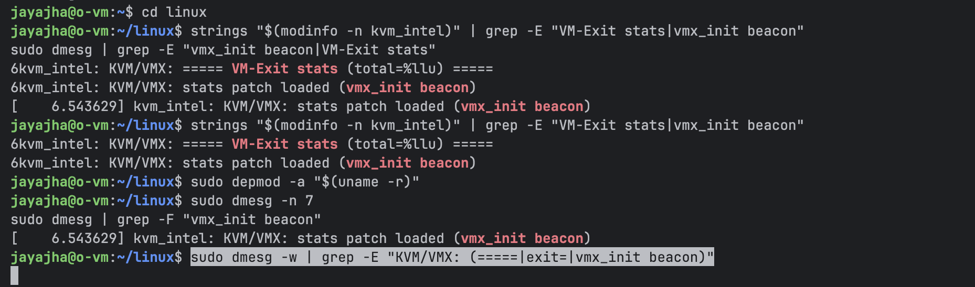

Figure 6 Successful KVM module build and installation.
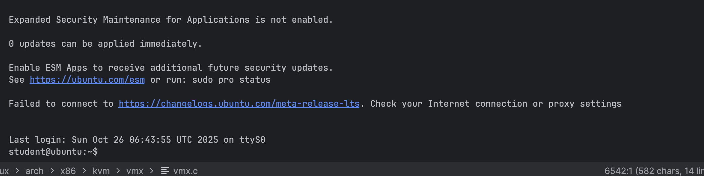

c) Reload (or reboot) to ensure the patched module is active:
sudo virsh list --state-running # destroy guest if running
sudo systemctl stop libvirtd virtqemud virtlogd
sudo modprobe -r kvm_intel kvm || true
sudo modprobe kvm
sudo modprobe kvm_intel nested=1
sudo systemctl start libvirtd
# (or simply: sudo reboot)
Figure 7 dmesg showing the vmx_init beacon after reload.


Step 3 Boot Inner VM and Observe printk Output
a) Enable nested KVM (if not already):
echo Y | sudo tee /sys/module/kvm_intel/parameters/nested
b) Start and attach to the inner VM, then generate exits:
sudo virsh start inner-ubuntu
sudo virsh console inner-ubuntu # login
for i in {1..50000}; do cat /proc/cpuinfo >/dev/null; done


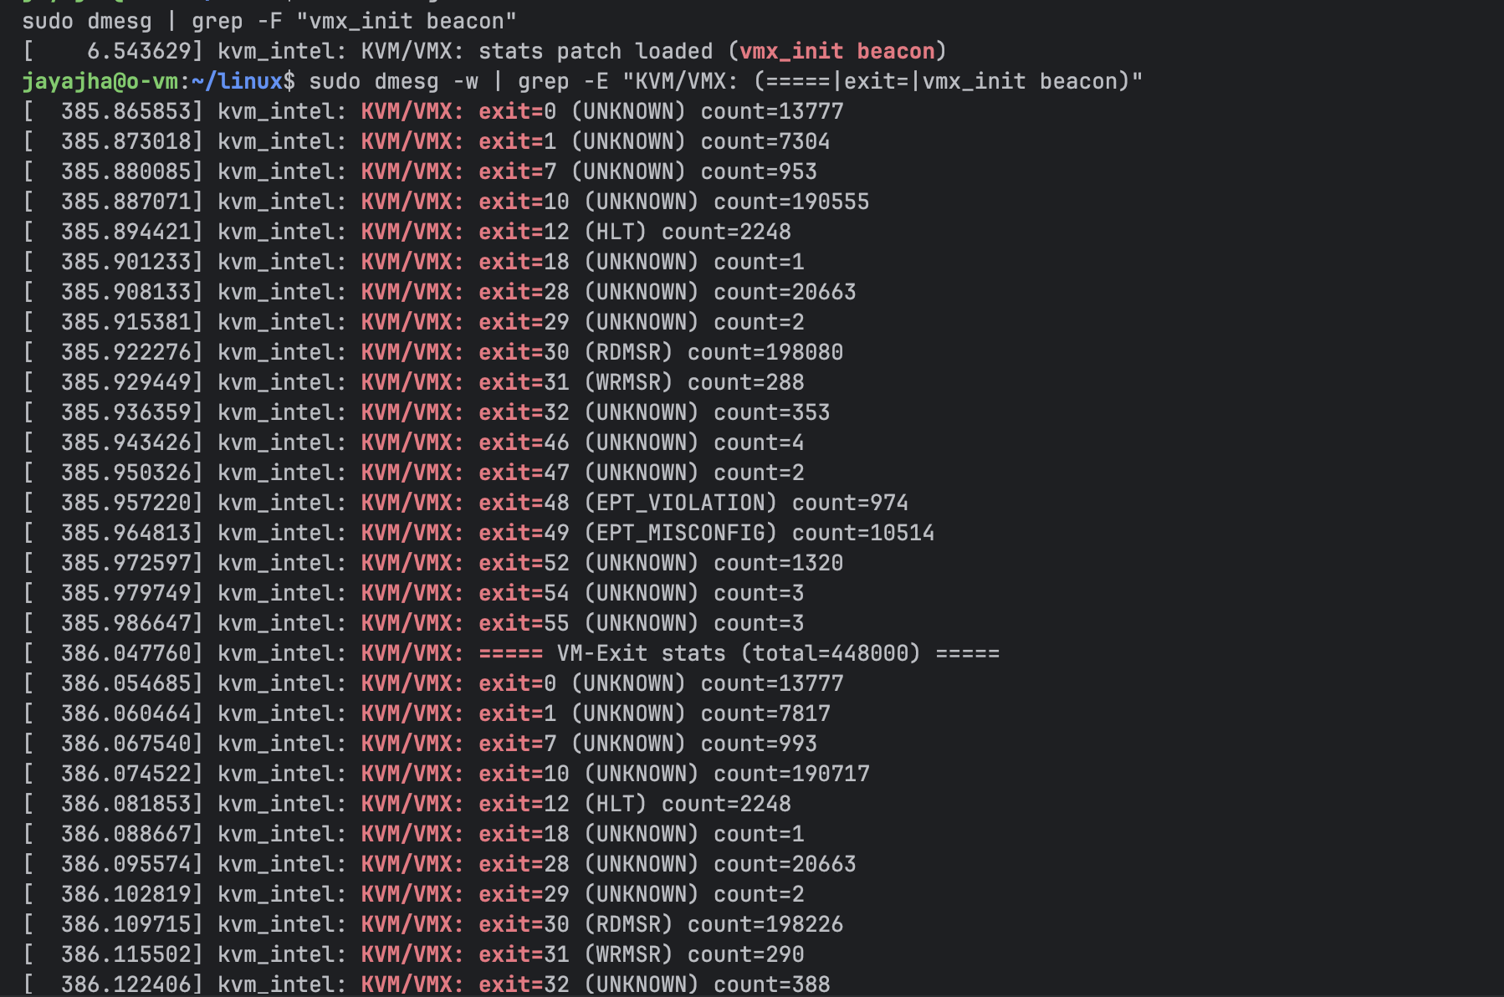
c) Watch kernel logs for periodic stats (every 10k total exits):
sudo dmesg -w | grep -E "KVM/VMX: (=====|exit=|vmx_init beacon)"
Figure 8 — VM-Exit statistics printing in dmesg at the configured interval.

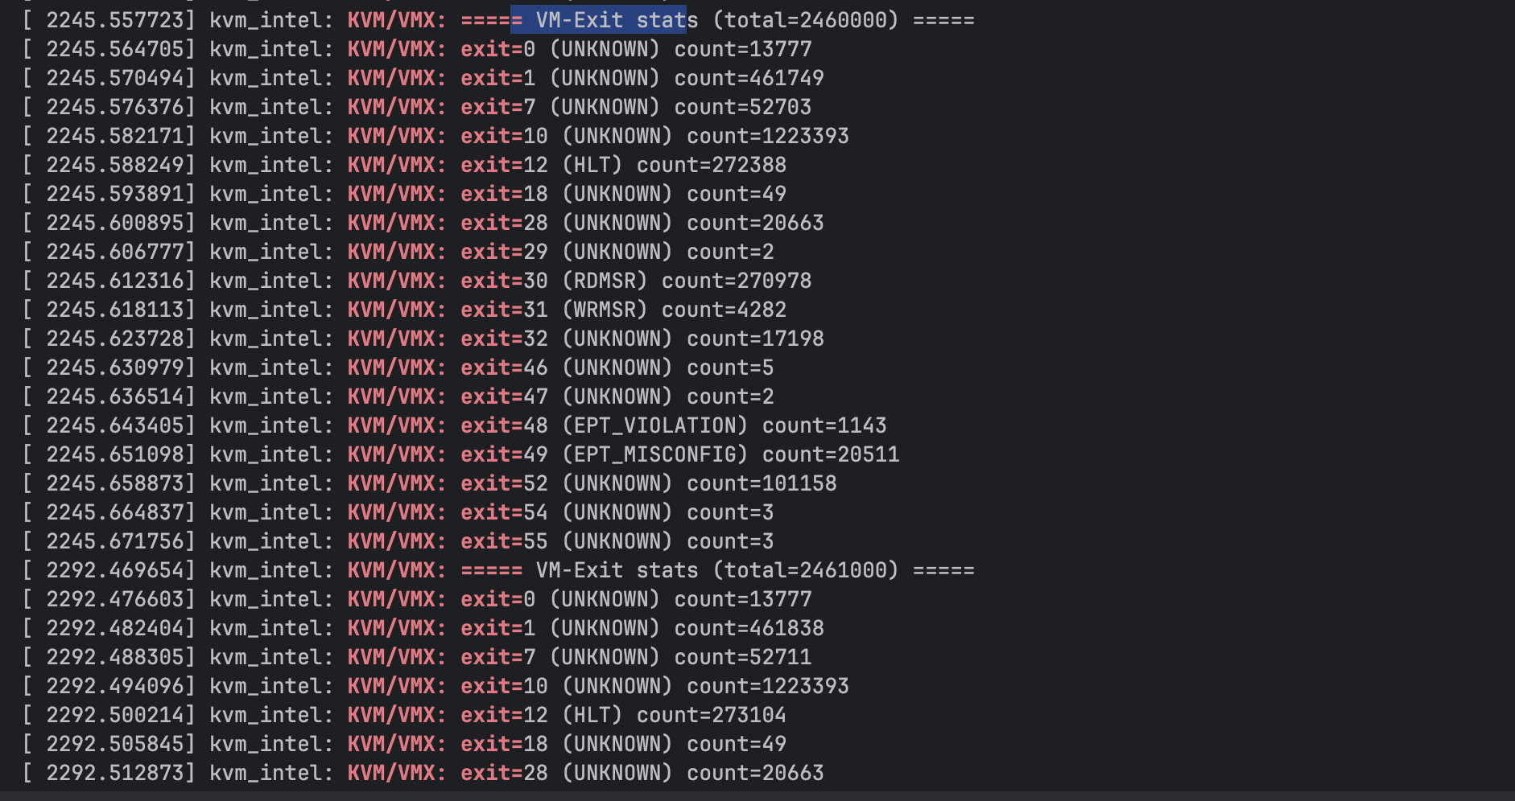

3) Frequency of Exits
The total exit count increases steadily over time but not at a perfectly constant rate. Spikes occur during CPU feature discovery (e.g., CPUID), MSR accesses, and memory management events (e.g., EPT violations) especially during boot. Once the guest is idle, exit rate stabilizes. In my measurements a full VM boot was on the order of ~400K–500K total exits.

4) Exit-Type Frequency (Most vs Least)
Exit Type | Meaning | Observed Frequency | Context / Notes
CPUID (9) | CPU feature query | Very frequent | During kernel/userspace init and library probing
HLT (12) | Guest idle loop | Frequent | When waiting for interrupts / scheduler idle
RDMSR/WRMSR (30/31) | Model-specific register access | Moderate | System setup and drivers
EPT_VIOLATION (48) | MMU translation fault | Common | Boot/memory mapping activity
EPT_MISCONFIG (49) | Invalid EPT mapping | Occasional | Early boot / misconfig paths
UNKNOWN | Unlabeled exit reasons | Rare | Any exit not explicitly named in the switch

