Problem Statement: -

Check Writer: To print the given integer / float number available on Check in English equivalent word.

Ex:

Input: 10985.25 Output: Ten thousand nine hundred eighty-five dollars and 25/100

Input: 125.75 Output: One hundred twenty-five dollars and 75/100

Input: 95.00 Output: Ninety-five dollars only

Input: 69 Output: Sixty-nine dollars only

**APPROACH USED-**

Below are few algorithm steps to solve **Check Writer** problem.

Algorithm:

1. START
2. Declare variables to receive input values (inputNumber (either integer or float))
3. Declare a String Type Arrays to hold the tens values & first twenty values in word.
4. Separate floating input into two-part 1. pre-decimal & 2. post-decimal parts.
5. Called conversion methodconvertPreDecimalNumberIntoWord(intpart)

For pre-decimal part.

1. Segregated this number into 3 digit trillions, billions, millions, thousand, ones value.
2. Called convertThreeDigitNumberIntoWord (int number) for each of above value (trillions, billions, millions, thousand, ones).
3. Appended result returned by convertThreeDigitNumberIntoWord (int number) for trillions, billions, millions, thousand, ones values and returned result.
4. Removed leading and trailing spaces of resulted string.
5. Returned above resulted string to main method for display if there is no

post-decimal part exists.

1. Append resulted string with “post decimal part/100” first if post decimal part exists and then returned resulted string to main method for display.
2. Display number in word format on console
3. END

**TEST SCENARIOS-**

SUCCESS SCENARIO:

* If valid integer number is given as input values, then it will convert it into word successfully.

Input no.: This should be positive integer.

* If valid float number is given as input values, then it will convert it into word successfully.

Input no.: This should be positive float.

ERROR SCENARIO:

* Given input no. should not be negative integer or float else it will show error “Entered input is invalid, please enter the valid positive integer or float number.”
* Given input no. should not contain special character other than ‘.’ it will show error “Entered input is invalid, please enter the valid positive integer or float number.”

**JUNIT test case report:**

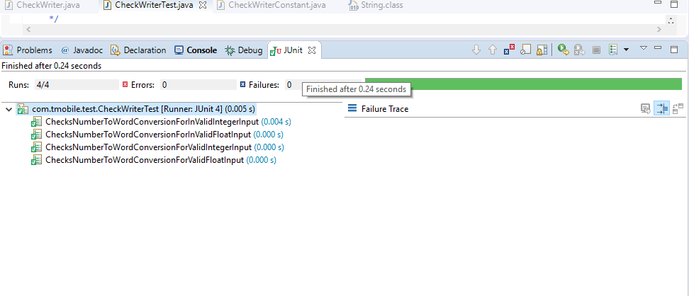

**OUTPUT-**

SUCCESS scenario#1

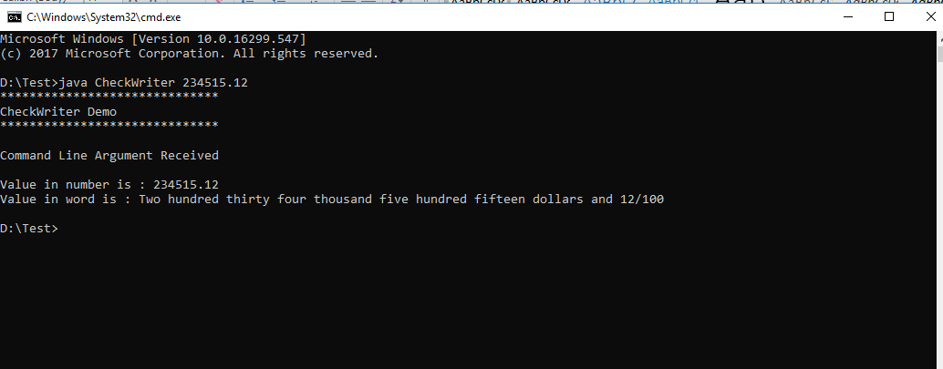

SUCCESS scenario#2

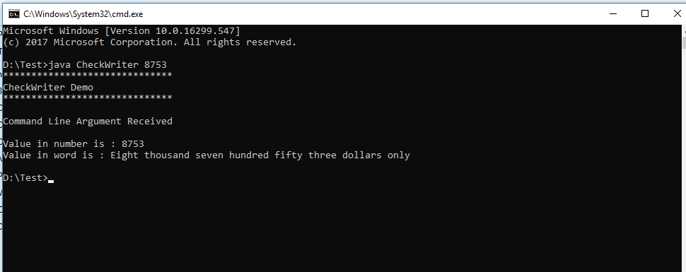

ERROR scenario#1

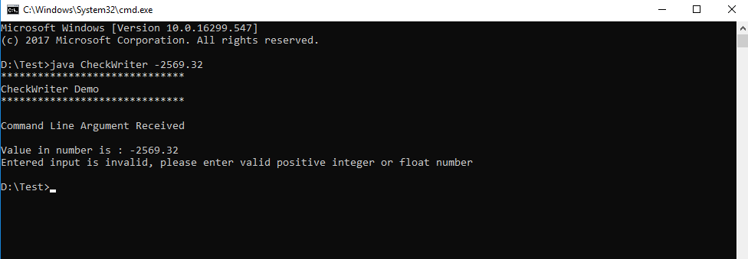

ERROR scenario#2

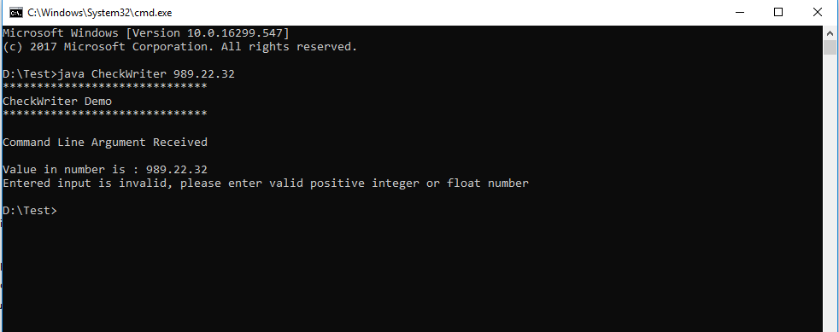

ERROR scenario#2

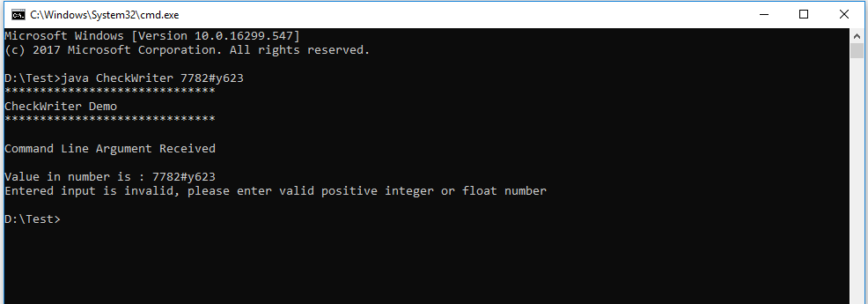

**STEPS to RUN the program from command line**

1. Download the folder from GIT URL:

<https://github.com/jayawantchavan/CheckWriter>

1. Unzip the folder, Keep the downloaded folder in any drive (valid path) on your system
2. Open command prompt and navigate to the path of that folder:

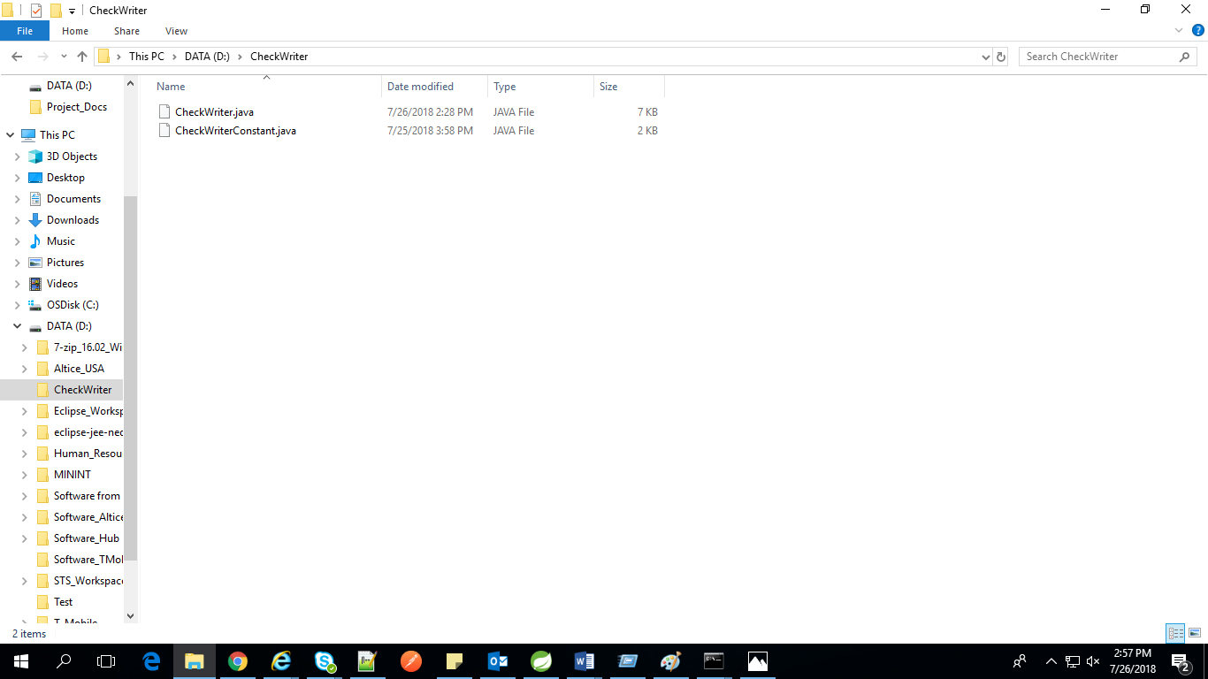

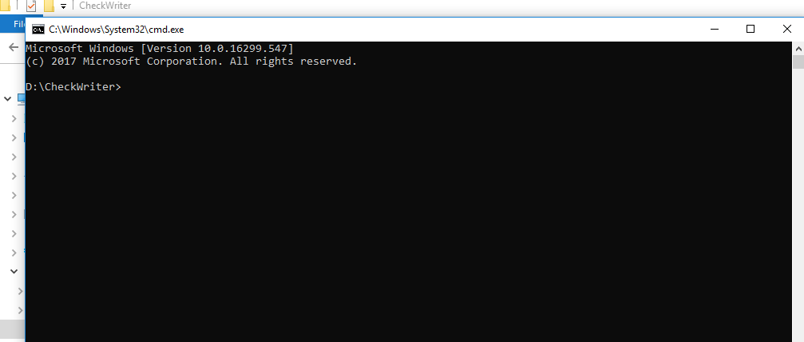

1. Run below java command to compile the program:

**javac CheckWriterConstant.java**

**javac CheckWriter.java**

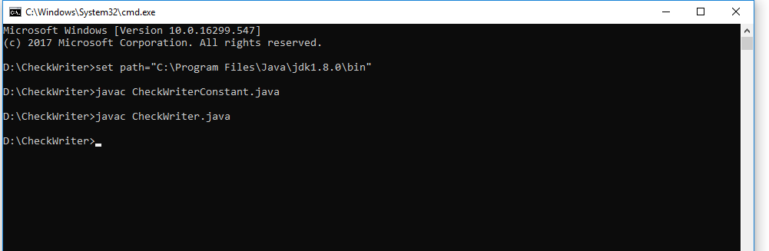

1. Run below java command to run actual program while passing input values:

**java CheckWriter 3452**

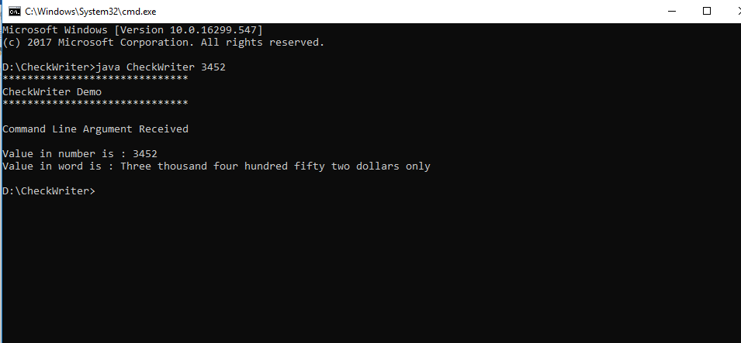

Flow Diagram

Start

Enter Integer or float Input Number

Segregate this integer number into three digit trillions, billions, millions, thousands, ones

Call convertPreDecimalNumberIntoWord ()

**No**

Call convertInputNumberIntoWord () method

Split the string into parts and convert it into pre-decimal and post decimal integer part

**YES**

Display error Message

Check if the Input Number is valid or not

Convert these three digits trillion, billions, millions, thousands and ones value into word by calling convertThreeDigitNumberIntoWord () method

‘result’ variable value will be returned and stored into ‘numberInWord’ for removing leading, trailing and extra spaces and After making first character in capital letter this string will be stored into resultedString

Stop

Result will be displayed in main method

resultedString value will be returned to main method by appending some string value

Store the value returned by convertThreeDigitNumberIntoWord ()

into ‘result’ variable