**[Intro]**

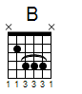

e|---------------------------------------------------------------------|

B|--------4-------4--5--4--5--4-----------4----------------------------|

G|--------4-------4--4--4--4--4-----------4----------------------------|

D|-----4-------4-----------------------4-------------1--4--2--1--------|

A|--2--2-------2--------------------2--2-------2--4--------------4--2--|

E|---------------------------------------------------------------------|

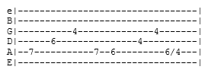 **[Verses 1 ]**

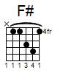 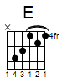

Guess I got what I deserved

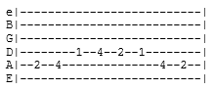

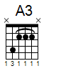  

Kept you waiting there too long my love

 

All that time without a word

   

Didn’t know you’d think that I’d forget

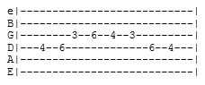

Or I’d regret

**[Chorus]**

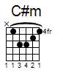 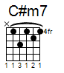 

The special love I had for you

My baby blue

^ v

e|-----------------------4-----------7-7--|

B|-------------5-------------5-------5-5--|

G|----------4-----4--------------4--------|

D|------6------------6--------------------|

A|--7-------------------------------------|

E|----------------------------------------|



e|---------------------------------------------------------------------|

B|--------4-------4--5--4--5--4-----------4----------------------------|

G|--------4-------4--4--4--4--4-----------4----------------------------|

D|-----4-------4-----------------------4-------------1--4--2--1--------|

A|--2--2-------2--------------------2--2-------2--4--------------4--2--|

E|---------------------------------------------------------------------|

**[Verses 2]**

 

All the days became so long



  

Did you really think I’d do you wrong

 

Dixie, when I let you go



  

Thought you'd realize that I would know



I would show

**[Chorus]**

  

The special love I had for you

My baby blue

^ ^

e|-----------------------4-----------7-7--|

B|-------------5-------------5-------5-5--|

G|----------4-----4--------------4--------|

D|------6------------6--------------------|

A|--7-------------------------------------|

E|----------------------------------------|



e|---------------------------------------------------------------------|

B|--------4-------4--5--4--5--4-----------4----------------------------|

G|--------4-------4--4--4--4--4-----------4----------------------------|

D|-----4-------4-----------------------4-------------------------------|

A|--2--2-------2--------------------2--2-------------6--9--7--6--------|

E|---------------------------------------------7--9-------------9-6----|

**[Bridge]**

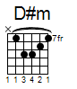 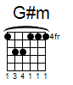 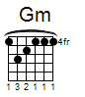

What can I do

 

What can I say

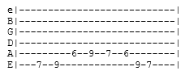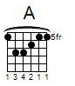  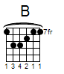

Except I want you by my side

  

How can I show you

 

Show me the way

  

Don't you know the times I've tried

**[Solo 1]**

e|------------------5------------------------------------9--12-14b14b14b—17b-|

B|---5b-b5--3------------7b7b7b--5---------9b9b9b--7--10---------------------|

G|-------------4/6----------------6~~~~~~-----------9------------------------|

D|---------------------------------------------------------------------------|

A|---------------------------------------------------------------------------|

E|---------------------------------------------------------------------------|

**[Outro]**

  [Fill 1]

Guess that's all I have to say

  B [Fill 2]

Except the feeling just gets stronger every day

 [Fill 1]

Just one thing before I go

  B [Fill 2]

Take good care, baby, let me know

 [Fill 3] 

Let it grow

   [Fill 4] 

The special love you had for me

B

My Dixie dear

e|-----------------------4-----------7-7--|

B|-------------5-------------5-------5-5--|

G|----------4-----4--------------4--------|

D|------6------------6--------------------|

A|--7-------------------------------------|

E|----------------------------------------|

**[Ending]**

   

e|---------------------------------------------------|

B|--------4-----4-------4-------------5----5----5----|

G|------4—-4----------4---4---------6--6-----6-------|

D|----4------4------4------4------6------6----6------|

A|--2-------------2-------------4--------------------|

E|------------------------------------------------7--|

**[Solo 2]**

e|-----------------------------------------|

B|----------------------------12\14b~~~~---|

G|-------------------9\11--9---------------|

D|-----------9\11--9-----------------------|

A|----7\9--7-------------------------------|

E|---5-------------------------------------|

*[Solo 2] chords A E B*

