J8CM Stack Operations Demo

Instructions used
load accumulator: 00000100
push: 00010001
clear accumulator: 00011101
pop: 00010010
halt: 00001001

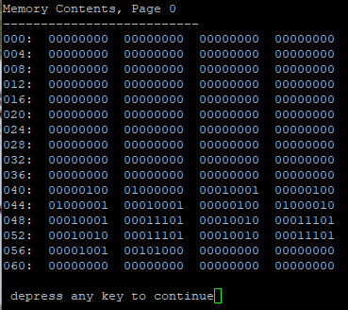
Program data
040: 00000100 Load accumulator
041: 01000000 From memory address
042: 00010001 Push to stack
043: 00000100 Load accumulator
044: 01000001 From memory address
045: 00010001 Push to stack
046: 00000100 Load accumulator
047: 01000010 From memory address
048: 00010001 Push to stack
049: 00011101 Clear accumulator
050: 00010010 Pop from stack
051: 00011101 Clear accumulator
052: 00010010 Pop from stack
053: 00011101 Clear accumulator
054: 00010010 Pop from stack
055: 00011101 Clear accumulator
056: 00001001 Halt
057: 00101000 Loads location 40 back into the Program Counter
Memory data
064: 11111111
065: 01010101
066: 10011001

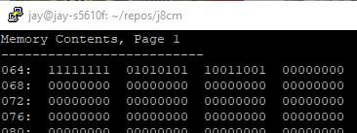
Stack data after all three push instructions are executed (040 through 048)

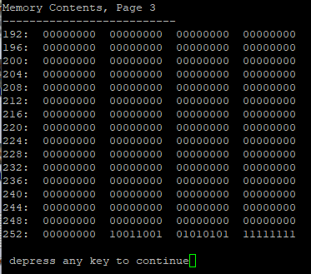
Using the Memory Editor beginning at location 246 to view the stack, it looks like this:

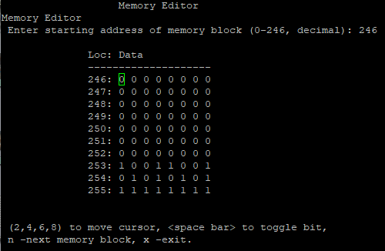

First push
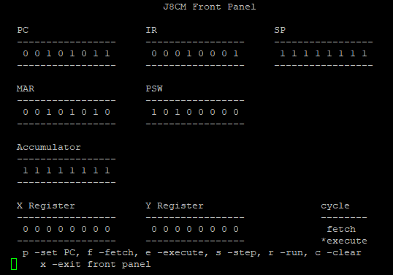

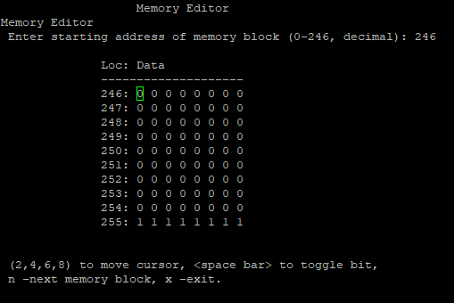

Second Push
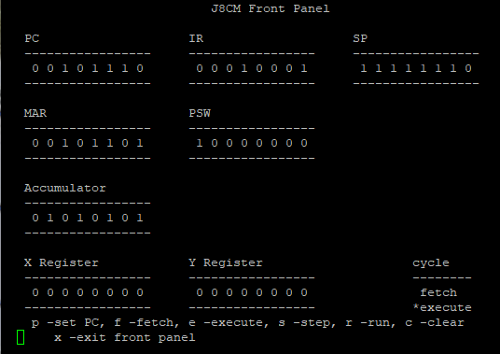
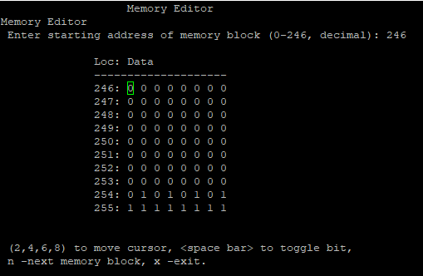
Third push
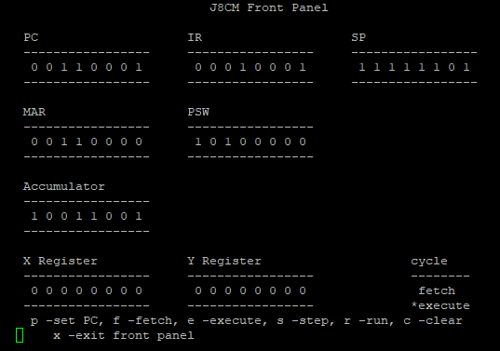
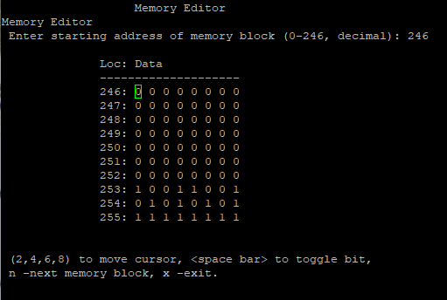

First pop
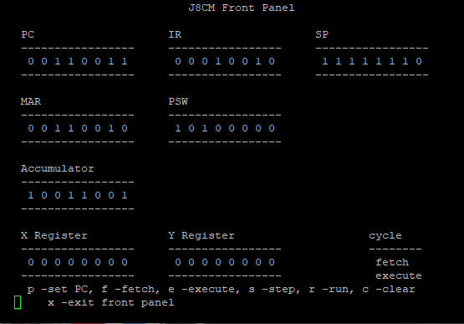

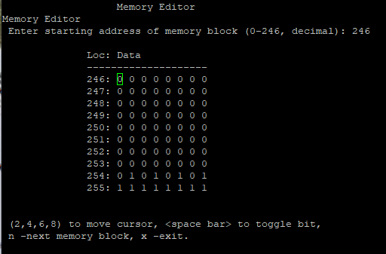
Second pop
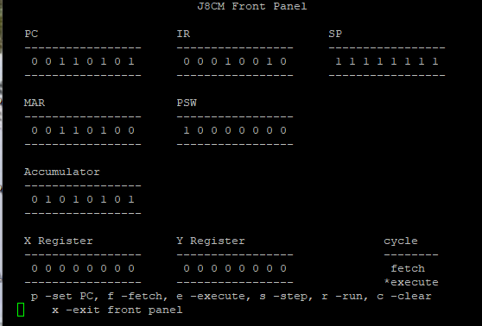

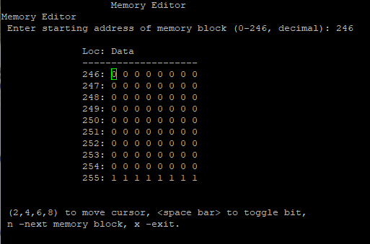
Third pop
