**Program To Check the Value is Palindrome or Not:**

**public class Num{**

**public static void main(String args[]){**

**int st=12321;**

**int rev=0;**

**int digit=0;**

**int str=st;**

**while(st>0){**

**digit=st%10;**

**rev=(rev*10)+digit;**

**st=st/10;**

**}**

**if(rev==str){**

**System.out.println(rev+"_Value is Palindrome");**

**}**

**else{**

**System.out.println(rev+"_Value is not Palindrome");**

**}**

**}**

**}**

**Program to check Number is Armstrong or not:**

**public class Num{**

**public static void main(String args[]){**

**int no=153;**

**int n=no;**

**int sum=0;**

**int digit=0;**

**while(no>0){**

**digit=no%10;**

**sum=sum+digit*digit*digit;**

**no=no/10;**

**}**

**if(sum==n){**

**System.out.println(sum+"_No is Armstrong");**

**}**

**else{**

**System.out.println(sum+"_No is not Armstrong");**

**}**

**}**

**}**

**Program to find largest among three:**

**public class Num{**

**public static void main(String args[]){**

**int a=20;**

**int b=43;**

**int c=12;**

**if(a>b && a>c){**

**System.out.println("A is Greater");**

**}**

**else if(b>a && b>c){**

**System.out.println("B is Greater");**

**}**

**else{**

**System.out.println("C is Greater");**

**}**

**}**

**}**

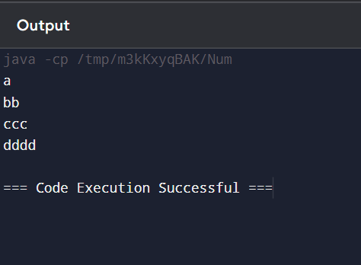

**Program to print following pattern:**

**A**

**BB**

**CCC**

**DDDD**

**public class Num{**

**public static void main(String args[]){**

**char n[]={'a','b','c','d'};**

**for(int i=0;i<n.length;i++){**

**for(int j=0;j<=i;j++){**

**System.out.print(n[i]);**

**}**

**System.out.print("\n");**

**}**

**}**

**}**