Toronto emotional speech set (TESS)

- It is a voice-based dataset which content human emotions. All the voice available in this dataset are of female’s, there are two categories first one is of Old Female Voice (OAF) & second one is of Young Female Voice (YAF).
Data Set:
- TESS Toronto emotional speech set data
  - OAF_Fear
  - OAF_Pleasant_surprise
  - OAF_Sad
  - OAF_angry
  - OAF_disgust
  - OAF_happy
  - OAF_neutral
  - YAF_angry
  - YAF_disgust
  - YAF_fear
  - YAF_happy
  - YAF_neutral
  - YAF_pleasant_surprised
  - YAF_sad

OAF: Older Adult Female
YAF: Younger Adult Female

- The Common Sentence in all the voice is “Say the word …….”, and all audios are of almost same range 1 to 2 sec.
- Model: LSTM (Long Short-Term Memory)

- Strategy that we can use:
- Amplitude normalization + gain
- Pitch shifting
- Time stretching
- Noise injection
- Spec Augment
- Silence Removal

- Which Strategies we will be using:
- Amplitude (Normalization + Random Gain)
- Frequency-Based (Pitch Shifting)

Reason behind choosing these two strategies is:
1] Amplitude: Emotion recognition should not get confused between volume & emotion. People can speak the same sentence loudly or softly, while being angry, scared, or calm. If someone has a high-pitched voice and speaks loudly when scared, the system might get confused and predict it as angry. Here Normalizing amplitude ensures that model focuses on emotion cues instead of loudness (Low, High Pitch).
2] Frequency-Based (Pitch Shifting): As we know emotions strongly affect pitch. Anger and happiness can increase pitch, while sadness lowers it. Pitches shifting can help us to specify different speakers (male, female, young, old) and prevents the model from memorizing the two TESS voices (Old Women & Young Women). This will help LSTM to learn patterns from different-different pitch variations rather than just learning emotional patterns.
How both will work together:
So, in our project we are using both amplitude normalization and pitch shifting together. they are not doing same work; both are like two different helpers. amplitude normalization is like making every audio same volume level. sometime one recording is very loud, other is very low, so model get confused and may think loud voice means angry always. but emotion is not about loudness only. so, we normalize, means we fix volume at common level, so model only look at the pattern not the sound loudness.
Then pitch shifting is different. in Tess dataset we only got 2 voices, one young woman and one old woman. if we train like that model can just memorize them, like "oh this high pitch voice is of young woman which is happy" and "this low pitch voice is of old woman which is sad". then when new speaker comes model fail. so, we do pitch shifting, means we make copy of audio with little higher or lower pitch. this makes model listen many kinds of fake speakers, male, female, child. so, model don’t only learn voices, it learns emotion inside.
When we use both together, first normalization makes fairground, so loudness does not trick model, then pitch shifting gives more variety, so model don’t memorize just two voices. both mixes give model better brain to catch emotion pattern and not depend on who is speaking or how loud.

LSTM Model Architecture
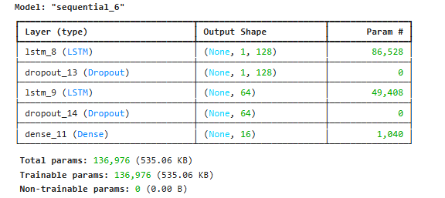
The architecture of the LSTM model is as follows:

Hyperparameters:
- Optimizer: Adam
- Loss Function: Categorical Cross entropy
- Epochs: 30
- Batch Size: 32
- Layers: Two LSTM layers (128 and 64 units), Dropout = 0.3, Dense SoftMax output layer.

Test Accuracy
Model saved to /kaggle/working/lstm_emotion_model.h5
Label encoder saved to /kaggle/working/label_encoder.pkl
LSTM model training complete!
Final test accuracy: 0.6643

Tranning vs Validation Accuracy & Loss
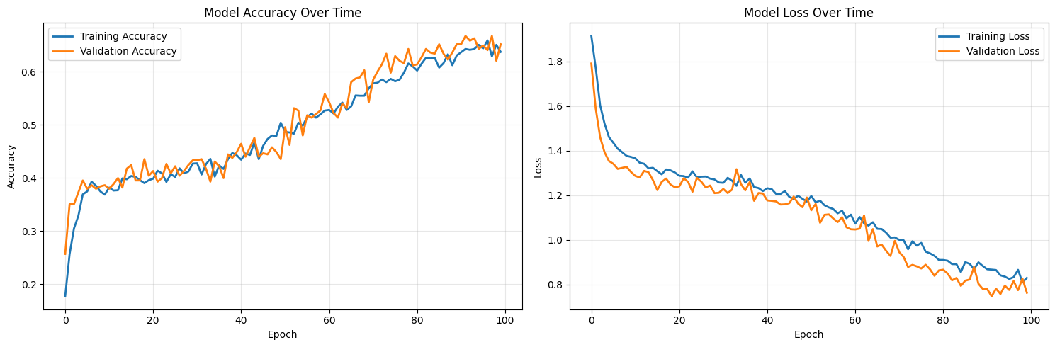

Confusion Matrix

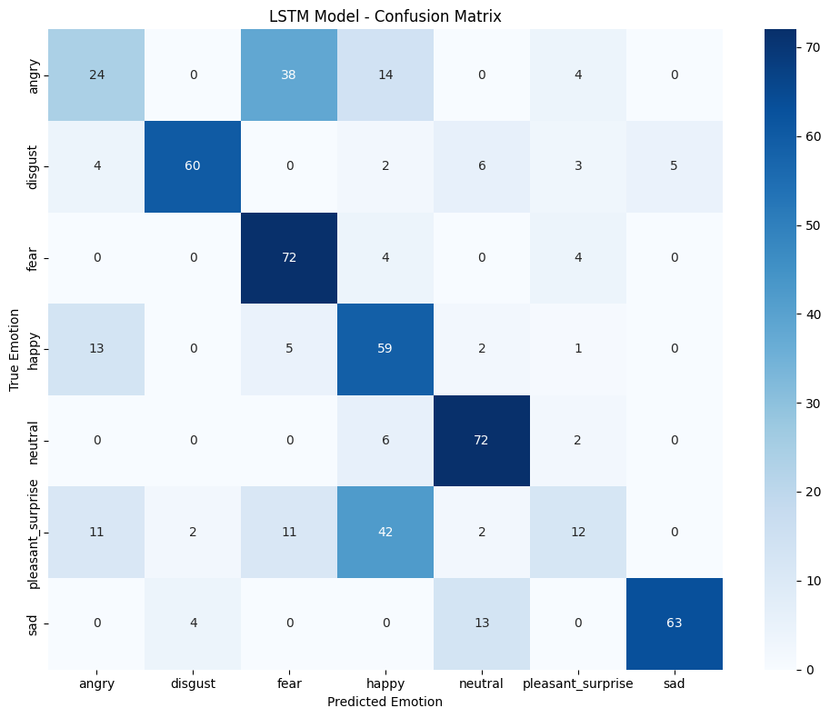

R-Square
- R square is like a score of how good your model is at explaining the data.
- If R² = 1 means your model is perfectly predicting the marks.
- If R² = 0 means your model is totally useless, like just random guessing.
- If R² = 0.85 means your model explains 85% of the variation in the marks, rest 15% still noise.
- In short → higher R² means your model fits better, lower means model is weak.

LSTM (Long Short-Term Memory)
- LSTM is a special type of neural network, mostly used for time-based or sequence data like audio, text, stock prices.
- Normal neural network forgets past info very fast, but LSTM has a memory cell which can remember long term info and decide what to keep, what to throw.
- For example, when listening to someone talking, the word "not" earlier in sentence is very important later for meaning. LSTM can keep that in memory.
- In speech emotion recognition (like TESS dataset), LSTM helps model understand tone changes across time rather than just single points.

Confusion Matrix
- Confusion matrix is like a table of truth vs prediction.
- Rows actual labels what is true.
- Columns predicted labels like what model said.
- The diagonal numbers e.g. top-left to bottom-right are correct predictions.
- Off diagonal mistakes.
- Example: If model confuse between “happy” and “excited”, you will see many numbers in those wrong cells.
- It’s called "confusion" matrix because it shows where the model got confused.

Conclusion
The LSTM model performed well on the TESS dataset for speech emotion recognition. Using amplitude normalization and pitch shifting helped the model generalize better by avoiding bias toward volume and speaker identity. Further performance improvements can be achieved with additional augmentations and more advanced architectures like Bi-LSTM or CNN-LSTM hybrids.

