C19 Data and Trends

## Worldwide Summary - All dates to current

## # A tibble: 4 x 2  
## type cases  
## <chr> <dbl>  
## 1 confirmed 109836   
## 2 death 3803   
## 3 recovered 60695   
## 4 mort_rate 0.0346

## # A tibble: 108 x 2  
## Country.Region cases  
## <chr> <int>  
## 1 Mainland China 80699  
## 2 Italy 7375  
## 3 South Korea 7314  
## 4 Iran 6566  
## 5 France 1126  
## 6 Germany 1040  
## 7 Others 696  
## 8 Spain 673  
## 9 US 538  
## 10 Japan 502  
## # ... with 98 more rows

## Worldwide Trends - Timeseries

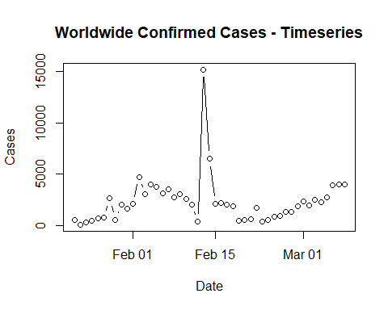

## Worldwide Summary - All dates to current (excluding China)

## # A tibble: 5 x 2  
## type cases  
## <chr> <dbl>  
## 1 confirmed 29137   
## 2 death 706   
## 3 recovered 3375   
## 4 mort_rate 0.0242  
## 5 rate_of_growth 1.22

## Growth Rate Plot

##### Rate of Growth = 1 + ( (Number of cases per day - Previous day’s cases) / Previous day’s cases )

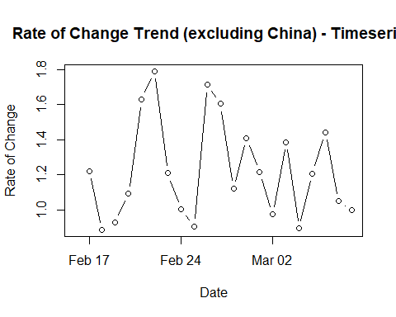

## Worldwide Trends - Timeseries (excluding China)

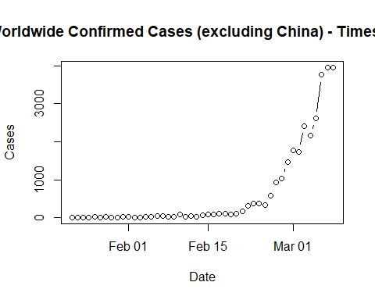

## US Totals

## # A tibble: 4 x 2  
## type cases  
## <chr> <dbl>  
## 1 confirmed 538   
## 2 death 21   
## 3 recovered 8   
## 4 mort_rate 0.0390

## US Trends - Timeseries

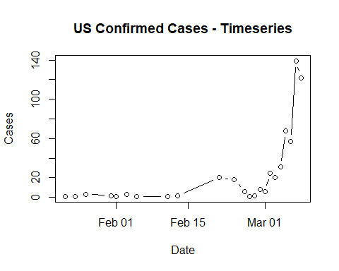

## China Totals

## # A tibble: 4 x 2  
## type cases  
## <chr> <dbl>  
## 1 confirmed 80699   
## 2 death 3097   
## 3 recovered 57320   
## 4 mort_rate 0.0384

## China Trends - Timeseries - All

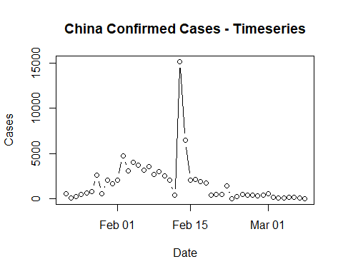

## China Trends - Timeseries - Feb 14th to current

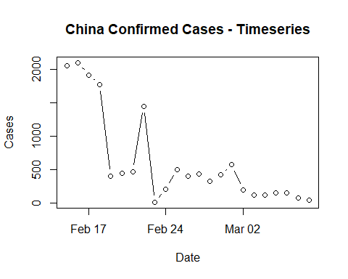

## CA Summary

## # A tibble: 4 x 2  
## type cases  
## <chr> <dbl>  
## 1 confirmed 98   
## 2 death 1   
## 3 recovered 2   
## 4 mort_rate 0.0102

## # A tibble: 17 x 2  
## Province.State confirmed_cases  
## <chr> <int>  
## 1 Santa Clara County, CA 38  
## 2 Los Angeles, CA 14  
## 3 Contra Costa County, CA 12  
## 4 San Francisco County, CA 9  
## 5 Placer County, CA 5  
## 6 Orange County, CA 3  
## 7 San Diego County, CA 3  
## 8 Alameda County, CA 2  
## 9 Sacramento County, CA 2  
## 10 San Benito, CA 2  
## 11 San Mateo, CA 2  
## 12 Fresno County, CA 1  
## 13 Humboldt County, CA 1  
## 14 Madera County, CA 1  
## 15 Riverside County, CA 1  
## 16 Sonoma County, CA 1  
## 17 Yolo County, CA 1

## CA Trend

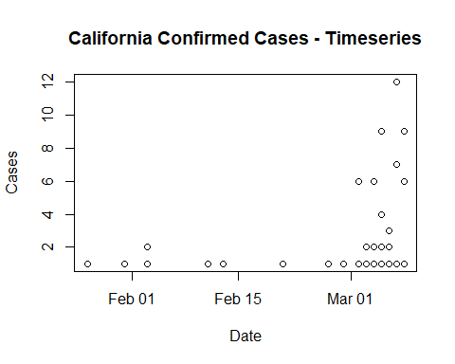

## Santa Clara Trend

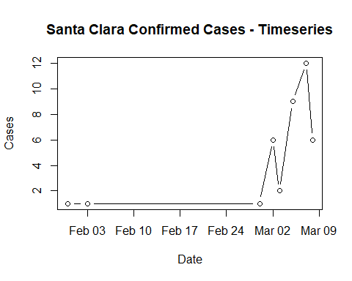

## South Korea Summary

## # A tibble: 4 x 2  
## type cases  
## <chr> <dbl>  
## 1 confirmed 7314   
## 2 death 50   
## 3 recovered 118   
## 4 mort_rate 0.00684

## South Korea Trend

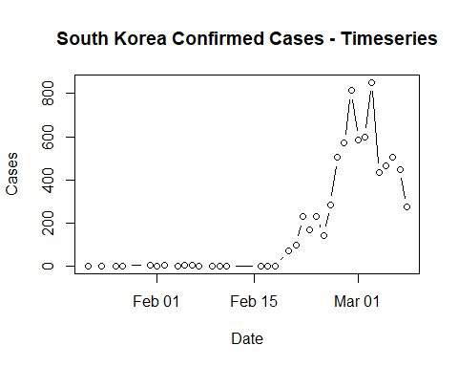

## Italy Summary

## # A tibble: 4 x 2  
## type cases  
## <chr> <dbl>  
## 1 confirmed 7375   
## 2 death 366   
## 3 recovered 622   
## 4 mort_rate 0.0496

## Italy Trend

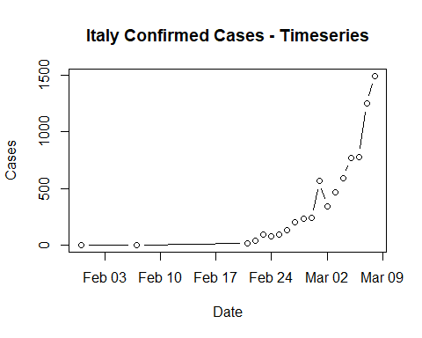

## Iran Summary

## # A tibble: 4 x 2  
## type cases  
## <chr> <dbl>  
## 1 confirmed 6566   
## 2 death 194   
## 3 recovered 2134   
## 4 mort_rate 0.0295

## Iran Trend

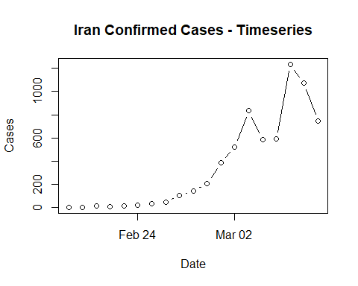

## France Summary

## # A tibble: 4 x 2  
## type cases  
## <chr> <dbl>  
## 1 confirmed 1126   
## 2 death 19   
## 3 recovered 12   
## 4 mort_rate 0.0169

## France Trend

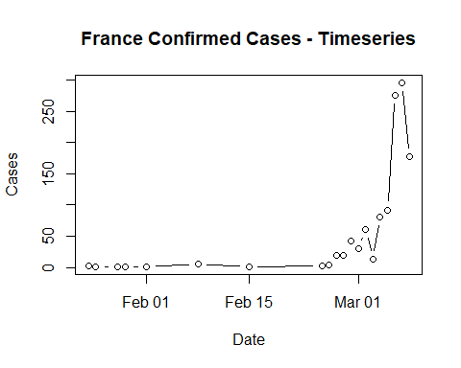

## Japan Summary

## # A tibble: 4 x 2  
## type cases  
## <chr> <dbl>  
## 1 confirmed 502   
## 2 death 6   
## 3 recovered 76   
## 4 mort_rate 0.0120

## Japan Trend

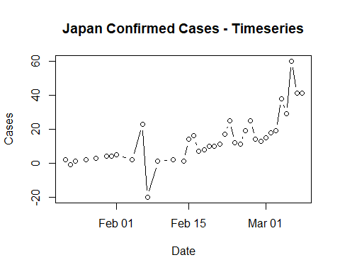

## Germany Summary

## # A tibble: 2 x 2  
## type cases  
## <chr> <int>  
## 1 confirmed 1040  
## 2 recovered 18

## Germany Trend

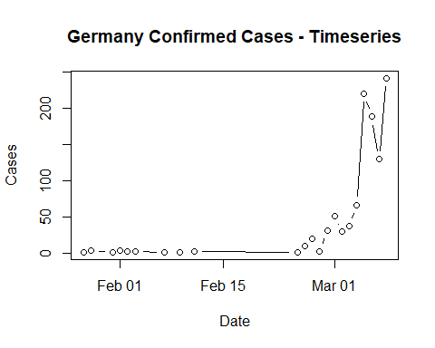

## Spain Summary

## # A tibble: 4 x 2  
## type cases  
## <chr> <dbl>  
## 1 confirmed 673   
## 2 death 17   
## 3 recovered 30   
## 4 mort_rate 0.0253

## Spain Trend

