# Week 7 – Milestone 1: Deliverable 2

## Team 5

## Coordinator: Kris Bebbington

## Contributors: Joshua Bauer, Kris Bebbington

# Contents

Week 7 – Milestone 1: Deliverable 2 1

Team 5 1

Coordinator: Kris Bebbington 1

Contributors: Joshua Bauer, Kris Bebbington 1

Contents 1

Overview - Competitive Analysis 2

Competitor 1 - https://www.cyberchallenge.com.au 2

Competitor 2 - http://www.eng.unimelb.edu.au/engage/schools/codemasters 2

Results 3

Strengths 3

Weaknesses 3

Table 1 – Content Criteria and Comparison 4

Table 2 – Functionality Criteria and Comparison 5

Table 3 – Strengths Comparison 6

Table 4 – Weaknesses Comparison 7

APPENDIX A – Author: Joshua Bauer 8

Competitor 1: Cyber Challenge (https://www.cyberchallenge.com.au) 8

Screenshots 8

Content/Functionality 10

Strengths 11

Areas for Improvement: 11

APPENDIX B – Author: Kris Bebbington 13

Competitor 2: Code Masters http://www.eng.unimelb.edu.au/engage/schools/codemasters 13

Screenshots 13

Content/Functionality 15

Strengths and Weaknesses 16

Strengths 17

Areas for Improvement: 17

# Overview - Competitive Analysis

As part of the development process for designing the CDU’s 2017 Code Fair site,

Our team performed competitive analyses of 2 similar websites.

Our criteria for choosing these websites was based on the following themes:

* Code Fair
* Code Masters
* Coding Competition
* University Coding

We focused on information inventory, functionality inventory, visual layout and general user experience. Tests were performed for accessibility, contrast, and code validation.

## Competitor 1 - <https://www.cyberchallenge.com.au>

Analysis by Joshua Bauer

## Competitor 2 - <http://www.eng.unimelb.edu.au/engage/schools/codemasters>

Analysis by Kris Bebbington

Content Criteria

* Relevance to stakeholders
* Layout of information
* External Links
* Help
* Search functionality
* Multimedia
* Similarity to CDU Code Fair Project

Code and resources

Criteria

* Standards
* External Libraries
* Multimedia
* Analytics
* Forms
* Local storage

# Results

Results from both analyses are tabulated below in Tables 1 – 4.

Main observations focused on User Experience, Usability, Responsive Design and Accessibility.

## Strengths

* Responsive Design
* Unobtrusive JavaScript
* Encryption / privacy
* Availability of content from past events
* Page load time
* Valid / semantically correct coding
* Accessibility
* Information well-laid out, easily findable, hard to get lost

## Weaknesses

* Navigation – missing back / top buttons, lacking hovering navigation
* JavaScript links broken when disabled
* Fails contrast test
* Incorrect form usage
* Content incorrectly labelled, or not obvious to user

## Table 1 – Content Criteria and Comparison

|  |  |  |
| --- | --- | --- |
| Content | Cyber Challenge | Code Masters |
| Content Criteria   * Relevance to stakeholders * Layout of information * External Links * Help * Search functionality * Multimedia * Similarity to CDU Code Fair Project | * “Poster” home page * Announcement – overall details and where to get extra information * Video * Registration form * The Challenge – What the challenge entails and how it came about * Rules and eligibility * Terms and Conditions * Privacy Statement * Resources * Past results * Solutions * Prizes * Sponsors * Links to sponsors | * What is it about? * Who can participate? * 2017 Results * 2017 Participating Schools * Problems and solutions   + Code Masters website – previous winners, leadership boards (lengthy) and problems / solutions. Registration. User management. * Code Masters Bits   + Code Masters Bits website - Currently run, all-year round competition with questions and leaderboard, rules. Team Registration. * Event format * Rules of the 2017 Competition * Contact us |

## Table 2 – Functionality Criteria and Comparison

|  |  |  |
| --- | --- | --- |
| Functionality | Cyber Challenge | Code Masters |
| Code and resources  Criteria   * Standards * External Libraries * Multimedia * Analytics * Forms * Local storage | * HTML5 and CSS3 * Bootstrap * JQuery for animation and DOM manipulation * Google Fonts * Cookies for tracking (used with analytics) * Google Analytics * YouTube video * Local storage and session storage for YouTube embedded video * Word and PDF forms * Email addresses in page | * HTML5 and CSS3. * Google Fonts. * University of Melbourne styling (shared stylesheets). * University of Melbourne shared JavaScript (common user functionality). * Google Analytics. * Isotope JavaScript layout. |

## Table 3 – Strengths Comparison

|  |  |  |
| --- | --- | --- |
| Strengths / Weaknesses | Cyber Challenge | Code Masters |
| Strengths   * Responsive * Unobtrusive JavaScript * Encryption / privacy * Availability of content from past events * Page load time * Valid / semantically correct coding * Accessibility | * Responsive, mobile first design * Main content and links work without JavaScript * Minimal, useful images/graphics * Page loads very quickly * Links descriptive * Each section or “page” is well defined * Resources and solutions available from previous events * Uses SSL for encrypted data * Semantic correct code * When styles disabled page displays information in order and easily readable | * Mobile first, responsive design. * Accessibility. * Simplified markup. * Style themes consistent with rest of organization. * In-site location and navigation. * Search functionality highly visible. * Sitemap for organisation. |

## Table 4 – Weaknesses Comparison

|  |  |  |
| --- | --- | --- |
| Strengths / Weaknesses | Cyber Challenge | Code Masters |
| Weaknesses   * Navigation * JavaScript links broken when disabled * Fails contrast test * Incorrect form usage * Content incorrectly labelled, or not obvious to user | * Floating navigation or top of page links from each section * 2 policy links and past events are JavaScript only and break when disabled * When styles disabled logos for sponsors are far too large and break page flow * Contrast ratio of 3.34:1 on most text, fails AA and AAA test for normal text * Missing first level heading (h1) * Email addresses used instead of forms * Links to documents are extraneous “click here”, “here” * A few links and images missing Alt text * Use of justified text, makes hard for reading flowing text * Word documents are used; documents have limitations in accessibility * PDF documents are used, often have issues with accessibility and need third party application * Cannot tab through links (keyboard use) | * Site is insecure   + No use of SSL for encryption. * Accessibility   + alt text required for all images * Previous Events and Results– Not highlighted in a menu.   + Labelled as Problems and Solutions, and positioned within the page content.   + Could be labelled more appropriately and accessible via side navigation. * Unobtrusive JavaScript   + Provide Search functionality when JavaScript disabled.   + Apply styling to top navigation links when JavaScript disabled. | |

# APPENDIX A – Author: Joshua Bauer

# Competitor 1: Cyber Challenge (https://www.cyberchallenge.com.au)

## Screenshots

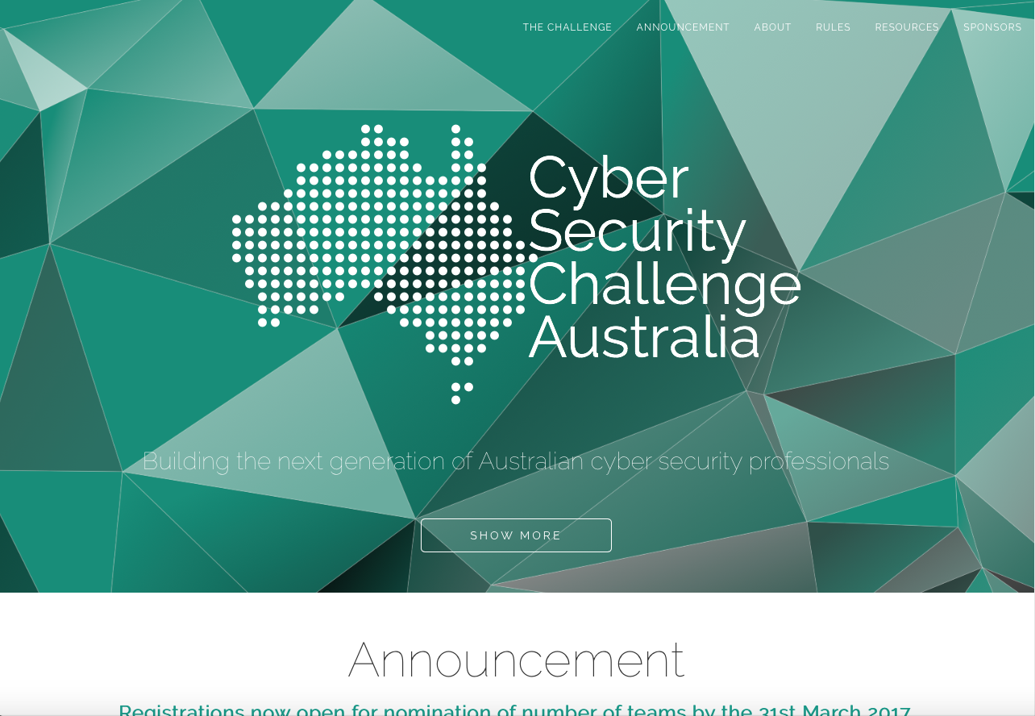

Cyber Challenge Home Page

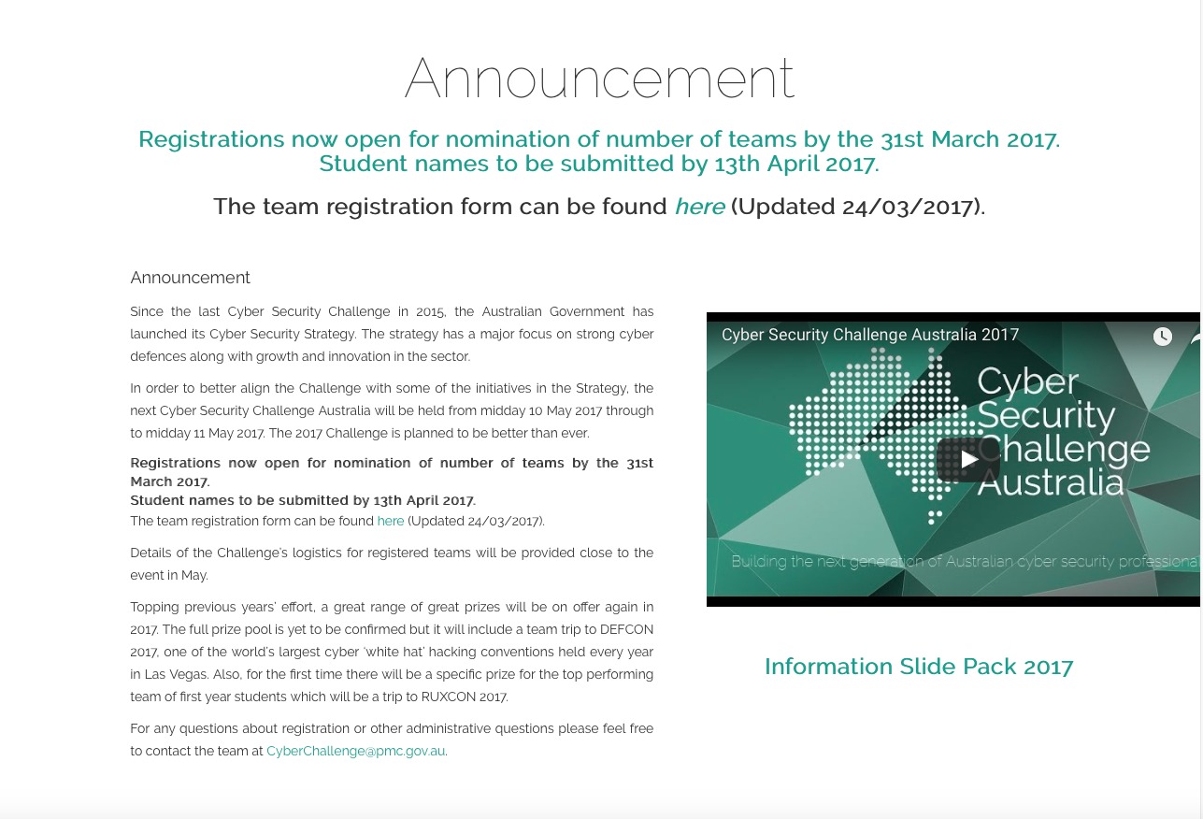

Cyber Challenge Sub Section (Page)

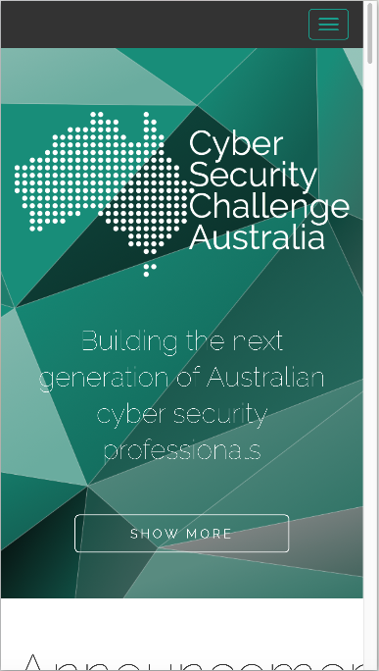

Cyber Challenge Mobile View (iPhone 6s)

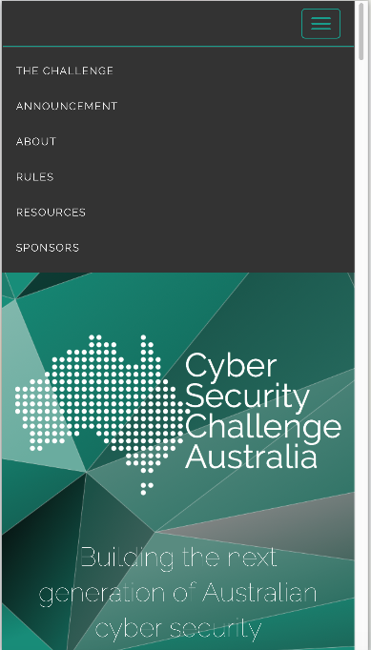

Cyber Challenge Mobile View with menu (iPhone 6s)

## Content/Functionality

Cyber Security Challenge Australia is a single page flyer site for the advertising of a hacking challenge presented by the government. The overall design is simple and appears to have all information available simply.

Specific content/function is listed in terms of analysis:

#### Information Offered:

* “Poster” home page
* Announcement – overall details and where to get extra information
  + Video
  + Registration form
* The Challenge – What the challenge entails and how it came about
* Rules and eligibility
* Terms and Conditions
* Privacy Statement
* Resources
  + Past results
  + Solutions
  + Prizes
* Sponsors
  + Links to sponsors

#### Technology Used:

* HTML5 and CSS3
* Bootstrap
* JQuery for animation and DOM manipulation
* Google Fonts
* Cookies for tracking (used with analytics)
* Google Analytics
* YouTube video
* Local storage and session storage for YouTube embedded video
* Word and PDF forms
* Email addresses in page

#### Search Functionality:

* None

## Strengths

The greatest strength of this site is the well laid out information, easily findable and hard to get lost.

#### Specific strengths include:

* Responsive, mobile first design
* Main content and links work without JavaScript
* Minimal, useful images/graphics
* Page loads very quickly
* Links descriptive
* Each section or “page” is well defined
* Resources and solutions available from previous events
* Uses SSL for encrypted data
* Semantic correct code
* When styles disabled page displays information in order and easily readable

## Areas for Improvement:

The main issue found with the site was that there is no easy movement between “pages” or parts of the page, missing some sort of back button or top button or having a hovering navigation.

#### Specific areas for improvement:

* Floating navigation or top of page links from each section
* 2 policy links and past events are JavaScript only and break when disabled
* When styles disabled logos for sponsors are far too large and break page flow
* Contrast ratio of 3.34:1 on most text, fails AA and AAA test for normal text
* Missing first level heading (h1)
* Email addresses used instead of forms
* Links to documents are extraneous “click here”, “here”
* A few links and images missing Alt text
* Use of justified text, makes hard for reading flowing text
* Word documents are used; documents have limitations in accessibility
* PDF documents are used, often have issues with accessibility and need third party application
* Cannot tab through links (keyboard use)

# APPENDIX B – Author: Kris Bebbington

# Competitor 2: Code Masters http://www.eng.unimelb.edu.au/engage/schools/codemasters

## Screenshots

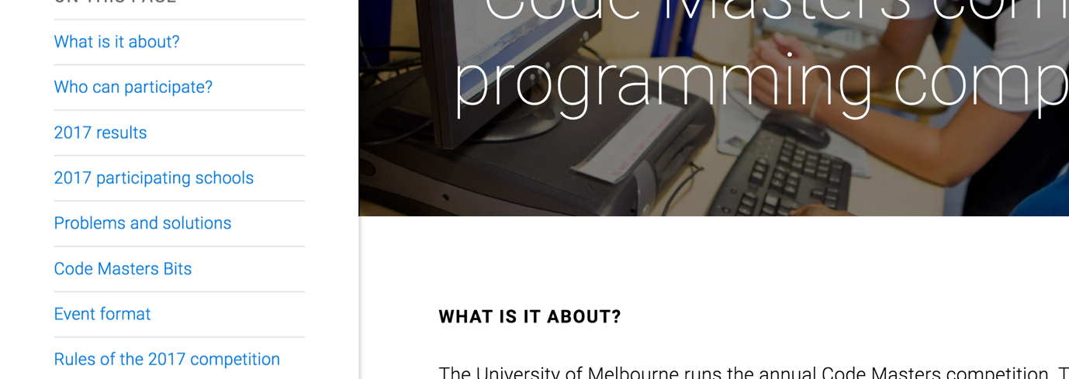

Screenshot Home Page

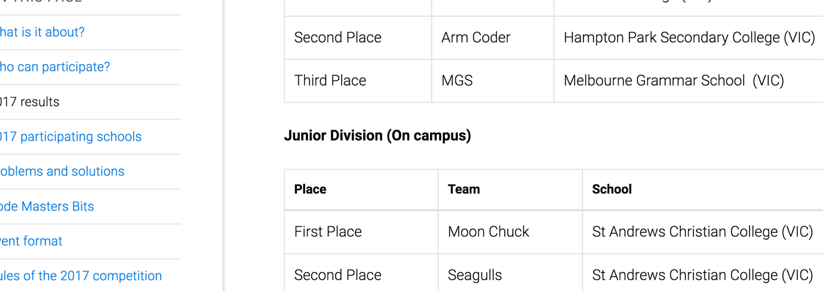

Screenshot Home Page

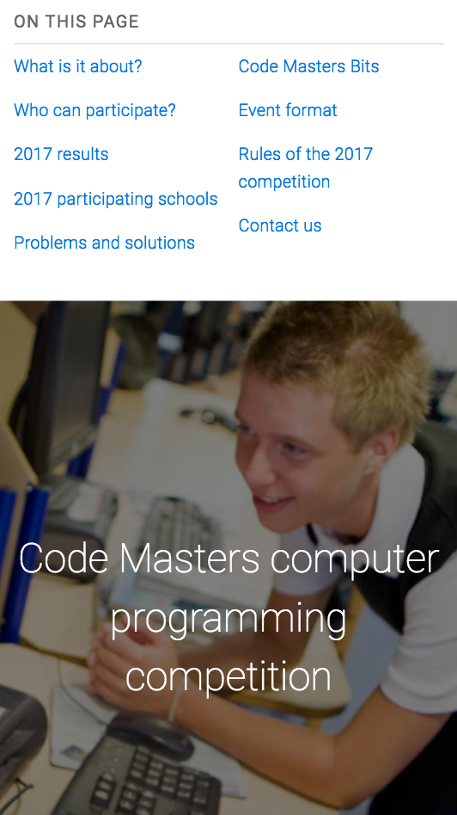

Screenshot IPhone 6 Portrait

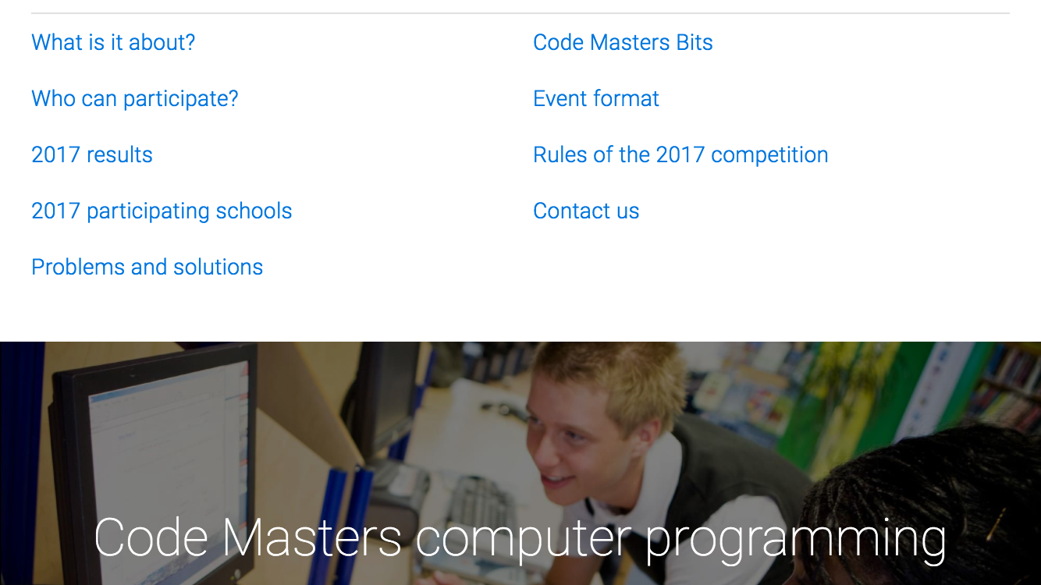

Screenshot IPhone 6 Landscape

## Content/Functionality

The Code Masters website promotes the annual programming competition run by the School of Engineering at the University of Melbourne. It features all information for the competition on a single page, and has an easy to use in-site navigation menu, and search facilities.

Content and functionality specifics:

#### Information Offered:

* What is it about?
* Who can participate?
* 2017 Results
* 2017 Participating Schools
* Problems and solutions
  + Code Masters website – previous winners, leadership boards (lengthy) and problems / solutions. Registration. User management.
* Code Masters Bits
  + Code Masters Bits website - Currently run, all-year round competition with questions and leaderboard, rules. Team Registration.
* Event format
* Rules of the 2017 Competition
* Contact us

#### Technology Used:

* HTML5 and CSS3.
* Google Fonts.
* University of Melbourne styling (shared stylesheets).
* University of Melbourne shared JavaScript (common user functionality).
* Google Analytics.
* Isotope JavaScript layout.

#### Search Functionality:

* Easily seen. Prominently displayed upper right hand side of page.
* Available with JavaScript Enabled only.

## Strengths and Weaknesses

* Markup (HTML5)
  + Well written and easily understandable HTML5 markup.
  + Validation – passed.
* JavaScript / CSS
  + “No-JavaScript” fallback – designed for use without JavaScript functionality.
  + Polyfills – IE < v9.
  + With JavaScript off
    - Menu functionality moved (top right).
    - Layout at bottom of page stacked – not impressive visually.
    - Simplified Navigation Bar – List contains no styling and looks primitive.
    - Main content remains accessible.
    - Search functionality removed.
  + Uses University of Melbourne JavaScript files and stylesheets.
    - Minimized CSS– difficult to analyse.
* Accessibility
  + Passes Chrome accessibility audit for most content.
    - Missing alternative text for some content.
  + Passes contrast testing 21:1 AAA.
* In-site navigation
  + Focused sidebar – focus adapts as page scrolls.
* Content
  + Similar requirements to ours.
  + Useful information.
  + Past events and results included.
* Top navigation
  + Inter-organizational navigation (Links for University of Melbourne).
  + Dropdown menu top right is visible and easy to find.
  + Search functionality top right is visible and easy to find.
* Responsive Design
  + Designed for mobile first.
  + Layout changes between device sizes.
  + Side menu moves to top as screen get smaller.
  + Some scrolling still required when side menu still on side.
  + Overall responsive site. Works well across devices
* Visual styles
  + Images / multimedia.
  + Easy to find search – done.
  + University Sitemap at bottom of page.
  + Performs well with styles removed.

## Strengths

* Mobile first, responsive design.
* Accessibility.
* Simplified markup.
* Style themes consistent with rest of organization.
* In-site location and navigation.
* Search functionality highly visible.
* Sitemap for organisation.

## Areas for Improvement:

* Site is insecure
  + No use of SSL for encryption.
* Accessibility
  + alt text required for all images
* Previous Events and Results– Not highlighted in a menu.
  + Labelled as Problems and Solutions, and positioned within the page content.
  + Could be labelled more appropriately and accessible via side navigation.
* Unobtrusive JavaScript
  + Provide Search functionality when JavaScript disabled.
  + Apply styling to top navigation links when JavaScript disabled.