# Milestone 3 – Design & Documentation Processes

**Group 5**

**Coordinator: Kris Bebbington**

**Contributors: Joshua Bauer & Kris Bebbington**

**Paper Wireframes and User Testing preparation: Kris Bebbington**

**HTML Wireframe, Administer User Testing: Josh Bauer**

**Remaining tasks were a collective effort, and all tasks finalised after team collaboration.**

## Inclusive Persona

To make our website more inclusive, we updated Patrick’s persona to give him a disability.

Scenario

Patrick has heard about the website from his lecturers and other students at Charles Darwin University.

Patrick follows a link from his course note announcements and wants to know more about the prize money for the Coding Fair. He notes there are other events of interest to him, namely the *Industry Employer Speed Dating* event.

Patrick decides he wants to register for the Code Fair, and finds this process intuitive and efficient. Patrick talks about it with his classmates and they think about visiting the site also.

Patrick recently had a motorcycle accident, and injured one of his hands. Because of the accident, Patrick finds it difficult to use the mouse and keyboard with fluency. His injuries are temporary; however, he is in pain and can’t focus for long.

Inclusive%20Persona/KB%20-%20persona_inclusive.pdf

Patrick’s new persona, updated after his recent motorcycle accident.

## Site map

Taking into account our new persona’s accessibility issues, we decided to group our content into categories, Common Links, Targeted Info, Event info, Sign up, and History.

Our intention is to simplify our navigation structure to make things more discoverable, and reduce the total number of pages.

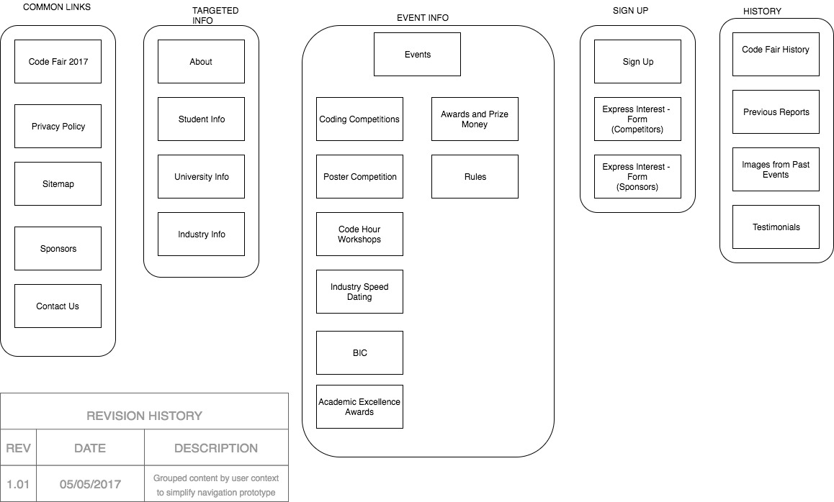

## Concept Map

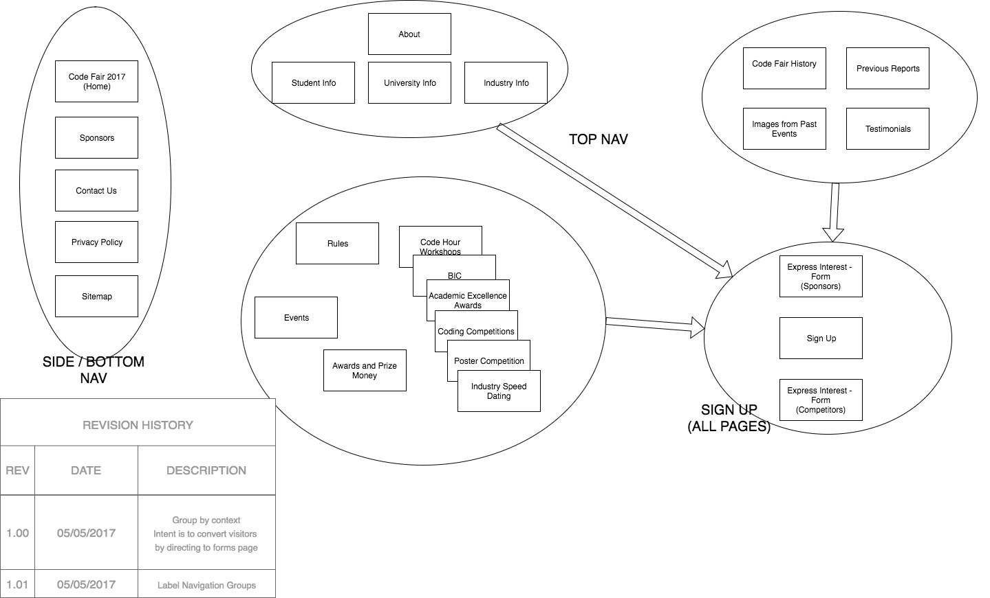 For our concept map, we grouped together what we considered “common navigation groups”. The main focus of the site is to convert visitors into participants, so we need to ensure our website guides our users to the Sign Up form.

## ../../../Apps/drawio/wireframe1.jpg3a. Paper Wireframe - Monitor

## 3b. Paper Wireframe – Mobile Device

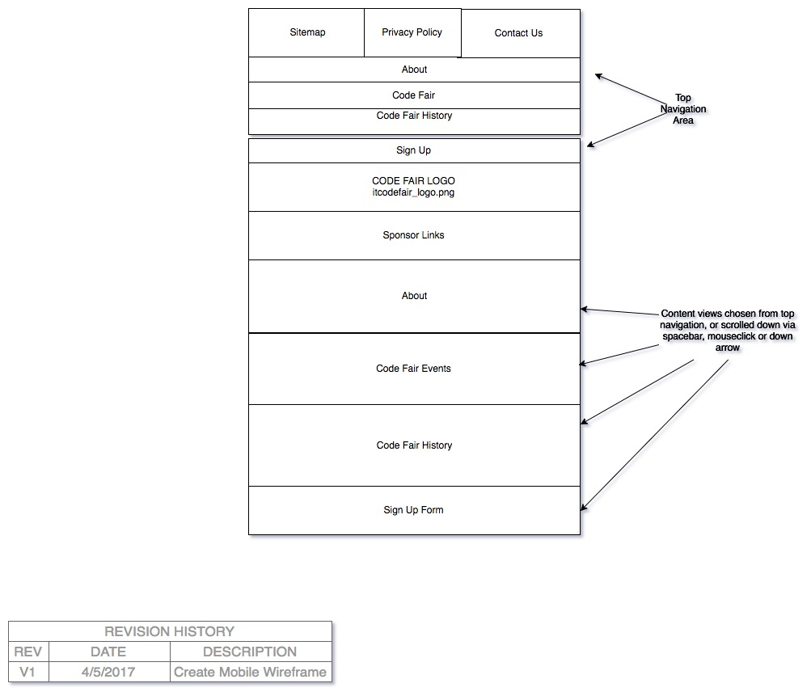

## HTML Wireframe

<https://jaybeebauer.github.io/codefair/working_documents/Milestone3/wireframe/index.html>

## screenshot1.png

## 5. Usability Testing

The following usability template was taken from Steve Krug’s “Instructions for Observers”:

Top three usability problems

After each test session, list the three most serious usability problems you noticed.

Participant #1

1. Confusion between About and The Code Fair menu items

2. Even though the menu item’s there, seem to want to scroll more

3. No contact us on the same page as everything else

The following was adapted from Usability.gov - “Notetaker’s Guide”:

### Scenario 3 – Self-Directed Activity

*Now, we’d like to hear about how you might use this site. Please identify an item that you would be interested in finding on this site. Please state your question and then search for the answer. Let me know when you’ve found the information.*

*Write the participant’s question:*

***Participant: Sarah, General Public User***

* *How to sign up to the fair?*
* *Where is the fair located?*
* *I’m an industry rep how do I get involved?*

| Pathway(s) | Success  (Circle 1) | Notes/Observations |
| --- | --- | --- |
| n/a | 0  Not completed  1  Completed with difficulty or help  2  Easily completed | (Note why was the user successful or not successful, e.g., wrong pathways, confusing page layout, navigation issues, terminology) |
| *How to sign up to the fair?*  Clicked Sign Up either top menu or hero menu. | 2  Easily completed | User found sign up straight away, and noted both in top menu and home page hero. |
| *Where is the fair located?*  Click “The Code Fair”, then reviewed, then clicked About | 1  Completed with difficulty or help | User straight away clicked on “The Code Fair” and was confused when the information was not there. Then went to about, might be worth moving the fair location information to the code fair spot and or change the About menu item. |
| *I’m an industry rep how do I get involved?*  Scrolled up and down for a second. | 0  Not completed | This does not really exists in this this site, we’ll need to add a contact form as well for people of industry and potentially students who want more information or want to get involved. |

## Exit Questions/User Impressions

[You may wish to customize this section for general questions about your site]

* What is your overall impression to [site]?
  + As a concept I can see the idea and direction, it’s laid out well and clean navigation and content.
* What is your impression of the search capability?
  + The search function doesn’t work at this stage, but at face value it’s clear where the search bar is, right at the top of the page all the time.
* Do you feel this site is current? Why?
  + I can’t really comment on this at this time.
* What did you like best about the site?
  + It’s simple and easy to follow, all the information in one spot yet still linked to so you can choose to scroll or use the links.
* What did you like least about the site?
  + It’s confusing the difference between About and The Code Fair.
* If you were the website developer, what would be the first thing you would do to improve the website?
  + I can’t really comment on this in such a raw form.
* Is there anything that you feel is missing on this site? *(Probe: content or site features/functions)*
  + Can’t really comment on this at this time, after content is added I could.
* If you were to describe this site to a colleague in a sentence or two, what would you say?
  + I don’t feel I’d have a need to.
* Do you have any other final comments or questions?
  + Not at this time.