# ../../../../Downloads/index.pngGroup 5 – Wireframe and SiteMap

Kris Bebbington

Josh Bauer

## Wireframe index.html

* Event links will navigate to Learn More page (still working on this).
* All pages will have signup at the bottom of the page above the footer

## Wireframe – history.html

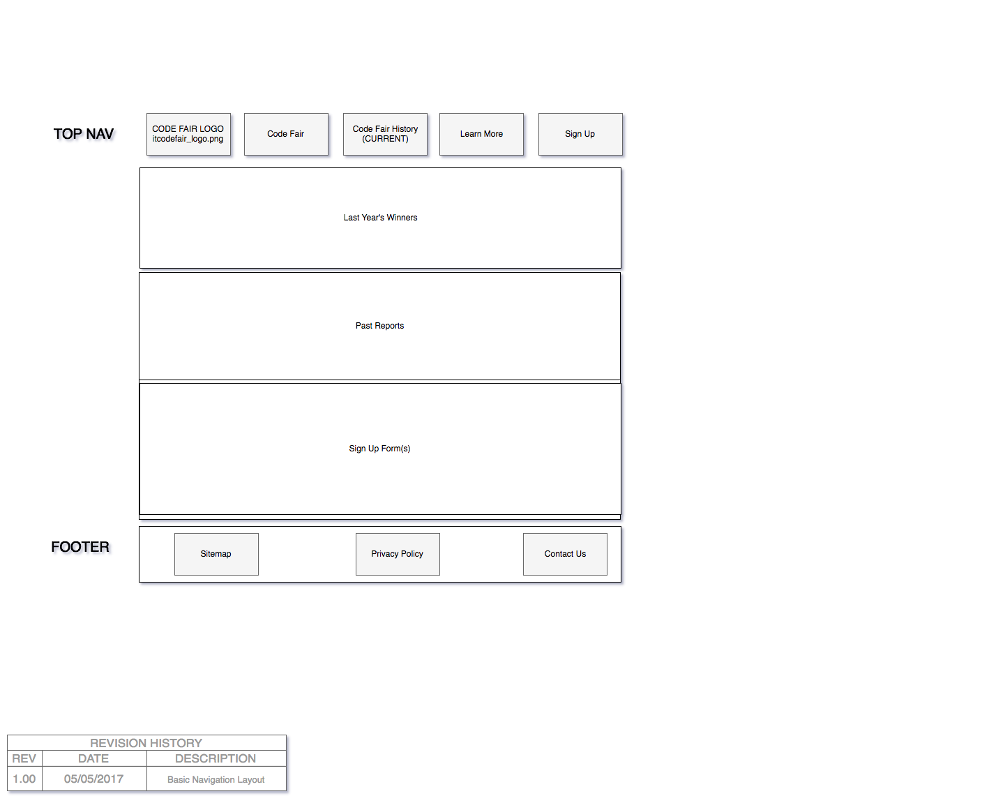

* Images from past events to be included (possibly on another page at the time).

## Code Fair 2017 – Site map

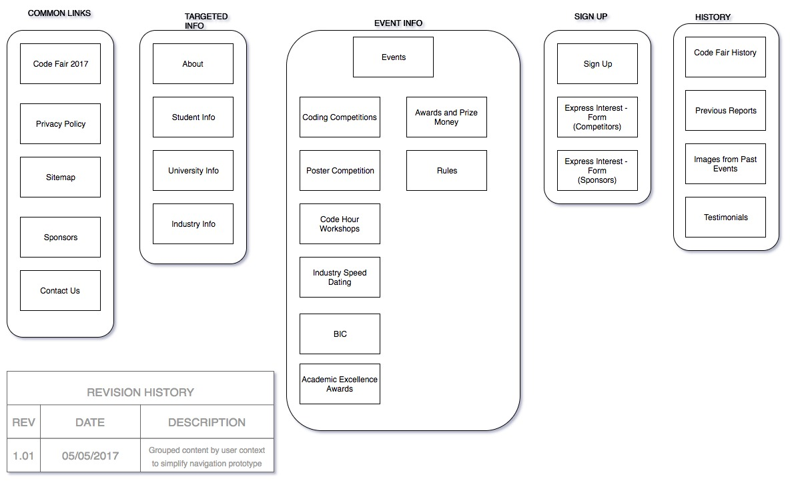

* Site map needs to be updated as content has been reduced / moved.