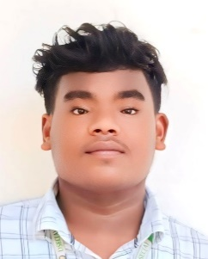
Mob No: 8610749248
jaybethpragathees@gmail.com Jaybeth Pragathees|Linkedin

Jaybeth Pragatheeswarar G
AI & Deep Learning Enthusiast

EXECUTIVE SUMMARY

Aspiring AI/ML Engineer with knowledge in Python and deep learning, along with a good understanding of full stack development. Interested in building intelligent systems and continuously learning advanced AI technologies to solve real-world problems.

EDUCATION

COURSE | NAME OF THE INSTITUTION | BOARD OF  STUDY | PERCENTAGE  OR  CGPA | YEAR
B.TECH [IT] | Dhanalakshmi Srinivasan Engineering College , Perambalur . | Autonomous | 7.9 | 2023- 2027
HSC | Government Higher secondary school,Kannirajapuram | State Board | 80% | 2022-2023
SSLC | Government Higher secondary school,Kannirajapuram | State Board | COVID | 2020-2021

PROJECTS
Computer Vision Project using OpenCV:
- Developed a computer vision project using OpenCV and Python to perform image processing tasks such as object detection.
BM-SEVA:
- Led a team in developing a cross-platform mobile application using Flutter with a Node.js backend for biomedical waste management and healthcare support.

SKILLS
- Python
- Java (Basic)
- Deep Learning
- AI Agent Development
- HTML/CSS
- JavaScript
- Flutter

SOFT SKILLS
• Problem Solving
• Strong Communication
• Teamwork
• Quick Adaptability Time
• Analytical Thinking

AWARDS
Pantech AI:
Completed Deep Learning Internship at Pantech AI Solutions.
Science Expo:
Participated in Science Expo,

LANGUAGES
Tamil , English

DECLARATION
I hereby declare that the information furnished above is true and correct to the best of my knowledge and belief.
Place: Kannirajapuram jaybeth
Date: 09/05/2026 Signature

