**Practical Number 5**

**Aim:** Random Forest using scikit-learn's built-in dataset, Iris Flowers.

**Theory:**

Random Forest is a popular machine learning algorithm that belongs to the supervised learning technique. It can be used for both Classification and Regression problems in ML. It is based on the concept of **ensemble learning,** which is a process of combining multiple classifiers to solve a complex problem and to improve the performance of the model.*.*

**Code:**

import numpy as np

import pandas as pd

import matplotlib.pyplot as plt

import matplotlib.patches as patches

from sklearn import datasets

from sklearn.ensemble import RandomForestClassifier

from sklearn.metrics import accuracy_score

# Load the iris dataset

iris = datasets.load_iris()

# Use only two features for visualization purposes

X = iris["data"][:, (2, 3)]

y = iris["target"]

# Train the Random Forest classifier

rf = RandomForestClassifier()

rf.fit(X, y)

# Predict the class labels

y_pred = rf.predict(X)

# Calculate the accuracy

accuracy = accuracy_score(y, y_pred)

print("Accuracy: {:.2f}".format(accuracy))

# Plot the actual values, predicted values, and difference

fig, ax = plt.subplots(1, 3, figsize=(18, 4))

# Plot the actual values

sc = ax[0].scatter(X[:, 0], X[:, 1], c=y, cmap=plt.cm.Paired, edgecolor="black")

ax[0].set_xlabel("Petal length")

ax[0].set_ylabel("Petal width")

ax[0].set_title("Actual values")

# Plot the predicted values

sc = ax[1].scatter(X[:, 0], X[:, 1], c=y_pred, cmap=plt.cm.Paired, edgecolor="black")

ax[1].set_xlabel("Petal length")

ax[1].set_ylabel("Petal width")

ax[1].set_title("Predicted values")

# Plot the difference

difference = y - y_pred

sc = ax[2].scatter(X[:, 0], X[:, 1], c=difference, cmap=plt.cm.Paired, edgecolor="black")

ax[2].set_xlabel("Petal length")

ax[2].set_ylabel("Petal width")

ax[2].set_title("Difference")

# Select five random difference points

n_points = 5

random_indices = np.random.choice(range(len(difference)), n_points, replace=False)

random_points = X[random_indices]

# Add a box around each selected difference point

for point in random_points:

ax[2].add_patch(patches.Rectangle(point - 0.3, 0.6, 0.6, color="red", fill=None))

plt.show()

**Results:**

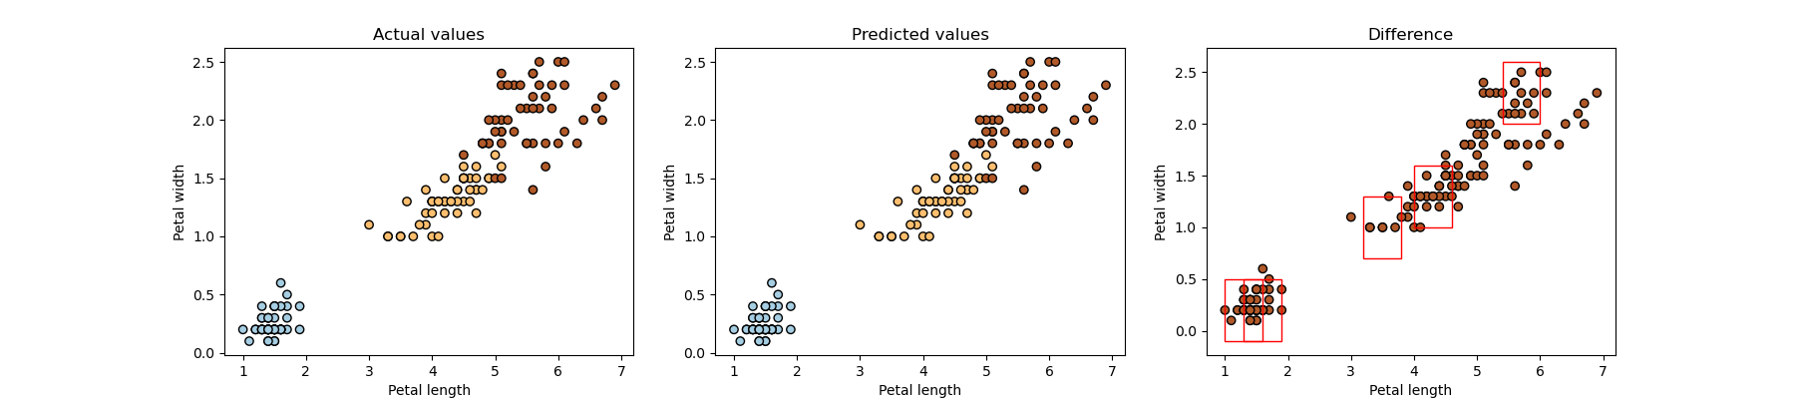

**Accuracy:** 0.99

**Conclusion** : In this practical, we have successfully studied and implemented Random Forest using scikit-learn's built-in dataset, Iris Flowers.