**Practical Number 6**

**Aim:** Support Vector Machines using scikit-learn's built-in dataset, Iris Flowers.

**Software Used :** Pycharm Community Edition 2023.1, Python(3.9.12)

**Theory:**

Support Vector Machine or SVM is one of the most popular Supervised Learning algorithms, which is used for Classification as well as Regression problems. However, primarily, it is used for Classification problems in Machine Learning.

The goal of the SVM algorithm is to create the best line or decision boundary that can segregate n-dimensional space into classes so that we can easily put the new data point in the correct category in the future. This best decision boundary is called a hyperplane.

**Code:**

import numpy as np

import pandas as pd

import matplotlib.pyplot as plt

import matplotlib.patches as patches

from sklearn import datasets

from sklearn.svm import SVC

from sklearn.metrics import accuracy_score

# Load the iris dataset

iris = datasets.load_iris()

# Use only two features for visualization purposes

X = iris["data"][:, (2, 3)]

y = iris["target"]

# Train the SVM classifier

svm = SVC()

svm.fit(X, y)

# Predict the class labels

y_pred = svm.predict(X)

# Calculate the accuracy

accuracy = accuracy_score(y, y_pred)

print("Accuracy: {:.2f}".format(accuracy))

# Plot the actual values, predicted values, and difference

fig, ax = plt.subplots(1, 3, figsize=(18, 4))

# Plot the actual values

sc = ax[0].scatter(X[:, 0], X[:, 1], c=y, cmap=plt.cm.Paired, edgecolor="black")

ax[0].set_xlabel("Petal length")

ax[0].set_ylabel("Petal width")

ax[0].set_title("Actual values")

# Plot the predicted values

sc = ax[1].scatter(X[:, 0], X[:, 1], c=y_pred, cmap=plt.cm.Paired, edgecolor="black")

ax[1].set_xlabel("Petal length")

ax[1].set_ylabel("Petal width")

ax[1].set_title("Predicted values")

# Plot the difference

difference = y - y_pred

sc = ax[2].scatter(X[:, 0], X[:, 1], c=difference, cmap=plt.cm.Paired, edgecolor="black")

ax[2].set_xlabel("Petal length")

ax[2].set_ylabel("Petal width")

ax[2].set_title("Difference")

# Select five random difference points

n_points = 5

random_indices = np.random.choice(range(len(difference)), n_points, replace=False)

random_points = X[random_indices]

# Add a box around each selected difference point

for point in random_points:

ax[2].add_patch(patches.Rectangle(point - 0.3, 0.6, 0.6, color="red", fill=None))

plt.show()

**Results:**

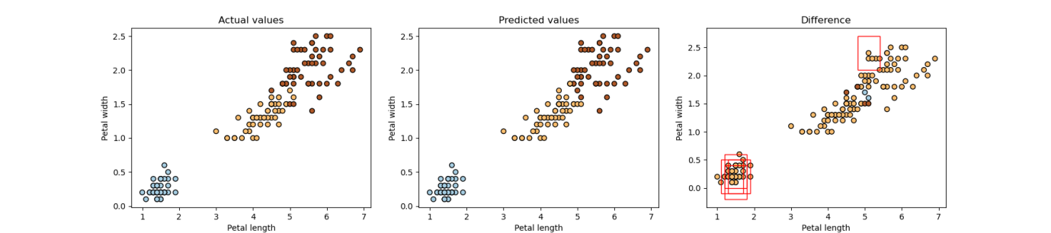

**Accuracy:** 0.99

**Conclusion** : In this practical, we have successfully studied and implemented Support Vector Machines using scikit-learn's built-in dataset, Iris Flowers.