**A PROJECT REPORT ON**

**DOCUMENT MANAGEMENT SYSTEM**

***Submitted by***

**GREESHMA P**

**RegisterNo: 95580015**

***in partial fulfillment for the award of***

**MASTER OF COMPUTER APPLICATIONS**

***from***

**Department of Computer Applications**

**Cochin University of Science And Technology**

**KOCHI-22**



***Under the Esteemed Guidance of***

**Mr. SATHEESH MENON**

**Project Manager**

**Sumantra Technologies**

**APRIL 2011**



**Cochin University of Science And Technology**

**KOCHI-22**

**BONAFIDE CERTIFICATE**

Certified that this project report **DOCUMENT MANAGEMENT SYSTEM** is the bonafide work of **GREESHMA P(Register No: 95580015)** who carried out the project work under my guidance.

………………………………

Dr. K V Pramod

Head of the Dept.

Department of Computer Applications Cochin University of Scince And Technology

…………………………. …………………… …….

INTERNAL EXAMINER EXTERNAL EXAMINER

**DECLARATION**

I hereby declare that this project work entitled **DOCUMENT** **MANAGEMENT SYSTEM** Submitted to **SUMANTRA TECHNOLOGIES, COCHIN** is a record of original work done by me and this project have notformed the basis for the award of any Degree/Diploma/Fellowship or any similar title to any candidate of any university.

**Place:** **KALAMASSERY**

**Date:** **28-03-2011** **GREESHMA P**

**ACKNOWLEDGEMENT**

At the very outset, I would like to give the first honors to God who gave the wisdom and knowledge to complete this project.

I express my heart-felt gratitude to our Head of the Department, Dr.K.V Pramod, for having given me the opportunity to complete this project successfully.

I wish to extend my sincere thanks to Mrs.Anu James, Lecturer, Department of Computer Applications, for her valuable guidance and support. I thank her for the timely suggestions and constant encouragement that led to the accomplishment of this project.

I also take this opportunity to thank my external guide Mr.satheesh Menon ,Sumantra technologies,cochin, for his valuable suggestion and encouragement throughout my project.

Last but not the least, I take this opportunity to express my sincere word of gratitude and thanks to all the staffs of the Department, my parents, friends and all my well wishers ,who had supported me directly or indirectly, to complete my project successfully.

**GREESHMA P**

**ABSTRACT**

|  |  |  |  |  |  |  |
| --- | --- | --- | --- | --- | --- | --- |
|  | The | | project | **entitled DOCUMENT MANAGEMENT** | | |
| **SYSTEM** | is | a | web | application developed | in ASP.NET | to create |
| software | for | managing | | files by providing a | web solution | for them. |
| The web solution provides facility for manipulating the internal | | | | | | |
| operation | of | the firm. | |  |  |  |

.

Document Management System is an efficient, time saving and easy way to report,view and control the version of a file. It is now an easy task and managing it is much easier.

DMS, a suite of programs that automates away most of the drudgery involved in keeping an annotated history of your project and avoiding modification conflicts. Most DMS share the same basic logic. To use one, start by registering a collection of source files — that is, telling you r DMS to start archive files describing their change histories. Thereafter, when you want to edit one of these files, you have to check out the file — assert an e xclusive lock on it. When you're done, you check in the file, adding your changes to the archive, releasing the lock, and entering a change comment explaining what you did.

**TABLE OF CONTENTS**

**CHAPTER NO.** **TITLE**

1. INTRODUCTION

1. About Organization
2. Problem Definition

2. SYSTEM ANALYSIS

* + 1. Existing System
       - 1. Problem with Existing System
  1. Proposed System
     + - 1. Advantages of the Proposed System
  2. Feasibility Study
     + 1. Technical Feasibility
       2. Economic Feasibility
       3. Behavioral Feasibility

1. Data Flow Diagram

3. PROGRAMMING ENVIRONMENT

* 1. Hardware Configuration
  2. Software Configuration
  3. DBMS Descriptions

1. Features of Operating System
2. Language Overview

4. SYSTEM DESIGN

* 1. Database Design

1. Input Design
2. Output Design
3. Hierarchy Chart

5. SYSTEM DEVELOPMENT

|  |  |  |  |
| --- | --- | --- | --- |
|  | 5.1 | System Specification | 39 |
| 6. | SYSTEM IMPLEMENTATION | | 42 |
|  | 6.1 | Testing, Training & Documentation | 43 |
| 7. | CONCLUSION AND SUGGESTIONS | | 46 |
|  | 7.1 | Conclusion | 47 |
|  | 7.2 | Future Enhancements | 47 |
| 8. | APPENDIX | | 48 |
|  | 8.1 | Tables | 59 |
|  | 8.2 | Screen shots | 49 |
| 9 | BIBLIOGRAPHY | | 62 |
|  | 9.1 | References | 63 |

Document Management System Introduction

**INTRODUCTION**

COCHIN UNIVERSITY OF SCIENCE AND TECHNOLOGY

Document Management System Introduction

1. **INTRODUCTION**
2. **ABOUT THE ORGANIZATION**
3. **About Us**

Sumantra Technologies is the advanced technology training division of Orionis Technologies & Solutions Pvt.Ltd. Sumantra Technologies provides continuous professional training to our group’s technical team and others (Corporate Organizations, Professionals, and Students) to maintain their skill sets on par with the latest in

technology. Our programs cover threshold technology subjects in several areas including

Microsoft Technologies, Open Source Technologies, Internet Programming, Multimedia,

and Administration.sumantra Technologies provides qualified training and education to

effectively prepare individuals for today's technology driven business environment. Pupil

participates in live discussions/lectures and benefit from labs and exercises to advance

their skills.

Our Major Training Programs are

1. On Job Training
2. Academic Projects
3. Embedded Systems
4. Advanced Career Training
5. Curriculum Based Training For Schools and Colleges
6. Corporate Training
7. Placement Assistance*

COCHIN UNIVERSITY OF SCIENCE AND TECHNOLOGY

Document Management System Introduction

**Mission**

Our Training mission is to make people more productive through effective training.

**Our Objectives** are to be:

* The preferred provider of training and training materials for our customers(Corporate Organizations, Professionals, and Students)
* Partners with our customers in delivering their training,
* The recognized leading supplier of premium quality courseware for personal computing.

**Why We**

We conduct training programs on technical, higher-end subjects for the IT professionals as well as on office automation products like MS-Office, Outlook Express, Lotus Notes, MS Project, Crystal Reports, Multimedia tools for the IT users.Our training programs is been very well received by the participating organizations, Professional and Students. We put a lot of emphasis on delivering top-quality training programs that are tailored to suit the requirements of the client (Organizations, Professional and Students), level of the participants and their prior familiarity with the subject. We have a formal and rigorous process of internal Training, Evaluation and Certification of our training professionals, who are well experienced and well trained, to ensure that the programs delivered by them provide delight to the participants and judge the expectations and their interests and accordingly customize the pace and content of the training modules **Sumantra Technologies** is a respected name for high-quality IT training and Consulting Services. We offer training programs on a wide range of subjects, such as:

* Object Oriented Analysis and Design
* UML Modeling
* Design Patterns
* Data Warehousing
* Oracle (SQL and PL/SQL, DBA, Performance Tuning)
* Microsoft SQL Server,
* J2EE and related areas (Core Java, Servlets + JSP, EJB, JSF, JFC, Struts, Hibernate, Spring, etc.)

COCHIN UNIVERSITY OF SCIENCE AND TECHNOLOGY

Document Management System Introduction

* .NET (VB.NET, C#, ASP.NET, etc.)
* C, C++ ,VC++
* Office Automation Tools (MS Office, Open Office, MS Project, MS Access, Business Objects, etc.)
* Linux (Basic, Shell Scripting, Administration)
* Microsoft Office Share Point Server
* Windows and Networking (Server Administration, ADS, IIS)
* Scripting Languages.
* PHP & MySQL

We also offer training programs in a few non-IT reas, such as:

* Soft skills (Communication Skills, Negotiation Skills, Presentation Skills, Email Etiquette)**Sumantra Technologies** operates with a vision to provide high-quality training to its Corporate Organizations, Professionals, Students through innovative and pioneering processes. Our programs are focused on helping organizations meet or exceed operational performance goals in terms of **Effectiveness, Efficiency and** **Excellence**. We continuously strive to equip our clients with Knowledge, Expertiseand Skills that help their staff enhance productivity and the quality of their work

.Some of the key factors that makes us the preferred learning partner for leading corporations in South India are:

* Customized training for you and your ***Personal*** computer school
* Hands-on Professionals led training.
* Globally recommended official curriculum.
* Lab Environment as per globally recommended standards.
* Post Training Support.
* Special Batches for Corporate Clients.
* Convenient batch timings.
* Instructors with Considerable Industry Experience.
* Placement Assistance* .

COCHIN UNIVERSITY OF SCIENCE AND TECHNOLOGY

Document Management System Introduction

**A word about Orionis Technologies & Solutions Pvt.Ltd.**

**‘Orionis Technologies & Solutions Pvt. Ltd.’** a reputed Software Research & DevelopmentCompany, providing high-end customized software solutions (ERP) to diversified sectors and vivid IT services like Research & Development, Customized Software Solutions (Application, Web, WAP, Mobile), Application Integration Services, On Shelf Products, Data Transformation Services, QCA Activities and Project Consulting. To get more details, log on to www.orionistechnologies.com.

**1.2 PROBLEM DEFINITION**

There are courses which do not provide option for revaluation, but at the time of valuation it is done on two stages i.e. by two staff members. But there are course which provides the facility for revaluation, but initially the paper is valued once. The software should be designed and developed in such a way that it accommodates all needs in dynamic fashion. It should be a general purpose one.

The first problem is that there are loads of hard copied documents are being generated. Keeping the information in the form of hard copied documents lead to many problems

All the process done manually at the centers and all the records are maintained on the papers. So the maintenance of the record is very difficult in the departments as well as it is very difficult for the staff to check the record. The existing system is monotonous, time consuming, less flexible and provides a very hectic working schedule. The chance of loss of record is very high and also record searching is very difficult. Maintenance of the system is also very difficult and take a lot of time. Result processing is slow due to paper work and requirement of staff.

.

COCHIN UNIVERSITY OF SCIENCE AND TECHNOLOGY

Document Management System Introduction

**PROJECT DESCRIPTION**

**Document Management System [DMS]**

Document Management System is an efficient, time saving and easy way to report, view and control the version of a file. It is now an easy task and managing it is much easier. DMS, a suite of programs that automates away most of the drudgery involved in keeping an annotated history of your project and avoiding modification conflicts. Most DMS s share the same basic logic. To use one, start by registering a collection of source files — that is, telling your DMS to start archive files describing their change histories. Thereafter, when you want to edit one of these files, you have to check out the file — assert an exclusive lock on it. When you're done, you check in the file, adding your changes to the archive, releasing the lock, and entering a change comment explaining what you did.

**MODULE DESCRIPTION**

This DMS consists of mainly 5 modules. They are:

Administrator Version control Registration

User Search

**Administrator**

Administrator is the main module of this DMS. The main function of the administrator is user approval. Administrator has full authority on this system. Administrator has the provision for deleting the files. He can also provided function of maintain the category of different files.

Main features are:

User group User creation Role setting

Providing right to group

COCHIN UNIVERSITY OF SCIENCE AND TECHNOLOGY

Document Management System Introduction

Providing right to files History

Check in.

**Visual Source Control**

It is another important module. The main function is to control the version of each and every file. All the information about the files is stored in this module.

Main features are:

Check in and check out View version

Latest version download Upload

**Registration**

All types of users must be a registered user. In this module all the users are registering and creating a folder to download the file and store in their directories.

Main features are:

Check in

Employees creation

Employees registration

**User**

Another important module is users. A special feature is only users can download or upload files. For this purpose it provides a user authentication mechanism. Users are allowed to create folders in their login. Users can implement various security measures on the files they upload.

Main features are:

Check in/check out File editing

Automatic versioning Upload

History

COCHIN UNIVERSITY OF SCIENCE AND TECHNOLOGY

Document Management System Introduction

**Search**

In this module searching for a file is possible. The searching option can be done in two ways. One is by filename and the other is metadata search.

Main features are:

Check in File search

Metadata search

Tools|platform,Hardware and Software requirement specification:

**Software Requirements**

|  |  |  |
| --- | --- | --- |
| Front End | : | ASP.Net |
| Back End | : | SQL Server |

**Hardware Requirements**

1. PC with Pentium 4 class processor or higher recommend.
2. Access and control - IBM PC compatible.
3. Memory -1GB RAM minimum, 2GB or higher recommend.
4. DVD ROM drive.
5. Additional hardware printer with manufactures latest print drivers.
6. OS-MS Windows XP or above.
7. Display super VGA or higher resolution monitor recommend.

Future scope and future enhancement of project

In future the software can get modified to use more efficiently and reliably and enhancements can be made since the software is build on user friendly language.

COCHIN UNIVERSITY OF SCIENCE AND TECHNOLOGY

Document Management System System Analysis

**SYSTEM ANALYSIS**

**COCHIN UNIVERSITY OF SCIENCE AND TECHNOLOGY**

Document Management System System Analysis

**2.SYSTEM ANALYSIS**

System analysis is the process of gathering and interpreting facts, diagnosing problems and using the information to recommended improvements on the system. System is a problem solving activity that requires intensive communication with the system users and the system developers. The system is studied to the minutest detail and analyzed. The system analyst plays the role of the interrogator and dwells deep into the working of the present system. The system is viewed as a whole and the input to the system are identified. The outputs from the organizations are traced to the various processes.

A detailed study of the process must be made by various techniques like interviews, questionnaires etc. The data collected by these sources must be scrutinized to arrive to a conclusion. The conclusion is an understanding of how the system functions. This system is called the existing system. Now the existing system is subjected to close study and problem areas are identified. The designer now functions as a problem solver and tries to sort out the difficulties that that the enterprise faces. The solutions are given as proposals. The proposals are then weighted with existing system analytically and the best one is selected. The proposal is presented to the user for an endorsement by the user. The proposal is reviewed on user request and suitable changes are made. This loop that ends as soon as the user is satisfied with the proposal.

Preliminary study is the process of gathering and interpreting facts, using the information for further studies on the system. Preliminary study is problem solving activity that requires intensive communication between the system users and system developers. It does various feasibility studies. In these studies a rough figure of the system activities can be obtained, from which the decision about the strategies to be followed for effective system study and analysis can be taken.

Here in the **DOCUMENT MANAGEMENT SYSTEM**, a study of the existing system is carried along with all steps in system analysis. An idea for creating a better system was carried and the next steps were followed.

**COCHIN UNIVERSITY OF SCIENCE AND TECHNOLOGY**

Document Management System System Analysis

**2.1 EXISTING SYSTEM**

In the existing system giving rights to the groups and files both were not given. A single history was saved for the project. The file manipulating method was not done in a centralised manner. In the existing system when the file is being modified the change in version number is done by the particular user. Searching process is mainly done on the file name itself.

**2.2 PROPOSED SYSTEM**

In the proposed system rights to the groups and files were separately given. The members in a particular project group cannot work in another project at the same time. Along with this right file accessing privileges are also set for each member in the project. Two different histories are maintained along the project. The file manipulating process is controlled by a centralised controlling system. The version numbering process is done automatically. When a particular user access a file and update it and when uploading the to the server its version number automatically increases and the latest version of the file will be stored in server. The searching process is done in two ways. One is filename and the other is by metadata search.

**2.3 FEASIBILITY STUDY**

Feasibility study is made to see if the project on completion will serve the purpose of

the organization for the amount of work, effort and the time that spend on it. Feasibility study lets the

developer foresee the future of the project and the usefulness. Feasibility study is a test of system

proposed regarding its workability, impact on the organization, ability to meet the needs and

effective use of resources. Thus when a new project is proposed, it normally goes through a

feasibility study before it’s approved for development.

The document provide the feasibility of the project that is being designed and lists

various areas that were considered very carefully during the feasibility study of this project such as

technical, economical and behavioral feasibilities.

Investigating the existing system in the area under investigation does, to test the

technical, social and economical feasibility of a system and generating ideas about the new system.

There are three aspects in the feasibility study portion of the preliminary investigation.

**COCHIN UNIVERSITY OF SCIENCE AND TECHNOLOGY**

Document Management System System Analysis

Technical Feasibility Economical Feasibility Behavioral Feasibility

1. **TECHNICAL FEASIBILITY**

Technical feasibility examines the work for the project be done with correct equipments, existing software technology and available personnel. The important advantage of the system is that it is platform independent.

**2.3.2 ECONOMIC FEASIBILITY**

The system is economically feasible since the savings and benefits of the system are more when compared to the cost. The Sposed system reduces the human effects and also reduces the drawbacks of the existing system .The proposed system is more accurate, speedy and dependable. Thus the cost by benefit ratio is very small.

**2.3.3 BEHAVIORAL FEASIBILTY**

The proposed project would be beneficial to all Organizations that, it satisfies the objectives when developed and installed. All the behavioral aspects are considered carefully. Thus the project is behaviorally feasible and it can also be implemented easily.

**1.4** **DATA FLOW DIAGRAM**

Data Flow Diagrams represent one of the most ingenious tools used for structured analysis. A Data Flow Diagram or DFD as it is shortly called is also known as a bubble chart. It has the purpose of clarifying system requirements and identifying major transformations that will become programs in System design. It is the major starting point in the design phase that functionally decomposes the requirements specifications down to the lowest level of detail.

A DFD consists of a series of bubbles joined by lines. The bubble represents data transformation and lines represent data flow in the system.

In the normal convention, a DFD has four major symbols

**COCHIN UNIVERSITY OF SCIENCE AND TECHNOLOGY**

Document Management System System Analysis

**Square,** which defines source or destination of data

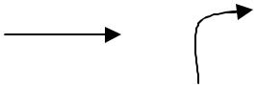

**Arrow** ,which shows data flow



**Circle,** which represents a process that transformsincoming data into outgoing flow

**Open rectangle,** which shows a data store

The DFD at the simplest level is referred to as the ‘Zero Level DFD’ or in the simple words a ‘Context Analysis Diagram’. These ar e expanded level by level each explaining its process in detail. Processes are numbered for easy identification and are normally labeled in block letters. Each data flow is labeled for easy understanding.

**Steps to Construct a DFD**

Four steps are commonly used to construct a DFD

o Process should be named and numbered for easy reference. o Each name should be representative of the process.

o The direction of flow is from top to bottom and from left to right.

o When a process is exploded into lower level details they are numbered. o The names of data stores, source and destination are written in capital.

**COCHIN UNIVERSITY OF SCIENCE AND TECHNOLOGY**

Document Management System System Analysis

**LEVEL 0 :(CONTEXT LEVEL)**

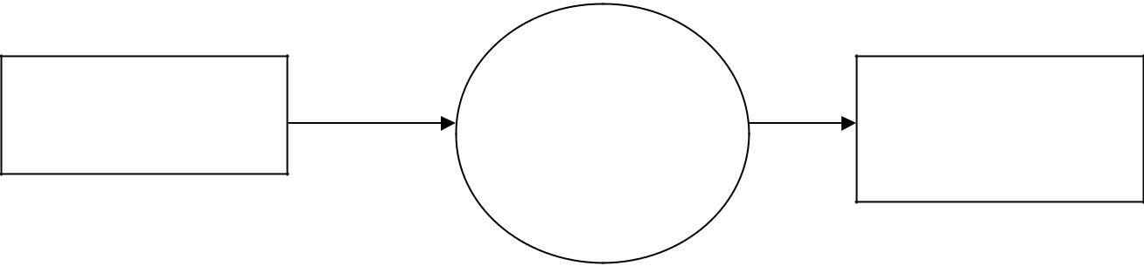

**Document**

**Administrator/user** REQUEST **Management**

**System**

RESPONSE **Administrator/user**

**COCHIN UNIVERSITY OF SCIENCE AND TECHNOLOGY**

Document Management System

System Analysis

Level 1Administrator

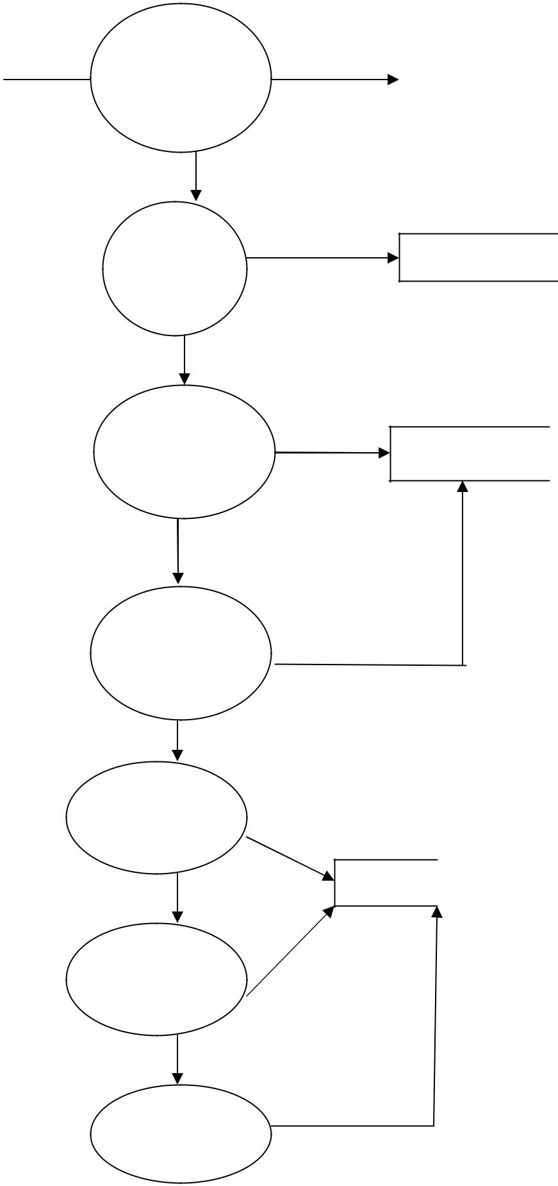

|  |  |  |  |
| --- | --- | --- | --- |
|  |  |  |  |
| Administratdeails | details | register |  |
| or | Registratio |  |  |
|  |  |

n

valid

User group user

User creation

Right to group

Right to file

group details

group

user details

user

group rights

file rights

file

file details

History

file

Check in

COCHIN UNIVERSITY OF SCIENCE AND TECHNOLOGY

Document Management System

System Analysis

Level 1User

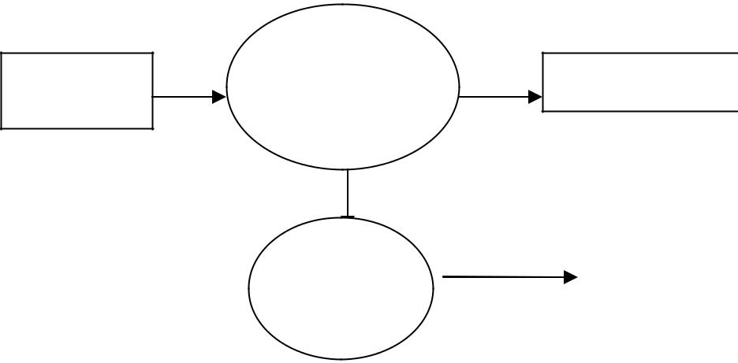

Registratio

|  |  |  |  |  |
| --- | --- | --- | --- | --- |
| detailsUser | n | details | register |  |
|  |  |  |  |

|  |  |  |  |  |
| --- | --- | --- | --- | --- |
| Check | File details | file |  |  |
| in/out |  |  |  |  |
|  |  |  |  |

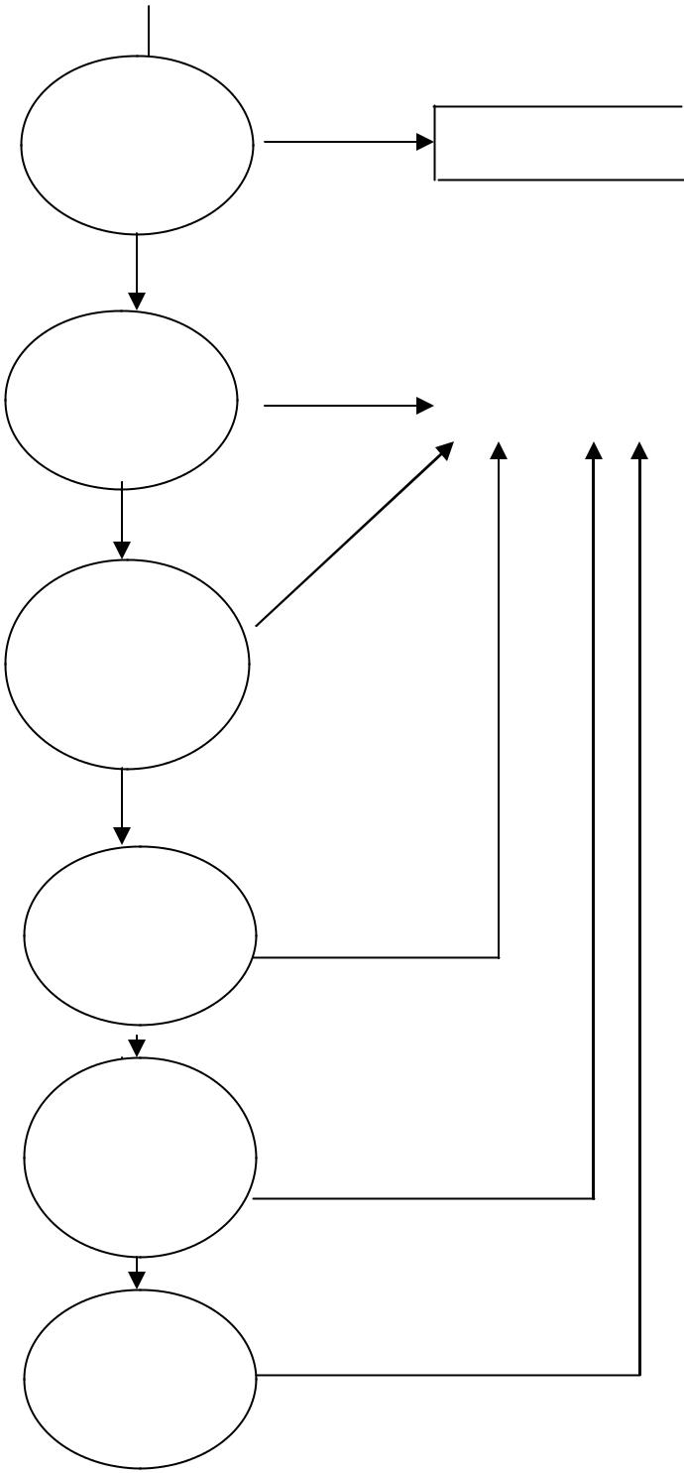

|  |  |  |
| --- | --- | --- |
| Project | details |  |
| project |  |
| creatio |  |
|  |  |

|  |  |  |  |  |
| --- | --- | --- | --- | --- |
| File | file details |  |  |  |
|  |  |  |
| editing |  | file |  |  |
|  | vrsnNo: | |  |  |

Auto

versionin File file details g

Upload

History

Search

COCHIN UNIVERSITY OF SCIENCE AND TECHNOLOGY

Document Management System System

Analysis

HIERARCHICAL CHART

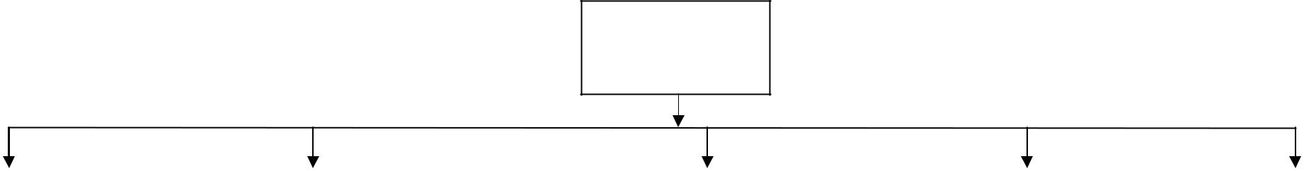

Document management system

|  |  |  |  |  |  |  |  |  |
| --- | --- | --- | --- | --- | --- | --- | --- | --- |
| Administrator |  | Version control |  | Registration |  | User |  | Search |
|  |  |  |  |  |  |  |  |  |

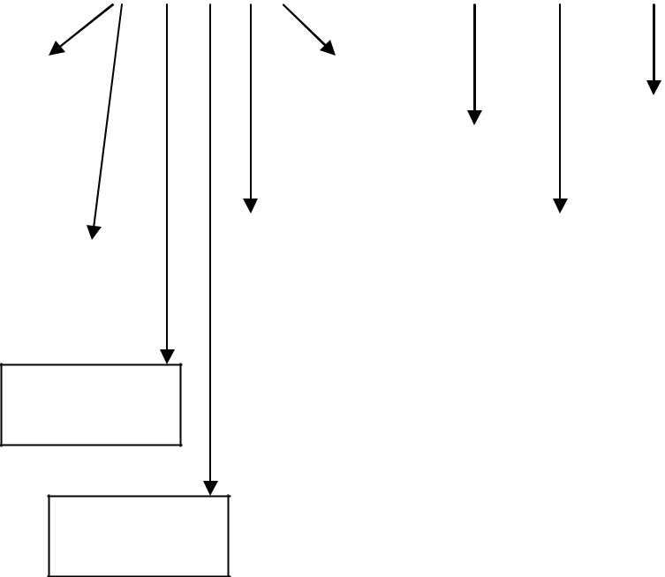

|  |  |  |  |  |  |  |  |  |  |  |  |  |  |  |  |  |  |  |  |  |  |  |  |  |  |  |
| --- | --- | --- | --- | --- | --- | --- | --- | --- | --- | --- | --- | --- | --- | --- | --- | --- | --- | --- | --- | --- | --- | --- | --- | --- | --- | --- |
| User group |  |  | Check in | | |  |  |  |  |  |  | Registration | |  | Check out | |  | Check in/out | |  |  | History | |  |  |  |
|  |  |  |  |  |  |  |  |  |  | |  |  |  |  |  |  |  |  |  |  |  |  |  |  |  |  |
|  |  |  |  |  |  |  |  |  | Latest version | |  |  |  |  |  |  |  |  |  |  |  |  |  |  |  |  |
|  |  |  |  |  |  |  |  |  |  |  |  |  |  |  |  |  |  |  |  |  |  |  |
|  |  |  |  | Check in/out | | | |  |  | download |  |  |  |  |  |  |  |  |  |  |  |  |  | File search |  |  |
|  |  |  |  |  |  |  |  |  |  |  |  |  |  | Project | |  |  |  | File edit & | | |  |  |  |  |  |
|  |  |  |  |  |  |  |  |  |  |  |  |  |  |  |  |  |  |  |  |  |  |
|  |  |  |  |  |  |  |  |  |  |  |  |  |  |  |  |  | upload | | |  |  |  |  |  |
|  |  |  |  |  |  |  |  |  |  |  |  |  |  | creation | |  |  |  |  |  |  | Metadata |  |
|  |  | History | | |  |  |  | View | |  |  |  |  |  |  |  |  |  |  |  |  |  |  |  | search |  |
| User creation |  |  |  |  |  |  |  | version | |  |  |  |  |  |  |  |  |  |  |  |  |  |  |  |  |
|  |  |  |  |  |  |  |  |  |  |  |  |  |  |  |  |  |  |  |  |  |  |  |  |
|  |  |  |  |  |  |  |  |  |  |  |  |  |  |  |  |  |  |  |  |  |  |  |  |  |  |  |
|  |  |  |  |  |  |  |  |  |  |  |  |  |  |  |  |  |  |  |  |  |  |  |  |  |  |  |

Providing right to group

Providing right to files

COCHIN UNIVERSITY OF SCIENCE AND TECHNOLOGY

Document Management System Programming Environment

**PROGRAMMING ENVIRONMENT**

**COCHIN UNIVERSITY OF SCIENCE AND TECHNOLOGY**

Document Management System Programming Environment

**3.PROGRAMMING ENVIRONMENT**

**3.1 HARDWARE SPECIFICATION**

The hardware is the place where all the information and data are stored permanently. So hardware must be reliable and cost effective. The hardware must suit all the application development. It is fast enough to complete and do all the jobs and executions.

1. PC with intel core2duo processor
2. Memory - 2GB RAM Minimum, 2GB or higher recommend.
3. DVD ROM drive.
4. OS-MS Windows XP or above

.

**3.2 SOFTWARE SPECIFICATION**

The software specification means the operating system and all other applications or tools used for the development of the proposed system. It includes the Operating System, and the software which we are going to use.

|  |  |  |
| --- | --- | --- |
| Platform | - | .NET Frame |
| Front end | - | ASP.NET 2008 |
| Back End | - | MS SQL Server 2005 |
| Operating System | - | Windows XP |

**COCHIN UNIVERSITY OF SCIENCE AND TECHNOLOGY**

Document Management System Programming Environment

**3.3 DATA BASE MANAGEMENT SYSTEM DESCRIPTION**

The overall objective in the development of database technology has been to treat data as an organizational resource and as an integrated whole. Database Management System allows data to be protected and organized separately from other resources. Database is an integrated collection of data. The most significant of data as seen by the programs and data as stored on the direct storage devices. This is the difference between logical and physical data.

The organization of data in the database aims to achieve three major objectives:

Data integration Data integrity

Data independence

The databases are implemented using a DBMS package. Each particular DBMS has unique characteristics and general techniques for database design. The proposed System stores the information relevant for processing in the SQL server database. This SQL Server database contains tables, where each table is called a field or column. A table also contains records, which is a set of fields. All records, in a table the same set of fields with different information. Each table contains key fields that establish relationships in an SQL database and how the records are stored. There are primary key fields that uniquely identify a record in a table. There are also fields that contain the primary key from another table called foreign keys.

**RELATIONAL DATABASE RULES**

Certain rules followed in creating and relating the databases in the relational databases. This governs how to relate data and prevent redundancy of the data in the database. The first set of rules called relational rules ensures that the database is a relational database.

The second set called the normalization rules simplifies the database and reduce the redundancy of the data. In the proposed system this relational database rules are applied to reduce the redundancy make future changes to the table structure easier to and minimize the impact of these changes on users interface to the database. This is done first determining what information is needed, how items are related, what constraints are established tables are

**COCHIN UNIVERSITY OF SCIENCE AND TECHNOLOGY**

Document Management System Programming Environment

created and linked by appropriate key fields. The constraints on the data are used to guide the building of tables. Making use of the normalization principles creates the tables. The proposed system has its own tables in the third normal form.

**SQL Server 2000**

Relational database systems are the most important database systems used in the software industry today. One of the most outstanding systems in Microsoft SOL Server. SQL Server is a database management system developed and marketed by Microsoft. It runs exclusively under Windows NT, Windows 95/98, and Windows 2000 Server. The most important aspects of SQL Server are

SQL Server is easy to use.

SQL Server scales from a mobile laptop to symmetric multiprocessor system.

SQL Server provides data warehousing features that until now have only been available in Oracle and other more expensive DBMS.

A database system is an overall collection of different database software components and database containing the part viz. Database application programs, front-end components, Database Management Systems and Database. A database system must provide following features.

A variety of user interfaces. Physical data independence. Logical data independence.

Query optimization. Data integrity. Concurrency control. Backup and recovery.

Security and authorization.

**Enterprise manager** is the main administrative console for SQL Server installations.It provides you with a graphical “Birdseye” view of all of the SQL Server installations on your network. You can perform high-level administrative functions that affect one or more servers. Schedule common maintenance tasks or create and modify the structure of individual databases.

**Query Analyzer** offers a quick and dirty method for performing queries against anyof your SQL Server databases. It’s a great way to quickly pull information out of a database in

**COCHIN UNIVERSITY OF SCIENCE AND TECHNOLOGY**

Document Management System Programming Environment

response to a user request, test queries before implementing them in other applications, create/modify stored procedures and execute administrative tasks.

**SQL Profiler** provides a window into the inner working of your database. You canmonitor many different event types and observe database performance in real time. SQL Profiler allows you to capture and replay system “t races” that log various activities. It’s a great tool for optimizing databases with performance issues or troubleshooting particular problems.

**Service Manager** is used to control the MS SQL Server, MSDTC (MicrosoftDistributed Transaction Coordinator) and SQL Server Agent processes. An icon for this service normally resides in the system tray of machines running SQL Server. You can use Service Manager to start, stop or pause any one of these service.

**Data Transformation Services** (DTS) provide an extremely flexible methodfor importing and exporting data between a Microsoft SQL Server installation and a large variety of other formats. The most commonly used DTS application is the “Import and Export Data” wizard found in the SQL Server program group.

**3.3 FEATURES OF OPERATING SYSTEM**

|  |  |  |  |  |  |  |  |
| --- | --- | --- | --- | --- | --- | --- | --- |
| This project work is done | | | on the windows XP | | professional,which is The | | |
| os. An OS is set of | software | tools | designed | to make | it easy | for people | Or |
| programmers to make | optimum | use of computer. People who use | | | | computers | have |
| different levels of needs and interest. | | |  |  |  |  |  |
| The main features of windows 2000 professional | | | | operating system are: | | |  |

1. Easier to use.
2. Easier to manage.
3. More compatible.
4. More powerful.

**EASIER TO USE**

With windows xp professional ,you have faster access to information , And you are able to accomplish tasks more quickly and easily. Windows xp professional makes it easier to:

Work with files.

**COCHIN UNIVERSITY OF SCIENCE AND TECHNOLOGY**

Document Management System Programming Environment

Find information personalize your computing enviorment. Work on the web.

Work remotely

**EASIER TO MANAGE**

Windows XP, your workstation will be easier to:

Set up

Administrator. Support

**MORE COMPATIBLE**

Windows XP, also provides:

Improved driver support.

Increased support for new_generation hardware multimedia technologies.

**MORE POWERFUL**

For all your computing needs ,windows xp professional provides:

Industrial _strength reliability. The highest level of security. Powerful performance.

1. **LANGUAGE OVERVIEW**

.**NET Architecture:**

Microsoft released the .net framework in February 2002.It is the biggest initiative since the launch of windows in 1991. .Net is a revolutionary Multilanguage platform that knits various aspects of application development together with the internet. The framework covers all layers of software development above the operating system. Several software will be developed by Microsoft to achieve this goal. It is accepted that every player in the industry, be it a software developer or a device manufacture, adopt .Net so that they can be integrated. The

.Net initiative is all about enabling data transfer between networks, PC’s and devices seamlessly, independent of platforms, architecture and solutions. Microsoft has taken many of the best ideas in the industry, combined with some ideas of their own, and bought them all in to one coherent package. .Net is Microsoft’s next generation platform for building web applications and web services. It is a platform for XML web services areas of Microsoft.

**COCHIN UNIVERSITY OF SCIENCE AND TECHNOLOGY**

Document Management System Programming Environment

Net is Microsoft’s new internet web strategy. .Net is not a new operating system.

.Net delivers software as web services.

.Net is a framework for universal services. .Net is a server centric computing model.

.Net will run on any browser on any platform. .Net is based on latest web standards.

**MICROSOFT .NET FRAMEWORK**

The Microsoft .NET Framework is a software component that can be added to the Microsoft Windows operating system .It provides a large body of pre-coded solutions to common program requirements, and manages the execution of programs written specifically for the framework. The .NET Framework is a key Microsoft offering, and is intended to be used by most new applications created for the Windows platform.

Programs written for the .NET Framework execute in a software environment that manages the program's runtime requirements. This runtime environment, which is also a part of the .NET Framework, is known as the Common Language Runtime (CLR). The CLR provides the appearance of an application virtual machine so that programmers need not consider the capabilities of the specific CPU that will execute the program. The CLR also provides other important services such as security mechanisms, memory management, and exception handling. The class library and the CLR together compose the .NET Framework. The framework is intended to make it easier to develop computer applications and to reduce the vulnerability of applications and computers to security threats.The .NET Framework was designed with several intentions:

**Interoperability:**

Because interaction between new and older applications is commonly required, the .NET Framework provides means to access functionality that is implemented in programs that execute outside the .NET environment. Access to COM components is provided in the Enterprise Services namespace of the framework, and access to other

**COCHIN UNIVERSITY OF SCIENCE AND TECHNOLOGY**

Document Management System Programming Environment

functionality is provided using the P/Invoke feature.

**Common Runtime Engine:**

Programming languages on the .NET Framework compile into an intermediate language known as the Common Intermediate Language or CIL; Microsoft's implementation of CIL is known as Microsoft Intermediate Language, or MSIL. In Microsoft's implementation, this intermediate language is not interpreted, but rather compiled in a manner known as just-in-time compilation (JIT) into native code. The combination of these concepts is called the Common Language Infrastructure (CLI), a specification; Microsoft's implementation of the CLI is known as the Common Language Runtime (CLR).

**Language Independence**:

The .NET Framework introduces a Common Type System, or CTS. The CTS specification defines all possible data types and programming constructs supported by the CLR and how they may or may not interact with each other. Because of this feature, the .NET Framework supports development in multiple programming languages.

**Base Class Library:**

The Base Class Library (BCL), sometimes referred to as the Framework Class Library (FCL), is a library of types available to all languages using the .NET Framework. The BCL provides classes which encapsulate a number of common functions, including file reading and writing, graphic rendering, database interaction and XML document manipulation.

**Simplified Deployment :**

Installation of computer software must be carefully managed to ensure that it does not interfere with previously installed software, and that it conforms to increasingly stringent security requirements. The .NET framework includes design features and tools that help address these requirements.

**Security:**

NET allows for code to be run with different trust levels without the use of a

**COCHIN UNIVERSITY OF SCIENCE AND TECHNOLOGY**

Document Management System Programming Environment

separate sandbox.

The design of the .NET Framework is such that it supports platform independence.

**ASP.NET**

ASP.NET is a programming framework built on the common language runtime that can be used on a server to build powerful Web applications. The enterprise class web applications are accessible on a global basis, leading to efficient information management. ASP.NET offers several important advantages over previous Web development models.

**ADVANTAGES OF ASP.NET**

ASP is a linear processing model. An ASP page is processed in a top-to-bottom sequence. Each line of ASP code and static HTML is processed in sequence as it appears in the file. User actions cause the page to be posted to the server in a round trip. Since this action causes a round trip, the server must recreate the page. After the page is recreated, it is processed in the same top-to-bottom sequence as before, and therefore the page is not exhibiting truly event-driven behavior. To create an event-driven experience, you need to explicitly design it. In addition, you have to explicitly maintain page and control state at the most basic level. This model limits the richness of the user interfaces that can be assembled, and it increases the complexity of the code needed to support it.

In comparison, an event-driven model, as in a traditional Visual Basic application, contains programmable elements that are initialized and displayed on the form. Users interact with the elements, which cause events to be raised that in turn call event handlers. This model supports true event-driven behavior, which, by design, greatly extends the richness of the user interfaces that can be assembled, and it reduces the complexity of the code needed to support it.

ASP.NET allows us to set up event handlers in server code for events that are passed from the browser. Assume the user is interacting with a Web Forms page that contains one button server control. The user clicks the button control and an event is raised that is transmitted via an HTTP post to the server where the ASP.NET page framework

**COCHIN UNIVERSITY OF SCIENCE AND TECHNOLOGY**

Document Management System Programming Environment

interprets the posted information and associates the raised event with an appropriate event handler. This event handler can be a default handler supplied by ASP.NET or it can be your custom implementation. The framework automatically calls the appropriate event handler for the button as part of the framework's normal processing.

**THREE TIER ARCHITECTURE**

In software engineering, multi-tier architecture (often referred to as n-tier architecture) is a client-server architecture in which the presentation, the application processing, and the data management are logically separate processes. For example, an application that uses middleware to service data requests between a user and a database employs multi-tier architecture. The most widespread use of "multi-tier architecture" refers to three-tier architecture.

**The 3 Layers**

**1. The GUI Layer**

The GUI is the "top layer". It contains all things that are visible to the user, the 'outside' of the system, such as screen layout and navigation.

The GUI layer has techniques like HTML, CSS

**2. The Object Layer**

This is the core of the system, the linking between the other layers. The object layer has knowledge, in two different ways:

1. Runtime values, like the customer name "Warkeys" or the invoice number "OAA2000".
2. Structural knowledge, about data and processing.

**Data Example**

A customer can receive many invoices, and an invoice always goes to just one customer.

**Process Example**

**COCHIN UNIVERSITY OF SCIENCE AND TECHNOLOGY**

Document Management System Programming Environment

Know who does what. Every object knows his own methods, and those of his neighbors. In a pure OO model an object talks to his neighbors, and nobody but his neighbors.

In the object layer you'll find things like Classes, Objects, instance variables, methods, Polymorphism, Encapsulation and Inheritance. The objects mostly have a temporary nature. They "live" just in memory for the duration of a transaction or session.

**3. Database Layer**

The database layer takes care of persistency. An object from the object layer can write itself to one or more tables. In the database layer you'll find things like

Database connection SQL and result set.

**COCHIN UNIVERSITY OF SCIENCE AND TECHNOLOGY**

Document Management System System Design

**SYSTEM DESIGN**

**COCHIN UNIVERSITY OF SCIENCE AND TECHNOLOGY**

Document Management System System Design

**4. SYSTEM DESIGN**

**4.1 INPUT DESIGN**

Input design is the process of converting the user originated input to a computer based format.The design decision for handling input specify hoe data are accepted for computer processing .Input design is a part of overall system design that needs careful attention.

**4.2 OUTPUT DESIGN**

One of the most important features of a system for user is the output it produces. Output design should improve the systems relationship with the user and help in decision making.Computer output is a process that involves designing necessary output that have to be given to various users according to their requirements. Efficient, intelligible output design should improve the system relationship with the user and help and in decision making. A major form of output is the hardcopy from the printer. The output devices are selected by considering the response time requirements, print quickly etc. The print formats and editing for the final printout are very much considered during output design.

The objective of output design is to define the controls and format of all printed documents and reports and screens that will be produced by the system. The output is the most important and direct source of information to the user. For many end users output is the main reason for developing the system and the basis on which they will evaluate the usefulness of the application.Output generally refers to the system results. The output of the system is designed so as to include a number of reports. Reports reflect the output design.

Output design is an ongoing activity, which start during study phase itself. Output generally refers to the results and information data are generated by the system. It can be in the form of operational documents and reports.

Objectives of Output Design

o Design output to serve the intended purpose o Deliver appropriate quantity of output

o Choose the right output method o Provide output on time

**COCHIN UNIVERSITY OF SCIENCE AND TECHNOLOGY**

Document Management System System Design

**4.3 DATABASE DESIGN**

A database is an organized mechanism that has the capability of storing information through which a user can retrieve stored information in an effective and efficient manner. The data in the database is safe and easily accessed.

The database design is a two level process. In the first step, user requirements are gathered together and a database is designed which will meet these requirements as clearly as possible. This step is called Information Level Design and it is taken independent of any individual DBMS.

In the second step, this Information level design is transferred into a design for the specific DBMS that will be used to implement the system in question.This step is called Physical Level Design, concerned with the characteristics of the specific DBMS that will be used. A database design runs parallel with the system design. The organization of the data in the database is aimed to achieve the following two major objectives.

Data Integrity

Data independence

Normalization is the process of decomposing the attributes in an application, which results in a set of tables with very simple structure. The purpose of normalization is to make tables as simple as possible. Normalization is carried out in this system for the following reasons.

To structure the data so that there is no repetition of data, this helps in saving space. To permit simple retrieval of data in response to query and report request.

To simplify the maintenance of the data through updates, insertions, deletions.

To reduce the need to restructure or reorganize data which new application requirements arise.

**Relational Database Management System (RDBMS)**

A relational model represents the database as a collection of relations. Each relation resembles a table of values or file of records. In formal relational model terminology, a row is called a tuple, a column header is called an attribute and the table is called a relation. A relational database consists of a collection of tables, each of which is assigned a unique name. A row in a tale represents a set of related values.

**COCHIN UNIVERSITY OF SCIENCE AND TECHNOLOGY**

Document Management System System Design

**Relations Domains & Attributes**:

A table is a relation. The rows in a table are called tuples. A tuple is an ordered set of n elements. Columns are referred to as attributes. Relationships have been set between every table in the database. This ensures both Referential and Entity Relationship Integrity. A domain D is a set of atomic values. A common method of specifying a domain is to specify a data type from which the data values forming the domain are drawn. It is also useful to specify a name for the domain to help in interpreting its values. Every value in a relation is atomic, i.e. Not decomposable.

**Relationships**

Table relationships are established using Key. The two main keys of prime importance are Primary Key & Foreign Key. Entity Integrity and Referential Integrity Relationships can be established with these keys.

* Entity Integrity enforces that no Primary Key can have null values.
* Referential Integrity enforces that no Primary Key can have null values.
* Referential Integrity for each distinct Foreign Key value, there must exist a matching Primary Key value in the same domain. Other keys are Super Key and Candidate Keys.
* Relationships have been set between every table in the database. This ensures both Referential and Entity Relationship Integrity.

**NORMALIZATION**

As the name implies, it denoted putting things in the normal form. The application developer via normalization tries to achieve a sensible organization of data into proper tables and columns and where names can be easily correlated to the data by the user. Normalization eliminates repeating groups at data and thereby avoids data redundancy, which proves to be a great burden on the computer resources.

Normalization is the systematic technique of transforming data subject to a whole range of file maintenance problem into an organized data free from such problem Detecting tables through a number of levels of normalization. It is carried out in four different steps

1. Represent the unnormalized table or relation.
2. Transform the unnormalized table to the First Normal Form (1NF).
3. Transform of First Normal Form into Second Normal Form (2NF).
4. Transformation of Second Normal Form into the Third Normal Form (3NF**).**

**COCHIN UNIVERSITY OF SCIENCE AND TECHNOLOGY**

Document Management System System Design

These include:

Normalize the data.

Choose proper names for the tables and columns. Choose the proper name for the data.

**First Normal Form:**

The first step is to put the data into First Normal Form. This can be done by moving data into separate tables where the data is of similar type in each table. Each table is given a Primary Key or Foreign Key as per requirement of the project. This eliminated repeating groups of data.

**Second Normal Form:**

This step helps in taking out data that is only dependant on apart of the key.

**Third Normal Form:**

This step is taken to get rid of anything that does not depend entirely on the

Primary Key.

**TABLE DESIGN**

**Table Name :** **Admin_login**

**Primary key: Id**

|  |  |  |
| --- | --- | --- |
| **Field** | **Data type** | **Description** |
| **Username** | **Varchar(50)** | **username** |
| **Password** | **Varchar(50)** | **password** |
| **Type** | **Varchar(50)** | **type** |
| **Id** | **Int(10)** | **tbid** |
| **Type ID** | **int(10)** | **Type id** |
| **Table Name: checkin** |  |  |
| **primary key: Id** |  |  |
|  |  |  |
| **Field** | **Datatype** | **Description** |
| **Id** | **Int(10)** | **tblid** |
| **Project Id** | **Int(10)** | **Projectid** |
| **FileId** | **Varchar(50)** | **FileId** |
| **UserId** | **Varchar(50)** | **UserId** |
| **CheckInDate** | **Date** | **date** |

**COCHIN UNIVERSITY OF SCIENCE AND TECHNOLOGY**

Document Management System System Design

**Table Name: checkOut primary key: Id**

|  |  |  |  |  |
| --- | --- | --- | --- | --- |
| **Field** | |  | **Datatype** | **Description** |
| **Id** | |  | **Int(10)** | **tblid** |
| **Project Id** | |  | **Int(10)** | **Projectid** |
| **UserId** | |  | **Varchar(50)** | **UserId** |
| **FileId** | |  | **Varchar(50)** | **FileId** |
| **status** | |  | **Int(10)** | **Checkin/out** |
| **CheckOutDate** | |  | **Date** | **date** |
| **Table Name: FileRegistration** | | |  |  |
| **primary key:Id** | | |  |  |
|  |  |  |  |  |
| **Field** |  |  | **Datatype** | **Description** |
| **Id** |  |  | **Int(10)** | **tblid** |
| **ProjectId** |  |  | **Int(10)** | **projId** |
| **Author** |  |  | **Varchar(50)** | **owner** |
| **FilePath** |  |  | **Varchar(50)** | **Path of file** |
| **FileName** |  |  | **Varchar(50)** | **name of file** |
| **FileType** |  |  | **Varchar(50)** | **Type of file** |
| **VrsnNo** |  |  | **Int(10)** | **Version number** |
| **Table Name: FileRight** | | |  |  |
| **primary key:Id** | | |  |  |
|  | | |  |  |
| **Field** |  |  | **Datatype** | **Description** |
| **Id** |  |  | **Int(10)** | **tblid** |
| **FileId** |  |  | **Int(10)** | **id** |
| **ProjectId** |  |  | **Int(10)** | **projId** |
| **GroupId** |  |  | **Int(10)** | **id** |
| **Date** |  |  | **Date** | **date** |
| **privilege** |  |  | **Varchar(50)** | **Read/write** |
| **Table Name: GroupRegistration** | | | |  |
|  | | |  |  |
| **Field** |  |  | **Datatype** | **Description** |
| **GroupId** |  |  | **Int(10)** | **tblid** |
| **GroupName** |  |  | **Varchar(50)** | **groupname** |
| **GroupCode** |  |  | **Int(10)** | **code** |

**COCHIN UNIVERSITY OF SCIENCE AND TECHNOLOGY**

|  |  |  |
| --- | --- | --- |
| Document Management System | | System Design |
| **Table Name: History** |  |  |
| **primary key: Id** |  |  |
|  |  |  |
| **Field** | **Datatype** | **Description** |
| **Id** | **Int(10)** | **tblid** |
| **VersionNo** | **Int(10)** | **Version number** |
| **CheckOutDate** | **Date** | **date** |
| **UserId** | **Varchar(50)** | **UserId** |
| **FileId** | **Varchar(50)** | **FileId** |
| **Table Name: Metadata** |  |  |
| **primary key:mId** |  |  |
|  |  |  |
| **Field** | **Datatype** | **Description** |
| **mId** | **Int(10)** | **tblid** |
| **FileName** | **Varchar(50)** | **name of file** |
| **FileType** | **Varchar(50)** | **Type of file** |
| **Description** | **Varchar(50)** | **Description of file** |
| **Table Name: ProjectRegistration** | |  |
| **Field** | **Datatype** | **Description** |
| **ProjectId** | **Int(10)** | **projid** |
| **ProjectName** | **Varchar(50)** | **name of project** |
| **ProjectCode** | **Int(10)** | **code** |
| **No_Modules** | **Int(10)** | **Number of modules** |
| **Table Name: Registration** |  |  |
| **Field** | **Datatype** | **Description** |
| **UserId** | **Int(10)** | **userid** |
| **Name** | **Varchar(50)** | **name of user** |
| **UserCode** | **Int(10)** | **code** |
| **Qualification** | **Varchar(50)** | **qualification** |
| **Specialisation** | **Varchar(50)** | **Specialisation** |
| **Table Name: Right_Group** |  |  |
| **primary key: Id** |  |  |
|  |  |  |
| **Field** | **Datatype** | **Description** |
| **Id** | **Int(10)** | **tblid** |
| **GroupId** | **Int(10)** | **groupid** |
| **Date** | **Date** | **createddate** |
| **Table Name: Right_GroupRow** | |  |
| **primary key: Id** |  |  |
|  |  |  |
| **Field** | **Datatype** | **Description** |
| **Id** | **Int(10)** | **tblid** |
| **LId** | **Int(10)** | **listId** |
| **UserId** | **Int(10)** | **userId** |

**COCHIN UNIVERSITY OF SCIENCE AND TECHNOLOGY**

Document Management System System Design

**4.4** **HIERARCHIAL**

**CHART**

Document management system



|  |  |  |  |  |
| --- | --- | --- | --- | --- |
| Administrator |  | Version control |  | Registration |
|  |  |  |  |  |

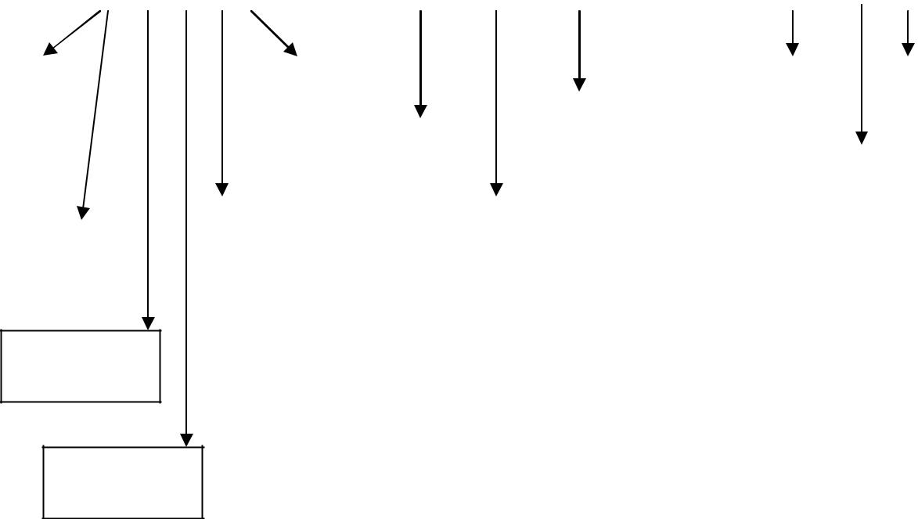

|  |  |  |  |  |  |  |  |  |  |  |  |  |  |  |  |  |  |  |  |  |  |
| --- | --- | --- | --- | --- | --- | --- | --- | --- | --- | --- | --- | --- | --- | --- | --- | --- | --- | --- | --- | --- | --- |
| User group |  |  | Check in | | |  |  |  |  |  |  | Registration |  |  | Check out | | |  | Check in/out | |  |
|  |  |  |  |  |  |  |  |  |  | |  |  |  |  |  |  |  |  |  |  |  |
|  |  |  |  |  |  |  |  |  | Latest version | |  |  |  |  |  |  |  |  |  |  |  |
|  |  |  |  |  |  |  |  |  |  |  |  |  |  |  |  |  |  |  |  |
|  |  |  |  | Check in/out | | | |  |  | download |  |  |  |  |  |  |  |  |  |  |  |
|  |  |  |  |  |  |  |  |  |  |  |  |  |  | Project | |  |  |  | File edit & |  |  |
|  |  |  |  |  |  |  |  |  |  |  |  |  |  |  |  |  |
|  |  |  |  |  |  |  |  |  |  |  |  |  |  |  |  |  | upload |  |  |
|  |  |  |  |  |  |  |  |  |  |  |  |  |  | creation | |  |  |  |  |  |
|  |  | History | | |  |  |  | View | |  |  |  |  |  |  |  |  |  |  |
|  |  |  |  |  |  |  |  |  |  |  |  |  |  |  |  |  |
|  |  |  |  |  |  |  |  |  |  |  |  |  |  |  |  |  |
| User creation |  |  |  |  |  |  |  | version | |  |  |  |  |  |  |  |  |  |  |  |  |
|  |  |  |  |  |  |  |  |  |  |  |  |  |  |  |  |
|  |  |  |  |  |  |  |  |  |  |  |  |  |  |  |  |  |  |  |  |  |  |
|  |  |  |  |  |  |  |  |  |  |  |  |  |  |  |  |  |  |  |  |  |  |

Providing right to group

Providing right to files

**COCHIN UNIVERSITY OF SCIENCE AND TECHNOLOGY**

Document Management System System Development

**SYSTEM DEVELOPMENT**

**COCHIN UNIVERSITY OF SCIENCE AND TECHNOLOGY**

Document Management System System Development

1. **SYSTEM SPECIFICATION**

**Indrodution**

The purpose of this software require specification (SRS) is to describe all externalrequire requirement of the system. It also describes the interfaces required for the system.

**Scope**

The scope of this SRS is only to describe the requirement of this system . the developer is responsible for asking for clarification ,where necessary and will not makeany alterations without the permission of either or administrator.

Developer,s Responsible Overview The developer is responsible for

Developing the system.

Install the operating system

Install and configure the necessary enviorment for the proper working of the new developed system

**Visual Source Security Management System [VSSMS]**

Visual Source Security Management System is an efficient, time saving and easy way to report, view and control the version of a file. It is now an easy task and managing it is much easier. VSSMS, a suite of programs that automates away most of the drudgery involved in keeping an annotated history of your project and avoiding modification conflicts. Most VSSMS s share the same basic logic. To use one, start by registering a collection of source files — that is, telling your VSSMS to start archive files describing their change histories. Thereafter, when you want to edit one of these files, you have to check out the file — assert an exclusive lock on it. When you're done, you check in the file, adding your changes to the archive, releasing the lock, and entering a change comment explaining what you did.

**COCHIN UNIVERSITY OF SCIENCE AND TECHNOLOGY**

Document Management System System Development

**MODULE DESCRIPTION**

This VSSMS consists of mainly 5 modules. They are:

Administrator Version control Registration

User Search

**Administrator**

Administrator is the main module of this VSSMS. The main function of the administrator is user approval. Administrator has full authority on this system. Administrator has the provision for deleting the files. He can also provided function of maintain the category of different files.

Main features are:

User group User creation Role setting

Providing right to group Providing right to files History

Check in.

**Visual Source Control**

It is another important module. The main function is to control the version of each and every file. All the information about the files is stored in this module.

Main features are:

Check in and check out View version

Latest version download Upload

**COCHIN UNIVERSITY OF SCIENCE AND TECHNOLOGY**

Document Management System System Development

**Registration**

All types of users must be a registered user. In this module all the users are registering and creating a folder to download the file and store in their directories.

Main features are:

Check in

Employees creation

Employees registration

**User**

Another important module is users. A special feature is only users can download or upload files. For this purpose it provides a user authentication mechanism. Users are allowed to create folders in their login. Users can implement various security measures on the files they upload.

Main features are:

Check in/check out File editing

Automatic versioning Upload

History

**Search**

In this module searching for a file is possible. The searching option can be done in two ways. One is by filename and the other is metadata search.

Main features are:

Check in File search

Metadata search

**COCHIN UNIVERSITY OF SCIENCE AND TECHNOLOGY**

Document Management System Implementation and Maintenance

**IMPLEMENTATION AND**

**MAINTENANCE**

**COCHIN UNIVERSITY OF SCIENCE AND TECHNOLOGY**

Document Management System Implementation and Maintenance

**6. IMPLEMENTATION AND MAINTENANCE**

**6.1 SYSTEM TESTING**

In a software development project, errors can be injected at any stage during development phase. For each phase we have discussed, there are different methods and techniques that are available for eliminating errors. However no technique is perfect, and it is expected that some of the errors of the earlier phase will manifest themselves in the code. Hence, the code developed during the coding activities is likely to have some requirements errors and design errors, in addition to errors introduced during the coding activity

Testing is an important and critical stage in software development. Testing plays an important role in determining the quality and reliability of the application. With this process, several test cases are devised. A test case means a set of data that the system will process as the normal input. System testing consists of several key activities and steps for program testing.

The different levels of testing are:

* Unit testing
* Integration testing
* Validation testing
* Output testing
* User acceptance testing

**6.1.1 UNIT TESTING**

Unit testing focuses on the different modules of the system individually, considering that the functions will be coordinated as a unit. In this testing module interface is tested to assure that information properly and correctly flows into and out of the module.

This testing involves the testing of data truncation, the structure of the data, and whether the program correctly accepts the input data. The whole validation of the program is encountered in this testing.

Unit testing has been implemented and successfully tested.

**COCHIN UNIVERSITY OF SCIENCE AND TECHNOLOGY**

Document Management System Implementation and Maintenance

**6.1.2 INTEGRATION TESTING**

When the modules are linked together, they should work properly apart from working

individually. This is often referred as interfacing. Data loss may occur at the time of

interfacing. This should be carefully avoided because this will affect the other modules

also. Integration testing is systematic technique for constructing the program linkage

while conducting tests at the same time to uncover errors associated with that interface.

This test, the tests were carried out each time a module was linked. Thus errors were easy

to isolate.

Integration testing has been implemented and successfully tested.

**6.1.3 VALIDATION TESTING**

At the culmination of black box testing, software is completely assembled as a

package. Interfacing errors have been uncovered and corrected and final series of test, i.e,

validation test is defined with a simple definition that validation succeeds when software

functions in a manner that can be reasonably accepted by a customer.

Validation testing has been implemented and successfully tested.

**6.1.4 OUTPUT TESTING**

After performing validation testing the next step is output testing of the proposed system, since the system cannot be useful if it does not produce the required output. Asking the user about the format in which the system is required tests the output displayed by the system. Here the output format is considered in two ways-screen format and printed format. The output format on screen is considered to be correct as the format was designed in the system phase according to the user needs. As for the hard copy the output comes according to

**COCHIN UNIVERSITY OF SCIENCE AND TECHNOLOGY**

Document Management System Implementation and Maintenance

the specification requested by the user. Here the output testing does not result in any correction in the system.

Output testing has been implemented and successfully tested

**6.1.5 USER ACCEPTANCE TESTING**

User acceptance testing of the system is the key factor for the success of any system. The system under consideration is tested for the user acceptance by constantly keeping in touch with prospective system at the time of development and making change whenever needed. This is done with regard to input screen design and output screen design.

User Acceptance testing has been implemented and successfully tested.

**6.2 TRAINING**

The success of the developed system depends on how it is operated and used. Therefore training the users is an important activity. Training can be classified into two, training operators and users. Training system operators involves familiarization with run procedures which is working through a sequence of activities needed to use a new system. The users training deals with operation of the system, ie. how to operate the system.

**6.3 DOCUMENTATION**

Documenting all the processes taking place in the working of the developed software is an important step in the system development life cycle. The system analyst must prepare a documentation including comments that explain both how and why a certain procedure was coded in a specific way. Documentation is also essential to test the program and carry out maintenance once the application has been installed.

**COCHIN UNIVERSITY OF SCIENCE AND TECHNOLOGY**

Document Management System conclusion

**CONCLUSION**

**& SUGGESTION**

**COCHIN UNIVERSITY OF SCIENCE AND TECHNOLOGY**

Document Management System conclusion

**7. 1. CONCLUSION**

The project entitled DOCUMENT MANAGEMENT SYSTEM is done in an effective manner. Document Management System is an efficient, time saving and easy way to report, view and control the version of a file. All the operations are done efficiently. To use one, start by registering a collection of source files — that is, telling your DMS to start archive files describing their change histories. Thereafter, when you want to edit one of these files, you have to check out the file — assert an exclusive lo ck on it. When you're done, you check in the file, adding your changes to the archive, releasing the lock, and entering a change comment explaining what you did.

**7.2 FUTURE ENHANCEMENT**

As a future venture, it is suggested to make some changes to provide more services and information at right time in right manner.

**COCHIN UNIVERSITY OF SCIENCE AND TECHNOLOGY**

Document Management System Appendix

**APPENDIX**

**COCHIN UNIVERSITY OF SCIENCE AND TECHNOLOGY**

Document Management System Appendix

1. **APPENDIX**
   1. **SCREEN SHOTS**

LOGIN PAGE

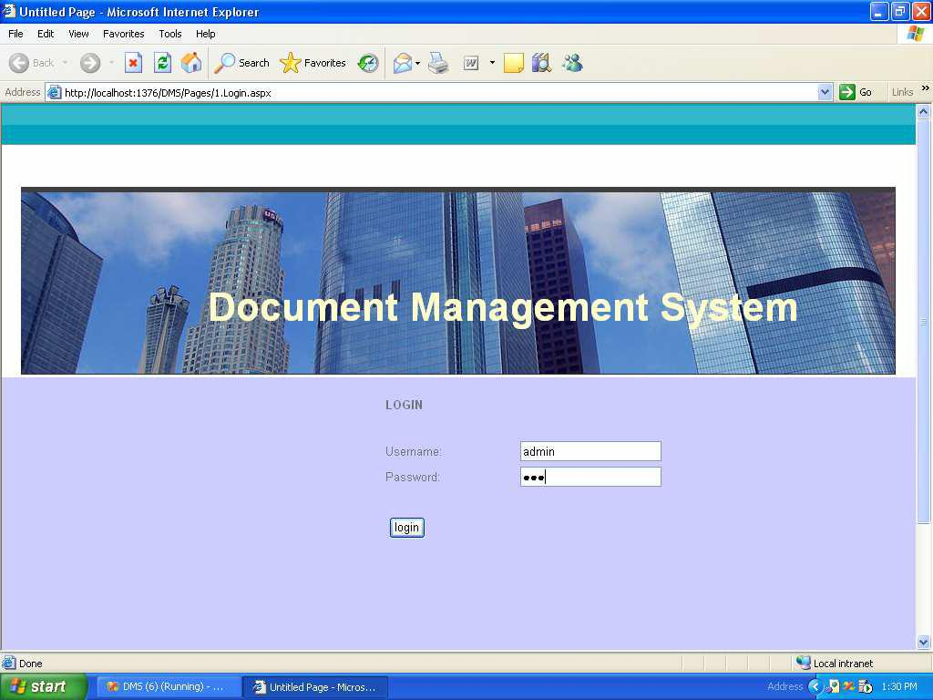

COCHIN UNIVERSITY OF SCIENCE AND TECHNOLOGY

Document Management System Appendix

ADMIN HOME PAGE

COCHIN UNIVERSITY OF SCIENCE AND TECHNOLOGY

Document Management System Appendix

PROJECT CREATION

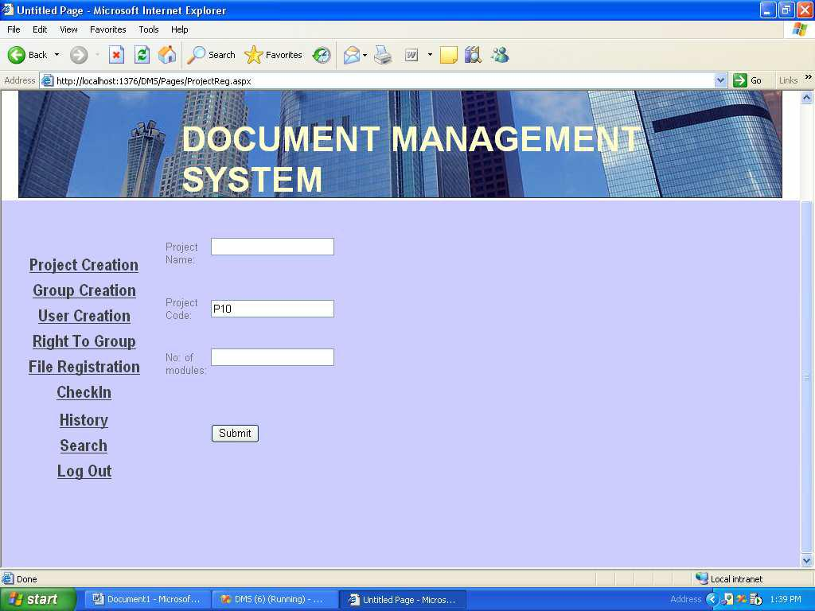

COCHIN UNIVERSITY OF SCIENCE AND TECHNOLOGY

Document Management System Appendix

GROUP CREATION

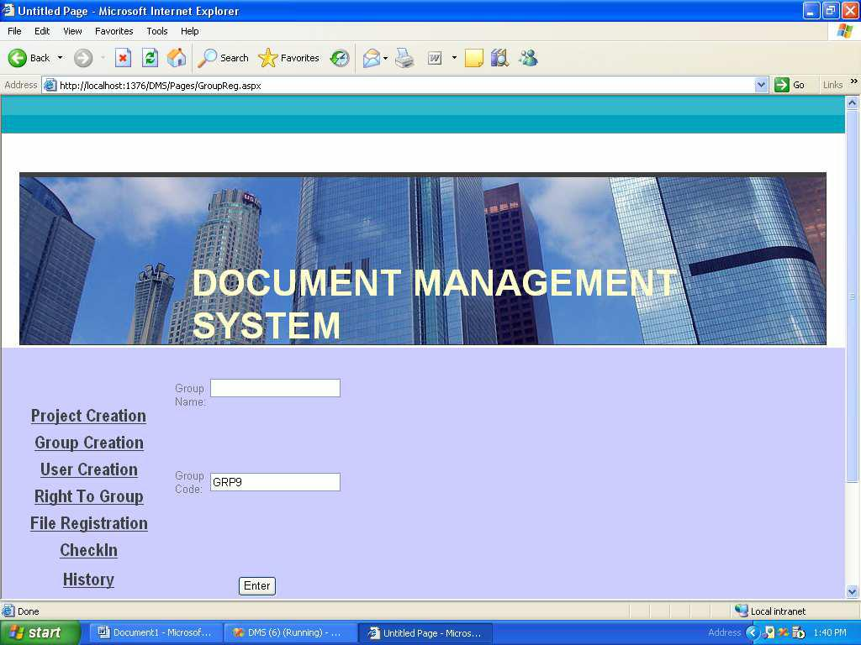

COCHIN UNIVERSITY OF SCIENCE AND TECHNOLOGY

Document Management System Appendix

USER CREATION

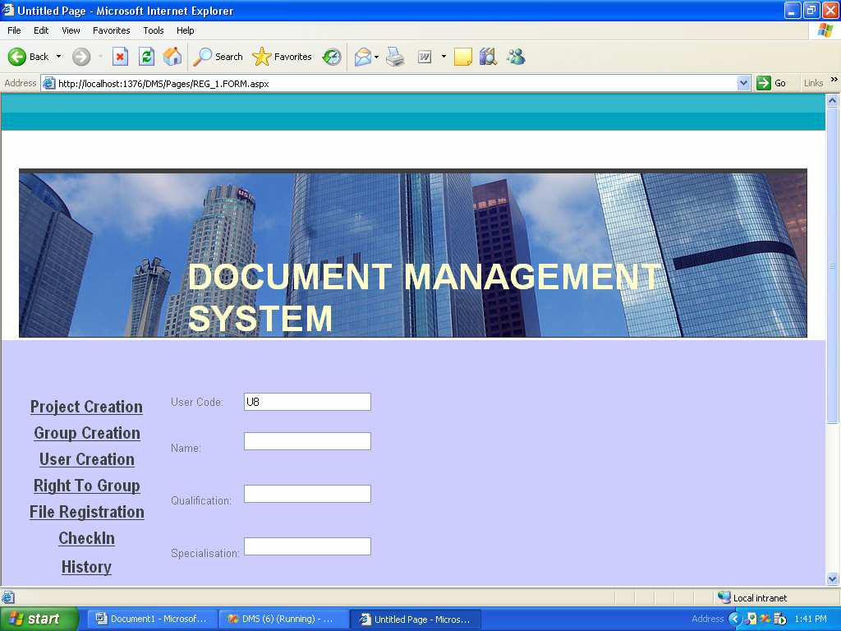

COCHIN UNIVERSITY OF SCIENCE AND TECHNOLOGY

Document Management System Appendix

RIGHT TO GROUP

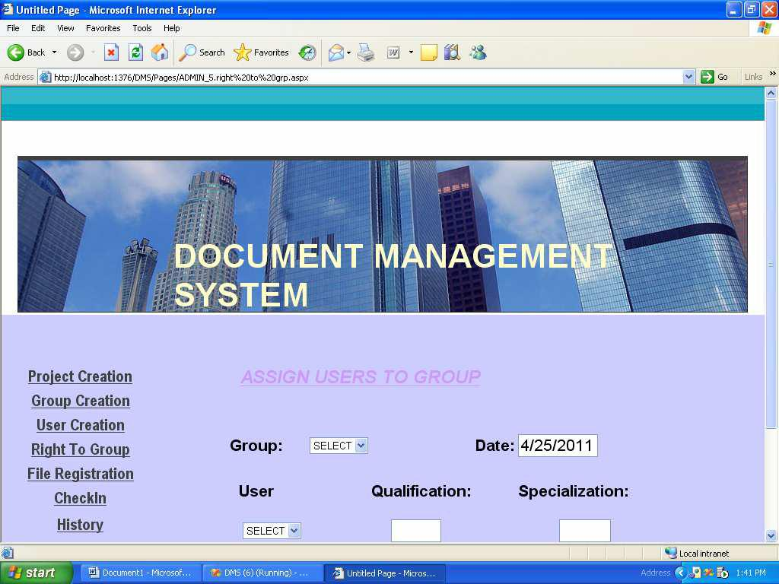

COCHIN UNIVERSITY OF SCIENCE AND TECHNOLOGY

Document Management System Appendix

FILE REGISTRATION

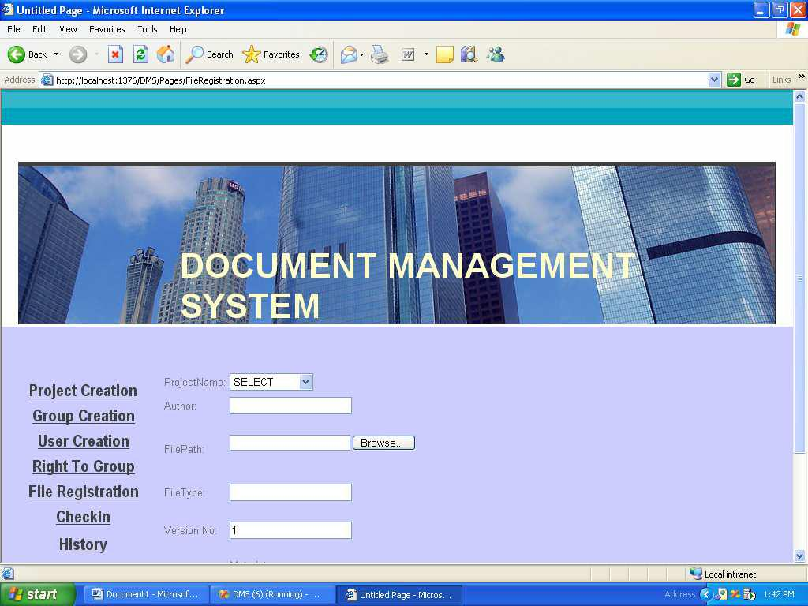

COCHIN UNIVERSITY OF SCIENCE AND TECHNOLOGY

Document Management System Appendix

CHECKIN

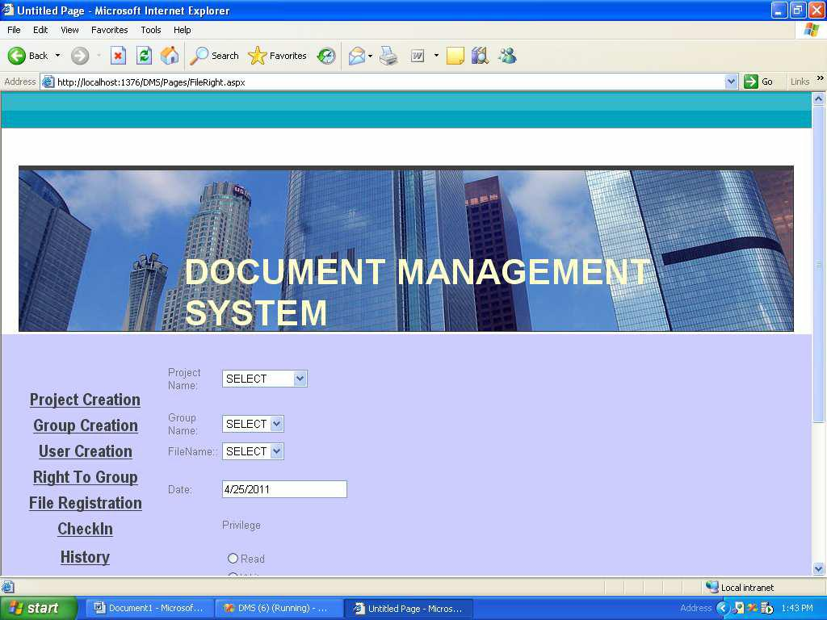

COCHIN UNIVERSITY OF SCIENCE AND TECHNOLOGY

Document Management System Appendix

HISTORY

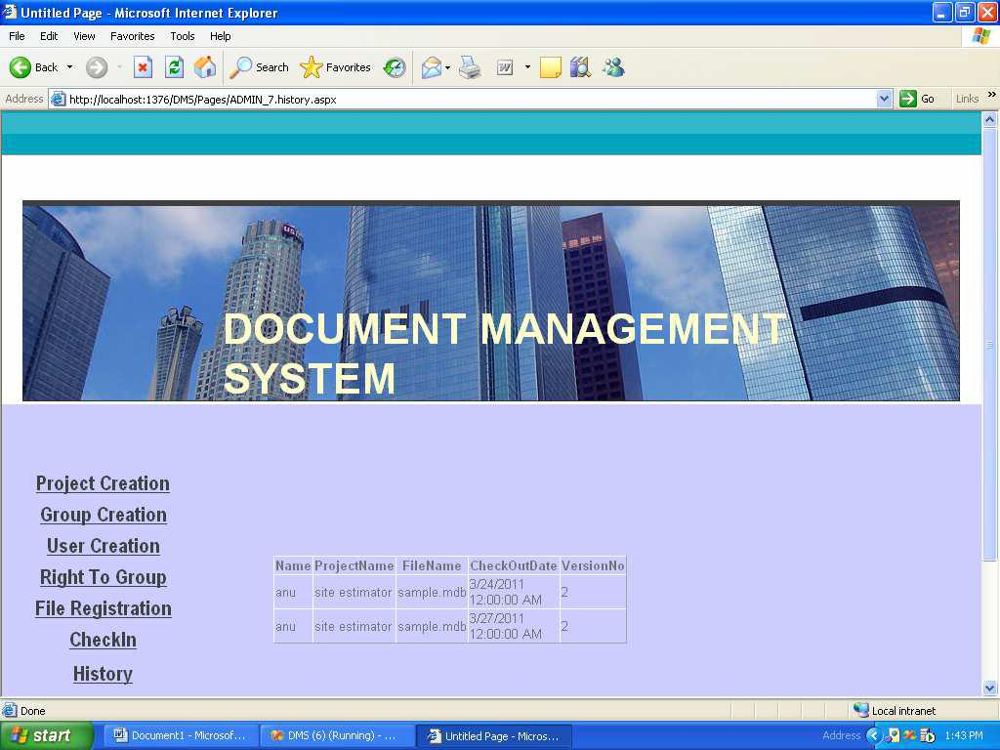

COCHIN UNIVERSITY OF SCIENCE AND TECHNOLOGY

Document Management System Appendix

SEARCH

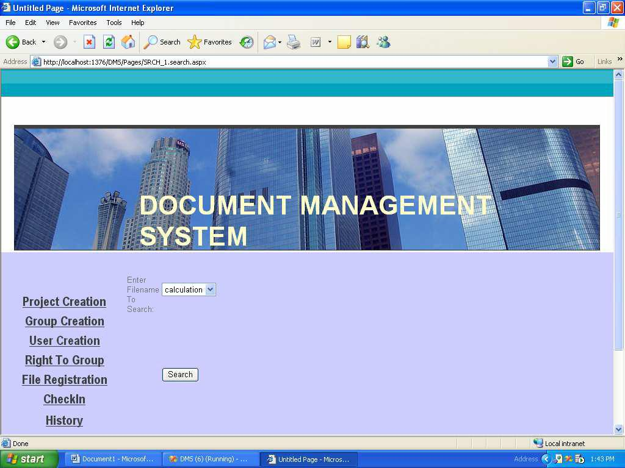

COCHIN UNIVERSITY OF SCIENCE AND TECHNOLOGY

Document Management System Appendix

USER CHECKIN

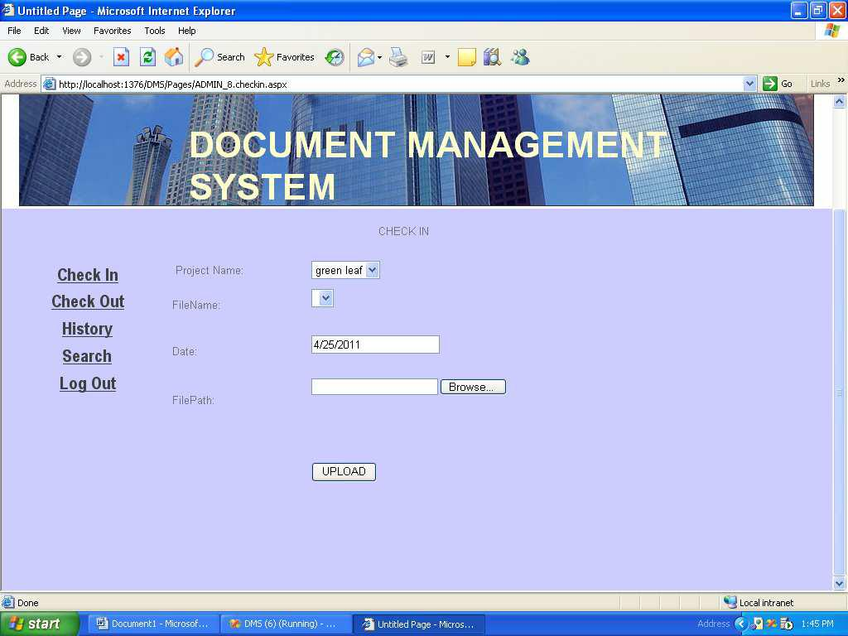

COCHIN UNIVERSITY OF SCIENCE AND TECHNOLOGY

Document Management System Appendix

USER CHECKOUT

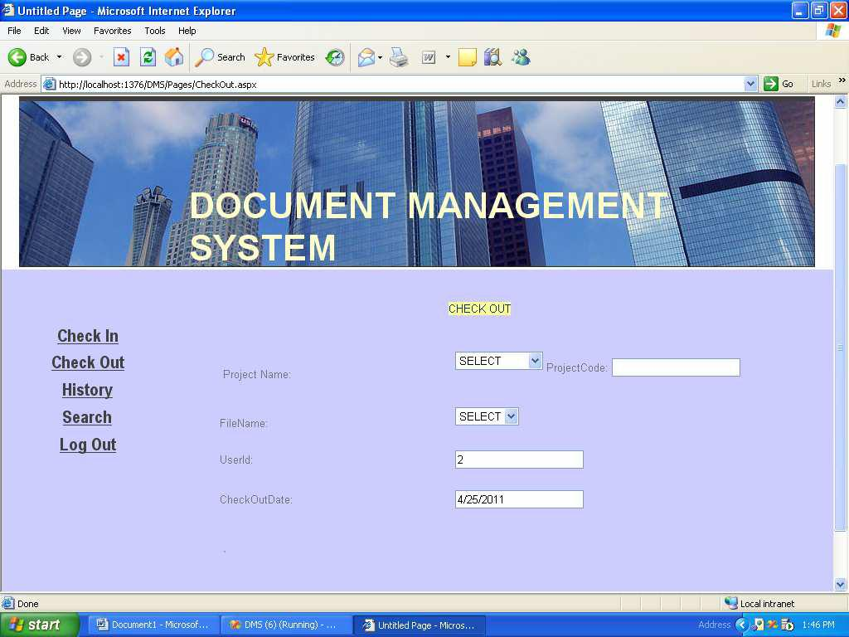

COCHIN UNIVERSITY OF SCIENCE AND TECHNOLOGY

Document Management System Appendix

USER SEARCH

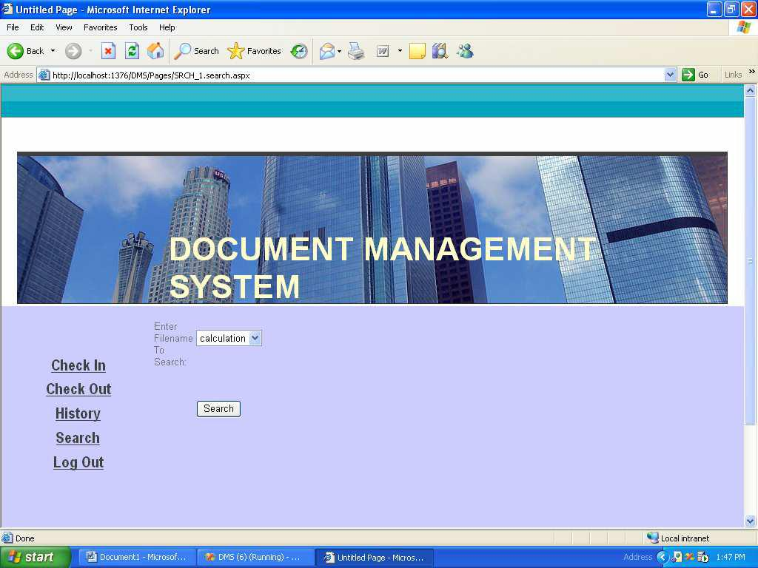

COCHIN UNIVERSITY OF SCIENCE AND TECHNOLOGY

Document Management System Appendix

**8.2 DATABASE TABLES**

Admin_login

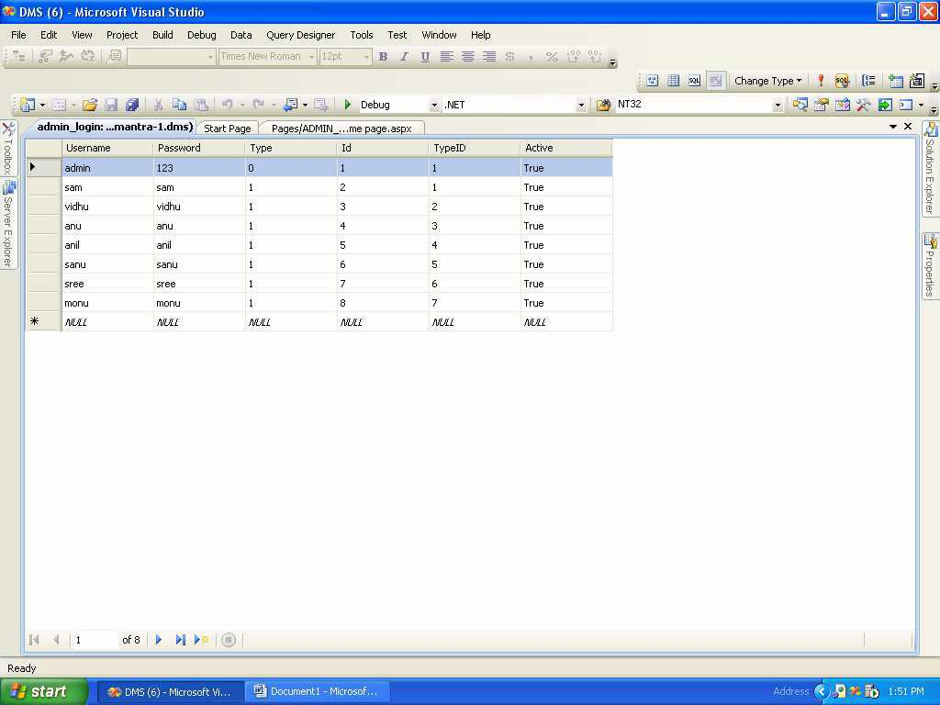

COCHIN UNIVERSITY OF SCIENCE AND TECHNOLOGY

Document Management System Appendix

Checkin

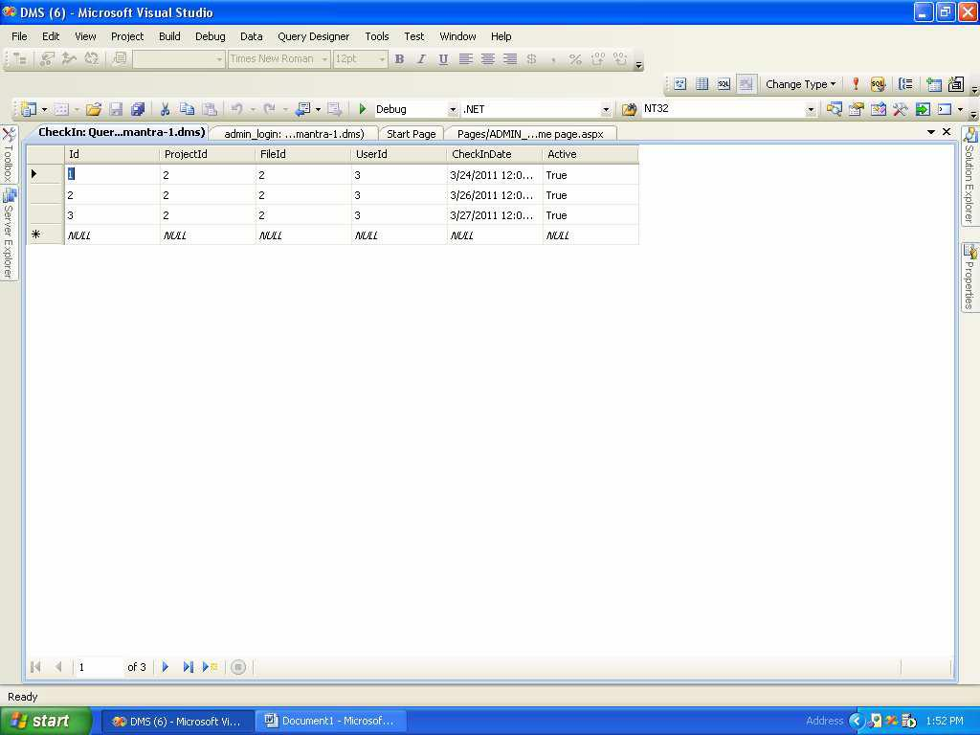

COCHIN UNIVERSITY OF SCIENCE AND TECHNOLOGY

Document Management System Appendix

Checkout

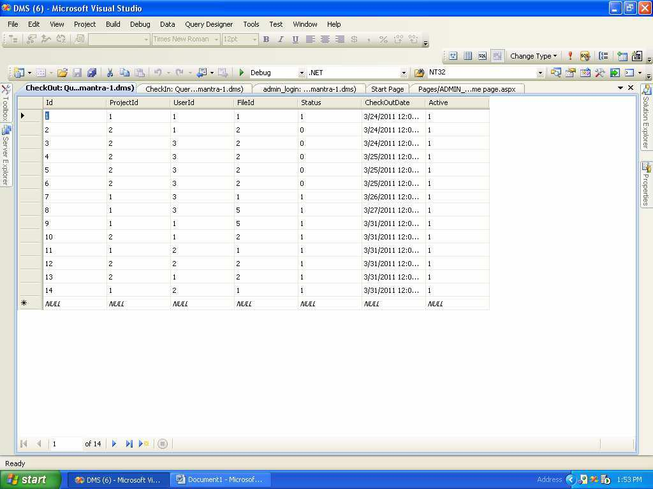

COCHIN UNIVERSITY OF SCIENCE AND TECHNOLOGY

Document Management System Appendix

FileRegistration

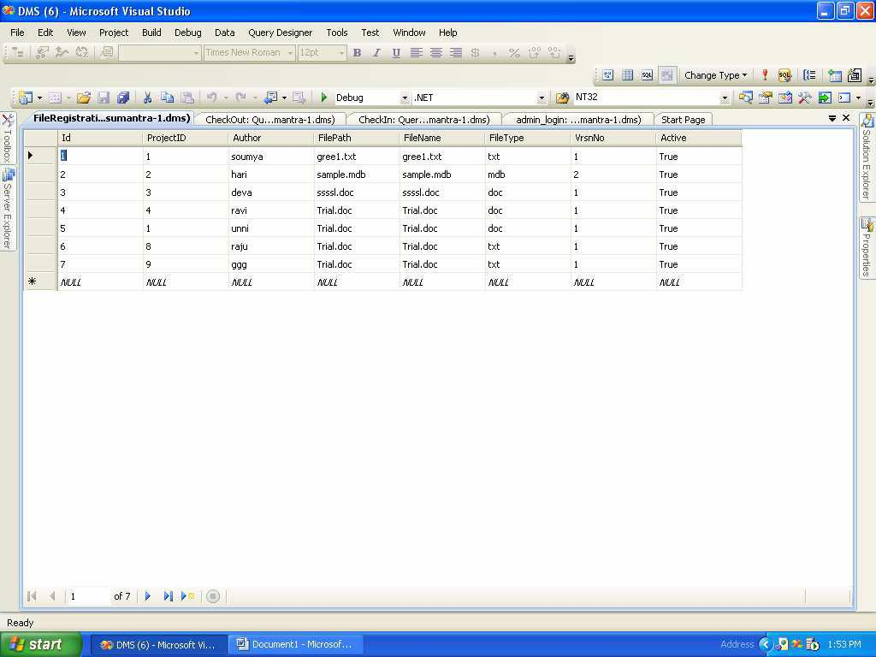

COCHIN UNIVERSITY OF SCIENCE AND TECHNOLOGY

Document Management System Appendix

FileRight

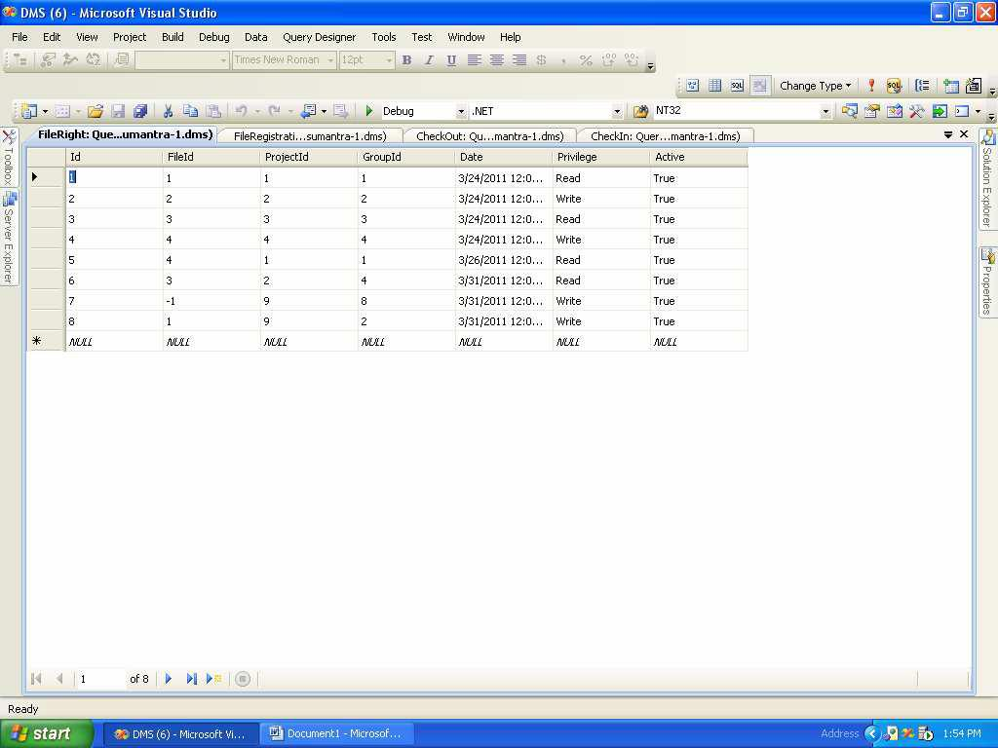

COCHIN UNIVERSITY OF SCIENCE AND TECHNOLOGY

Document Management System Appendix

GroupRegistration

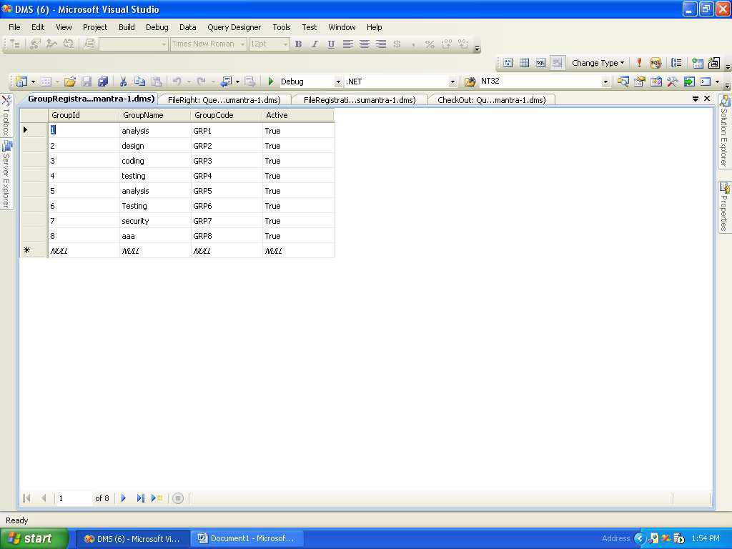

COCHIN UNIVERSITY OF SCIENCE AND TECHNOLOGY

Document Management System Appendix

History

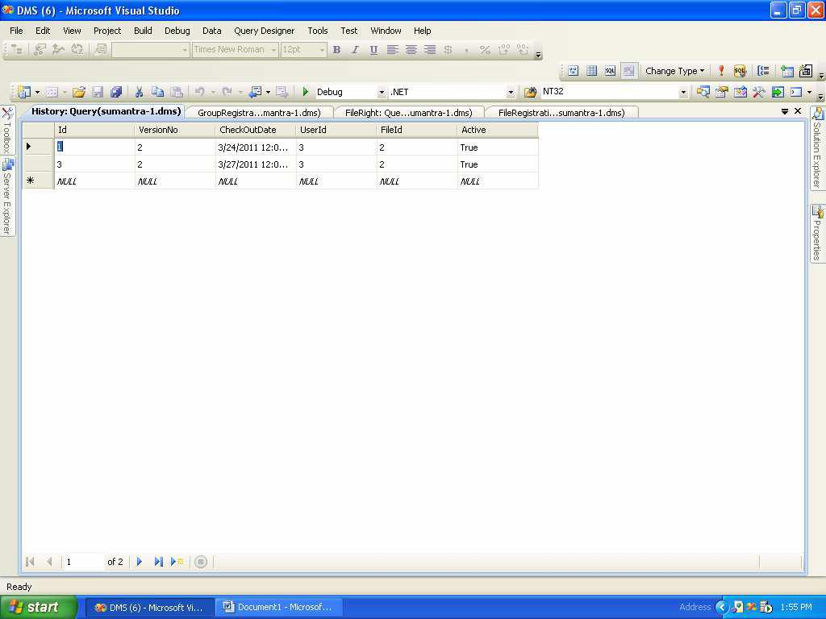

COCHIN UNIVERSITY OF SCIENCE AND TECHNOLOGY

Document Management System Appendix

Metadata

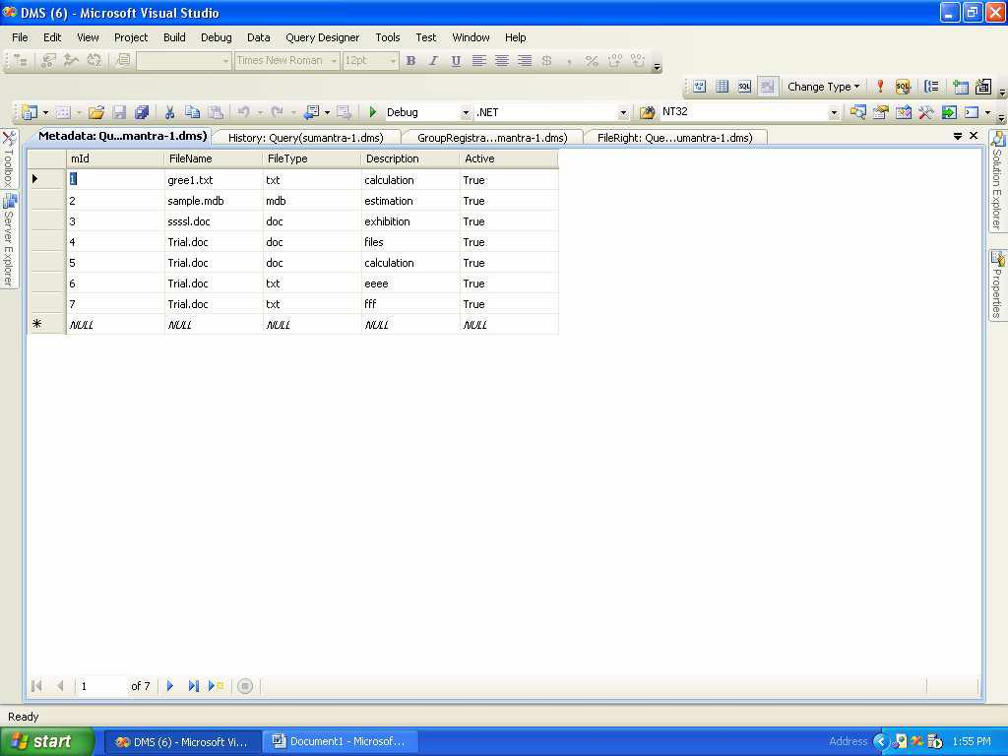

COCHIN UNIVERSITY OF SCIENCE AND TECHNOLOGY

Document Management System Appendix

ProjectRegistration

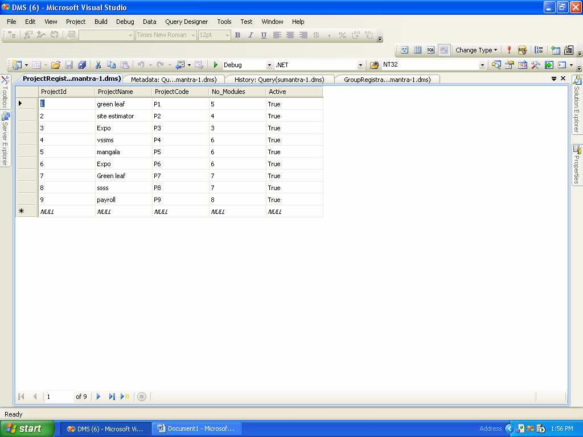

COCHIN UNIVERSITY OF SCIENCE AND TECHNOLOGY

Document Management System Appendix

UserRegistration

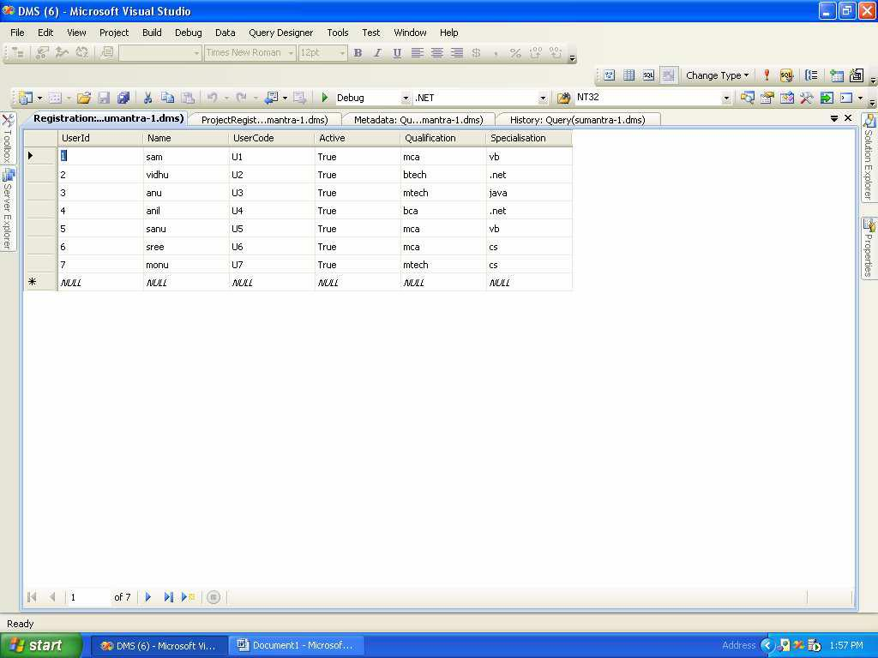

COCHIN UNIVERSITY OF SCIENCE AND TECHNOLOGY

Document Management System Appendix

Right to group

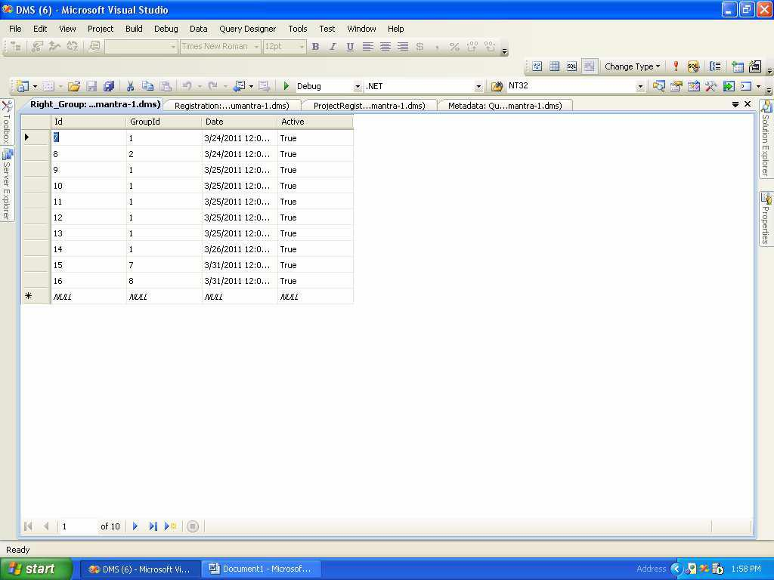

COCHIN UNIVERSITY OF SCIENCE AND TECHNOLOGY

Document Management System Appendix

Roght to group2

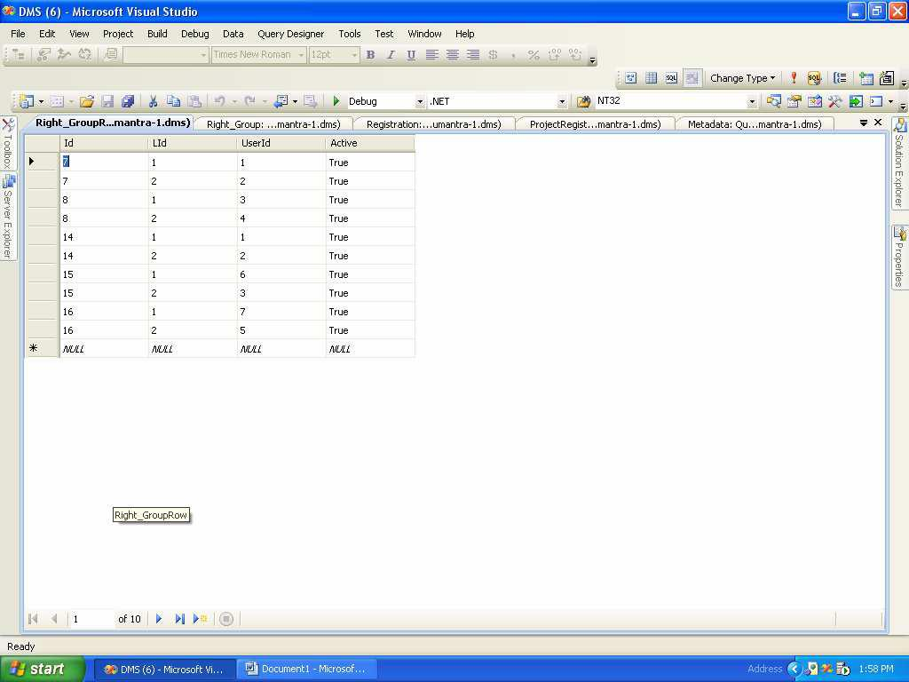

COCHIN UNIVERSITY OF SCIENCE AND TECHNOLOGY

Document Management System Bibliography

**BIBLIOGRAPHY**

**COCHIN UNIVERSITY OF SCIENCE AND TECHNOLOGY**

Document Management System Bibliography

**9. BIBLIOGRAPHY**

1. **Reference Books**
   1. **ASP.NET-COMPLETE REFERENCE,** Mathew Macdonald, Tata Megraw-HillPublications, First Edition, 2003.
   2. **DATABASE SYSTEM CONCEPTS,** Henry F.Korth, Megraw-Hill, Third Edition,1997.
   3. **PROGRAMMING WITH ASP.NET,** Dan Hurwitz, Jesse Liberty**,** WroxPublications, Second Edition, 2001.
   4. **SQL SERVER HIGH AVAILABILITY,** Paul Bertucci**,** Sams publishing, FirstEdition, 2004.
   5. **SOFTWARE ENGINEERING CONCEPT,**Richared E.Fairly Tata Megraw-HillPublications, Third Edition, 1997.

**COCHIN UNIVERSITY OF SCIENCE AND TECHNOLOGY**