**CPT Bugs & Enhancements**

This document is arranged in the same side view grid sequence as arranged in the tool.

* **Template**
* Update Sequence is idol not able to do anything on this.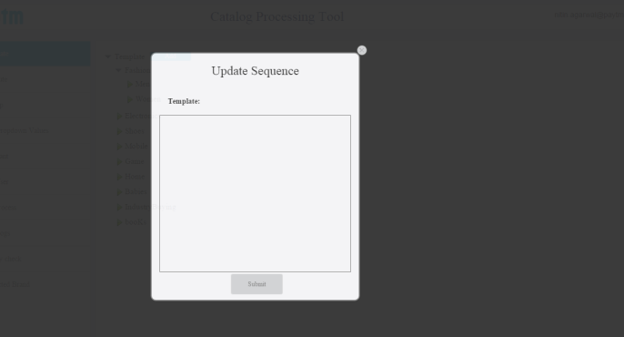
* Return time is not required while adding category & Idol **Group** remark.

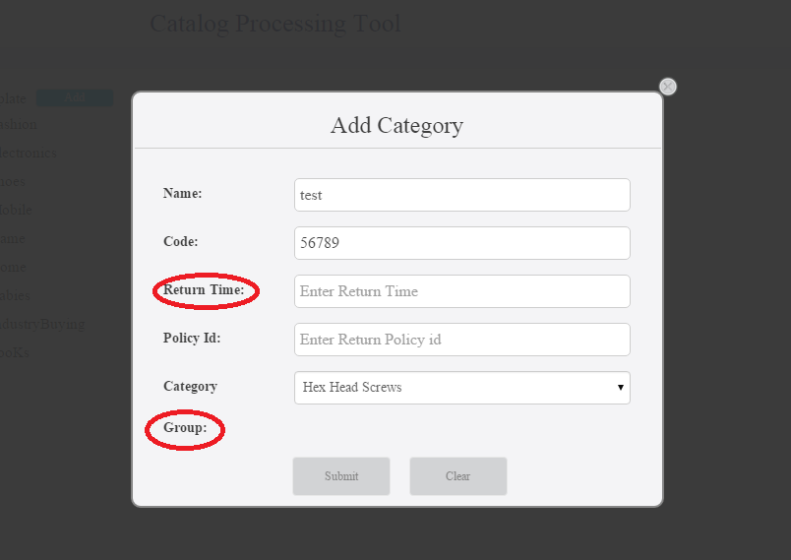

* **Attributes**
* Edit attribute not working.
* We should be able to choose from the list itself by clicking on the attribute as right now it is mandatory to write the whole name in the tab.

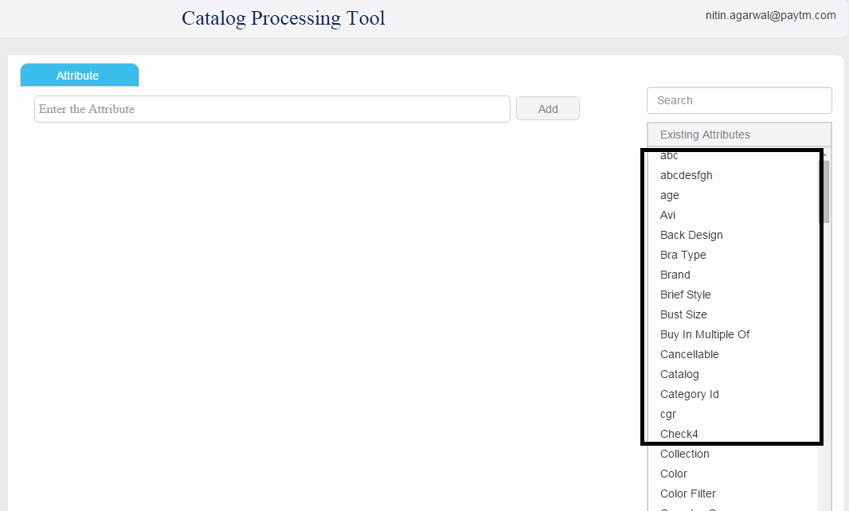

* Need to have “Select all” button in the list while mapping to the categories.

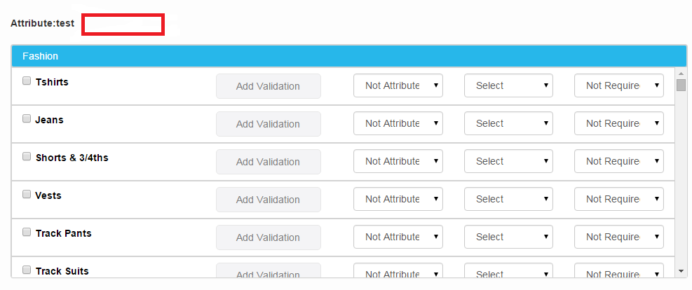

* Select **button** significance
* **Group**
* Does not show (Get) values if the template is already selected.
* **Edit Drop down values**
* Bulk uploading would be preferred.
* Should be able to choose from the list directly.
* **Add User**
* Bulk Upload option is required.
* Not able to delete the user
* **Add Logs**
* User name or mail id is required rather than user id also vertical wise summarised report is required.
* **Quality Check**
* As discussed this needs a meeting.
* **Restricted Brands**
* Brand Id should also should be there.