# 

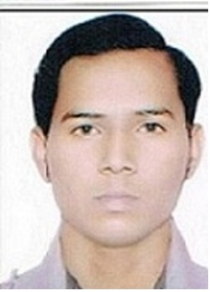

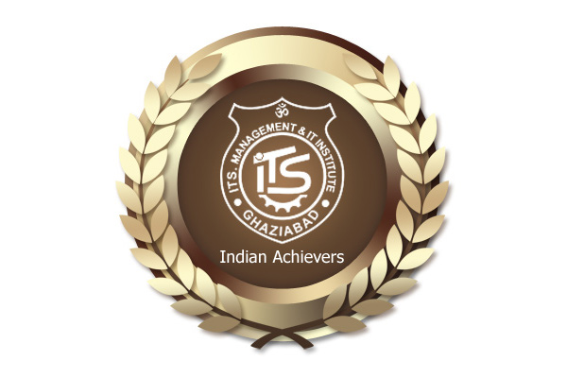

# PANKAJ KUMAR

**Finance & Marketing**

# 

**CAREER OBJECTIVE**

Looking for a challenging and task oriented position in an organization which demands the best of my professional ability in terms of managerial and analytical skills and helps me in broadening and enhancing my current skill and knowledge and to be involved as a part of a team that dynamically works towards the growth of the organization and reach the top with determination, dedication and hard work.

**PROFESSIONAL QUALIFICATION**

|  |  |  |
| --- | --- | --- |
| **EXAMINATIONonal interests:shments:** | **BOARD/ UNIVERSITY** | **YEAR OF PASSING** |
| **MBA** (Finance & Marketing) | **Institute of Technology and Science**, Ghaziabad**.** | 2014 |

**OTHERS QUALIFICATION**

|  |  |  |
| --- | --- | --- |
| **Certification examination in life insurance** | Insurance institute of India | 2011 |

**EDUCATIONAL QUALIFICATION**

* **B.Com. (commerce)** from **M.M.H COLLEGE**, GHAZIABAD, in 2010.
* **12th** (**commerce**)from S.S.D Inter College, Ghaziabad, Uttar Pradesh in 2007
* **10th** (**commerce**) from S.S.D Inter College, Ghaziabad in 2005.

**SUMMER INTERNSHIP TRAINING**

**At ‘MODEX International Securities Ltd.’** Project done on the topic **‘A STUDY ON SECURITIZATION: AN INNOVATIVE VEHICLE’**

**PROJECTS UNDERTAKEN**

**Project on SUB-PRIME CRISES ANF SECURITIZATION**

This project mainly focus on why sub-prime crises arise in US, what are the main reasons of this crises, where US has committed mistake and what are the effects of this crises on whole world?

**Project Report on economy and social impact of securitization**

This report examines the economy and social impact of securitization and tries to develop a conceptual framework for asset management, and key risks in securitization.

**Financial Markets and Their Existence in Overall Economy** The project pertains to the introduction and application of different types of financial markets and how they fit into the overall economy of a country.

**Securitization and financial intermediaries**

This project examines that disintermediation is one of the important aims of present day organizations, since by skipping the intermediary; the company intends to reduce the cost of its finances .securitization has been employed to disintermediate.

**SIGNIFICANT ACCOMPLISHMENT**

* Active participation in **“ACCOUNTING & FINANCE” workshops** at all levels.
* Active participation in **9th - 10th GLOBAL HR SUMMIT** at ITS Institution.
* Active participation in **Corporate Summits** at I.T.S Institutions.
* Was co-ordinator for **Orientation Programme 2013** at I.T.S Institutions.
* Participated in Fashion Show in **ITS Youth Fest 2013** at I.T.S Institutions.
* Participated in **Business Plan Event** at ITS Youth Fest 2013 at I.T.S Institutions, Ghaziabad.
* Won prizes, participated and co-ordinated in different Photography competition.
* Awarded for the best performer award in football in 2012.

**SOFTWARE SKILLS**

* MS Office, Excel, PowerPoint.
* Blog Designing and Website Building- had made many Blogs and FB Pages for to promote college events and competitions.

**STRENGTHS**

* Highly confident and innovative in the area of expertise.
* Swift in learning and implementing new topics and techniques.
* Determined to learn with practical approach.
* Good communication skills and managing skills.

**FIELDS OF INTEREST**

* Market Research.
* Analysis for Investment.
* Stock Market Trading
* Case based Studies.

**LIGUISTIC PROFICIENCY**

* English
* Hindi

**PERSONAL INFORMATION**

**Contact** Mob:9015088953, pankaj.kumar516018@yahoo.in

**Date of Birth** 30-03-1990

**Sex** Male

**Marital Status** Single

**Permanent Address** 115C/H2 New kot goan colony, Ghaziabad (U.P) 201001

**Hobbies** Reading books, playing pc games, Internet surfing

Date:

Place: GHAZIABAD **PANKAJ KUMAR**