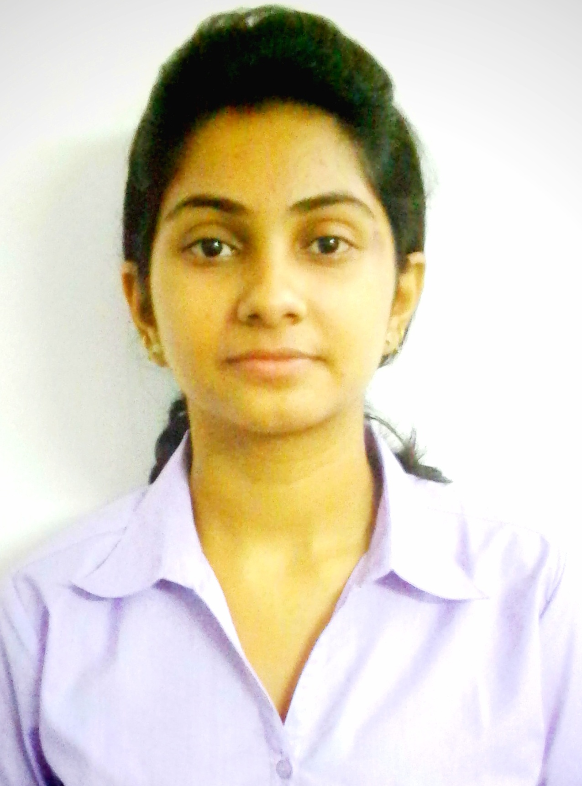

Akanksha Singh

|  |  |
| --- | --- |
| 2015 Batch B.tech student  Information Technology  Dr. K.N Modi Institute of Engineering and Technology  +91 8859384117  akankshasingh713@gmail.com  DR.knmiet,Ghaziabad,Modinagar |  |
|  |  |

Objective

To obtain a position of responsibilities that utilizes my skills and environment where I can enrich my knowledge, and in doing so provide myself job satisfaction, self development and help me achieve personal as well as organizational goals.

Academic Details

|  |  |  |  |  |
| --- | --- | --- | --- | --- |
| Year | Degree | Institute | Percentage |  |
| 2015- | B. Tech in Information technology | DR. K.N Modi institute of Engineering and technology | 73% |  |
| Present |  |  |  |  |
|  |  |  |  |  |
| 2011 | Class XII | Satyam International | 77% |  |
| CBSE |  |  |  |
|  |  |
|  |  |  |  |  |
| 2009 | Class X | A.V.N. English School | 82.6% |  |
| CBSE |  |  |  |
|  |  |
|  |  |  |  |  |

Technical Expertise

* **Programming Languages**: C, Core Java
* **Computer Science:** Data structure
* **Database:** MySQL
* **Tools:** Eclipse
* **Web Development:** HTML, JSP

|  |  |  |  |  |  |
| --- | --- | --- | --- | --- | --- |
| Academic Project | |  | |  | |
|  | **Development of Company Mailer System**   * **Team Size:** 3 * **Development Environment:** Oracle 10g * **Description:** It is an Intranet mailing system. It provides the facility to user to sign in and view mails, send mails etc. The project makes use of the platforms SERVLET(Frontend) and ORACLE(Backend). | |  |  | |
|  |  | | | |  |
|  |  |  | |  | |
|  |  | | | |  |

Extra Curricular Activities

* Participated in dancing competition in college annual function.
* Participated in **Blood donation** camp organized in college campus.

Key Strengts

* Innovative approach towards any problem.
* Focused dedication towards my objective.
* Ability to take my colleagues forward in moving scenarios by simplifying the way.
* Quick learner
* Good verbal communication
* Self motivated

Hobbies

Dancing , singing, listening music, playing badminton

Personal Details

**Language Proficiency** English & Hindi

**Father’s Name** Mr. Jai Singh

**Current Address** E-203, Ispatika Apartment, plot no 29, sec-4,

Dwarka,(Delhi)

Declaration

I hereby declare that all the information mentioned above is true and complete to the best of my knowledge.

DATE:

PLACE: **(Akanksha singh)**