CHAPTER 1



INTRODUCTION

**1.1 DOCUMENT MANAGEMENT SYSTEM**

Document Management System is an efficient, time saving and easy way to report, view and control the version of a file. It is now an easy task and managing it is much easier. DMS, a suite of programs that automates away most of the drudgery involved in keeping an annotated history of your project and avoiding modification conflicts. Most DMS s shares the same basic logic. To use one, start by registering a collection of source files — that is, telling your DMS to start archive files describing their change histories. Thereafter, when you want to edit one of these files, you have to check out the file — assert an exclusive lock on it. When you're done, you check in the file, adding your changes to the archive, releasing the lock, and entering a change comment explaining what you did.

**1.2 MODULE DESCRIPTION**

This DMS consists of mainly 3 modules. They are:

* Administrator version
* Control version
* File search system

**1.2.1 Administrator**

Administrator is the main module of this DMS. The main function of the administrator is user approval. Administrator has full authority on this system. Administrator has the provision for deleting the files. He can also provide function of maintain the category of different files.

**1.2.2 Visual Source Control**

It is another important module. The main function is to control the version of each and every file. All the information about the files is stored in this module.

**1.2.3 Registration**

All types of users must be a registered user. In this module all the users are registering and creating a folder to download the file and store in their directories.

**1.2.4 User**

Another important module is users. A special feature is only users can download or upload files. For this purpose it provides a user authentication mechanism. Users are allowed to create folders in their login. Users can implement various security measures on the files they upload.

**1.3 Existing System with Limitations:**

**1.3.1 Search**

In this module searching for a file is possible. The searching option can be done in two ways. One is by filename and the other is meta data search.

Main features are:

* Check in File Search .
* Meta data search .

**1.4 Software Requirements**

* Front End : web browser.
* Middleware : nodejs .
* Back end : Mysql .

**1.5 Hardware Requirements**

* PC with Pentium 4 class processor or higher recommend.
* Access and control - IBM PC compatible.
* Memory -1GB RAM minimum, 2GB or higher recommend.
* DVD ROM drive.
* Additional hardware printer with manufactures latest print drivers.
* OS-MS Windows XP or above.
* Display super VGA or higher resolution monitor recommend.

**1.6 EXISTING SYSTEM**

In the existing system giving rights to the groups and files both were not given. A single history was saved for the project. The file manipulating method was not done in a centralised manner. In the existing system when the file is being modified the change in version number is done by the particular user. Searching process is mainly done on the file name itself.

**1.7 PROPOSED SYSTEM**

In the proposed system rights to the groups and files were separately given. The members in a particular project group cannot work in another project at the same time. Along with this right file accessing privileges are also set for each member in the project. Two different histories are maintained along the project. The file manipulating process is controlled by a centralised controlling system. The version numbering process is done automatically. When a particular user access a file and update it and when uploading the to the server its version number automatically increases and the latest version of the file will be stored in server. The searching process is done in two ways. One is filename and the other is by metadata search.

**1.8 FEASIBILITY STUDY**

Feasibility study is made to see if the project on completion will serve the purpose of the organization for the amount of work, effort and the time that spend on it. Feasibility study lets the developer foresee the future of the project and the usefulness. Feasibility study is a test of system proposed regarding its workability, impact on the organization, ability to meet the needs and effective use of resources. Thus when a new project is proposed, it normally goes through a feasibility study before it’s approved for development.

The document provide the feasibility of the project that is being designed and lists various areas that were considered very carefully during the feasibility study of this project such as

Technical economical and behavioral feasibilities.

Investigating the existing system in the area under investigation does, to test the technical social and economical feasibility of a system and generating ideas about the new system.

There are three aspects in the feasibility study portion of the preliminary investigation also. This leads the inconsistency of information. So we need a system, which is both quick and accurate. This can be achieved by mailing system.

In present organization structure most of the work is done using software applications. In order to improve service for customers we need effective applications. Similarly considering need of work flow we need intranet mailing application.

**CHAPTER 2**

**SPECIFICATION REQUIREMENT**

Requirement analysis for web applications encompasses three major tasks: formulation, requirements gathering and analysis modeling. During formulation, the basic motivation and goals for the web application are identified, and the categories of users are defined. In the requirements gathering phase, the content and functional requirements are listed and interaction scenarios written from end-user’s point-of-view are developed. This intent is to establish a basic understanding of why the web application is built, who will use it, and what problems it will solve for its users.

2.1 Software requirement Specification:

A set of programs associated with the operation of a computer is called software. Software is the part of the computer system, which enables the user to interact with several physical hardware devices.

The minimum software requirement specifications for developing this project are as follows:

Operating System : Window 2000 , XP , Ubuntu

Presentation layer : web browser

middleware : nodejs

Database : MySQL

Documentation Tool : Ms Office

## 2.2 Hardware Requirement Specification:

The collection of internal electronic circuits and external physical devices used in building a computer is called the Hardware. The minimum hardware requirement specifications for developing this project are as follows:

Processor : Standard processor with a speed of 1.6 GHz or more

**RAM :** 256 MB RAM or more

**Hard Disk :** 20 GB or more

**CHAPTER 3**

**TECHNOLOGIES USED**

## 3.1. NODE JS

**3.1.1 INTRODUCTION**

Initially released in 2009, NodeJS set out to revolutionize web applications. Its creator, Ryan Dahl, sought to give web developers the opportunity to create highly interactive websites

with push capabilities in order to maximize throughput and efficiency. Today, dozens of companies including LinkedIn, The New York Times, PayPal, and eBay utilize Node’s evented I/O model in order to power their large network programs on the web.

Just a few years ago, the web was a stateless environment based on the stateless request-response paradigm. Most interactive features were encapsulated within Flash or Java Applets , as isolated units within a web environment. Node allows web applications to establish real-time, two-way connections. Its major advantage lies in using asynchronous, Event - driven I/O, thus remaining lightweight and efficient. When managing a data-intensive application distributed across multiple devices.

Node is currently sponsored by Joyent, a software company specializing in high-performance cloud computing. Since its initial release as a Linux-only software platform, Node has acquired compatibility with Mac OS X, Windows, Solaris, FreeBSD and Opens operating systems.

Contributions to the code base are made regularly by just over a dozen developers via GitHub. With nearly one commit per day, Node’s fast-paced development has led to over 230 releases in just over 4 years. Nonetheless, it is imperative to note that Node has yet to release a version.

The project is currently open-source under the MIT license. With larger clients looking to integrate NodeJS into their mobile platforms, this relatively new technology is increasingly

Influenced by enterprise application in comparison to its initial popularity among autonomous developers. This trend is certain to persist as Node gains popularity, but it is doubtful to replace solutions provided by Java and .NET with much more significant worldwide investment. This text will give an overview of the architecture of NodeJS, with a focus on a handful of key ideas that have led to its widespread adoption.

**3.1.2. TECHNOLOGY**

NodeJS is divided into two main components: the core and its modules. The core is built in C and C++. It combines Google’s V8 JavaScript engine with Node’s Libuv library and protocol bindings including sockets and HTTP.

**3.1.2.1 V8 Runtime Environment**

Google’s V8 engine is an open-source Just In Time, or JIT, compiler written in C++. In recent benchmarks, V8’s performance has surpassed other JavaScript interpreters including

Spider Monkey and Nitro. It has additionally surpassed PHP, Ruby and Python performance. Due to Google’s approach,

it is predicted that in fact it could become as fast as C.

The engine compiles JavaScript directly into assembly code ready for execution by avoiding any intermediary representations like tokens and codes which are further interpreted.

The runtime environment is itself divided into three major’s components: a compiler, an optimizer and a garbage collector.

**3.1.2.1 Compiler**

The compiler dissects the JavaScript code provided, extracting relevant commands. A built-in profiler identifies portions requiring optimization and sends these to the optimizing module.

**3.1.2.2 Optimizer**

The optimizer, known as Crankshaft, constructs an Abstract Syntax Tree, or AST using targeted code. It is then translated to a Static Single Assignment, or SSA representation

and optimized.

**3.1.2.3 Garbage Collector**

V8 divides memory into two categories: the new space and the old space. Both are located in the heap and used to keep track of JavaScript objects as referenced by pointers.

Any new object is added to the new space. When the new space reaches a size threshold, the garbage collector will remove any ”dead” objects from the new space and store them within the old space. Although the garbage collector disallows manual memory management and may slow the web application, it is a necessary component in order to maintain a lightweight JavaScript code base.

**3.1.3 NPM**

The Node package manager, denoted npm, is the official package manager for NodeJS, written entirely in JavaScript.

It comes bundled and installed automatically with the Node environment. It is responsible for managing dependencies for the Node application and allows users to install applications already available on the npm registry. Npm was initially developed in 2010 with the immediate goal for quick integration into the NodeJS platform. As of Node version . Although it can function as a separate entity, npm is essential in keeping the small, easily maintainable nature of Node’s main core. By managing dependencies outside of Node, the platform focuses on its true objectives.

**3.1.3.1 Influences**

The NodeJS platform is heavily influenced by the architecture of the Unix operating system. The Unix OS is composed of a small kernel; it is complemented by layers of system calls, library routines and other modules. One of its main components consists of a concurrency-managing subsystem.

This schema is reproduced in Node’s main thread, complemented by the Libuv component, all of which wrap around the V8 runtime environment.

Node was further influenced by the Ruby Mongrel web server, an open-source platform available on all major operating systems developed in 2008. Mongrel offered both an HTTP

Library and simple web server written entirely in Ruby; it was the first web server utilized by social networking service Twitter.

**3.1.4 INSTALLATION OVERVIEW**

NodeJS is composed of a large main code base and an additional 6 libraries; these include C-Ares, HTTP Parse, OpenSSL, Libuv, V8 and Zlib. The code is well organized and well commented, allowing any developer to easily understand Node’s individual components and better assess how these interact to provide a complete server-side platform.

Node.js is a server side platform built on Google Chrome's JavaScript Engine (V8 Engine). Node.js was developed by Ryan Dahl in 2009 and its latest version is v0.10.36. The definition of Node.js as supplied by its official documentation is as follows −

Node.js is a platform built on Chrome's JavaScript runtime for easily building fast and scalable network applications. Node.js uses an event-driven, non-blocking I/O model that makes it lightweight and efficient, perfect for data-intensive real-time applications that run across distributed devices.

Node.js is an open source, cross-platform runtime environment for developing server-side and networking applications. Node.js applications are written in JavaScript, and can be run within the Node.js runtime on OS X, Microsoft Windows, and Linux.

Node.js also provides a rich library of various JavaScript modules which simplifies the development of web applications using Node.js to a great extent.

## 3.1.5 Nodejs Advantages

1. Asynchronous and Event Driven All APIs of Node.js library are asynchronous that is, non-blocking. It essentially means a Node.js based server never waits for an API to return data. The server moves to the next API after calling it and a notification mechanism of Events of Node.js helps the server to get a response from the previous API call.
2. Very Fast Being built on Google Chrome's V8 JavaScript Engine, Node.js library is very fast in code execution.
3. Single Threaded but Highly Scalable - Node.js uses a single threaded model with event looping. Event mechanism helps the server to respond in a non-blocking way and makes the server highly scalable as opposed to traditional servers which create limited threads to handle requests. Node.js uses a single threaded program and the same program can provide service to a much larger number of requests than traditional servers like Apache HTTP Server.
4. No Buffering - Node.js applications never buffer any data. These applications simply output the data in chunks.
5. License - Node.js is released under the MIT license

## 3.2 Express Framework

Express is a minimal and flexible Node.js web application framework that provides a robust set of features to develop web and mobile applications. It facilitates a rapid development of Node based Web applications.

Following are some of the core features of Express framework:

1. Allows setting up middleware’s to respond to HTTP Requests.
2. Defines a routing table which is used to perform different action based on HTTP Method and URL.
3. Allows to dynamically rendering HTML Pages based on passing arguments to templates.

### 3.2.1 Directives

Import required modules − we use require directive to load a Node.js module.

Create server − A server which will listen to client's request similar to Apache HTTP Server.

Read request and return response − server created in earlier step will read HTTP request made by client which can be a browser or console and return the response.

#### 3.2.2 Declarations

Declarations are used to specify supplemental methods and variables. You can think of these are the page's private functions; they can only be called by the nodejs where they are defined, or by another it that includes it (using the require (module name) > directive).

Here is a sample declaration:

var express = require('express');

var router = express.Router();

var db = require('../lib/db_connection.js');

var fn = require('../lib/fns.js');

var crypto = require('crypto'),

key = 'efghabcdijklmnop',

iv = '0123456789654321',

cipher = crypto.createCipheriv('aes-128-cbc', key, iv);

#### 3.2.3 Scriptlets

Scriptlets are bits of Java code. They can do anything but they will most likely concentrate on generating HTML code or setting up variables to be part of later expressions.

#### Expressions

Expressions are special-purpose mini-Scriptlets used for evaluating expressions. This could be something as simple as outputting the value of a variable, or a more complicated Java expression, like calling a function and outputting the result. <%= counter %> Note that counter is defined as an int, but we do not need to explicitly convert it to a string.

**3.2.4.1 Look up any other information about the request that is embedded in the HTTP request :**

This information includes details about browser capabilities, cookies, the host name of the requesting client, and so froth.

**3.2.4.2 Generate the results**:

This process may require talking to a database, executing an RMI or CORBA call, invoking a legacy application, or computing the response directly.

**3.2.4.3 Send the document back to the client:**

This document may be sent in text format (HTML), binary format (GIF images), or even in a compressed format like zip that is layered on top of some other underlying format.

## CHAPTER 4

**SYSTEM DESIGN**

**4.1 INPUT DESIGN**

Input design is the process of converting the user originated input to a computer based format. The design decision for handling input specifies hoe data are accepted for computer processing .Input design is a part of overall system design that needs careful attention.

**4.2 OUTPUT DESIGN**

One of the most important features of a system for user is the output it produces. Output design should improve the systems relationship with the user and help in decision making. Computer output is a process that involves designing necessary output that have to be given to various users according to their requirements. Efficient, intelligible output design should improve the system relationship with the user and help and in decision making. A major form of output is the hardcopy from the printer. The output devices are selected by considering the response time requirements, print quickly etc. The print formats and editing for the final printout are very much considered during output design. The objective of output design is to define the controls and format of all printed documents and reports and screens that will be produced by the system. The output is the most important and direct source of information to the user. For many end users output is the main reason for developing the system and the basis on which they will evaluate the usefulness of the application. Output generally refers to the system results. The output of the system is designed so as to include a number of reports. Reports reflect the output design.

Output design is an ongoing activity, which start during study phase itself. Output generally refers to the results and information data are generated by the system. It can be in the form of operational documents and reports.

**4.3 DATABASE DESIGN**

A database is an organized mechanism that has the capability of storing information through which a user can retrieve stored information in an effective and efficient manner. The data in the database is safe and easily accessed.

The database design is a two level process. In the first step, user requirements are gathered together and a database is designed which will meet these requirements as clearly as possible. This step is called Information Level Design and it is taken independent of any individual DBMS.

In the second step, this Information level design is transferred into a design for the specific DBMS that will be used to implement the system in question.This step is called Physical Level Design, concerned with the characteristics of the specific DBMS that will be used. A database design runs parallel with the system design. The organization of the data in the database is aimed to achieve the following two major objectives.

* Data Integrity
* Data independence
* Normalization is the process of decomposing the attributes in an application, which results in a set of tables with very simple structure. The purpose of normalization is to make tables as simple as possible. Normalization is carried out in this system for the following reasons.
* To structure the data so that there is no repetition of data, this helps in saving space. To permit simple retrieval of data in response to query and report request.
* To simplify the maintenance of the data through updates, insertions, deletions.
* To reduce the need to restructure or reorganize data which new application requirements arise?

**4.3.1 Relational Database Management System (RDBMS)**

A relational model represents the database as a collection of relations. Each relation resembles a table of values or file of records. In formal relational model terminology, a row is called a tuple, a column header is called an attribute and the table is called a relation. A relational database consists of a collection of tables, each of which is assigned a unique name. A row in a tale represents a set of related values.

**4.3.1.1 Relations Domains & Attributes**:

A table is a relation. The rows in a table are called tuples. A tuple is an ordered set of n elements. Columns are referred to as attributes. Relationships have been set between every table in the database. This ensures both Referential and Entity Relationship Integrity. A domain D is a set of atomic values. A common method of specifying a domain is to specify a data type from which the data values forming the domain are drawn. It is also useful to specify a name for the domain to help in interpreting its values. Every value in a relation is atomic, i.e. Not decomposable.

**4**.**3.1.1.1** **Relationships**

Table relationships are established using Key. The two main keys of prime importance are Primary Key & Foreign Key. Entity Integrity and Referential Integrity Relationships can be established with these keys.

* Entity Integrity enforces that no Primary Key can have null values.
* Referential Integrity enforces that no Primary Key can have null values.
* Referential Integrity for each distinct Foreign Key value, there must exist a matching Primary Key value in the same domain. Other keys are Super Key and Candidate Keys.
* Relationships have been set between every table in the database. This ensures both Referential and Entity Relationship Integrity.

**4.3.2 NORMALIZATION**

As the name implies, it denoted putting things in the normal form. The application developer via normalization tries to achieve a sensible organization of data into proper tables and columns and where names can be easily correlated to the data by the user. Normalization eliminates repeating groups at data and thereby avoids data redundancy, which proves to be a great burden on the computer resources.

Normalization is the systematic technique of transforming data subject to a whole range of file maintenance problem into an organized data free from such problem Detecting tables through a number of levels of normalization. It is carried out in four different steps

1. Represent the un normalized table or relation.
2. Transform the unnormalized table to the First Normal Form (1NF).
3. Transform of First Normal Form into Second Normal Form (2NF).
4. Transformation of Second Normal Form into the Third Normal Form (3NF**)**

**4.3.2.1 First Normal Form:**

The first step is to put the data into First Normal Form. This can be done by moving data into separate tables where the data is of similar type in each table. Each table is given a Primary Key or Foreign Key as per requirement of the project. This eliminated repeating groups of data.

**4.3.2.2 Second Normal Form:**

This step helps in taking out data that is only dependent on a part of the key.

**4.3.2.3 Third Normal Form:**

This step is taken to get rid of anything that does not depend entirely on the

Primary Key.

## TABLE DESIGN

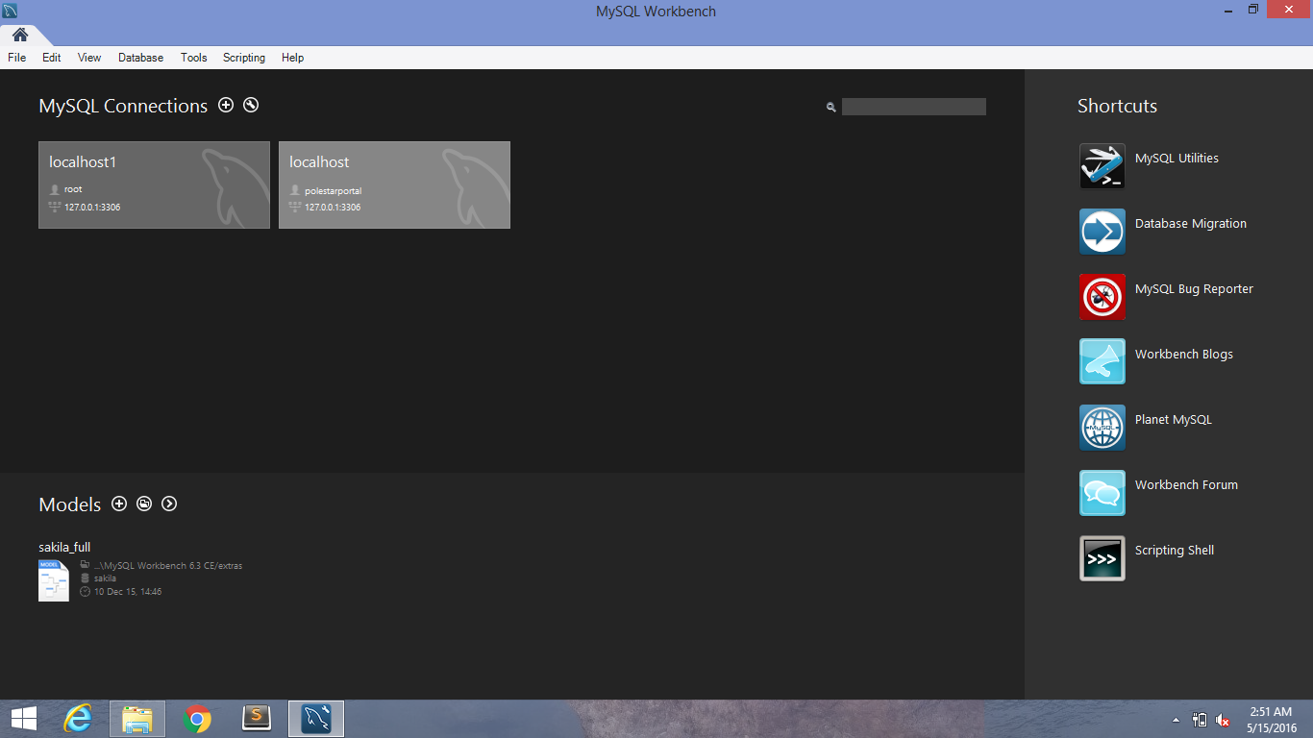

Figure 4.7.1 : Mysql workbench Connections

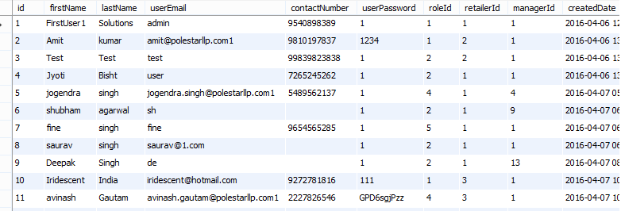

Table 4.7.2 : user details table .



Table 4.7.3: file table.

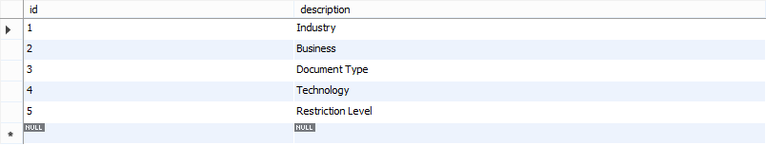

Table 4.7.4: vertical table.

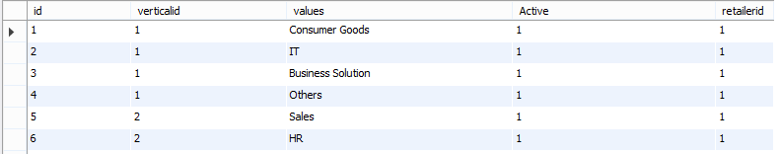

Table 4.7.5: vertical values table.

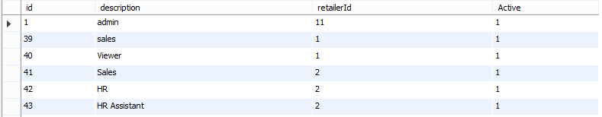

Table 4.7.6: custom role table

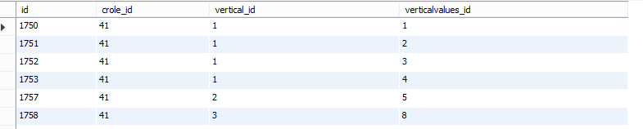

Table 4.7.7: attachrolemap table

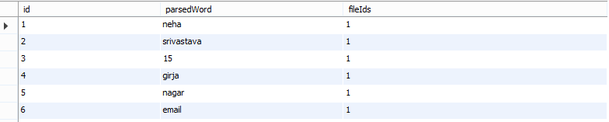

Table 4.7.8: parse data table

**Chapter-5**

**SYSTEM DEVELOPMENT**

**5.1 Introduction**

The purpose of this software require specification (SRS) is to describe all externalrequire requirement of the system. It also describes the interfaces required for the system.

**5.2 Scope**

The scope of this SRS is only to describe the requirement of this system. The developer is responsible for asking for clarification, where necessary and will not make any alterations without the permission of either or administrator.

Developers Responsible Overview The developer is responsible for developing the system.

Install the operating system Install and configure the necessary environments for the proper working of the new developed system

**5.3 Visual Source Security Management System [VSSMS]**

Visual Source Security Management System is an efficient, time saving and easy way to report, view and control the version of a file. It is now an easy task and managing it is much easier. VSSMS, a suite of programs that automates away most of the drudgery involved in keeping an annotated history of your project and avoiding modification conflicts. Most VSSMS s share the same basic logic. To use one, start by registering a collection of source files — that is, telling your VSSMS to start archive files describing their change histories. Thereafter, when you want to edit one of these files, you have to check out the file — assert an exclusive lock on it. When you're done, you check in the file, adding your changes to the archive, releasing the lock, and entering a change comment explaining what you did.

**5.4 MODULE DESCRIPTION**

This VSSMS consists of mainly 5 modules.

They are:

* Administrator Version
* Control Registration
* User Search

**5.4.1 Administrator**

Administrator is the main module of this VSSMS. The main function of the administrator is user approval. Administrator has full authority on this system. Administrator has the provision for deleting the files. He can also provided function of maintain the category of different files.

Main features are:

* User group
* User creation
* Role setting Providing right to group Providing right to files History Check in.

**5.4.2 Visual Source Control**

It is another important module. The main function is to control the version of each and every file. All the information about the files is stored in this module.

Main features are

* Check in and check out
* View version
* Latest version download Upload

**5.4.3 Registration**

All types of users must be a registered user. In this module all the users are registering and creating a folder to download the file and store in their directories.

Main features are:

* Check in
* Employees creation
* Employees registration

**5.4.4 User**

Another important module is users. A special feature is only users can download or upload files. For this purpose it provides a user authentication mechanism. Users are allowed to create folders in their login. Users can implement various security measures on the files they upload.

* Main features are:
* Check in/check out
* File editing
* Automatic versioning
* Upload History

**5.4.5 Search**

In this module searching for a file is possible. The searching option can be done in two ways. One is by filename and the other is metadata search.

Main features are:

* Check in File search
* Metadata search

## 

## 

## CHAPTER 6

## CODING

**6.1. app.js**

'use strict';

var http = require('http');

var https = require('https');

var express = require('express');

var path = require('path');

var cookieParser = require('cookie-parser');

var bodyParser = require('body-parser');

var session = require('express-session');

var logger = require('morgan');

var errorHandler = require('errorhandler');

var favicon = require('serve-favicon');

var util = require('util');

var app = express();

var router = express.Router();

app.set('port', process.env.PORT || 8986);

app.set('views', path.join(__dirname, 'views'));

app.set('view engine', 'ejs');

app.use(favicon( path.join(__dirname, '/public/images/favicon.ico')));

app.use(bodyParser.json({limit: '15mb'}));

app.use(bodyParser.urlencoded({ extended: false }))

app.use(cookieParser('1a2b3c4d5e6f'));

app.use(session({secret: 'a234l7678s746kmdtjyjuyfjt2tyj4fhn5fgh24k7lu6jj4j75k2j56lkh24lk4j2l'}));

app.use(express.static(path.join(__dirname, 'public')));

var env = process.env.NODE_ENV = (process.env.NODE_ENV || 'development');

if (env.toLowerCase() === 'production') {

logger.token('istDate', function () {

return new Date();

});

app.use(logger({ format: ':istDate :method :url :status :res[Content-Length] :response-time ms' }));

app.use(router);

app.use(function(req, res) {

return res.send(404);

});

app.use(function(err, req, res, next) {

res.status(err.status || 500);

res.render('error', {

message: err.message,

error: err

});

});

}

if (env.toLowerCase() === 'development') {

app.use(logger('dev'));

app.use(router);

app.use(function(req, res) {

return res.sendStatus(404);

});

app.use(errorHandler());

}

require('./routes')(router);

http.createServer(app)

.on('error', function(err) {

util.log(util.inspect(err));

process.exit(1);

})

.listen(app.get('port'), function() {

util.log('Server listening on port ' + app.get('port') + ' in ' + app.get('env'));

});

**6.2 portal.js :**

'use strict';

var modelPortal = require('../../model/modelPortal');

var mailTemplates = require('../../lib/mailtemplates');

var randomString = require('../../lib/common').generateRandomString;

var flag = require('../../config/config').flagUsed;

var path = require('path');

var fs = require('fs');

var textract = require('textract');

var config = {

preserveLineBreaks: true,

tesseract: {

lang: "eng"

}

}

var options = {

type: 'text' // extract the actual text in the pdf file

}

var pdf_extract = require('pdf-extract');

var skillsIdfromdb = [];

var skillsfromdb = [];

var location = [];

var institituefromdb = [];

var instititueIdfromdb = [];

var locationId = [],

countFiles = [],

totalFiles = [],

parsing = [],

done = 0;

module.exports = {

customRolesExist: function(req, res, next) {

modelPortal.customRolesExist(req.session.userId, req.session.roleId, req.session.retailerId, req.body.roleName, function(err, result) {

if (err) {

next(err);

} else {

console.log('aaaaaaaaaaaaaaaaaa');

}

});

},

getModules: function(req, res, next) {

modelPortal.getModules(req.session.userId, req.session.roleId, req.session.retailerId, function(err, result) {

if (err) {

next(err);

} else {

req.result = result;

console.log('aaaaaaaaaaaaaaaaaa');

req.session.url = req.url;

next();

}

});

},

registration: function(req, res, next) {

console.log("just entered portal registration");

modelPortal.retailerRegistration(

req.body.compname,

req.body.email,

req.body.pass,

req.body.fname,

req.body.lname,

req.body.cno,

req.body.modules,

function(err, result) {

if (err) {

console.log("Error in portal registration", error);

next(err);

} else {

if (result[0] && result[0][0].flag == flag.inserted) {

mailTemplates.retailerRegistration(req.body.fname, req.body.email, req.body.pass, function(error, resultMail) {

if (error) {

console.log("Error in portal else --- if registration", error);

result[0].flag = flag.mailFailed;

}

});

}

console.log("Mail sent.......and data brought is : ", result);

res.json(result);

}

});

},

validateUser: function(req, res, next) {

console.log('cccccccccccccccccccccccccccccccccccccccc', req.query.validateid);

modelPortal.validateUser(

req.query.validateid,

function(err, result) {

if (err) {

next(err);

} else {

req.session.firstName = result[0][0].firstName;

req.session.userName = result[0][0].userEmail;

req.session.password = result[0][0].userPassword;

req.session.userId = result[0][0].id;

req.session.roleId = result[0][0].roleId;

req.session.retailerId = result[0][0].retailerId;

req.session.logo = result[0][0].logo;

req.session.isVerified = true;

req.session.croleId = result[0][0].crole_id;

req.session.isRetailer = result[0][0].isRetailer;

req.session.modules = result[1].map(function(v) {

return v.id;

});

res.redirect('/portal');

}

});

},

recoverPassword: function(req, res, next) {

modelPortal.recoverPassword(req.body.femail, function(err, result) {

if (err) {

next(err);

} else

if (result[0] && result[0][0].flag == flag.updated) {

mailTemplates.recoverPassword(result[1][0].firstName,result[1][0].userEmail, result[1][0].userPassword, function(error, resultMail) {

if (error) {

result[0][0].flag = flag.mailFailed;

}

});

}

res.json(result);

}

});

},

changePass: function(req, res, next) {

modelPortal.changePass(req.session.userId,req.body.pass,req.body.oldpass,function(err, result) {

if (err) {

next(err);

} else {

res.json(result[0]);

}

});

},

getCustomRoleById: function(req, res, next) {

modelPortal.getCustomRoleById(req.body.rid,function(errorCustomRoles,resultCustomRole) {

if (errorCustomRoles) {

next(errorCustomRoles);

return;

}

console.log(resultCustomRoles)

res.json(resultCustomRoles);

});

},

getIndustry: function(req, res, next) {

modelPortal.getIndustry(req.session.userId,req.session.roleId,req.session.retailerId, req.session.croleId, function(error, resultIndustry) {

if (error) {

next(error);

return;

}

req.resultIndustry = resultIndustry;

next();

});

},

getBusiness: function(req, res, next) {

modelPortal.getBusiness(req.session.userId, req.session.roleId, req.session.retailerId, req.session.croleId, function(error, resultBusiness) {

if (error) {

next(error);

return;

}

// console.log(resultBusiness)

req.resultBusiness = resultBusiness;

next();

});

},

getDocument: function(req, res, next) {

modelPortal.getDocument(req.session.userId, req.session.roleId, req.session.retailerId, req.session.croleId, function(error, resultDocument) {

if (error) {

next(error);

return;

}

req.resultDocument = resultDocument;

next();

});

},

getTechnology:function(req, res, next) {

modelPortal.getTechnology(req.session.userId, req.session.roleId, req.session.retailerId, req.session.croleId, function(error, resultTechnology) {

if (error) {

next(error);

return;

}

req.resultTechnology = resultTechnology;

next();

});

},

getRestriction: function(req, res, next) {

modelPortal.getRestriction(req.session.userId, req.session.roleId, req.session.retailerId, req.session.croleId, function(error, resultRestriction) {

if (error) {

next(error);

return;

}

req.resultRestriction = resultRestriction;

next();

});

},

addCustomRole:function(req,res,next){ modelPortal.addCustomRole(req.session.retailerId, req.body.rname, req.body.industry, req.body.business,req.body.doctypes,req.body.technology,req.body.rLevelreq.body.industryhide,req.body.businesshide,req.body.doctypehide, req.body.newTechide, req.body.rLevelhide,

function(err, result) {

if (err) {

next(err);

return;

}

next();

});

},

updateCustomRole:function(req,res,next){ modelPortal.updateCustomRole(req.session.retailerId,req.body.editRoleId,eq.body.rname, req.body.industry,req.body.business,eq.body.doctypes, req.body.technology, req.body.rLevel, req.body.industryhide,req.body.businesshide,q.body.doctypehide,req.body.newTechide, req.body.rLevelhide, req.body.isActive,function(err, result) {

if (err) {

next(err);

return;

}

res.json(result);

});

},

getAllFiles: function(req, res, next) {

modelPortal.getAllFiles(req.session.userId,req.session.roleId,req.session.retailerId,ession.croleId, function(err, resultFiles) {

if (err) {

next(err);

return;

}

req.resultFiles = resultFiles;

next();

})

},

setFilePermission:function(req,res,next){ modelPortal.setFilePermission(req.session.userId,req.session.roleId,req.session.retailerId, function(err, permissionResult) {

if (err) {

next(err);

return;

}

req.permissionResult = permissionResult;

next();

});

},

confirmedFilePermission:function(req,res,next){ odelPortal.confirmedFilePermission(req.session.userId,req.session.roleId,eq.session.retailerId, req.body.status, function(err, result) {

if (err){

next(err);

return;

console.log(result[0][0].userEmail);

}

mailTemplates.confirmFile(req.session.firstName,result[0][0].userEmail,function(error,resultail) {

if (error) {} else

console.log("successful", resultMail);

});

next();

});

},

deleteFileByIdPermanentely: function(req, res, next) {

var delPath = path.resolve('./public/attach/');

odelPortal.deleteFileByIdPermanentely(req.session.userId,req.session.roleId,req.session.retailerId, req.body.status, req.body.status1, function(err, result) {

if (err) {

next(err);

return;

}

console.log(result[0][0].fpath);

delPath = path.resolve('./public/attach/' + result[0][0].fpath);

console.log("finally", delPath);

fs.unlinkSync(delPath);

res.json('succs');

});

},

rejectFileById: function(req, res, next) {

// console.log('rejectFileById in portal',req.body)

modelPortal.rejectFileById(req.session.userId, req.session.roleId, req.session.retailerId, req.body.status, req.body.status1, function(err, result) {

if (err) {

next(err);

return;

}

mailTemplates.rejectFile(req.session.firstName,result[0][0].userEmail,req.body.status1, function(error, resultMail) {

if (error) {

console.log("errorrrrrr", req.session.userId, error);

} else

console.log("successful", resultMail);

});

next();

});

},

showRejectedFiles: function(req, res, next) {

modelPortal.showRejectedFiles(req.session.userId,req.session.roleId,eq.session.retailerId, function(err, resultRejectedFile) {

if (err) {

next(err);

return;

req.resultRejectedFile = resultRejectedFile;

next();

}

);

},

attachDocFile: function(req, res, next) {

var parsedData = null;

if (req.file != undefined) {

var currfolder = req.body.currfolder;

var now = Date.now();

var fname = req.file.originalname;

var exet = fname.split('.');

var exe = exet[exet.length - 1];

var tempPath = req.file.path,

targetPath = path.resolve('./public/attach/' + exet[0] + '_' + now + '.' + exe);

var strname = exet[0] + '_' + now + '.' + exe;

fs.rename(tempPath, targetPath, function(err) {

if (err) {

res.redirect('/breakdown');

} else {

if (exe.toLowerCase() == 'doc' || exe.toLowerCase() == 'docx') {

var newpath = './public/attach/' + exet[0] + '_' + now + '.' + exe;

textract.fromFileWithPath(newpath, config, function(error, text) {

if (error) {

console.log(error);

} else {

if (typeof text != undefined) {

var textLowerCase = text.toLowerCase().replace(/,/g, ' ').replace(/-/g, ' ').replace(/:/g, ' ').replace(/\n/g, ' ').replace(/\./g, '').replace(/ +/g, ' ').replace(/'/g, '').replace(/"/g, '').split(' ');

parseAll(textLowerCase, req, strname, next);

next();

} else {

console.log('file cannot be parsed');

}

}

});

} else if (exe.toLowerCase() == 'pdf') {

var newpath = './public/attach/' + exet[0] + '_' + now + '.' + exe;

targetPath = path.resolve('./public/attach/' + exet[0] + '_' + now + '.' + exe);

var processor = pdf_extract(targetPath, options, function(err) {

if (err) {

console.log(err);

}

});

processor.on('complete', function(data) {

// console.log('start*************',data.text_pages[0],'*********',Date.now());

var text = '';

for (var i = 0; i < data.text_pages.length; i++) {

text = text.concat(data.text_pages[i]);

}

var textLowerCase = text.toLowerCase().replace(/,/g, ' ').replace(/-/g, ' ').replace(/:/g, ' ').replace(/\n/g, ' ').replace(/ +/g, ' ').replace(/'/g, '').replace(/"/g, '').split(' ');

parseAll(textLowerCase, req, strname, next);

next();

});

processor.on('error', function(err) {

});

} else {

var industry = req.body.industry == null ? '' : req.body.industry.toString();

var business = req.body.business == null ? '' : req.body.business.toString();

var doctype = req.body.doctype == null ? '' : req.body.doctype.toString();

var tec = req.body.newTec == null ? '' : req.body.newTec.toString();

var restriction = req.body.rLevel == null ? '' : req.body.rLevel.toString();

modelPortal.attachDocFile(req.session.userId,req.session.retailerId, strname,req.body.currfolder,fname,req.body.descbox,req.body.authname, industry,business,req.body.title,doctype,tec,req.session.roleId,restriction, req.body.industryhide, req.body.businesshide, req.body.doctypehide, req.body.newTechide, req.body.rLevelhide, parsedData,function(err, result) {

if (err) {

next(err);

return;

} else {

next();

}

});

}

}

});

}

}

**6.3 modalportal.js :**

'use strict';

var mysql = require('../lib/mysql').executeQuery;

var randomString = require('../lib/common').generateRandomString;

module.exports = {

customRolesExist: function(userId, roleId, retailerId, roleName, callback) {

var query = {

sql: 'call usp_customRolesExist(?)',

values: [roleName]

};

mysql(query, function(err, result) {

callback(err, result);

});

},

validateUser: function(emailid, callback) {

var query = {

sql: 'call usp_verifyUserViaEmail(?)',

values: [emailid]

};

mysql(query, function(err, result) {

callback(err, result);

});

},

retailerRegistration: function(companyName, emailId, password, firstName, lastName, contactNo, choosedModule, callback) {

var query = {

sql: 'call usp_retailerRegistration(?,?,?,?,?,?,?)',

values: [companyName, emailId, password, firstName, lastName, contactNo, choosedModule]

};

mysql(query, function(err, result) {

callback(err, result);

});

},

recoverPassword: function(emailId, callback) {

var randomPassword = randomString(10);

var query = {

sql: 'call usp_recoverPassword(?,?)',

values: [emailId, randomPassword]

};

mysql(query, function(err, result) {

callback(err, result);

});

},

changePass: function(userid, pass, oldpass, callback) {

var query = {

sql: "call usp_changePassword(?,?,?)",

values: [userid, pass, oldpass]

};

console.log('cxxxxxxxxxxxx', userid);

mysql(query, function(err, result) {

callback(err, result);

});

},

getAllClient: function(clientId, roleId, retailerId, status, callback) {

if (clientId == 'undefined') {

clientId = '0';

}

var query = {

sql: 'call usp_getAllClientsById(?,?,?,?)',

values: [clientId, roleId, retailerId, status]

};

console.log('getAllClient', query);

mysql(query, function(err, result) {

if (err) {

console.log("get all clients--------", err);

}

callback(err, result);

});

},

addEditClient: function(id, f,

ccode,

cname,

cabbname,

category,

caccount,

location,

address,

ccontactperson,

ccperemail,

clconphone,

active,

userid1,

userid2,

retailerId, callback) {

var query = {

sql: "call usp_addEditClient(?,?,?,?,?,?,?,?,?,?,?,?,?,?,?,?)",

values: [id,

f,

ccode,

cname,

cabbname,

category,

caccount,

location,

address,

ccontactperson,

ccperemail,

clconphone,

active,

userid1,

userid2,

retailerId

]

};

console.log(query);

mysql(query, function(err, result) {

callback(err, result);

});

},

addEditClientAjax: function(userid, roleid, retailerid, id, name, newid, callback) {

var query = {

sql: "call usp_addEditClientCheck(?,?,?,?,?,?)",

values: [userid, roleid, retailerid, id, name, newid]

};

console.log(query);

mysql(query, function(err, result) {

callback(err, result);

});

},

mailServerInfo: function(retailerId, callback) {

var query = {

sql: 'call usp_mailServerInfo(?)',

values: [retailerId]

};

console.log(query);

mysql(query, function(err, result) {

console.log("-----------------------", result);

callback(err, result);

});

},

mailServerConfigure: function(retailerId, domainname, uname, smtppass, portnum, callback) {

var query = {

sql: 'call usp_mailServerConfigure(?,?,?,?,?)',

values: [retailerId, domainname, uname, smtppass, portnum]

};

console.log(query);

mysql(query, function(err, result) {

console.log("-----------------------", result);

callback(err, result);

});

**},**

**6.4 documentHome.ejs :**

<html lang="en">

<head>

<% include ../partials/head %>

<style type="text/css">

.show {

display: grid !important;

}

#my-select5 {

width: 100%;

height: 29px;

}

.modal {

overflow: hidden;

z-index: 1100;

}

.modal-dialog {

margin-right: 0;

margin-left: 0;

}

.col-lg-8 {

color: black;

margin-top: 900px;

}

.glyphicon-folder-open {

color: black;

}

.glyphicon-plus {

color: black;

}

.glyphicon-minus {

color: black;

}

.a {

color: #2b2b2b;

}

input[type=search] {

height: 29px !important;

border-radius: 5px !important;

border: 1px solid #669ECC !important;

}

thead {

background-color: #808080;

color: white;

font-size: 12px;

}

tbody {

color: #808080;

font-size: 12px;

}

#sidebar-wrapper2 {

height: auto;

min-height: 650px;

}

#sidebar-wrapper3 {

height: auto;

}

body {

overflow-y: scroll;

}

</style>

<meta charset="utf-8">

<meta http-equiv="X-UA-Compatible" content="IE=edge">

<meta name="viewport" content="width=device-width, initial-scale=1">

<meta name="description" content="">

<meta name="author" content="">

<title>Document Management</title>

</head>

<body class="color3" style="">

<div>

<% include ../partials/adminheader %>

<% include headerDoc.ejs %>

</div>

<div class="se-pre-con"></div>

<div style="background-color:antiquewhite;">

<div id="wrapper">

<div id="sidebar-wrapper2" class="one">

<div class="one1 row" style="padding-left: 7%;margin-top:-1%"><b> Search By :</b></div>

<ul class="sidebar-nav" id="treeid" style='margin-top:2%'></ul>

<div id="new111">

<div class="col-md-10 col-md-offset-1" style="margin-top:7%">

<div class="col-md-12" style="position:relative;top:10%;margin-top:-10px;margin-left:-8%"><b>Industry:</b>

</div>

<div class="">

<select id="select1" multiple="multiple" required name="industry1">

<%for(var i=0;i<industry[0].length;i++){%>

<option value="<%=industry[0][i].values_id%>"><%=industry[0][i].values%></option>

<%}%>

</select>

</div>

</div>

<div class="col-md-10 col-md-offset-1" style="margin-top:7%">

<div class="col-md-12" style="position:relative;top:10%;margin-top:-10px;margin-left:-8%"><b>Business:</b></div>

<div class="">

<select id="select2" multiple="multiple" required name="business1">

<%for(var i=0;i<business[0].length;i++){%>

<option value="<%=business[0][i].values_id%>"><%=business[0][i].values%></option>

<%}%>

</select>

</div>

</div>

<div class="col-md-10 col-md-offset-1" style="margin-top:7%">

<div class="col-md-12" style="position:relative;top:10%;margin-top:-10px;margin-left:-8%"><b>Document type:</b></div>

<div class="">

<select id="select3" multiple="multiple" required name="doctype">

<%for(var i=0;i<document[0].length;i++){%>

<option value="<%=document[0][i].values_id%>"><%=document[0][i].values%></option>

<%}%>

</select>

</div>

</div>

<div class="col-md-10 col-md-offset-1" style="margin-top:7%">

<div class="col-md-12" style="position:relative;top:10%;margin-top:-10px;margin-left:-8%"><b>Technology :</b></div>

<div class="">

<select id="select4" multiple="multiple" required name="newTec1">

<%for(var i=0;i<technology[0].length;i++){%>

<option value="<%=technology[0][i].values_id%>"><%=technology[0][i].values%></option>

<%}%>

</select>

</div>

</div>

<div class="col-md-10 col-md-offset-1" style="margin-top:7%">

<div class="col-md-12" style="position:relative;top:10%;margin-top:-10px;margin-left:-8%"><b>Restriction Level:</b>

</div>

<div class="">

<select id="select5" multiple="true" required name="rLevel1">

<%for(var i=0;i<restriction[0].length;i++){%>

<option value="<%=restriction[0][i].values_id%>"><%=restriction[0][i].values%></option>

<%}%>

</select>

</div>

</div>

<div class="col-md-6 col-md-offset-4 " id="lastfiveuploads6" style="margin-top:5%;">

<button type="submit" class="btn btn-success" id="searchBoxId1" onclick="filterdata()" style="

background-color: #f05f40;border-color: #f05f40;margin-left: -16px;height: 30px;">Search</button>

</div>

</div>

</div>

</div>

<div class="container-fluid col-md-12 color3" style="margin-left:20%;width:60.5%;margin-top:4%">

<table id="data_table" class="table table-striped table-bordered" cellspacing="0" width="100%" style="ALIGN-CONTENT: CENTER;">

<thead>

<th>File Name</th>

<th>File Title</th>

<th>Author</th>

<th>Upload Date</th>

<th>Action</th>

</thead>

<tbody id="orderbody">

<%for(var i=files[0].length-1;i>=0;i--) {%>

<tr class="" id='row_<%=files[0][i].id%>'>

<td>

<a download href="./attach/<%=files[0][i].fpath%>">

<%=files[0][i].name%>

</a>

</td>

<td>

<%=files[0][i].title%>

</td>

<td>

<%=files[0][i].author%>

</td>

<td>

<%=files[0][i].uploadDate%>

</td>

<td><a title="view details"><i onclick="editModel(<%=files[0][i].id%>)" style="max-width: 25px" class="fa fa-search"></i></a>

<a title="delete file"><img src="./img/DeleteRed.png" class =' delete' onclick="deleteFile(<%=files[0][i].id%>)" style="max-width: 15px" ></a>

</td>

</tr>

<%}%>

</tbody>

</table>

</div>

<div style="position:relative;" class="col-md-11 col-md-offset-1" id='divtable'>

<table id="tableData" class="CSSTableGenerator" border="1" style="position:relative;width:91%;margin-top:1%;">

</table>

</div>

<div id="sidebar-wrapper3" class="one ">

<div class="one1 row" style="padding-left: 7%;margin-top:-1%;margin-left: -5px;width: 103%;"><b>File Upload</b></div>

<form name="formName" action="/attachDocFile" id="formID" method="post" enctype="multipart/form-data" style="margin-left:-12%">

<div class="col-md-10 col-md-offset-1 " id="lastfiveuploads7" style="margin-top:7%;">

<input type="file" id="fileAttach" class="fileStyle form-control" name='attach' style="font-size:11px;height:30px" required>

<input type="number" name='currfolder' value='0' class="hide" id="currfolderId">

</div>

<div class="col-md-10 col-md-offset-1" id="lastfiveuploads6" style="margin-top:7%;">

<input type="text" id="ftitle" required name="title" placeholder=" File Title(Required)" style="width:100%">

</div>

<div class="col-md-10 col-md-offset-1 " id="lastfiveuploads6" style="margin-top:7%;">

<input type="text" id="fauthor" equired name="authname" placeholder=" Author Name(Required)" style="width:100%">

</div>

<div class="col-md-10 col-md-offset-1 " id="lastfiveuploads6" style="margin-top:5%;">

<textarea rows="6" cols="12" id="des" name="descbox" placeholder=" Description(Required)" style="width:193px;"></textarea>

</div>

<div class="col-md-10 col-md-offset-1" style="margin-top:7%">

<div class="col-md-12" style="position:relative;top:10%;margin-top:-10px;margin-left:-8%"><b>Industry:<sup style="color:red;">*</sup></b></div>

<div class="">

<input type="hidden" id="<%=industry[0][0].id%>" required name="industryhide" value="<%=industry[0][0].id%>"></input>

<select id="my-select1" multiple="multiple" required name="industry">

<%for(var i=0;i<industry[0].length;i++){%>

<option value="<%=industry[0][i].values_id%>"><%=industry[0][i].values%></option>

<%}%>

</select>

</div>

</div>

<div class="col-md-10 col-md-offset-1" style="margin-top:7%">

<div class="col-md-12" style="position:relative;top:10%;margin-top:-10px;margin-left:-8%"><b>Business:<sup style="color:red;">*</sup></b></div>

<div class="">

<input type="hidden" id="<%=business[0][0].id%>" required name="businesshide" value="<%=business[0][0].id%>"></input>

<select id="my-select2" multiple="multiple" required name="business">

<%for(var i=0;i<business[0].length;i++){%>

<option value="<%=business[0][i].values_id%>"><%=business[0][i].values%></option>

<%}%>

</select>

</div>

</div>

<div class="col-md-10 col-md-offset-1" style="margin-top:7%">

<div class="col-md-12" style="position:relative;top:10%;margin-top:-10px;margin-left:-8%"><b>Document type:<sup style="color:red;">*</sup></b></div>

<div class="">

<input type="hidden" id="<%=document[0][0].id%>" required name="doctypehide" value="<%=document[0][0].id%>"></input>

<select id="my-select3" multiple="multiple" required name="doctype">

<%for(var i=0;i<document[0].length;i++){%>

<option value="<%=document[0][i].values_id%>"><%=document[0][i].values%></option>

<%}%>

</select>

</div>

</div>

<div class="col-md-10 col-md-offset-1" style="margin-top:7%">

<div class="col-md-12" style="position:relative;top:10%;margin-top:-10px;margin-left:-8%"><b>Technology :<sup style="color:red;">*</sup></b></div>

<div class="">

<input type="hidden" id="<%=technology[0][0].id%>" required name="newTechide" value="<%=technology[0][0].id%>"></input>

<select id="my-select4" multiple="multiple" required name="newTec">

<%for(var i=0;i<technology[0].length;i++){%>

<option value="<%=technology[0][i].values_id%>"><%=technology[0][i].values%></option>

<%}%>

</select>

</div>

</div>

<div class="col-md-10 col-md-offset-1" style="margin-top:7%" id="hide11">

<div class="col-md-12" style="position:relative;top:10%;margin-top:-5%;margin-left:-8%"><b>Restriction Level:<sup style="color:red;">*</sup></b>

</div>

<div class="">

<input type="hidden" id="<%=restriction[0][0].id%>" required name="rLevelhide" value="<%=restriction[0][0].id%>"></input>

<select id="my-select5" required name="rLevel" class="form-control">

<%for(var i=0;i<restriction[0].length;i++){%>

<option value="<%=restriction[0][i].values_id%>"><%=restriction[0][i].values%></option>

<%}%>

</select>

</div>

</div>

<div class="col-md-6 col-md-offset-4 " id="lastfiveuploads6" style="margin-top:5%;">

<button type="submit" class="btn btn-success" style="height: 30px; background-color: #f05f40;border-color: #f05f40;" onclick="return validation()">Submit</button>

</div>

</div>

</form>

</div>

</div>

<div class="modal fade" id="tag1">

<div class="modal-dialog">

<div class="modal-content" id="express2" style="position: inherit;width:110%;margin-left: 50%;">

<div class="modal-header" style="background-color:#f05f40; height:7%; ">

<center><label id="head4" class="modal-title" style="color:white;font-size:14pt;"><b>View Details</b></label></center>

</div>

<div class="modal-body" style="height:500px">

<div class="col-md-12 a">

<div class="col-md-4">

<label style="line-height:42px !important;"> File Title:</label>

</div>

<div class="col-md-8">

<input type="label" maxlength="45" class="form-control" id="title1" style="width:" name="fname" readonly/>

</div>

</div>

<div class="col-md-12 a">

<div class="col-md-4">

<label style="line-height:42px !important;"> Auther Name:</label>

</div>

<div class="col-md-8">

<input type="label" maxlength="45" class="form-control" id="authname" style="width:" name="fname" readonly />

</div>

</div>

<div class="col-md-12 a">

<div class="col-md-4">

<label style="line-height:42px !important;">Description :</label>

</div>

<div class="col-md-8">

<textarea rows="4" cols="10" name="descbox" id="desc" value=" " placeholder="Description" style="width:100%;margin-bottom:3%" readonly></textarea>

</div>

</div>

<div class="col-md-12 a">

<div class="col-md-4">

<label style="line-height:42px !important;">Industry :</label>

</div>

<div class="col-md-8">

<input type="label" maxlength="45" class="form-control" id="industry" value="" style="width:" name="fname" readonly />

</div>

</div>

<div class="col-md-12 a">

<div class="col-md-4">

<label style="line-height:42px !important;">Business:</label>

</div>

<div class="col-md-8">

<input type="text" maxlength="45" class="form-control" id="business" value="" style="width:" name="fname" readonly/>

</div>

</div>

<div class="col-md-12 a">

<div class="col-md-4">

<label style="line-height:42px !important;">Document Type:</label>

</div>

<div class="col-md-8">

<input type="text" maxlength="45" class="form-control" id="docType" value="" style="width:" name="fname" readonly />

</div>

</div>

<div class="col-md-12 a">

<div class="col-md-4">

<label style="line-height:42px !important;">Technology:</label>

</div>

<div class="col-md-8">

<input type="text" maxlength="45" class="form-control" id="tech1" value="" style="width:" name="fname" readonly/>

</div>

</div>

<div class="col-md-12 a">

<div class="col-md-4">

<label style="line-height:42px !important;">Restriction Lavel:</label>

</div>

<div class="col-md-8">

<input type="text" maxlength="45" class="form-control" id="rest" value="" style="width:" name="fname" readonly/>

</div>

</div>

<div class="col-md-12 a">

<center>

<button id="cancel" type="reset" data-dismiss="modal" class="btn btn-default" style="background-color:#f05f40;color:black;padding-top: 4px; width:100px;height:30px;margin-top:10px;color:white">Close</button>

</center>

</div>

</div>

</div>

</div>

</div>

</body>

<script>

function validation() {

var file = $('#fileAttach').val();

var fname = $('#ftitle').val();

var fauthor = $('#fauthor').val();

var des = $('#des').val();

var indus = $('#my-select1').val();

var bus = $('#my-select2').val();

var doc = $('#my-select3').val();

var tec = $('#my-select4').val();

var res = $('#my-select5').val();

if (file == "") {

alert("Please Select a File First!");

return false;

}

if (fname == "") {

alert("Please Enter valid File Name!");

return false;

}

if (fauthor == "") {

alert("Please Enter valid Author Name!");

return false;

}

if (des == "") {

alert("Please Enter valid Description!");

return false;

}

if (indus == null) {

alert("Please select any Industry name! ");

return false;

}

if (bus == null) {

alert("Please select any Business name!");

return false;

}

if (doc == null) {

alert("Please select any Document Type!");

return false;

}

if (tec == null) {

alert("Please select any Technology Type!");

return false;

}

if (res == null) {

alert("Please select any Restriction Type!");

return false;

} else return true;

}

</script>

<footer style="margin-top:-50px;">

<% include ../partials/footer %>

</footer>

</html>

**6.5 header.ejs :**

<script>

$(document).ready(function() {

$('.modulemenu').removeClass('active');

$('.portal-menu').addClass('hide');

$('.document-tab').addClass("active");

});

</script>

<div class="module-menubar navbar-fixed-top " >

<table style="" >

<tr align="center" style="font-family: inherit;">

<td style="width:90px" id = 'docTab'>

<a href="/document" id="a1"><img src="img/bug/file.png" class="shadow" style="" height="30px" width="30px">

</a>

</td>

<%if(roleid==1){%>

<td style="width:90px" id = 'docTab2'>

<a href="/permission"><img src="img/bug/permission.png" class="shadow" style="" height="30px" width="30px">

</a>

</td>

<%}%>

<td style="width:90px" id = 'docTabR'>

<a href="/showRejectedFiles"><img src="img/bug/rejected.png" class="shadow" style="" height="30px" width="30px"></a>

</td>

</tr>

<tr style="font-size:12px;color:black" align="center">

<td id = 'docTabName' >Files</td>

<%if(roleid==1){%>

<td id = 'docTabName2'>Permissions</td><%}%>

<td id = 'docTabNameR' >Rejected Files</td>

</tr>

</table>

<!-- /#sidebar-wrapper -->

<div name="cse" id="searchbox_demo" class="col-md-8 col-md-offset-1" style="z-index: 1070;position: relative;top: 2%;margin-top: -1.5%;margin-bottom: -2%;right: -51%;">

<input placeholder="Search" name="q" id="searchBoxId" type="text" size="34" style="width: 200px; width: 200px;margin-top: -2%;margin-left: 36.5%;"/>

</div>

</div>

<hr style="margin-top:3.1%;max-width:100%">

**6.6 permission.ejs :**

<html>

<head>

<% include ../partials/head %>

</head>

<style type="text/css">

.modal

{

overflow: hidden;

}

.modal-dialog{

margin-right: 0;

margin-left: 0;

}

.modal-backdrop {

background-color: white;

}

.modal-content {

-webkit-box-shadow: 0 5px 15px rgba(0,0,0,.5);

box-shadow: 0 5px 15px rgba(0,0,0,.5);

margin-left: 62%;

width: 100%;

margin-top: 28%;

}

</style>

<div>

<% include ../partials/adminheader %>

<% include headerDoc.ejs %>

</div>

<body background-color="#FAEBD7">

<div class="modal fade" id="tag1" style="height:auto">

<div class="modal-dialog">

<!-- Modal content-->

<div class="modal-content" id="express2">

<div class="modal-header" style="background-color:#f05f40;">

<center><label id="head4" class="modal-title" style="color:white;font-size:14pt;"><b>Edit Details</b></label></center>

<span class='glyphicon glyphicon-remove ' onclick="fun()" style='color:#06394A;/* height: 34px; */float:right;margin-right: -3%;margin-top: -7%;/* width: 11%; *//* size: 233px; */font-size: 34px;font-style: 75px;margin-left: 23px;'title ='Close' >

</div>

<div class="modal-body" style="height:350px">

<div class="col-md-12 a">

<div class="col-md-4">

<label style="line-height:42px !important;"> File Title:</label>

</div>

<div class="col-md-8">

<input type="text" maxlength="45" class="form-control" id="title1" style="width:" name="fname" />

</div>

</div>

<div class="col-md-12 a">

<div class="col-md-4">

<label style="line-height:42px !important;"> Auther Name:</label>

</div>

<div class="col-md-8">

<input type="text" maxlength="45" class="form-control" id="authname" style="width:" name="fname" />

</div>

</div>

<div class="col-md-12 a">

<div class="col-md-4">

<label style="line-height:42px !important;">Description :</label>

</div>

<div class="col-md-8">

<textarea rows="4" cols="10" name="descbox" id="des" value=" " placeholder="Description" style="width:330px;"></textarea>

</div>

</div>

<div class="col-md-12 a">

<div class="col-md-4">

<label style="line-height:42px !important;">Industry :</label>

</div>

<div class="col-md-8">

<select class="dropdown1 form-control" required name="industry" id="industry" value="">

<option value="Consumer Goods">Consumer Goods</option>

<option value="IT">IT</option>

<option value="Business Solutions">Business Solutions</option>

<option value="Others">Others</option>

</select>

</div>

</div>

<div class="col-md-12 a">

<div class="col-md-4">

<label style="line-height:42px !important;">Business:</label>

</div>

<div class="col-md-8">

<select class="dropdown1 form-control" required name="business" id="business" value="">

<option value="Sales">Sales</option>

<option value="HR">HR</option>

<option value="Others">Others</option>

</select>

</div>

</div>

<div class="col-md-12 a">

<input type="submit" onclick=" editRow()" style="width:15%;margin-top: 2%;margin-left: 51%;margin-top: 2%;" class="btn btn-primary active"></input>

</div>

</div>

</div>

</div>

</div>

<div class="modal fade" id="tag" style="height:auto">

<div class="modal-dialog">

<!-- Modal content-->

<div class="modal-content" id="express2">

<div class="modal-header" style="background-color:#f05f40;">

<center>

<h4 id="head4" class="modal-title" style="color:;font-size:14pt;margin-top:-5px"><b>Please provide a reason !</b>

<span class='glyphicon glyphicon-remove ' onclick="fun()" style='color:#06394A;height:20px;float:right'title ='Close' >

</h4>

</center>

</div>

<h4 style="margin-left:17px" id="tagstatus"></h4>

<div class="modal-body" style="height:30%; text-align:center ;margin-top:-10px;padding-top:0px;padding-right:17px;padding-left:17px">

<textarea id="abcd" value=" "style="height:75%" class="form-control" rows="5" id="comment"></textarea>

<!-- <input class="form-control" rows="5" type="textarea" id="abcd" name="abcd" value=" " style="height:70%"class="form-control" </input> -->

<input type="hidden" id="hid" name="abcd1" value=" " class="form-control" </input>

<input type="submit" onclick=" deleteRow()" style="width:15% ; margin-top: 2%;" class="btn btn-primary active"></input>

</div>

</div>

</div>

</div>

<div class="row bug-background">

<!-- <div class="col-sm-1">

</div> -->

<div class="row table-responsive" style="padding:4%;padding-top:1%">

<span style="float:center; color:#f04f50;font-size:18px;padding-left:37%"><b>Files Pending for Approval</b></span>

<table id="data_table" class="table table-striped table-bordered" cellspacing="0" width="100%" style=" font-size: 87%;ALIGN-CONTENT: CENTER;">

<thead style= "background-color: #808080">

<th>File Name</th>

<th>File Title</th>

<th>Author</th>

<th>Date</th>

<th>Description</th>

<th>Permission</th>

</thead>

<tbody id="orderbody">

<%for(var i=files[0].length-1;i>=0;i--) {%>

<tr class="" id = 'row_<%=files[0][i].id%>'>

<td><a download href="./attach/<%=files[0][i].fpath%>"> <%=files[0][i].name%></a></td>

<td><%=files[0][i].title%></td><td><%=files[0][i].author%></td><td><%=files[0][i].uploadDate%>

</td><td><%=files[0][i].description%></td>

<td><a><span class="glyphicon glyphicon-ok" style="color:green" title="Approve"onclick="assingid(<%=files[0][i].id%>,1)"></span></a><a><span title="Reject" class="glyphicon glyphicon-remove" style="color:red;padding-left:10px" onclick="assingid(<%=files[0][i].id%>,2)" ></span></a><!-- <a><img src="./img/edit.png" onclick="editModel(<%=files[0][i].id%>)" style="max-width: 25px"></a> -->

</td>

</tr>

<%}%>

</tbody>

</table>

</div>

</div>

</body>

<script>

var rowid;

var temp_id ;

var temp_id1 ;

function deleteRow() {

var row_temp1=rowid.split("_");

var row_temp11=row_temp1[1];

if($('#abcd').val().trim()=="")

alert("please provide some input !");

else

$.ajax({

url: '/rejectFileById',

type: 'post',

data: {

"status": row_temp11,

"status1": $('#abcd').val()

},

success: function(data) {

console.log("sucessssss");

$('#tag').modal('hide');

otable.fnDeleteRow(rowid);

$("#abcd").val('');

}

});

}

function fun()

{

/*$("#hid").val(id);*/

$('#tag1').modal('hide');

$('#tag').modal('hide');

}

function assingid(id,b){

rowid = '#row_'+ id;

if(b==2)

{

$('#tag').modal('show');

$('.modal-backdrop.fade').css({

'background-color':'rgba(0,0,0,0)'

});

$("#tag").draggable({

handle: ".modal-header"

});

$("#hid").val(id);

}

else if(confirm(" Are you sure you want to confirm ?")==true)

{

$.ajax({

url: '/confirmedFilePermission',

type: 'post',

data: {

"status":id

},

success: function(data) {

console.log("sucessssss",rowid );

console.log("fsgsg");

otable.fnDeleteRow(rowid);

}

});

}

}

var otable;

$(document).ready(function(){

$('#searchbox_demo').hide();

var files=<%-JSON.stringify(files)%>;

console.log('files name',files);

$('#docTab2').addClass('active');

$('#docTabName2').addClass('active');

otable = $("#data_table").dataTable({

"aLengthMenu": [[10,20,50,100,-1],["10", "20","50","100","all"]],

"bDestroy": true,

"iDisplayLength": 5, "showNEntries": true,

"bFilter": true,

"bLengthChange": true,"aoColumnDefs": [{ }],

"order": []

});

});

</script>

<footer>

<% include ../partials/footer %>

</footer>

</html>

## 6.7 rejectfiles.ejs :

<!DOCTYPE html>

<head>

<% include ../partials/head %>

</head>

<style type="text/css">

#divcopyright{

position:absolute;

margin-top:auto;

margin-left:30%;

margin-bottom: 5%;

}

body {

overflow-x: hidden;

}

</style>

<!-- bootstrap files includeede in header.js file -->

<!-- datatable files includeede here -->

<link href="//cdn.datatables.net/1.10.10/css/jquery.dataTables.min.css" rel="stylesheet">

<script src="//cdn.datatables.net/1.10.10/js/jquery.dataTables.min.js"></script>

<!-- datatable files ends here -->

<script>

var otable;

$(document).ready(function(){

$('#searchbox_demo').hide();

if(<%=roleid%>!=1)

{

$("#docTab2").hide();

$("#docTab3").hide();

$("#docTab4").hide();

$("#docTabName2").hide();

$("#docTabName3").hide();

$("#docTabName4").hide();

}

$('#docTabNameR').addClass('active');

$('#docTabR').addClass('active');

otable = $("#data_table").dataTable({

"aLengthMenu": [[10,20,50,100,-1],["10", "20","50","100","all"]],/*1 array use foractual value

"iDisplayLength": 10, /*used to display no of element on page load or relaod*/

"showNEntries": true, /* for displaying showing 10 out of 50 entries at left bottom corner*/

"bFilter": true, /*dispalying search box at top right corner*/

"bLengthChange": true, /*dispalying show 10 out of 50 entries at top left corner*/

"aoColumnDefs": [{ // "bSortable": false,

// "aTargets": [0]

}],

"order": [] /*we can provide order to every column "order": [[0,'asc'],[1,'des']] */

});

});

</script>

<div>

<% include ../partials/adminheader %>

<% include headerDoc.ejs %>

</div>

<body class="">

<div class="row bug-background">

<!-- <div class="col-sm-1">

</div> -->

<div class="row table-responsive"style="padding:4%;padding-top:1%">

<span style="float:center; color:#f04f50;font-size:18px;padding-left:37%"><b>Rejected Files</b></span>

<table id="data_table" class="table table-striped table-bordered" cellspacing="0" width="100%" style="font-size: 87%;ALIGN-CONTENT: CENTER;">

<thead style=" background-color: #808080">

<th>File Name</th>

<th>File Title</th>

<th>Author</th>

<th>Date</th>

<th>Description</th>

</thead>

<tbody id="orderbody">

<%for(var i=files[0].length-1;i>=0;i--) {%>

<tr class="" id = 'row_<%=files[0][i].id%>'>

<td><a download href="./attach/<%=files[0][i].fpath%>"> <%=files[0][i].name%></a></td>

<td><%=files[0][i].title%></td><td><%=files[0][i].author%></td><td><%=files[0][i].uploadDate%>

</td><td><%=files[0][i].description%></td>

</tr>

<%}%>

</tbody>

</table>

</div>

</div>

<footer>

## 6.8 adminheader.ejs :

<!-- <div class="se-pre-con"></div>

-->

<nav id="mainNav" class="navbar navbar-default navbar-fixed-top" style="background-color:white;font-family: Merriweather,'Helvetica Neue',Arial,sans-serif;padding-right:10px;padding-left:10px">

<div class="navbar-header">

<% if(logo){%>

<a href="/portal"> <img src="/attach/<%=logo%>" height="70px" width="70px" /></a>

<%}else {%>

<a href="/portal"> <img src="/images/brand_logo.gif" href="/portal" height="70px" width="70px" /></a>

<%}%>

</div>

<div align="center">

<ul class="nav navbar-nav navbar-right" >

<%console.log(myModules);if(roleid==1){%>

<li class="modulemenu active setting-tab" >

<a class="page-scroll " href="/portal" > <label class="header-title" >Setting </label> </a>

</li>

<%}%>

<%if(myModules.indexOf(1)>=0){%>

<li class="modulemenu bug-tab" >

<a class="page-scroll " href="/bugHome"> <label class="header-title" >BUG </label> </a>

</li>

<%}%>

<%if(myModules.indexOf(6)>=0){%>

<li class="modulemenu document-tab">

<a class="page-scroll " href="/document"><label class="header-title" style="color:">DOCUMENT </label></a>

</li>

<%}%>

<%if(myModules.indexOf(3)>=0){%>

<li class="modulemenu expense-tab">

<a class="page-scroll " href="/expense"><label class="header-title">EXPENSE </label></a>

</li>

<%}%>

<%if(myModules.indexOf(5)>=0){%>

<li class="modulemenu asset-tab" >

<a class="page-scroll " href="/asset"><b class="header-title">ASSET </b></a>

</li >

<%}%>

<%if(myModules.indexOf(2)>=0){%>

<li class="modulemenu timesheet-tab">

<a class="page-scroll " href="/timesheet"><label class="header-title">TIMESHEET </label></a>

</li>

<%}%>

<%if(myModules.indexOf(7)>=0){%>

<li class="modulemenu timesheet-tab">

<a class="page-scroll " href="/rms"><label class="header-title">RMS </label></a>

</li>

<%}%>

<li style=" float:right ;" title="Logout">

<a href="/logout"><img src="/img/logout.png" id="logout" width="25px" height="25px" style=" "/></a>

</li>

<li style=" float:right"title="Change Password">

<a data-toggle='modal'data-target='#changepass'>

<img src="/img/change.png" id="changepassimg" width="25px" height="25px" style=" float:right;"/>

</a>

</li>

<li class="modulemenu">

<a><label class="header-title"style="color:#f04050; ">Hi, <%= user%> </label></a>

</li>

</ul>

</div>

</nav>

<div class="module-menubar ">

<!-- <hr style="max-width:100%"> -->

<%if((roleid==1)&&(hideFlag==1)){%>

<table class="portal-menu" style="width:70%">

<tr align="center">

<td class="master-img" style="width:12%">

<%if(roleid==1){%>

<a href="/masters">

<img src="../img/bug/setting.png" class="shadow" height="30px" width="30px">

</a>

<%}%>

</td>

<td class="user-img"style="width:10%">

<%if(roleid==1){%>

<a href="/users">

<img src="../img/bug/adduser.png" class="shadow" height="30px" title="View/Add User" width="30px">

</a>

<%}%>

</td>

<td class="client-img"style="width:10%">

<%if(roleid==1){%>

<a href="/clients?inactive=false">

<img src="../img/bug/addclient.png" class="shadow" style="" height="30px" title="View/Add Client" width="30px">

</a>

<%}%>

</td>

<td class="project-img"style="width:10%">

<%if(roleid==1){%>

<a href="/projectDetails">

<img src="../img/bug/addproject.png" class="shadow" style="" title="View/Add Project" height="30px" width="30px">

</a>

<%}%>

</td>

<td class="wbs-img"style="width:10%">

<%if(roleid==1){%>

<a href="/wbsDetails">

<img src="../img/bug/wbs.png" class="shadow" style=" " title="View/Add WBS" height="30px" width="30px">

</a>

<%}%>

</td>

<td class="assignment-img"style="width:10%">

<%if(roleid==1){%>

<a href="/assignment">

<img src="../img/bug/addbug.png" class="shadow" style=" " height="30px" title="Raise Bug" width="30px">

</a>

<%}%>

</td>

<td class="profile-img"style="width:10%">

<%if(roleid==1){%>

<a href="/profile">

<img src="../img/bug/profile.png" class="shadow" style=" " title="Edit Profile" height="30px" width="30px">

</a>

<%}%>

</td>

<td class="mail-img"style="width:10%">

<%if(roleid==1){%>

<a href='/mailServerInfo'>

<img src="../img/mailserver.png" class="shadow" style=" " height="30px" title="Raise Bug" width="30px">

</a>

<%}%>

</td>

</tr>

<tr style="font-size:12px;color:black" align="center">

<%if(roleid==1){%>

<td class="master-img">Masters</td>

<%}%>

<%if(roleid==1){%>

<td class="user-img"> User</td>

<%}%>

<%if(roleid==1){%>

<td class="client-img"> Client</td>

<%}%>

<%if(roleid==1){%>

<td class="project-img"> Project</td>

<%}%>

<%if(roleid==1){%>

<td class="wbs-img"> WBS</td>

<%}%>

<%if(roleid==1){%>

<td class="assignment-img">Assignment</td>

<%}%>

<%if(roleid==1){%>

<td class="profile-img">Profile</td>

<%}%>

<%if(roleid==1){%>

<td class="mail-img">Mails</td>

<%}%>

<%if(roleid==1){%>

<!-- <td class="calen-img">Calender Setting</td> -->

<%}%>

</tr>

</table>

<%}%>

</div>

<hr id="hr" style="max-width:100%">

<center>

<div class="modal fade" id="changepass" role="dialog">

<div class="modal-dialog">

<!-- Modal content-->

<div class="modal-content" id="express2">

<div class="modal-header" style="background-color:#f05f40;">

<center><label id="head4" class="modal-title" style="color:white;font-size:14pt;"><b>Change Password</b></label></center>

</div>

<div id="err" class="col-lg-6 col-sm-offset-3"></div>

<div class="modal-body">

<div class="col-md-12 a">

<div class="col-md-4">

<label style="line-height:42px !important;">Old Password:</label>

</div>

<div class="col-md-8">

<input type="password" maxlength="45" class="form-control" id="oldpass" style="margin-top:10px;" name="oldpass" />

</div>

</div>

<div class="col-md-12 a">

<div class="col-md-4">

<label style="line-height:42px !important;">New Password:</label>

</div>

<div class="col-md-8">

<input type="password" maxlength="45" style="margin-top:10px;" class="form-control" id="newpass" name="newpass" />

</div>

</div>

<div class="col-md-12 a">

<div class="col-md-4">

<label style="line-height:42px !important;">Confirm Password:</label>

</div>

<div class="col-md-8">

<input type="password" maxlength="150" style="margin-top:10px;" class="form-control" id="confpass" name="confpass" />

</div>

</div>

<br/>

<div class="modal-footer" style="border-top:0px;">

<center>

<button id="cancel" type="reset" data-dismiss="modal" class="btn btn-default" style="background-color:#f05f40;color:black;padding-top: 4px; width:100px;height:30px;margin-top:10px;color:white">Cancel</button>

<a onclick="return changePassword()" class="btn btn-default" style="margin-top:10px;background-color:#f05f40;color:black;padding-top: 4px; width:100px;height:30px;color:white">Submit</a>

</center>

</div>

</div>

</div>

</div>

</div>

</center>

<script type="text/javascript">

$(document).ready(function() {

if($('.portal-menu').hasClass('hide')){

$('setting-tab').removeClass('active');

}

$('#changepassimg').css('cursor', 'pointer');

});

function changePassword(){

var oldbox=$('#oldpass').val();

var newpass=$('#newpass').val();

if (oldbox.trim()==''){

alert("Please enter valid Old Password!");

return false;

}

if (newpass.trim()==''){

alert("Please enter valid New Password!");

return false;

}

if (newpass!=$('#confpass').val()){

alert("Confirm Password does not match!");

return false;

}

else {

$.ajax({

url:'/changePassword',

method: 'POST',

data:{"pass":newpass,'oldpass':oldbox},

success: function(data) {

},

dataType: 'JSON',

});}

}

</script>

## 6.9 footer.ejs :

<section id="contact" style="padding:0px;width:100% ;" >

<div class="container" style="width:100%">

<div class="row" style="width:102%">

<hr style="max-width:100%">

<div class="col-lg-8 col-lg-offset-2 text-center" style=" ">

<h2 class="section-heading">Let's Get In Touch!</h2>

<hr class="primary">

<p>Ready to start your next project with us? That's great! Give us a call or send us an email and we will get back to you as soon as possible!</p>

</div>

<div class="col-lg-4 col-lg-offset-2 text-center">

<i class="fa fa-phone fa-3x wow bounceIn"></i>

<p>+91 (120) 435 0400</p>

</div>

<div class="col-lg-4 text-center">

<i class="fa fa-envelope-o fa-3x wow bounceIn" data-wow-delay=".1s"></i>

<p><a href="mailto:contactus@polestarllp">contactus@polestarllp.com</a></p>

</div>

</div>

</div>

</section>

<!-- jQuery -->

<script src="/js/jquery.js"></script>

<!-- Bootstrap Core JavaScript -->

<script src="/js/bootstrap.min.js"></script>

<!-- Plugin JavaScript -->

<script src="/js/jquery.easing.min.js"></script>

<script src="/js/jquery.fittext.js"></script>

<!-- Custom Theme JavaScript -->

<script src="/js/creative.js"></script>

<script type="text/javascript" src="/js/chosen.jquery.js"></script>

<script type="text/javascript" src="https://cdn.datatables.net/1.10.10/js/jquery.dataTables.min.js"></script>

<link rel="stylesheet" type="text/css" href="https://cdn.datatables.net/1.10.10/css/jquery.dataTables.min.css">

<script type="text/javascript" src="/js/jquery.dataTables.columnFilter.js"></script>

<script src="/js/jquery-ui.min.js"></script>

<script src="/js/multiple-select.js" ></script>

<script src="/js/wow.min.js"></script>

<script src="/js/jquery.multiselect.js"></script>

<script type="text/javascript" src="/js/sol.js"></script>

<script src="/js/jquery.editable-select.js"></script>

<script src="https://cdnjs.cloudflare.com/ajax/libs/bootstrap-select/1.9.4/js/bootstrap-select.min.js"></script>

<script src="http://cdnjs.cloudflare.com/ajax/libs/jquery-datetimepicker/2.4.5/jquery.datetimepicker.min.js"></script>

# CHAPTER 7

# 

# TESTING AND IMPLEMENTATION

* **TCD (Test Case Documentation)**
* **STLC**
  + Test Planning.
  + Test Development.
  + Test Execution.
  + Result Analysis.
  + Bug-Tracing.
  + Reporting.
* **Microsoft Windows – Standards**
* **Manual Testing**
* **Automation Testing (Tools)**
  + Win Runner.
  + Test Director

**Testing:**

* The process of executing a system with the intent of finding an error.
* Testing is defined as the process in which defects are identified, isolated, subjected for rectification and ensured that product is defect free in order to produce the quality product and hence customer satisfaction.
* Quality is defined as justification of the requirements
* Defect is nothing but deviation from the requirements
* Defect is nothing but bug.
* Testing --- The presence of bugs
* Testing can demonstrate the presence of bugs, but not their absence
* Debugging and Testing are not the same thing!
* Testing is a systematic attempt to break a program or the AUT
* Debugging is the art or method of uncovering why the script /program did not execute properly.

**CHAPTER 8**

**USER INTERFACE DESIGN SPECIFICATIONS**

## 8.1 Login Page:

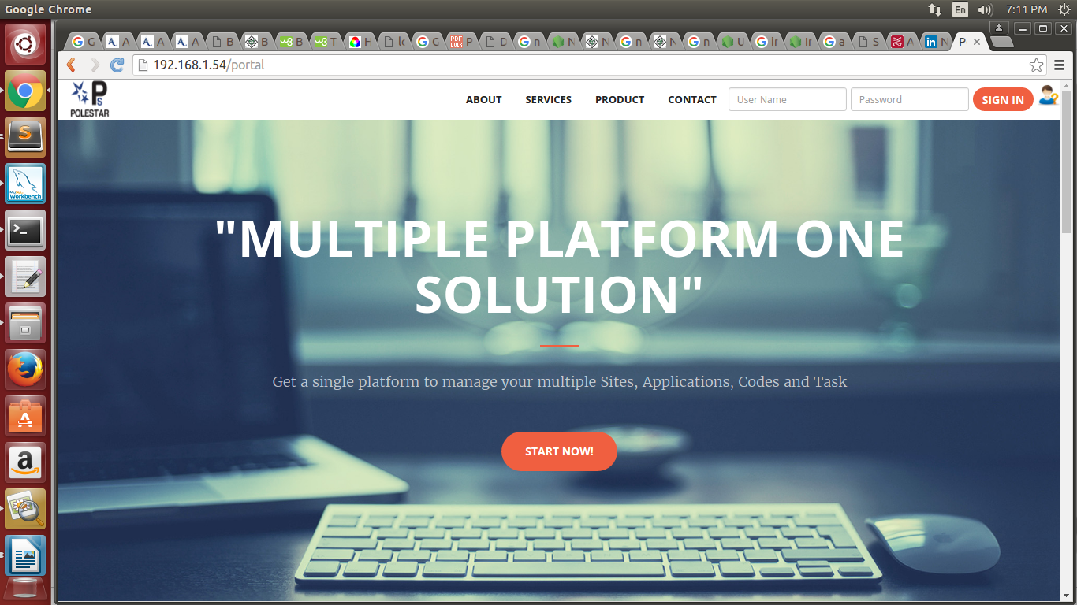

Figure 8.1 : Login Page

## 8.2 Home Page:

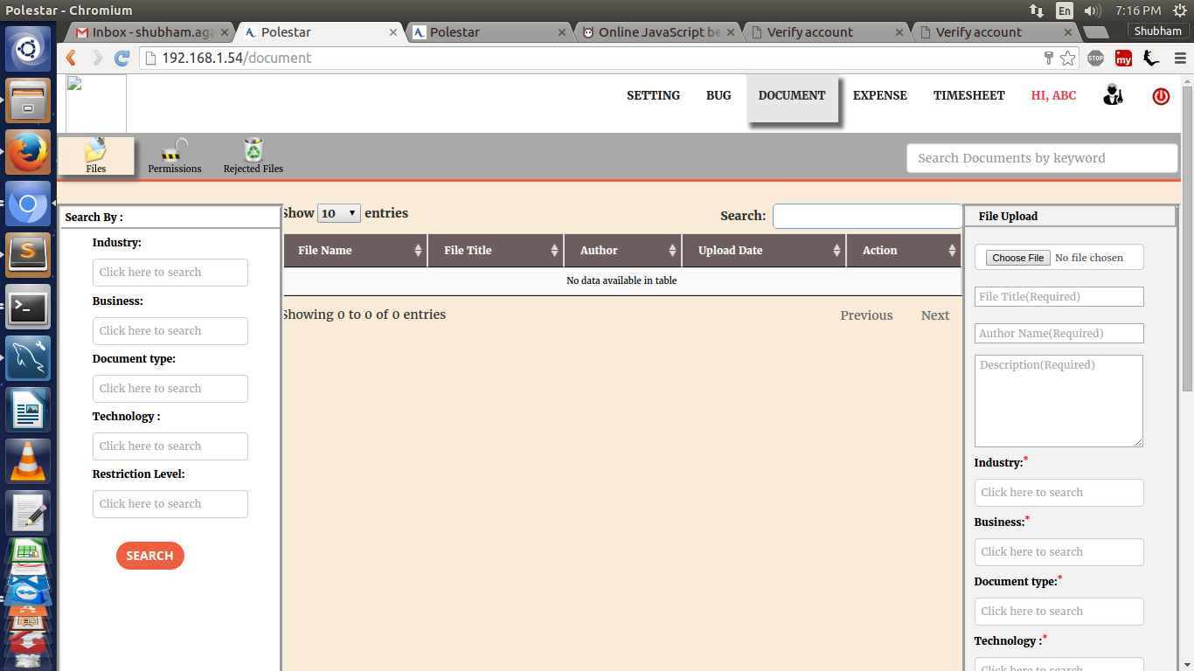

Figure 8.2 : home page

**8.3 Permission Page**

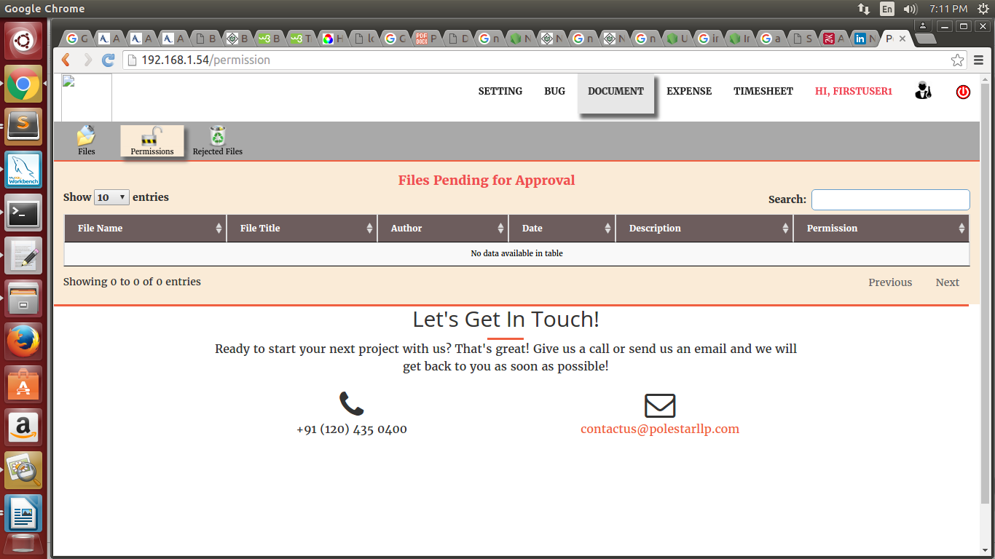

**4**

Figure 8.3 : Permission Page

**8.4 Rejected Files page**

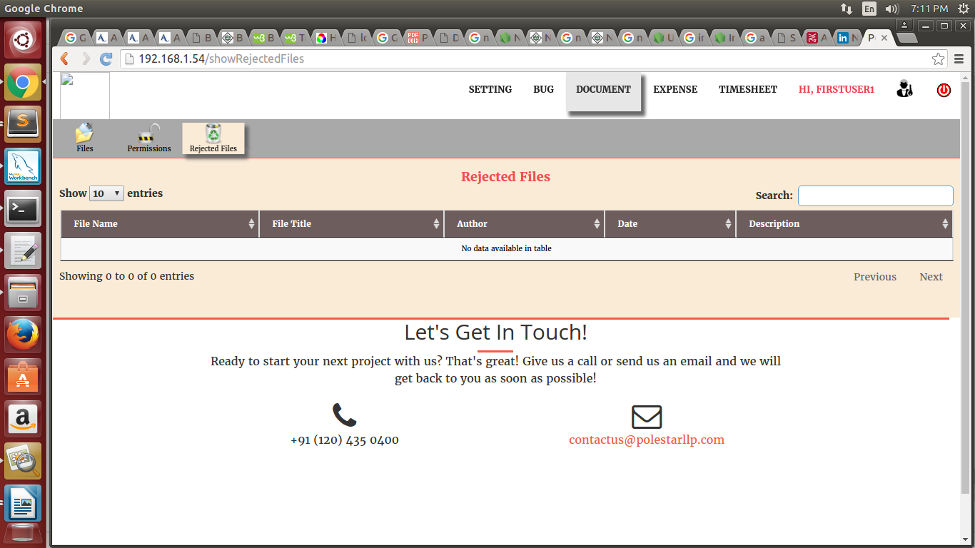

Figure 8.4 : Rejected page

**CHAPTER 9**

# CONCLUSION

**9. 1. CONCLUSION**

The project entitled DOCUMENT MANAGEMENT SYSTEM is done in an effective manner. Document Management System is an efficient, time saving and easy way to report, view and control the version of a file. All the operations are done efficiently. To use one, start by registering a collection of source files — that is, telling your DMS to start archive files describing their change histories. Thereafter, when you want to edit one of these files, you have to check out the file — assert an exclusive lo ck on it. When you're done, you check in the file, adding your changes to the archive, releasing the lock, and entering a change comment explaining what you did.

**9.2 FUTURE ENHANCEMENT**

As a future venture, it is suggested to make some changes to provide more services and information at right time in right manner.

# REFRENCES

* For Nodejs installation -https://www.nodejs.com
* For Mysql Database installation -http://www.mysql.com/index.html
* www.w3schools.com
* http://www.tutorialspoint.com
* www.google.com