A Project Report on
CREATION OF SORTING VISUALIZER USING WEB TECHNOLOGIES
Submitted in the partial fulfilment of the requirements for the Summer Internship of

BACHELOR OF TECHNOLOGY
In

INFORMATION TECHNOLOGY

Submitted by

Bh. Jaya Krishna Sri 19071A12C6
B. Meghana 19071A12C9
K. Mamatha Patil 19071A12E2
Sk. Afreen 19071A12G8



DEPARTMENT OF INFORMATION TECHNOLOGY

VNR Vignana Jyothi Institute of Engineering & Technology
(Autonomous Institute, Accredited by NAAC with ‘A++’ grade and NBA)
Bachupally, Nizampet (S.O.) Hyderabad- 500 090

February 2022

A Project Report on
CREATION OF SORTING VISUALIZER USING WEB TECHNOLOGIES
Submitted in the partial fulfilment of the requirements for the
Summer Internship of

BACHELOR OF TECHNOLOGY
In

INFORMATION TECHNOLOGY

Submitted by

Bh. Jaya Krishna Sri 19071A12C6
B. Meghana 19071A12C9
K. Mamatha Patil 19071A12E2
Sk. Afreen 19071A12G8

Under the esteemed guidance of


PROJECT GUIDE
Mrs. S. Swathi
Assistant Professor,
Dept. of Information Technology,
VNRVJIET

DEPARTMENT OF INFORMATION TECHNOLOGY

VNR Vignana Jyothi Institute of Engineering & Technology
(Autonomous Institute, Accredited by NAAC with ‘A++’ grade and NBA)
Bachupally, Nizampet (S.O.) Hyderabad- 500 090
February 2022

VNR Vignana Jyothi Institute of Engineering & Technology
Autonomous Institute, Accredited by NAAC with ‘A++’ grade and
NBA) Bachupally, Nizampet (S.O.) Hyderabad- 500 090
Department of Information Technology

Date: February 2022


CERTIFICATE
This is to certify that the project work entitled “CREATION OF SORTING VISUALIZER USING WEB TECHNOLOGIES” is being submitted by Bh. Jaya Krishna Sri (19071A12C6), B. Meghana (19071A12C9), K. Mamatha Patil (19071A12E2), Sk. Afreen (19071A12G8) in partial fulfilment for the award of Degree of BACHELOR OF TECHNOLOGY in INFORMATION TECHNOLOGY to the Jawaharlal Nehru Technological University, Hyderabad during the academic year 2021-22 is a record of bona-fide work carried out by them under our guidance and supervision.
The results embodied in this report have not been submitted by the students to any other University or Institution for the award of any degree or diploma.

Project Guide | Head of Department
Mrs. S. Swathi, | Dr. D. Srinivasa Rao,
Assistant Professor, | Head of Department,
Dept. of IT, | Dept. of IT,
VNRVJIET, | VNRVJIET,
Hyderabad. | Hyderabad.

VNR Vignana Jyothi Institute of Engineering & Technology
Autonomous Institute, Accredited by NAAC with ‘A++’ grade and NBA) Bachupally, Nizampet (S.O.) Hyderabad- 500090.

Department of Information Technology

Date: February 2022

DECLARATION

I hereby declare that the project entitled “Creation of Sorting Visualizer using Web Technologies” submitted for the B.Tech Degree is my original work and the project has not formed the basis for the award of any degree, associate ship, fellowship or any other similar titles.

Signature of the Student:

Bh. Jaya Krishna Sri B. Meghana K. Mamatha Patil Sk. Afreen
(19071A12C6) (19071A12C9) (19071A12E2) (19071A12G8)

Place: Hyderabad
Date: February 2022

ACKNOWLEDGEMENT

We express our deep sense of gratitude to our beloved President, Daggubati Suresh Babu, VNR Vignana Jyothi Institute of Engineering &Technology for the valuable guidance and for permitting us to carry out this project.

With immense pleasure, we record our deep sense of gratitude to our beloved Principal, Dr.C.D.Naidu for permitting us to carry out this project.

We express our deep sense of gratitude to our beloved professor Dr.D.Srinivasa Rao, Associate Professor and Head, Department of Information Technology, VNR Vignana Jyothi Institute of Engineering & Technology, Hyderabad-90 for the valuable guidance and suggestions, keen interest and through encouragement extended throughout period of project work.

We take immense pleasure to express our deep sense of gratitude to our beloved Guide
Mrs. S. Swathi, Assistant Professor in Information Technology, VNR Vignana Jyothi Institute of Engineering & Technology, Hyderabad, for his valuable suggestions and rare insights, for constant source of encouragement and inspiration throughout my project work.

We express our thanks to all those who contributed for the successful completion of our project work.

- BH. JAYA KRISHNA SRI - _______________________
- B. MEGHANA - _______________________
- K. MAMATHA PATIL - _______________________
- SK. AFREEN - _______________________

A Project Report on
CREATION OF SORTING VISUALIZER USING WEB TECHNOLOGIES
Submitted in the partial fulfilment of the requirements for the
Summer Internship of

BACHELOR OF TECHNOLOGY
In

INFORMATION TECHNOLOGY

Submitted by

BH. JAYA KRISHNA SRI 19071A12C6

Under the esteemed guidance of


PROJECT GUIDE
Mrs. S. Swathi
Assistant Professor,
Dept. of Information Technology,
VNRVJIET

DEPARTMENT OF INFORMATION TECHNOLOGY

VNR Vignana Jyothi Institute of Engineering & Technology
(Autonomous Institute, Accredited by NAAC with ‘A++’ grade and NBA)
Bachupally, Nizampet (S.O.) Hyderabad- 500 090

February 2022

A Project Report on
CREATION OF SORTING VISUALIZER USING WEB TECHNOLOGIES
Submitted in the partial fulfilment of the requirements for the
Summer Internship of

BACHELOR OF TECHNOLOGY
In

INFORMATION TECHNOLOGY

Submitted by

B. MEGHANA 19071A12C9

Under the esteemed guidance of


PROJECT GUIDE
Mrs. S. Swathi
Assistant Professor,
Dept. of Information Technology,
VNRVJIET

DEPARTMENT OF INFORMATION TECHNOLOGY

VNR Vignana Jyothi Institute of Engineering & Technology
(Autonomous Institute, Accredited by NAAC with ‘A++’ grade and NBA)
Bachupally, Nizampet (S.O.) Hyderabad- 500 090

February 2022

A Project Report on
CREATION OF SORTING VISUALIZER USING WEB TECHNOLOGIES
Submitted in the partial fulfilment of the requirements for the
Summer Internship of

BACHELOR OF TECHNOLOGY
In

INFORMATION TECHNOLOGY

Submitted by

K. MAMATHA PATIL 19071A12E2

Under the esteemed guidance of


PROJECT GUIDE
Mrs. S. Swathi
Assistant Professor,
Dept. of Information Technology,
VNRVJIET

DEPARTMENT OF INFORMATION TECHNOLOGY

VNR Vignana Jyothi Institute of Engineering & Technology
(Autonomous Institute, Accredited by NAAC with ‘A++’ grade and NBA)
Bachupally, Nizampet (S.O.) Hyderabad- 500 090

February 2022

A Project Report on
CREATION OF SORTING VISUALIZER USING WEB TECHNOLOGIES
Submitted in the partial fulfilment of the requirements for the
Summer Internship of

BACHELOR OF TECHNOLOGY
In

INFORMATION TECHNOLOGY

Submitted by

SK. AFREEN 19071A12G8

Under the esteemed guidance of


PROJECT GUIDE
Mrs. S. Swathi
Assistant Professor,
Dept. of Information Technology,
VNRVJIET

DEPARTMENT OF INFORMATION TECHNOLOGY

VNR Vignana Jyothi Institute of Engineering & Technology
(Autonomous Institute, Accredited by NAAC with ‘A++’ grade and NBA)
Bachupally, Nizampet (S.O.) Hyderabad- 500 090

February 2022

S No. | Content | Page no.
1 | Chapter-1
 | Abstract | 01
2 | Chapter-2
 | Introduction | 02
3 | Chapter-3
 | Analysis
3.1 | Literature Survey | 03
3.2 | Problem Statement | 04
3.3 | Proposed Method | 05
3.4 | Software Requirements | 06
3.5 | Hardware Requirements | 06
4 | Chapter-4
 | Designing | 07
4.1 | Flow of the system | 08
5 | Chapter-5
 | Implementation
5.1 | Implementation steps | 09
5.2 | Code Snippets | 13
5.3 | Results | 25
6. | Chapter-6
 | Conclusion | 28
 | Future Scope | 29
 | References | 30
INDEX

Chapter-1
ABSTRACT
The main objective of this project is to help beginners to be able to visualize the basic algorithms and get a better understanding of the underlying operations. This project sorting
visualizer is a very simple UI and it allows the users to select the sort algorithm, select the array size, and speed of the visualization. We created the website's User Interface (UI) using HTML, CSS and enhancing it further using Bootstrap; without actually implementing any of the app's core features. Implementation of animations, effects and core functionalities (sorting algorithms) was done using JavaScript. Async, Await functions and promises of JavaScript were used.

Chapter-2
INTRODUCTION
Sorting is a very classic problem of reordering items of an array (or a list) in a certain order (increasing, non-decreasing, decreasing, non-increasing, lexicographical, etc). We have learnt sorting algorithms like bubble sort, selection sort, insertion sort, quick sort. But often we fail to understand the core idea of a particular algorithm, maybe because we are unable to visualize how they work. So, visualization plays an important role in understanding these algorithms. The created website can be viewed on various devices of different sizes. It is user friendly and has various inbuilt website control features like size of the input, speed of the display, displaying of time complexities of the chosen algorithm etc. Algorithms are organized for the better understanding of the beginners. Better visualization of the website is obtained using certain graphical structures.

Chapter-3
ANALYSIS
3.1 Literature Survey
Sorting is one of the well-understood and widely-used interaction techniques. Sorting has been adopted in many software applications and supports various cognitive tasks. However, when used in analysing multi-attribute data in a table, sorting appears to be limited. When a table is sorted by a column, it rearranges the whole table, so the insights gained through the previous sorting arrangements of another column are often difficult to retain. Thus, this study proposed an alternative interaction technique, called “Sorting Visualizer.” By sorting all of the columns simultaneously, it helps users see an overview of the data at a glance. Additional interaction techniques, such as highlighting and zooming, were also employed to alleviate the drawbacks of Sorting Visualizer. A within-subject controlled study with 15 participants was conducted to compare Sorting Visualizer and the typical sorting feature. The results showed typical sorting and Sorting Visualizer work with comparable efficiency and effectiveness for most of the tasks. Sorting more effectively supports understanding correlation and reading corresponding values, and Sorting Visualizer shows the potential to more effectively support tasks that need multi-attribute analyses. The implications of the results and planned future work are discussed as well.

3.2 Problem Statement
Our Problem statement is “Creation of Sorting Visualizer using Web Technologies”. We decided to implement five sorting techniques namely Bubble sort, Insertion sort, Selection sort, Merge sort and Quick sort.
Bubble Sort – Bubble Sort is the simplest sorting algorithm that works by repeatedly swapping the adjacent elements if they are in wrong order.
Insertion Sort - Insertion sort is a simple sorting algorithm that works similar to the way you sort playing cards in your hands. The array is virtually split into a sorted and an unsorted part. Values from the unsorted part are picked and placed at the correct position in the sorted part.
Selection Sort – The selection sort algorithm sorts an array by repeatedly finding the minimum element (considering ascending order) from unsorted part and putting it at the beginning. The algorithm maintains two subarrays in a given array.
1) The subarray which is already sorted.
2) Remaining subarray which is unsorted.
In every iteration of selection sort, the minimum element (considering ascending order) from the unsorted subarray is picked and moved to the sorted subarray.
Merge Sort – Merge Sort is a Divide and Conquer algorithm. It divides the input array into two halves, calls itself for the two halves, and then merges the two sorted halves. The merge() function is used for merging two halves. The merge(arr, l, m, r) is a key process that assumes that arr[l..m] and arr[m+1..r] are sorted and merges the two sorted sub-arrays into one.

Quick Sort – Quick Sort is a Divide and Conquer algorithm. It picks an element as pivot and partitions the given array around the picked pivot. There are many different versions of quickSort that pick pivot in different ways. The key process in quickSort is partition(). Target of partitions is, given an array and an element x of array as pivot, put x at its correct position in sorted array and put all smaller elements (smaller than x) before x, and put all greater elements (greater than x) after x. All this should be done in linear time.

3.3 Proposed System
The proposed system involves the simulation of the different type of sorting algorithms codes. The scope has its limitations. Only 5 types of sorting algorithms codes are created which are bubble sort, insertion sort, selection sort, merge sort and quick sort. Only the software application development began with desktop applications used in this project, it is a responsive website and can be viewed on a mobile, PC and Tablet. Once the synthesize and simulation of the codes for the software application have been run, the following animations will show how successfully data sets from distinct unsorted data can be sorted using distinct algorithms.

3.4 Software Requirements
The following software was used for the implementation of the system:
- Windows 10
- Visual Studio Code with Live Server extension

3.5 Hardware Requirements
The following hardware was used for the implementation of the system:
- 4 GB RAM
- 10GB HDD
- Intel 1.66 GHz Processor Pentium 4

Chapter-4
DESIGNING
The main goal of this project is to design a system for sorting algorithm visualization as well as investigating and visualizing the best and worst case for each implemented sorting algorithm. The software which has been used in this system is Visual Studio Code. JavaScript language is used to develop the algorithm visualization. For the JavaScript code here, different methods like ‘Async’, ‘Await’ and ‘Promises’ are used as a method can be used many times in the program by call by method. It is reusable and the program will become more readable. After the sorting algorithms codes have been written and designed, they have been synthesized and simulated in the Visual Studio Code software. Once the synthesize and simulation of the JavaScript codes have been run, the user can choose the types of the sorting algorithm to find the time complexity for the each of the sorting algorithms. The flow chart of designing this sorting algorithm visualization via Visual Studio Code could be seen below.

4.1 Flow of the system:
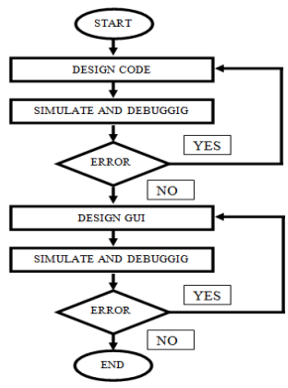

Chapter-5
IMPLEMENTATION
This section provides knowledge about the implementation environment and throws light on the actual steps for the implementation of algorithms to get better accuracy of visualization by using different JavaScript methods.

5.1 Implementation steps:
In this section we shall discuss about the actual steps which were implemented while doing the experiment. We shall explain the stepwise procedure used to sort the data.
The system consists of the following main steps:
While there are a large number of sorting algorithms, in practical implementations some algorithms predominate. Insertion sort is widely used for small datasets, whereas for large datasets, an asymptotically efficient sort is used, primarily heap sort, merge sort, or quick sort. Each algorithm uses a different mechanism to sort the data shown in the following Pseudocode:
Bubble Sort(A)
for i ← 1 to length[A]
do for j ← length[A] down to i + 1
do if A[j] < A[j - 1]
then exchange A[j] & A[j - 1]
Insertion Sort(A)
for j ← 2 to length[A]
do key ← A[j]
Insert A[j] into the sorted sequence A[1 : j - 1]. i ← j - 1
while i > 0 and A[i] > key
do A[i + 1] ← A[i] i ← i - 1
A[i + 1] ← key
Selection Sort (A)
for i ← 1 to length[A] – 1
do min ← i
for j ← i + 1 to length[A]
do if A[j] < A[min]
then min ← j
exchange A[i] & A[min]
Mergesort(A, P, R)
if p < r
then q ← (p + r)/2
MERGE-SORT(A, p, q)
MERGE-SORT(A, q + 1, r)
MERGE(A, p, q, r)
Quicksort(A, P, R)
if p < r
then q ← PARTITION(A, p, r)
QUICKSORT(A, p, q - 1)
QUICKSORT(A, q + 1, r)
The strategy of bubble sort is quite simple, however can be quite inefficient. The algorithm iterates through the array, contrast each pair of side by side elements, and if the elements are in the wrong order swaps them.
Insertion sort is another straightforward approach to sorting an array. Insertion sort starts at the beginning of the array and checks each element with the next and swaps them if necessary.
Selection sort is very intuitive and incredibly inefficient. The algorithm starts by creating an empty list to store values as they are sorted from the unsorted array. It then iterates through the entire unsorted array and adds the smallest (or largest) value to the sorted array.
Merge sort is one of the more effective sorting algorithms out there with a time complexity of only O(n log n). The algorithm starts by creating n lists with single values in each list and then proceeds to combine the lists into an array, sorting the values as the lists are combined.
Quick sort uses divide and conquer to pick up an indistinguishable focal points from the merge sort, while not utilizing extra memory. As an exchange off, nonetheless, it is conceivable that the list may not be partitioned into equal parts. At the points when this happens, the execution is reduced.
Solutions to sorting problems have pulled in a lot of research in the current year and in this procedure many sorting algorithms have started enhanced effectiveness. Throughout the year analysts have been contrasting and analyzing the sorting algorithm with decide their applicability to applications.
Below are the screenshots for the better understanding of flow of our implementation steps and the desired results.

The Fig no. 6 and 7 shows the Home Page of our project:





5.2 Code Snippets
Using Bubble Sort:
//heading
let heading = document.querySelector("#heading")
// let stopbtn=document.querySelector(".stop");

//adding eventListener for bubbleSort
let BubbleSortElement = document.querySelector(".BubbleSort");

BubbleSortElement.addEventListener("click",disablefun);
BubbleSortElement.addEventListener("click",BubbleSort);

// let stopbtn=document.querySelector(".stop");
// stopbtn.addEventListener("click",disablefun);
async function enablefun(){
if( i==length1-1)
disablefun();
}
//disable function
async function disablefun(){
const b=document.getElementsByTagName("button")
for(let i=0;i<b.length;i++)
{
b[i].disabled=!b[i].disabled
}
}
let i,j,length1=-1;

async function BubbleSort(){
heading.innerHTML = "Bubble Sort"

id2.innerHTML="Best:O(n) Average : O(n^2) Worst : O(n^2)"
let bars = document.querySelector("#bars")
let length = bars.childNodes.length
length1=length
for(i=0;i<length;i++)
bars.childNodes[i].innerHTML=bars.childNodes[i].style.height
for( i = 0 ; i < length-1 ; i++ ){
for( j = 0 ; j < length-i-1 ; j++ ){
bars.childNodes[j].innerHTML=bars.childNodes[j].style.height
let ele1 = bars.childNodes[j]
let ele2 = bars.childNodes[j+1]
//during comparision
compAnimation(ele1,ele2)
//delay
await delay(ms)
if(parseInt(ele1.style.height) > parseInt(ele2.style.height)){
//swapping
swapAnimation(ele1,ele2)
await delay(ms)
swap(ele1,ele2)

bars.childNodes[j].innerHTML=parseInt(bars.childNodes[j].style.height)

bars.childNodes[j+1].innerHTML=parseInt(bars.childNodes[j+1].style.height)

}
ele1.style.backgroundColor = 'black'
}
bars.childNodes[length-i-1].style.backgroundColor="green"
}enablefun();
bars.childNodes[0].style.backgroundColor="green"

}

Using Insertion Sort
let InsertionSortElement = document.querySelector(".InsertionSort")
InsertionSortElement.addEventListener("click",InsertionSort)
InsertionSortElement.addEventListener("click",disablefun)
async function disablefun(){
const b=document.getElementsByTagName("button")
for(let i=0;i<b.length;i++)
{
b[i].disabled=!b[i].disabled
}
}

async function InsertionSort(){
//heading
heading.innerHTML = "Insertion Sort"
id1.innerHTML=""
id2.innerHTML=" Best : O(n) Average : O(n^2) Worst : O(n^2)"
id3.innerHTML=""
let bars = document.querySelector("#bars")
length = bars.childNodes.length
bars.childNodes[0].style.backgroundColor = 'green'
for(let i = 1 ; i < length ; i++){
let key = bars.childNodes[i].style.height
//display current element
//span.style.height = key
//setKey(parseInt(key))
let j = i-1
// compAnimation(bars.childNodes[i],bars.childNodes[j])
// await delay(ms)
while(j >= 0 && parseInt(key) < parseInt(bars.childNodes[j].style.height)){
bars.childNodes[j].style.backgroundColor='cyan'
await delay(ms)
bars.childNodes[j+1].style.height = bars.childNodes[j].style.height

bars.childNodes[j+1].innerHTML=parseInt(bars.childNodes[j+1].style.height)

//await delay(ms)
bars.childNodes[j].style.height=0+'px'

bars.childNodes[j].innerHTML=parseInt(bars.childNodes[j].style.height)

await delay(ms)
bars.childNodes[j].style.backgroundColor = 'green'
j--
bars.childNodes[i].style.backgroundColor = 'green'
}
for(let k = i ; k >=0 ;k-- )
bars.childNodes[k].style.backgroundColor = 'green'
bars.childNodes[j+1].style.height = key

bars.childNodes[j+1].innerHTML=parseInt(bars.childNodes[j+1].style.height)
console.log(j)

}

disablefun();
}

Using Selection Sort:
let SelectionSortElement = document.querySelector(".SelectionSort")
SelectionSortElement.addEventListener("click",SelectionSort)
SelectionSortElement.addEventListener("click",disablefun)
async function SelectionSort(){
//heading
heading.innerHTML = "Selection Sort"
id1.innerHTML="Best : O(n^2) Average : O(n^2) Worst : O(n^2)"
id2.innerHTML=""
id3.innerHTML=""
let bars = document.querySelector("#bars")
let length = bars.childNodes.length
for(let i = 0 ; i < length - 1 ; i++ ){
let ele1 = bars.childNodes[i]
ele1.style.backgroundColor = 'cyan'
let min = ele1
for(let j = i + 1 ; j < length ; j++ ){
let ele2 = bars.childNodes[j]
ele2.style.backgroundColor = 'red'
await delay(ms)
if(parseInt(ele2.style.height) < parseInt(min.style.height) ){
if(min!=ele1)
min.style.backgroundColor='black'
min = ele2
ele2.style.backgroundColor = 'red'
}
if(ele2!=min)
ele2.style.backgroundColor = 'black'
}
if(ele1!=min)
swapAnimation(ele1,min)
await delay(ms)
swap(ele1,min)
min.style.backgroundColor='black'
ele1.style.backgroundColor = 'green'
}
bars.childNodes[length-1].style.backgroundColor = 'green'

disablefun();
}

Using Merge Sort:
let MergeSortElement = document.querySelector(".MergeSort")

MergeSortElement.addEventListener("click",MergeSort1)
MergeSortElement.addEventListener("click",disablefun)
async function disablefun(){
const b=document.getElementsByTagName("button")
for(let i=0;i<b.length;i++)
{
b[i].disabled=!b[i].disabled
}
}

//heading

async function MergeSort1(){

heading.innerHTML = "Merge Sort"
id1.innerHTML=""
id2.innerHTML="Best : O(nlog(n)) Average : O(nlog(n)) Worst : O(nlog(n))"
id3.innerHTML=" "
let bars = document.querySelector("#bars")
length = bars.childNodes.length;
let l=0;
let r=length-1;

await MergeSort(bars,l,r);
disablefun();
}

async function MergeSort(bars,l,r)
{
if(l>=r){

return;
}
const m=Math.floor((r+l)/2);
await MergeSort(bars,l,m);
await MergeSort(bars,m+1,r);
await Merge(bars,l,m,r);
}

async function Merge(bars,l,m,r)
{
const n1=m-l+1;
const n2=r-m;
let left=[]
let right=[]

for(let i=0;i<n1;i++)
{
await delay(ms);
bars.childNodes[l+i].style.backgroundColor='crimson';
left[i]=bars.childNodes[l+i].style.height;
}
for(let i=0;i<n2;i++)
{
await delay(ms);
bars.childNodes[m+i+1].style.backgroundColor='crimson';
right[i]=bars.childNodes[m+1+i].style.height;
}
await delay(ms);

let i=0,j=0,k=l;
while(i<n1 && j<n2)
{
await delay(ms);
if(parseInt(left[i])<parseInt(right[j]))
{
bars.childNodes[k].style.backgroundColor = 'green';
bars.childNodes[k].style.height=left[i];
bars.childNodes[k].innerHTML=parseInt(bars.childNodes[k].style.height)
i++;
k++;
}else
{
{
bars.childNodes[k].style.backgroundColor = 'green';
bars.childNodes[k].style.height=right[j];

bars.childNodes[k].innerHTML=parseInt(bars.childNodes[k].style.height)

j++;
k++;
}

}

}
while(i<n1)
{
await delay(ms);

bars.childNodes[k].style.backgroundColor='green';
bars.childNodes[k].style.height=left[i];
bars.childNodes[k].innerHTML=parseInt(bars.childNodes[k].style.height)
i++;
k++;
}

while(j<n2)
{
await delay(ms);

bars.childNodes[k].style.backgroundColor='green';
bars.childNodes[k].style.height=right[j];
bars.childNodes[k].innerHTML=parseInt(bars.childNodes[k].style.height)
j++;
k++;
}

}

Using Quick Sort:
let QuickSortElement = document.querySelector(".QuickSort")

QuickSortElement.addEventListener("click",QuickSort1)
// QuickSortElement.addEventListener("click",disablefun)
// async function disablefun(){
// const b=document.getElementsByTagName("button")
// for(let i=0;i<b.length;i++)
// {
// b[i].disabled=!b[i].disabled
// }
// }

async function QuickSort1(){
heading.innerHTML = "Quick Sort"
id1.innerHTML=""
id2.innerHTML="Best : O(nlog(n)) Average : O(nlog(n)) Worst : O(n^2)"
id3.innerHTML=""
let bars = document.querySelector("#bars")
let length = bars.childNodes.length
for(let i = 0 ; i < length - 1 ; i++ ){
let ele1 = bars.childNodes[i]
ele1.style.backgroundColor = 'cyan'
let min = ele1
for(let j = i + 1 ; j < length ; j++ ){
let ele2 = bars.childNodes[j]
ele2.style.backgroundColor = 'red'
await delay(ms)
if(parseInt(ele2.style.height) < parseInt(min.style.height) ){
if(min!=ele1)
min.style.backgroundColor='black'
min = ele2
ele2.style.backgroundColor = 'red'
}
if(ele2!=min)
ele2.style.backgroundColor = 'black'
}
if(ele1!=min)
swapAnimation(ele1,min)
await delay(ms)
swap(ele1,min)
min.style.backgroundColor='black'
ele1.style.backgroundColor = 'green'
}
bars.childNodes[length-1].style.backgroundColor = 'green'

disablefun();
}

5.3 Results
Results of Bubble Sort
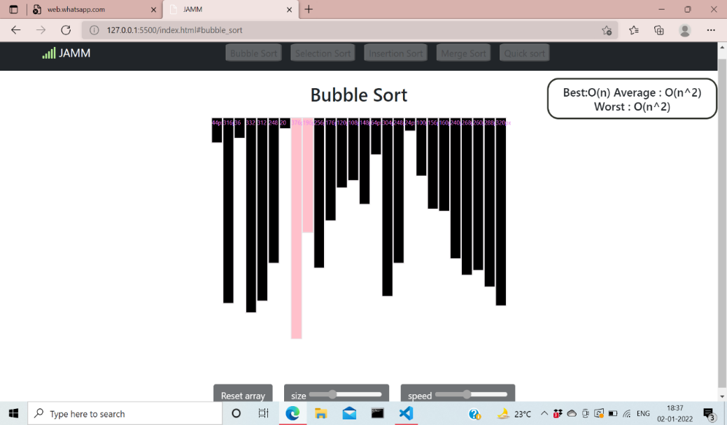

Results of Insertion Sort
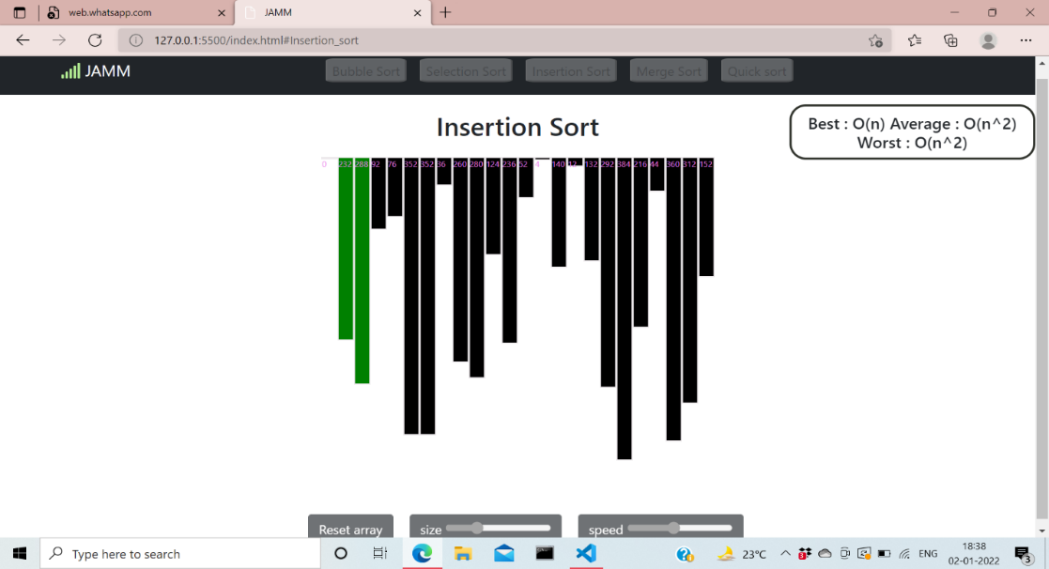

Results of Selection Sort
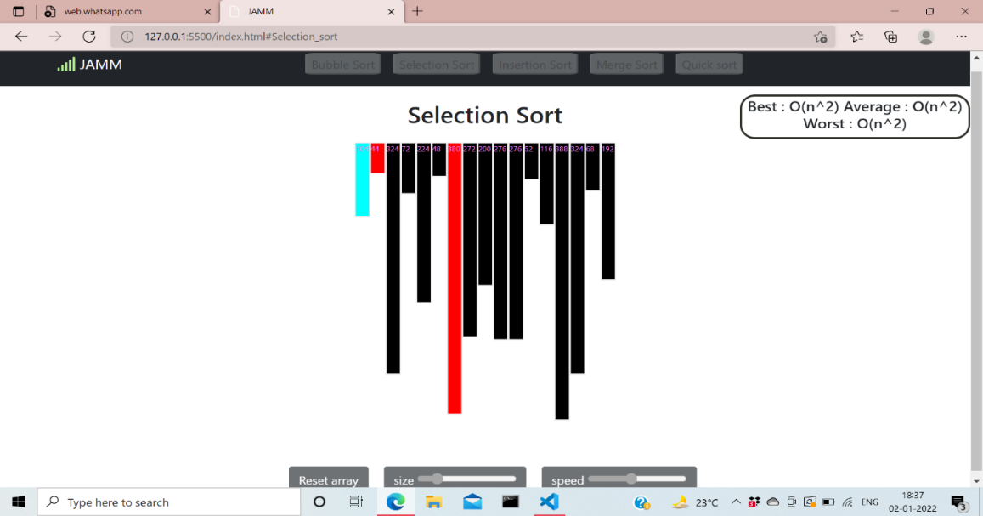

Results of Merge Sort

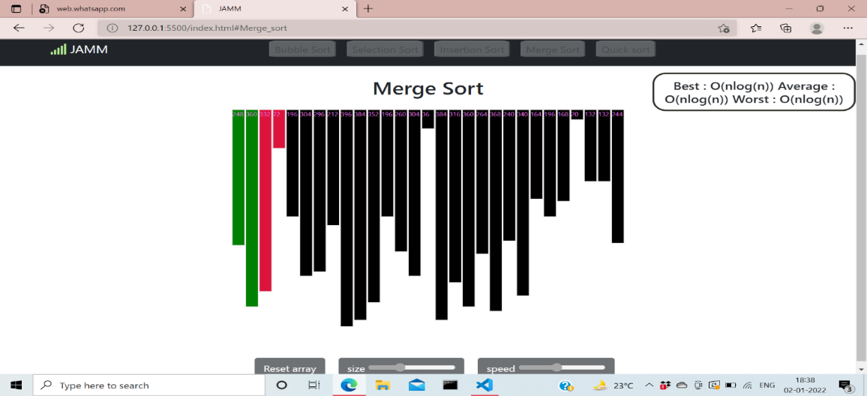

Results of Quick Sort

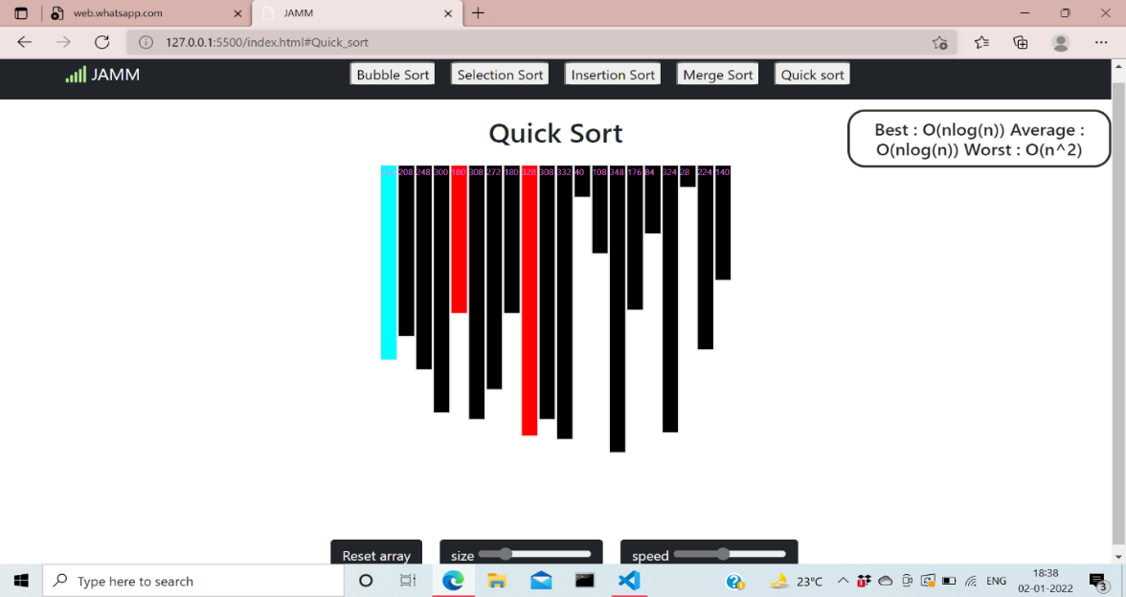

Chapter-6
CONCLUSION

From the results that have been obtained throughout this project, the JavaScript codes of the sorting algorithm user interface were successfully designed, synthesized and analyzed. The sorting algorithm for the JavaScript program has proven that each of the types for sorting algorithm is working precisely. Not only is that, based on the result for run time given by each of the sorting algorithm in line with the theory. This result verified that the half of the objectives for this project have been achieved. This is because this project has animation and visualization for sorting algorithm. As a conclusion, the development of system for algorithms visualization using JavaScript has been successfully made by wanted targets and particulars. Aside from that, this study can be enhanced to make further developed and dependable.
There are some suggestions in order to improve this study. First of all, the design of this sorting algorithm visualization should be further upgraded in order to use as a good teaching tool and able to gain a good understanding of the sorting algorithm for computer science student.
Algorithm visualization can be seen as a valuable supporting tool, used in addition to standard ways of education in the ﬁeld of computer science.

FUTURE SCOPE
Proposed system provides the visualization of Bubble sort, Insertion sort, Selection sort, Merge sort and Quick sort. In future, we can add more algorithms to be visualized where the input can be reset in between the visualization. User input, pause and play can be implemented.

REFERENCES
1.https://abhishekprakash5.github.io/Sorting-Visualization/
- https://www.crio.do/projects/javascript-sorting-visualiser/
- Analysis of different sorting techniques - GeeksforGeeks
- https://www.geeksforgeeks.org/c-program-for-bubble-sort/
- https://www.geeksforgeeks.org/c-program-for-selection-sort/
- https://www.geeksforgeeks.org/c-program-for-insertion-sort/
- https://www.geeksforgeeks.org/c-program-for-quick-sort/
- https://www.geeksforgeeks.org/c-program-for-merge-sort/

