**COURSE CODE**: PRAC3301 Section: BSIT 41020

**COURSE TITLE**: OJT/PRACTICUM 1

**TERM**: 1st Semester, SY 2024-2025

**PROFESSOR**: MR. VINCENT CARLO T. GARADOS

**NAME OF STUDENT**: Jaybie E. Sosmeña

**OJT VIRTUAL NARRATIVE REPORT**

1. **TOPIC**: Introduction to AI and Its Impact
2. **SPEAKER**: Mr. Marc Tonido
3. **DURATION**: 2:45PM-3:45PM
4. **SCREENSHOT OF ATTENDANCE**

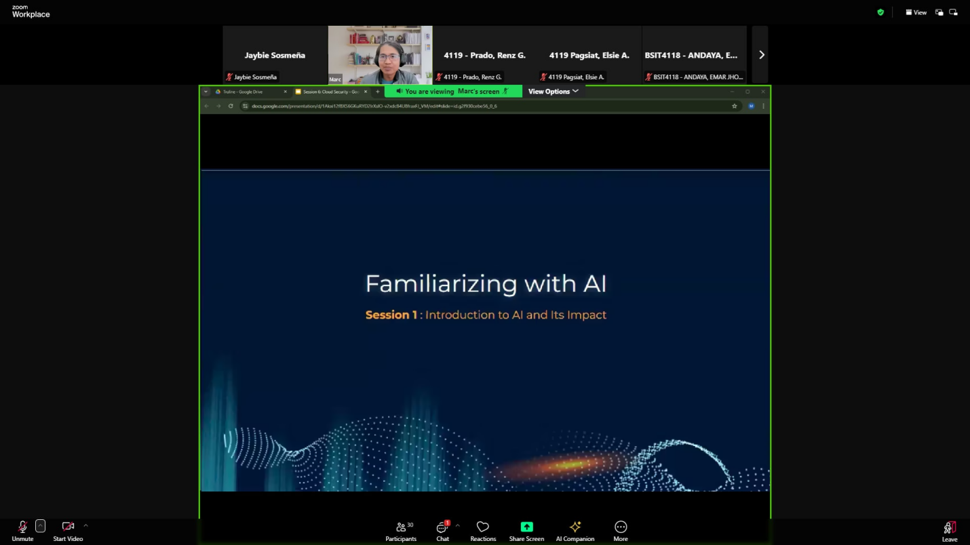

1. **NARRATIVE REPORT**

what i learn about AI, is how it works and what are the useful thinks about AI to make a human make them works faster than manual works, so AI is A Artificial intelligence that a u can see or use in technology like computer, mobile phone etc. Ai help us every single day example of AI help us do work in school, activity and so on. AI can give us more information that we didn't know and we just need to do is ask AI what information that we want to know and AI automatically search that word and it can explain us more easy so that how it works when we want to know something new, and AI can work on machine like robotic i know some factory have AI so some manual work and running using machine with AI, and the work and working smoothly, and current trend is self-driving cars that already implement in others country and some drones, self drive has build it with AI when the drives want to rest, the driver can do automatically the drive using AI, and he just need to do is rest in his sit, and do AI do the drive that is one of cool stuff can AI do to our technology, and i know that they already make some drones upgrade and use for battles or they use for army purpose's and so on. and if AI implement in hiring post job this can lead to problem to people like this can have discrimination in finding people for the position they looking for, like AI only find the people that suit to their company so this make people think that the AI is going to take their job in the future so its like they reduce manual job and only automatic machine that going to work, its good to have AI in our daily lives but its not good to replace manual job to AI because if that happens its not going to balance for the people that need some money for they lives too.