**COURSE CODE**: PRAC3301 Section: BSIT 41020

**COURSE TITLE**: OJT/PRACTICUM 1

**TERM**: 1st Semester, SY 2024-2025

**PROFESSOR**: MR. VINCENT CARLO T. GARADOS

**NAME OF STUDENT**: Jaybie E. Sosmeña

**OJT VIRTUAL NARRATIVE REPORT**

1. **TOPIC**: CYBERSECURITY SESSION 8: ADVANCED TECHNIQUES FOR SECURING WEB APPLICATIONS
2. **SPEAKER**: Mr. Marc Tonido
3. **DURATION**: 2:45pm-3:45pm
4. **SCREENSHOT OF ATTENDANCE**

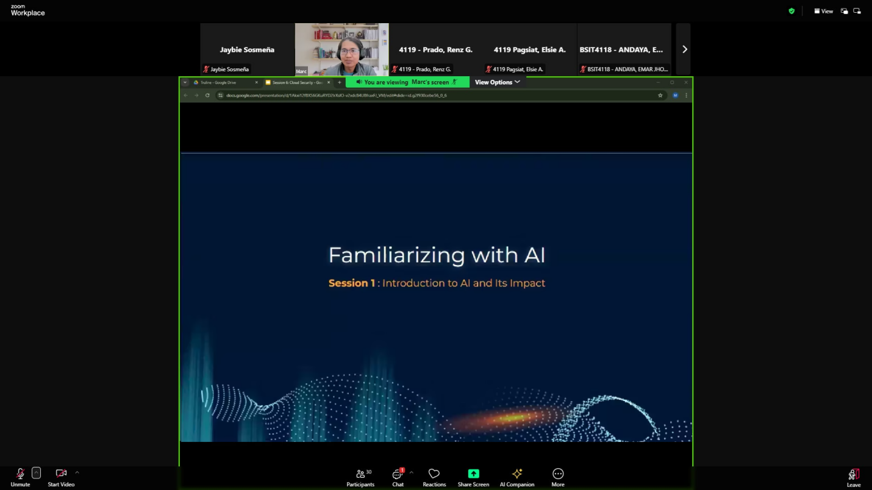

1. **NARRATIVE REPORT**

Exploring advanced techniques for securing web applications was incredibly insightful and practical! The idea of "Security by Design" really stood out to me it’s all about proactively incorporating security measures from the start, like threat modeling and following secure coding standards. It makes perfect sense that addressing vulnerabilities early on saves both time and money in the long run.I also found the role of Web Application Firewalls WAFs fascinating; they work like security guards for your application, blocking malicious requests before they can cause any damage. Learning about secure API design highlighted just how critical it is to safeguard access points, as they’re often prime targets for attacks.Advanced authentication methods like multi-factor authentication MFA and password-less options also stood out as essential in today’s cybersecurity landscape. It’s clear that staying proactive with continuous monitoring and having strong incident response plans is non-negotiable.Overall, this session was a powerful reminder that security isn’t a one-time effort—it’s an ongoing mindset that’s essential for keeping web applications secure.