Immersive UV Visual Stimulus Platform

Jay Borseth 2013.12.04

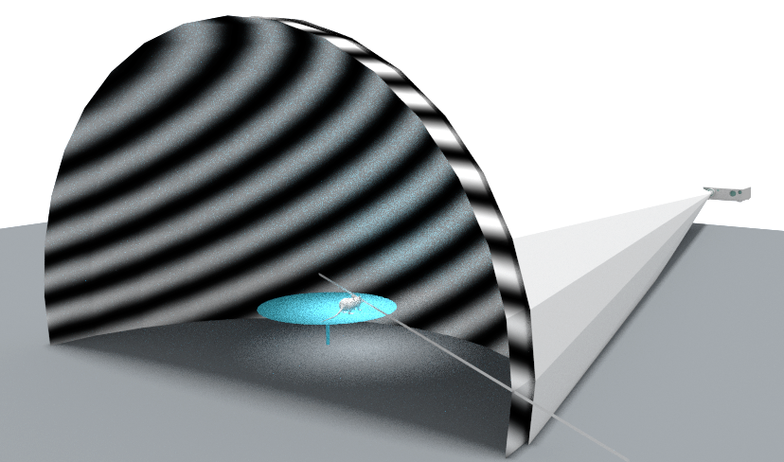

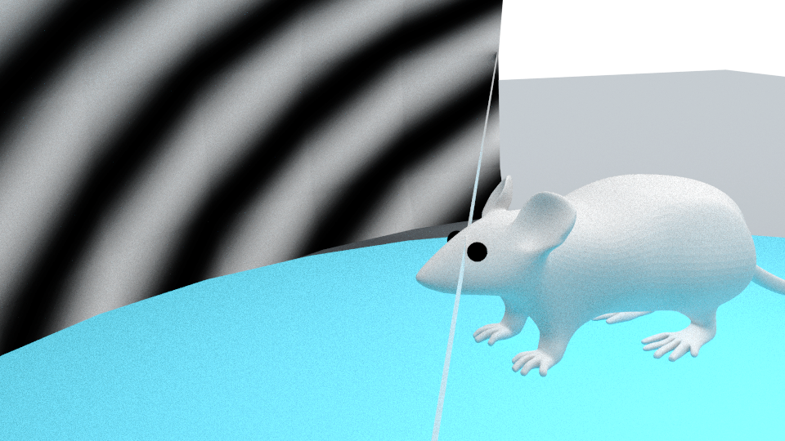

## 24” Dome, No Mirrors

* Dome diameter : 24”
* Eye to dome: 11.2 cm
* 240 degree stimulation
* Dome to lens: 39.8” assuming LightCrafter 4500

## 24” Dome, single mirror

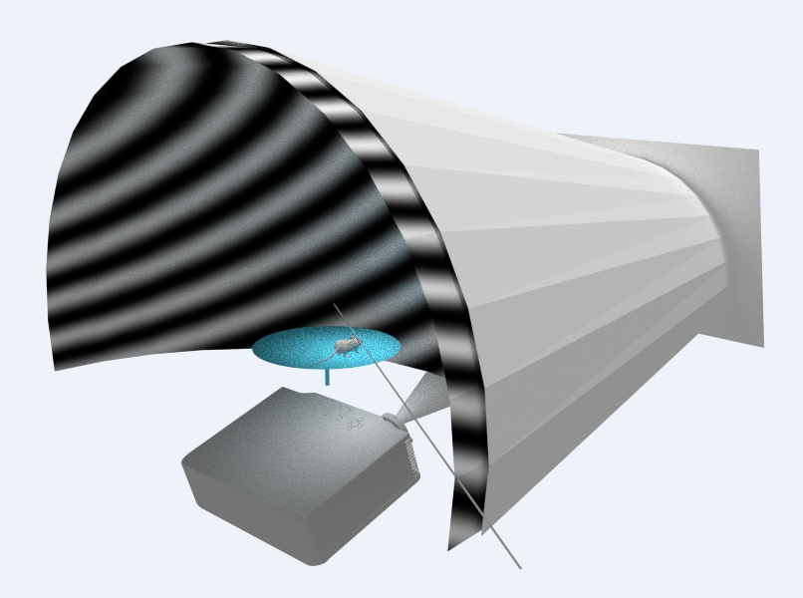

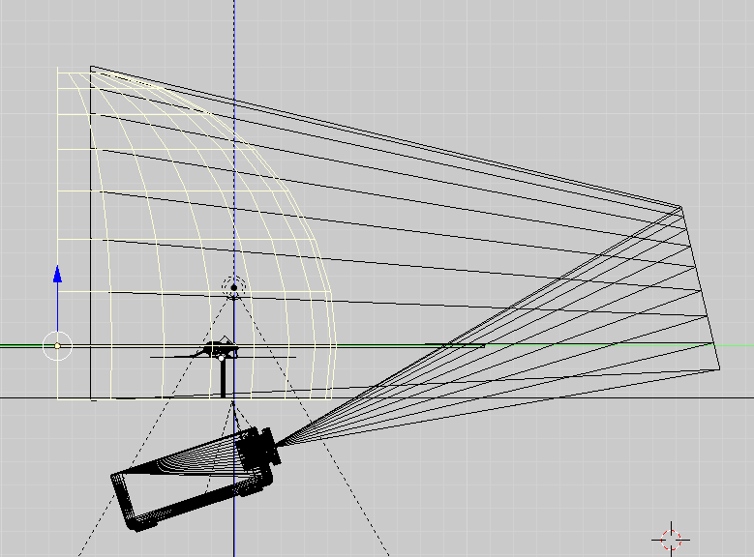

Folded light path: 29” deep (green) x 24”high (blue) x 24” wide

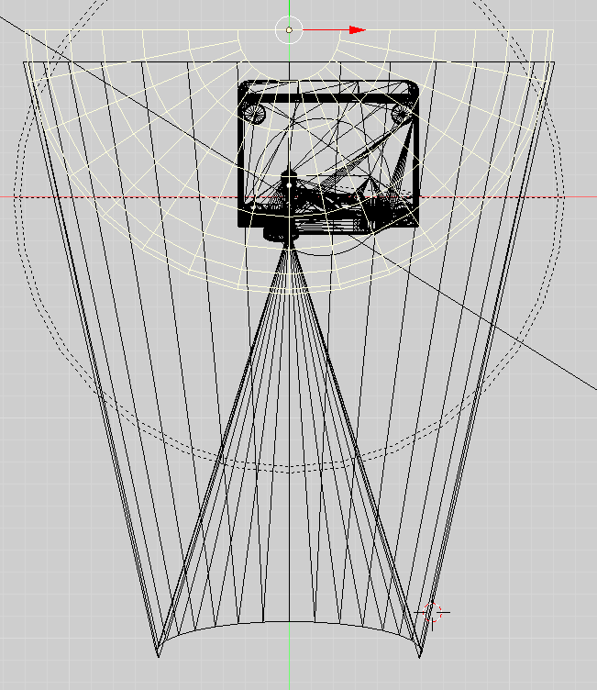

## Multiple mirrors with 12” / 18” dome

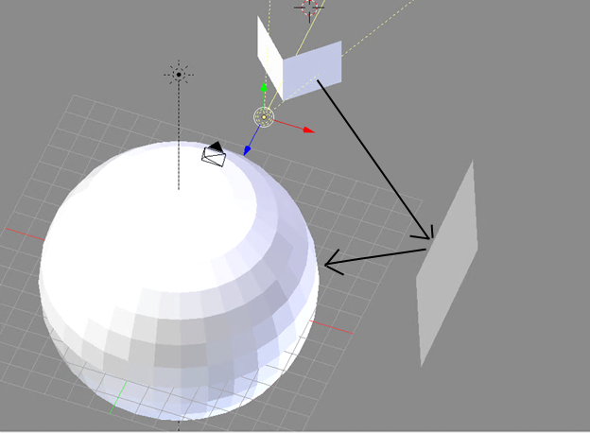

### Projection Issues

Will the image be in focus over the entire surface since the light path lengths differ? General Characteristics

## Two eye stimulus

* 240 degree visual stimulus
* 270 degree visual stimulus

## Spatial resolution

* 6 pixels per degree at equator of dome   
  1080x1080 @180 degrees
* 5 pixels per degree at equator of dome   
  LCr4500 912x912 @180 degrees
* 3.3 pixels per degree at equator of dome   
  LCr3000 608x684 @180 degree

## Bits per pixel

* 8 bits (implies higher end DLP chips)
* 7 bits (lower end DLP chips)

## Mouse platform

* Air bearing sphere
* Wheel

## Mouse eye sensitivity

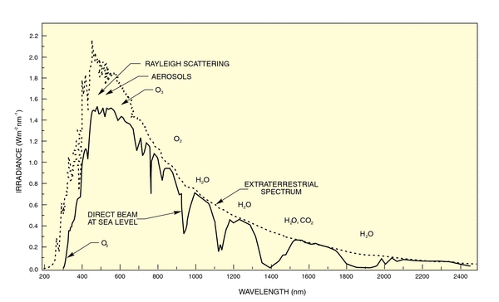

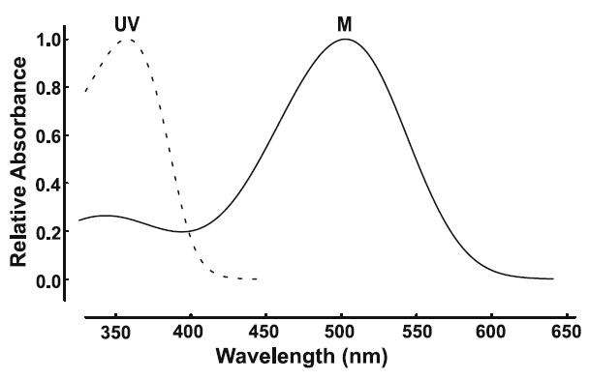 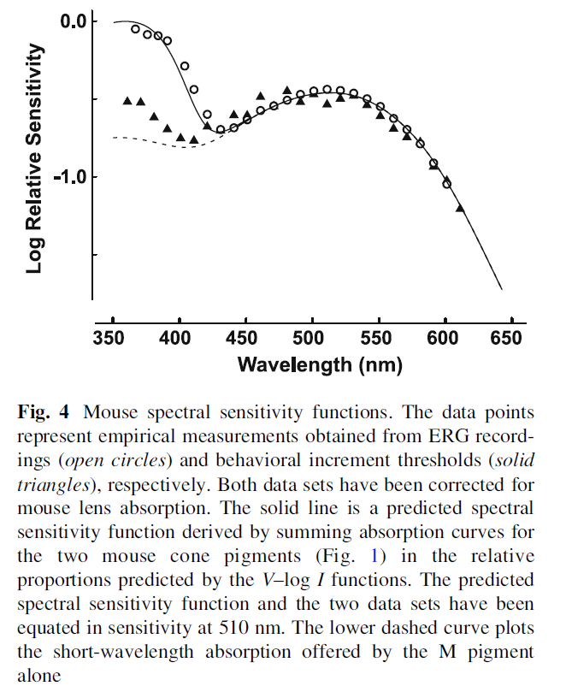

## Visual Channels

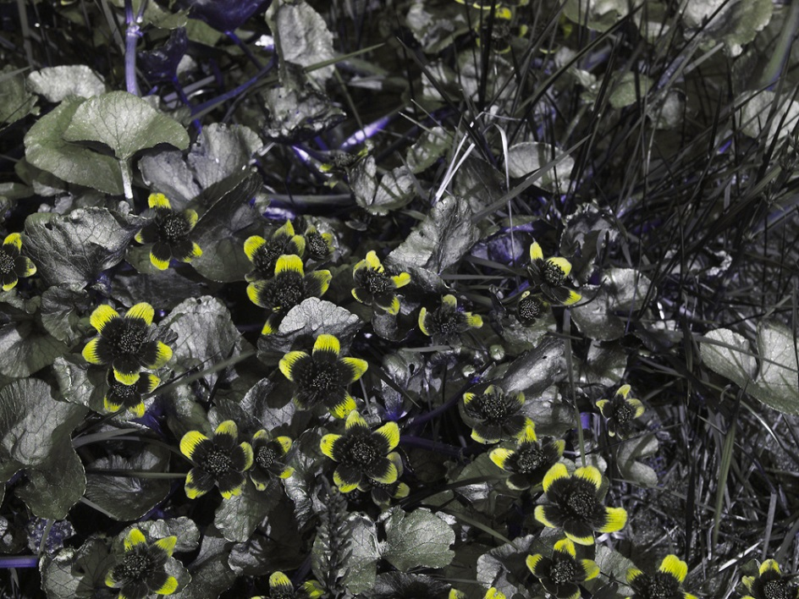

*C. palustris*  Panasonic GH-2, Coastal Optics 60 mm f/4 APO lens, daylight.

* One channel (UV & green together)
* Two channels (UV & green separate)
* Three channels (UV, blue, green)
* If only one channel, what is the relative proportion of UV/Green?
* If color source imagery is used, what is the mapping to monochrome?  
  Y = 0.2126 R + 0.7152 G + 0.0722 B (NTSC)

## Typical Dome plastics

MC is the most common Plexiglas.

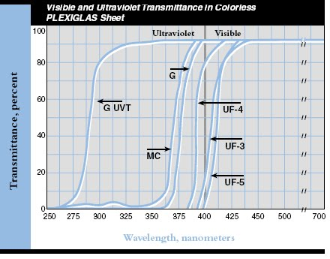

<http://www.cleardome.com/domes.htm> uses a comparable plastic called Acrylite FF which looks like:

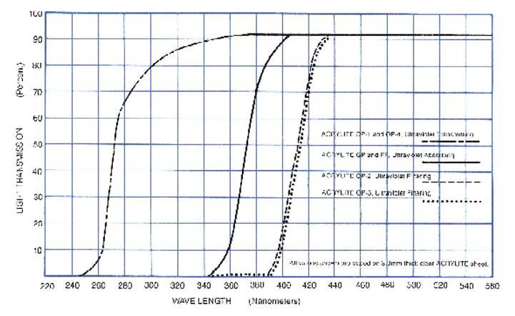

Solid line upwards at 340nm is Acrylite FF

## Light source

* Broad spectrum stimulus (Xenon lamp)

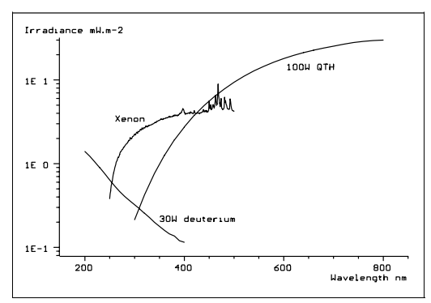

* Narrow spectrum (LEDs)

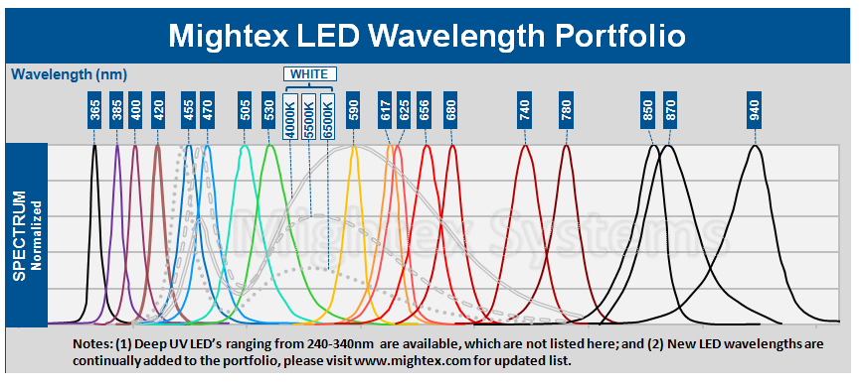

* Brightness range: maximum brightness of 20 mCd/m2

# Stimulus

## Framerate

* 60 Hz
* 120 Hz
* 180 Hz

## Movie Playback

* 60 Hz
* 120 Hz
* 180 Hz

## Patterns and Stimulus

* Grayscale Gradients
* Color Gradients / Objects
* Object scaling size to simulate depth
* Object occlusion
* Maximum number of objects displayed simultaneously
* 3D

# DLP

## Chipsets and Maximum Pattern Rates

Machine generated alternative text: Portfolio Overview
DLP Chipset Chipset Array Size Micromirror Micromirror Pitch Maximum Pattern
Components Orientation (pm) Rates
0.3 WVGA DLP3000 608x684 Diamond 7.6 4,000 Hz (binary)
DLPC300 120 Hz (8-bd)
0.45 WXGA DLP4500 912x1140 Diamond 7.6 4,225 Hz (binary)
DLPC35O 120 Hz (8-bd)
0.55 XGA DLP5500 1024x768 Orthogonal 10.8 5,000 Hz (binary)
DLPC200 120 Hz (8-bit)
DLPA200
0.7 XGA DLP7000 1 024x768 Orthogonal 13.6 32,552 Hz (binary)
DLPC41O 1,900Hz(8-bit)
DLPR41 O
DLPA200
0.95 1080p DLP9500 1920x1080 Orthogonal 10.8 23,148 Hz (binary)
DLPC41O 1,700 Hz (8-bd)
DLPR41 O
DLPA200 (x2)

### DLP and UV

Problems with UV and DLP devices

* In many non-UV designed system there is a plastic lens called the “fly eye” in the light path which will yellow after just a day of high UV exposure.
* Gas used between the cover and DLP mirrors acts as a lubricant for DLP mirrors and “thickens” with UV exposure. When it gets thick, the mirrors stop moving.

## Hardware Options

### LC3000-PRO DLP Pico Projector with UV LED DLP Pico

$1450

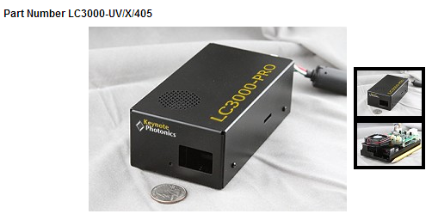

<http://keynotephotonics.3dcartstores.com/LC3000-PRO-DLP-Pico-Projector-with-UV-LED-DLP-Pico-Projector_p_48.html>

* 0.3” DLP
* ProjectorThrow ratio = 1.66
* Focus range 364mm to 2169mm (85.39 inches)
* width = distance / throw ratio
* 12” dome, dome to lens is 19”
* 18” dome, dome to lens is 29.88”
* 24” dome, dome to lens is 39.84”

#### Issues

* 120 Hz @ 8-bits, 180 Hz @ 7-bits CONFIRM!!!

### LightCrafter 4500

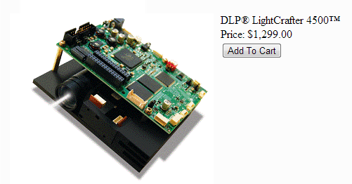

* 0.45” DLP
* Throw ratio = 1.66
* Focus range 300mm to infinity
* width = distance / throw ratio
* 12” dome, dome to lens is 19”
* 18” dome, dome to lens is 29.88”
* 24” dome, dome to lens is 39.84”

#### Issues

* As of Dec 3, 2013, unit shuts down with LEDs removed. Can’t substitute light modules. Firmware update promised.
* 120 Hz @ 8-bits, 180 Hz @ 7-bits
* Must hack each application to supply time series monochrome as RGB
* Not rated for UV. “Fisheye” lens will yellow with UV exposure.

### LightCrafter Pro4500 for UV

<http://www.wintechdigital.com/product_s.asp?id=17>

~$2000

* Manufacturer of LCr sold by TI
* New product, available end of Dec 2013
* Pro model handles UV includes glass replacement for “flyeye” lens and different coating for the 20 other lenses in the light module.

#### Issues

* Same as regular LCr4500
* Not yet available

### CEL5500-UV

<https://www.dlinnovations.com/wp/?page_id=759>

~$6500

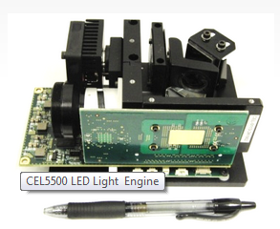

* .55” DLP
* UV specific model available
* 37mm projection lens ring

#### Issues

X3 Machine Vision Solution with DLP 5500 (X3-PM55)

<http://keynotephotonics.3dcartstores.com/X3-Machine-Vision-Solution-with-DLP-5500-X3-PM55_p_14.html>

$3999

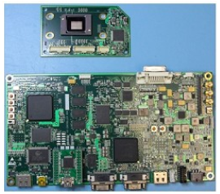

* .55” DLP
* No optics
* Can be converted to HDMI 8bit@180Hz monochrome for ~40K firmware development

#### Issues

### VPixx ProPixx

<http://www.vpixx.com/products/visual-stimulus-displays/propixx-lite.html>

$31K

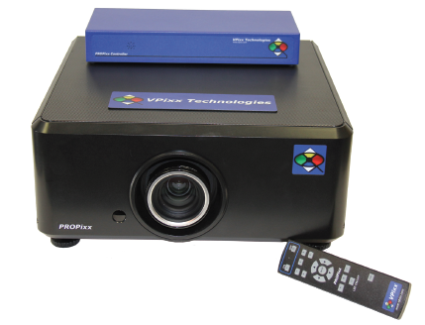

* 180 Hz native projection
* Run any software application without modification at 180Hz

#### Issues

* $31K

# Software

## Operating System

* Windows
* Mac
* Linux

## Applications

* PsychoPy
* matlab
* visionegg
* other