Research, Evaluation, and Systems Analysis (RESA)
Naval Warfare Simulation

USER GUIDE

RESA Version 9.1

January 2016

Korean Battle Simulation Center - Seoul
(KBSC)
Seoul, Korea

PART I

General Information
and
Orientation

TABLE OF CONTENTS
Section Page

1 INTRODUCTION 1
1.1 BACKGROUND 1
1.2 USER GUIDE OVERVIEW 1
1.3 RESA GENERAL DESCRIPTION 1
1.4 RESA HISTORY 13
1.5 SUMMARY OF MAJOR PROCESSES 15
2 RESA FUNCTIONAL DESCRIPTION 17
2.1 BLACKBOARD 17
2.2 COMMAND CENTER 17
2.2.1 Geographic Plot 17
2.2.2 ASTABS 17
2.2.3 Input/Output Terminal 18
2.3 MODEL ALGORITHMS 18
2.4 PREPARATION PROCESS 18
2.4.1 BUILD 18
2.4.2 FORCE 21
2.4.3 Game Initialization 21
2.4.4 RESA Message Generators 21
2.4.5 RESA ALSP Translator 22
2.4.6 RESA Link-16 Interface (RLI) 22
3 INPUTS AND OUTPUTS 23
3.1 RESA INPUTS 23
3.1.1 BUILD 23
3.1.2 FORCE 23
3.1.3 WARGAME DEFINE Orders 24
3.1.4 User Orders 24
3.1.5 Prescripts 25
3.1.6 Message Generator Data Files 25
3.2 SYSTEM OUTPUTS 25
4 MISCELLANEOUS 27
4.1 CAPACITIES 27
4.2 DISTRIBUTED SYSTEM OPERATIONS 27
5 SOFTWARE INSTALLATION 28
5.1 SYSTEM REQUIREMENTS 28
5.1.1 RESA System Requirements 28
5.1.2 RESA Command Center (Workstation) Requirements 28
5.1.3 Printer Requirements 29
5.2 SOFTWARE INSTALLATION NOTES 29
5.2.1 Supplied Media 29
5.2.2 Destination Disk 29
5.2.3 Core Tools Directory 30
5.2.4 User Account 30
Logon script .bashrc 30
6 COMMAND CENTER SETUP 32
6.1 COMMAND CENTER CONFIGURATION FILES 32
6.1.1 Purpose 33
6.1.2 Virtual Station (VSTA) 33
6.1.3 TROUBLESHOOTING VSTA 33

Figures

Figure 1.1 RESA Symbology (NTDS default, as seen by Blue) 5
Figure 1.2 RESA Symbology (NTDS default, as seen by Orange) 7
Figure 1.3 RESA Lines and Symbols 9
Figure 1.4 Common RESA Command Center Configurations 11
Figure 2.1 RESA Functional Diagram 19

Section 1
- INTRODUCTION
  - BACKGROUND
The Research, Evaluation, and Systems Analysis (RESA) software provides a simulation of the naval warfare environment that is capable of supporting a wide variety of research and development efforts, as well as training for senior officers. The design of the RESA simulation has focused on the command and control (C2) of naval battle group/force operations, with developments in progress to provide a simulation of the joint warfare environment. The range of operations that can be simulated with RESA extend from theater-level through carrier battle group and even surface action group/squadron-level operations. The system is designed for interactive control of simulated forces, with player command decisions forming a part of the simulation; however, capabilities exist to script a scenario and to replay it numerous times for statistical analysis. A capability also exists to generate realistic, scenario-driven data streams in various formats to stimulate Fleet or prototype C2 data processors to support shipboard training, system testing, interoperability assessment, or similar applications. The simulation may be operated as a distributed system, with interactive participants at various sites.
  - USER GUIDE OVERVIEW
The RESA User Guide, divided into eight Parts, provides the documentation necessary to use the system:

I General Information and Installation Notes
II Model Descriptions
III BUILD Program
IV FORCE Program
V Game Initialization
VI STATION Program
VII Postgame Analysis Programs
VIII RESA Message Generators

This part provides a brief summary of the history, applications, and users of the RESA simulator, as well as an overview of how the system operates. Other Parts provide the detailed information and reference data required by personnel who operate the simulation system. The RESA User Guide provides information pertinent to installation of the RESA software in a computer facility. The description of RESA provided in this issue of the RESA User Guide is pertinent to software release RESA 8.X.
  - RESA GENERAL DESCRIPTION
RESA is a computer-based, large-scale simulation of the naval warfare environment. It simulates three-sided (Blue vs. Orange plus Neutral) scenarios in which players may control forces ranging in size from multiple battle groups and associated aircraft, down to a single aircraft, submarine or surface vessel. The system is designed for interactive control of simulated forces, with Human-In-The-Loop (HITL) command decisions forming an integral part of the simulation. The forces simulated and their associated characteristics, sensors, weapons, and communications systems may be real, proposed, or notional.

Players monitor own forces and the contacts that they hold by viewing large color computer monitors, referred to as geographical plots, or Geos for short. On each Geo, friendly forces and contacts are represented by small, labeled icons that are superimposed over a projection of the land and/or coastline and political boundaries of the scenario area. Either NTDS symbology (figures 1.1 and 1.2) or top or side view icons can be used to represent friendly forces, shore bases, air defense sites, and tracks of non-friendly forces.

More detailed information about own forces (such as aircraft fuel remaining, weapons carried, etc.) and tracks held (such as ESM details), is shown as tabular text on separate computer monitors, called Automatic Status Boards (ASTABs). Each player station has from one to six of these. All ASTABs and Geos are updated automatically after each minute of simulated time (called a game minute).

An umpire-like function known as Control directs the simulation and supports users during an exercise. Control also commands Neutral forces included in an exercise to provide simulation of interfering air and ocean traffic. Control can monitor the ground truth situation, as well as the situation as perceived by Blue and Orange. Control may function as higher command authority when required (for example, Control can originate messages containing intelligence summaries and Rules-of-Engagement (ROE) for Blue and Orange). Control has only limited ability to intervene to deny tactical information to Blue or Orange or to prevent or restore damage to Blue or Orange forces. The Blue and Orange commanders or analysts are free to employ their forces as they would in an actual peacetime or wartime environment. They are bound only by ROE (but the system does not prevent users from violating ROE), and by the physical limitations imposed by the environment (sea state, weather, terrain, etc.) and available forces.

In addition to Control, a single neutral view may also be used to command Neutral forces. The neutral view does not have access to ground-truth information. This allows neutral views to be location in non-control cells. The neutral view behaves similar to Blue and Orange views.

Each user’s knowledge of the warfare environment is based on sensor contact reports and own force status reports, subject to simulated communication delays and established reporting policies. A sensor contact report may originate from a computer model simulating a long-range, airborne early warning radar detection of a flight of bombers 175 miles away, or a model simulation of a visual detection of a periscope sighted one mile from the bridge of a frigate. The current tactical situation revealed to a user is a subset of the simulated warfare environment and is known as a view. The tactical information transferred to a view is determined by the capability of sensors organic to the force elements included in the view. All own force and sensor information gained by forces within a view are shared via a simulated data link, and merged in a common data pool. This data is sorted and correlated so that no redundant information is retained. After each minute of simulation time, the shared ‘link’ data are distributed to all workstations (or Command Centers) in the view to update the tactical picture. The user may also update the information available in his view based upon communications received from users in other views. Thus, views differ in the currency and completeness of information, particularly detection information. The Tech Control and Control views differ from the Blue and Orange views in that it is driven from the ground truth information in the RESA database, and not limited to just what is available to the simulated links. Therefore, it always has current, complete, and accurate knowledge of all forces in the scenario—Blue, Orange, and Neutral.

Up to nine Blue and Orange views are provided in any combination, except that neither Blue nor Orange may be assigned more than eight views. One or more Command Centers may be assigned to a view. A Command Center consists of a command input/output (I/O) terminal (with keyboard), a color graphics terminal display (with mouse) for the geographic plot, and up to six Automatic Status Boards (ASTABs). The command I/O terminal is used for controlling forces and manipulating the geographic plot and ASTABs and may be instantiated without a geographic plot or ASTABs if desired. The command terminal and ASTABs may be brought up on individual VT terminals or in terminal windows on an X-window display. An entire command center, including geographic plot and ASTABs, may be hosted on a single X-window display monitor within separate terminal windows if desired. Figure 1.4 shows some common RESA Command Center hardware configurations.

RESA implements a number of computer algorithms (called models), which simulate the behavior of platforms, weapons, sensors, and communication systems. Users control the operation of forces using a set of orders directed to the units they control. The large set of orders and the ability of internal logic to automatically perform certain functions, such as air-to-air refueling, intercepts, and station keeping, help to provide for a realistic simulation of the warfare environment.

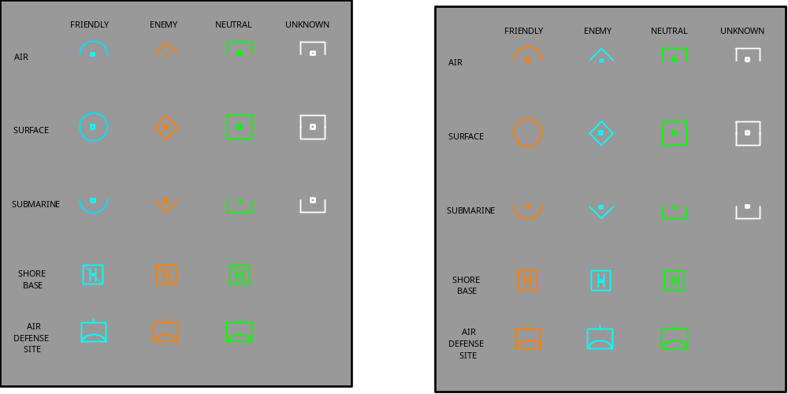
Figure 1.1 RESA Symbology (NTDS default, as seen by Blue)

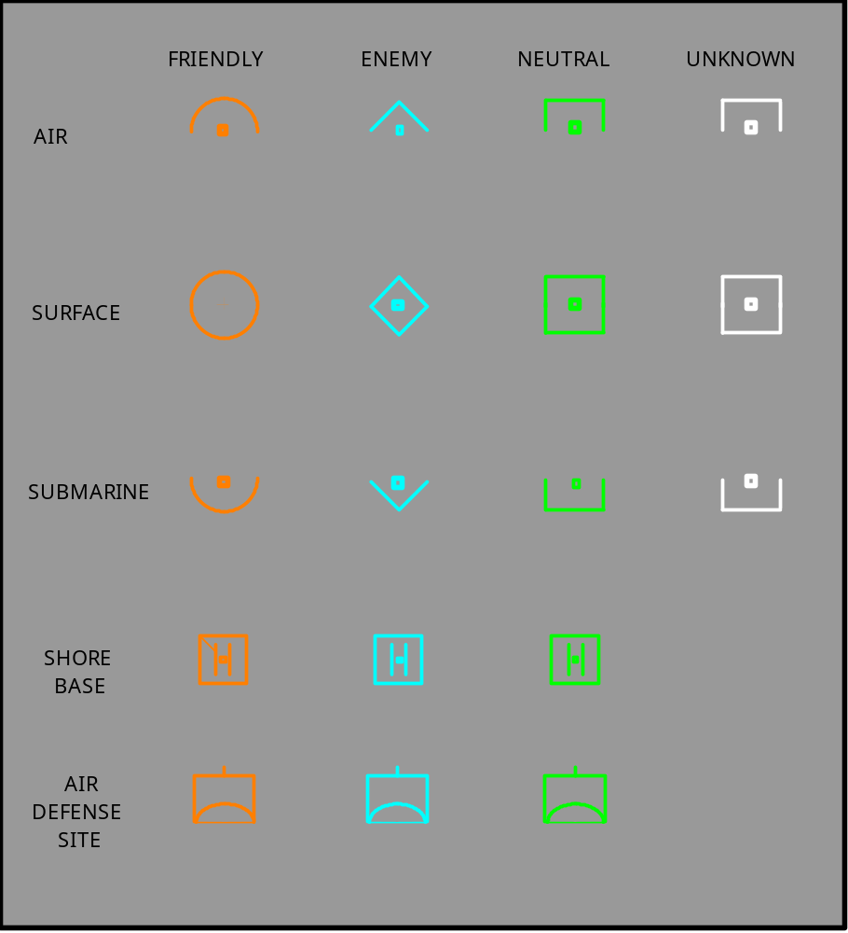
Figure 1.2 RESA Symbology (NTDS default, as seen by Orange)

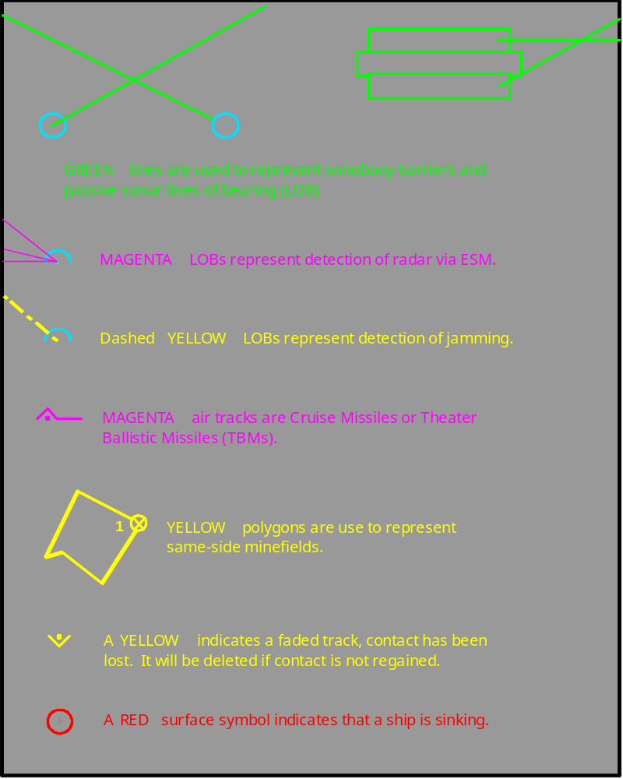
Figure 1.3 RESA Lines and Symbols

GEO

AStAB 1

AStAB 3

ASTAB
3
ASTAB
1
ASTAB
ASTAB

AStAB 2

AStAB 4

I/O
2
4
I/O

RESA Command Center with Terminal Window I/O, GEO, and ASTABs

RESA Command Center with VT I/O terminal,
GEO
I/O
TERMINAL
ASTAB
2
ASTAB
1
ASTAB
4
ASTAB
3
Terminal Window Geo, and ASTABs on VTs

ASTAB
1
ASTAB
3

I/O
ASTAB
2
ASTAB
4

RESA Command Center with VT I/O terminal,

Terminal Window Geo, and ASTABs on split VTs
GEO
I/O
TERMINAL
ASTAB
3
ASTAB
4
ASTAB
1
ASTAB
2

I/O
ASTAB 1
ASTAB 2
ASTAB 3
ASTAB 4

Figure 1.4 Common RESA Command Center Configurations

  - RESA HISTORY
The RESA simulation was originally developed by the Naval Ocean Systems Center (now SPAWAR Systems Center, San Diego) as the Naval Warfare Interactive Simulation System (NWISS). It was designed in the early 1980s to fulfill dual roles as a trainer for battle group commanders and their staffs, and as a tool for command, control, communications, and intelligence C3I analysis. The initial design was derived from an earlier large-scale simulator, called the Warfare Environment Simulator (WES).

In 1982, the Vice Chief of Naval Operations determined that another model, the Naval Wargaming System (NWGS), in use at the Naval War College, would be enhanced to fulfill requirements for both strategic wargaming and training for battle group staffs. The RESA simulation was designated as the Interim Battle Group Tactical Trainer (IBGTT) to provide training support to Tactical Training Group Pacific (TACTRAGRUPAC) until NWGS could be enhanced. The facility (SPAWAR or TTGP) provided this training support continuously between March 1982 and September 1988, including training for deploying battle group staffs, TACTRAGRUPAC classes in battle group tactics for both senior officers and staff tactical warfare officers; Fleet ASW Training Center, Pacific, classes in battle group ASW; and reserve unit training in battle group command and control. During this period, CNO (OP953) was the principal sponsor for the operation and maintenance of the RESA facility in order to provide this training support.
During the same time, RESA was applied on a not-to-interfere-with-training basis to a wide variety of C3I analytic efforts in support of various NOSC, SPAWAR, and other agency projects. These analytic efforts included assessing the impact on war fighting effectiveness of various advanced technology applications for DARPA; evaluating battle management issues associated with potential new sensor, command and control, and weapons systems; evaluating the interoperability of command and control support processors; and investigating joint C3I issues.

In FY89, RESA support to battle force training was terminated and all subsequent applications by NOSC have focused on research and development support, plus Joint and Allied training. Since training applications focus on simulation of the present naval warfare environment, while research and development applications generally focus on the projected naval warfare environment of the future, a variety of enhancements have been made or are in progress to improve the ability to model projected systems and weapons.

The extensive simulation capabilities of RESA, coupled with its record of reliable operations and transportability to virtually any VMS based computer system, have resulted in its use at a number of facilities for a variety of applications. RESA has been used at the following locations:

• SPAWAR, San Diego, California
• The USACOM Joint Training, Analysis & Simulation Center (JTASC), Suffolk, Virginia
• Warrior Preparation Center (WPC), Einseidlerhof AFB, Germany
• Naval Postgraduate School (NPS), Monterey, California
• US/ROK Combined Forces Command (CFC), Seoul, Korea
• National Simulation Center (NSC), Fort Leavenworth, Kansas
• Naval War College (NWC), Newport, Rhode Island
• ROK Naval War College, Taejon, Korea
• Ecole Superieure De Guerre Navale (French Naval War College), Paris, France
• U.S. Joint Forces Command Joint Warfighting Center (USJFCOM JWFC), Fort Monroe, Virginia
The capabilities of the RESA facility to realistically simulate the naval warfare environment, generate streams of realistic scenario-driven data that C2 support systems can process, and interface with other models/analysis tools that have been applied to a wide variety of projects, include the following:

1. Warfare system architecture definition and evaluation
2. Warfare system engineering Electromagnetic environment evaluation
3. C2 support system interoperability evaluation
4. Technology assessment
5. Battle Force shipboard command and control assessment and training
6. Over-the-Horizon Targeting (OTH-T) data management evaluation and training
7. Joint service systems, operations, and protocols evaluation and development
8. ASW combat systems and architecture testing and evaluation
9. National command authority crisis management capability assessment and development
10. Command and Control basic research
11. Battle management decision support system development
12. Development and testing of command and control structures, operational plans, communication plans, concepts of operation, and tactical employment of developmental systems

In accordance with agreements between SPAWAR and various user agencies, the basic RESA simulator has been modified by various activities, and the modified simulator has been renamed. Such developments include:
Air Warfare Simulation System (AWSIM) - Developed by the Warrior Preparation Center from a previous outgrowth of RESA. Incorporates expanded capacities and improved air/air and air/land warfare simulation for use in training senior NATO commanders. AWSIM was the US Air Force Battle Management Simulator for training support until 1997. It has now been superseded by a newer, re-engineered version, called AWSIM 2.0.
Battle Force Electromagnetic Interference Evaluation System (BEES) - Developed by the Electromagnetic Environmental Effects (E3) Branch of SPAWAR, BEES was designed to evaluate the operational impact of EMI at the equipment, platform, and Battle Force level in support of the acquisition manager. This was accomplished by expanding the electromagnetic system models in RESA to provide for the calculation of interference signal levels. The calculated interference levels are then used to determine signal-to-interference plus noise ratios (S/I+N) and subsequent impact on the ability of the force to effectively communicate, detect, track, and engage enemy targets as appropriate. This equipment level impact is then mapped into an overall operational impact via execution of a wargame simulation.
In 2011, KBSC assumed ownership of RESA from SPAWAR, San Diego. Cubic Corporation accepted a task to migrate RESA from VMS to PEO-STRI lockdown version of Redhat Enterprise Linux. The first operational use of the Linux version of RESA, RESA 9.0, is Decemer 2014. RESA will operate on a common hardware platform (CHP) using Linux services that meet security requirements.
  - SUMMARY OF MAJOR PROCESSES
RESA is made up of six major processes: (1) BUILD, (2) FORCE, (3) Game Initialization, (4) WARGAME, (5) STATION, and (6) Postgame Analysis (PGA). BUILD is used to create and modify a characteristics database of object types (e.g., ship classes, aircraft types, sensors, weapons, communication systems, etc.). FORCE is used to prepare a simulation scenario. Game Initialization copies the scenario data output from FORCE into the Blackboard for WARGAME to use. It also provides some control over how models are executed. WARGAME actually executes the models, processes the orders and updates the Blackboard. WARGAME also writes data to various history files for later use by Postgame Analysis (PGA). STATION parses user orders, and displays the current state of the warfare environment to the user via ASTABs and the Geographic Plot. PGA processes data recorded by WARGAME to support exercise reconstruction and evaluate MOEs (Measures Of Effectiveness) and MOPs (Measures Of Performance) related to the scenario.

An exercise is initiated using BUILD to generate or modify platform, sensor, communication, and weapon characteristics in a characteristics database. The user may add, or retrieve and modify characteristics data interactively using a video terminal. The BUILD Program will also produce a hard copy listing of the entire or selected portions of the database. The characteristics database, once developed, can be used to create a wide variety of scenarios.

The next step in an exercise is to prepare a scenario file using the FORCE Program. This file includes: (1) the names, classes, locations, and initial courses and speeds of all ships; (2) the names of shore bases to be used in the simulation together with associated aircraft, sensors, sonobuoys, commbuoys, etc.; and (3) the necessary ship class characteristics extracted from the characteristics database. Also included is the communication plan for each side expressed as a series of communication paths and circuits that support communications. The scenario file may also contain pre-stored orders to be automatically executed or invoked by users during the exercise.

After FORCE has been successfully run, the scenario files are mapped to the Blackboard using GAMEINIT. While executing this process, the user may also modify various parameters used by the WARGAME models using DEFINE commands.

Now that the Blackboard has been initialized, STATIONs may be brought up and the players may see the current state of the warfare environment via their Geographic Plots and ASTABs. Players may also issue orders to their forces, but they will not be executed until the WARGAME process is started, and the simulation is ordered to begin execution.

Next, the models are started by executing the WARGAME program using the SWARGAME command verb.

After starting WARGAME, the Tech Control Station directs simulation starting, stopping, timing and data collection. Tech Control can set the simulation game time to wall clock time ratio from 0.15 to 999. This is accomplished by using the RATIO Order. Tech Control can also alter how often the WARGAME executes per simulation game minute. This is referred to as the Variable Cycle Time (VCT) feature and is a way of increasing the WARGAME's level of fidelity. Using this feature, the WARGAME can execute all models at a frequency greater than a once per simulation-minute ratio. This is accomplished by using the DEFINE CYCLE TIME Order. The VCT feature was initially developed for the RESA DIS interface. See also: Game Initialization and STATION TIME, DEFINE CYCLE TIME, and DEFINE CYCLE RECURRENCE Orders.

During the simulation, the WARGAME process responds to user orders, generates displays and hardcopy messages, and updates the warfare environment database (Blackboard) each game cycle until Tech Control ends or interrupts the simulation.

Control and Tech Control stations may replenish or deplete any expendable equipment (such as sonobuoys, ammunition, etc.) loaded onto a unit. They have a limited ability to create new units (game objects) during execution of the WARGAME. They may also disable or enable sensors, repair damage, resurrect ships, aircraft and boats, and save the state of the simulation for later replay or review.

Selected elements of the Blackboard are collected each simulated minute for later analysis by PGA programs. The collected data include force user orders, and engagement outcomes. The Engagement PGA Program may create a chronological log of all weapon engagements. This log may be sorted in many ways, including by: target, weapon type, firing platform, and hits or misses. The Orders PGA Program provides a chronological text file of all orders (excluding geographic display and ASTAB orders) input from I/O terminals, along with the command station from where the order was entered. The Position PGA program provides a snapshot of Blue, Orange, and Neutral unit positions, courses and speeds.

In addition, other processes may generate standard military messages in various formats such as OTG, Link-11, and Link-16. These messages are created based upon the simulated tactical situation as it evolves over time. These messages may be written to files, displayed on terminals, transmitted to actual C4I systems such as the Global Command and Control System-Maritime (GCCS-M) and Link-16 Engine (LSE), or any other Tactical Data Processor (TDP) that can handle the appropriate message formats.
Section 2
- RESA FUNCTIONAL DESCRIPTION
  - BLACKBOARD
The overall architecture of RESA is depicted in Figure 2.1. The heart of the simulation is a database that describes the current state of the warfare environment. This database is called the Blackboard. It contains information that describes all of the information regarding the forces simulated, including locator, motion, sensor, weapon, C3 system capabilities, track data, and damage. The database is dynamic and is updated in response to input commands and various model algorithms at the designated cycle interval. The database and all associated processes can be hosted on virtually any Linux based computer system.
  - COMMAND CENTER
Information regarding the state of the warfare environment is taken from the Blackboard and presented at a set of devices comprising a Command Center (see Section 1, Figure 1.4). A Command Center includes one color Geographic Plot with a mouse, an input-output terminal, and up to six ASTABs. Command Centers provide the means to interface the simulation with the interactive user. Each RESA WARGAME may support up to 64 Command Centers. Data in the Blackboard are maintained such that only information from own platform (and other platforms sharing a communications link with own platform) are available to the interactive user at a particular Command Center. This partition of information is called a view, as described in Section 1.3.

A command center may be started by the user at the command center of remotely by tech control. Tech control can start, stop and monitor each command center.
    - Geographic Plot
The Geographic Plot provides the primary means for the interactive user to monitor the current tactical situation. This plot is presented in the NTDS symbology. The plot can be centered on any position, force, or track, and the radius can be set between 1 and 4,095 nmi. Various capabilities are also provided to erase various types of data to declutter the plot; or to overlay with circles, grids, x-marks, rectangles, and/or ellipses as aids in interpreting the plot. Associated with the Geographic Plot is a mouse that can aid in monitoring the tactical situation by allowing the user to determine the latitude/longitude/elevation of a point, unit or track; measure the bearing and range between points, units or tracks; or identify overlapping symbols. Software is currently available to interface RESA to devices that support the X protocol (X servers), including PCs, and Apple computers (when running X server software and supporting DECnet or TCP/IP).
    - ASTABS
Supplementing the Geographic Plot at a Command Center are one to six ASTABs, which present detailed alphanumeric data pertinent to the view regarding the current state of the warfare environment. This information includes own force locations and status, sensor track reports, engagement and damage reports, and intelligence reports. The ASTABs may be shown on any device that can emulate a VT-100 terminal. Available ASTABs are listed in Part VI, Appendix A.
    - Input/Output Terminal
Also at each Command Center is an input/output (I/O) terminal, which may be any device that can emulate a VT-100 terminal. The I/O terminal provides a means to enter orders to control the forces that are interactively commanded by a user at a Command Center. Some messages regarding the state of the warfare environment are also presented at the I/O terminal. Orders entered at a Command Center are processed to update the Blackboard and thus control the simulated forces commanded at a Command Center. Optimally, the I/O terminal will be operated by a person who is trained in the RESA order syntax, so that the interactive user will be able to concentrate on assessing the tactical situation, deciding on the appropriate response to the perceived situation, planning actions for the evolving situation, and communicating directives to the forces controlled via the input operator or information to other commanders.
  - MODEL ALGORITHMS
In addition to being updated by the force control commands inserted at various Command Centers, the Blackboard is also updated by the RESA model algorithms. These describe the various physical processes that occur over time during the simulated warfare environment. For example, the Motion Model determines the latitude and longitude of a force in the next game cycle by applying the current course and speed of that force to the current latitude and longitude of the force. Many of these models are Monte Carlo in nature. For example, the Radar Model computes the signal excess available for every active radar as a function of radar parameters (power, gain, noise, etc.), target radar cross-section, existing geometry (range, line-of-sight), and environmental parameters (ducting, sea clutter, etc.). The radar signal excess is then compared to the signal excess required for that radar, which is also a function of radar parameters (false alarm rate, pulse repetition rate, etc.). The relationship between the signal excess available and that required is then evaluated by drawing a random number from a normal distribution to determine if there is sufficient signal excess for a detection to occur during that game cycle. If so, the track symbol is drawn onto the geographic plots of the view that owns the force operating the radar, and track information is presented on the Active Track ASTAB. Part II describes each of the RESA models in detail.
  - PREPARATION PROCESS
The initial RESA WARGAME database is developed through three programs: (1) BUILD, (2) FORCE, and (3) Game Initialization. These are shown in the lower-left corner of Figure 2.1. Procedures to operate these programs are described in detail in Parts III, IV and V, respectively.
    - BUILD
The BUILD Program provides a means to develop and modify a database of force, weapon, sensor, communications, and other system characteristics that are required as inputs to various RESA models. These characteristics include such values as the maximum speed of a class of ships or the power output of a radar. The characteristics contained in the files created by the BUILD Program may cover a broad range of ship, aircraft, base, weapons, and sensor types, not all of which are necessarily used in a particular application. The BUILD Program allows characteristic files to be copied and readily reviewed and tailored as required for a particular application.

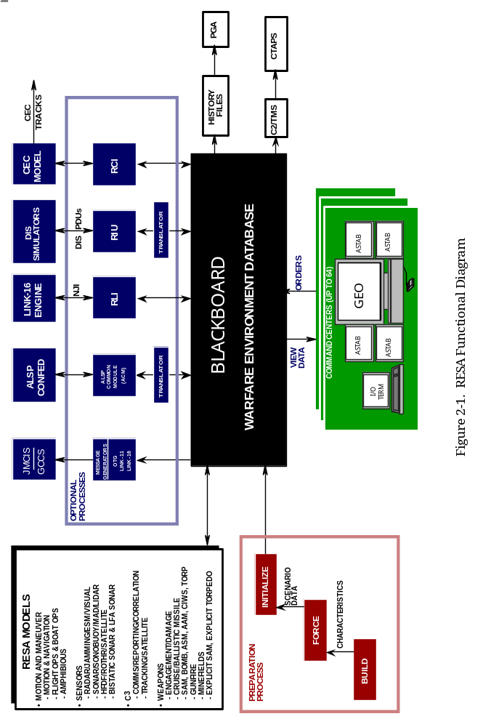
Figure 2.1 RESA Functional Diagram

    - FORCE
The FORCE Program allows the scenario designer to develop the initial conditions for a particular scenario. It provides for the definition of the specific ships, submarines, shore bases, aircraft, boats and hide sites to be included in a scenario and their initial location and motion, if applicable. The detailed characteristics for each force selected or all detailed characteristics, which are contained in the associated BUILD characteristics files, are then mapped into the FORCE files for the scenario. The FORCE Program also allows the scenario designer to define the initial environmental conditions (weather), communications networks, wide-area surveillance systems, and other data to be included in a particular warfare simulation.
    - Game Initialization
The Game Initialization (GAMEINIT or SINIT) Program maps the files created during the FORCE Program into the Blackboard and, as such, establishes the initial simulated warfare situation. GAMEINIT provides for defining a variety of parameters that control the operation of the simulation. Although many of these game control parameters can be changed during the simulation execution, it is important to note that characteristics defined in BUILD and data entered in FORCE cannot be readily changed after the simulation is started.

After the simulation is started, the Blackboard is updated by model computations and user input (force control orders) as previously described. The game may also be paused, restarted for replay from a prior time, or replayed without interactive control to review the action that occurred.

AUTOMATED DATA COLLECTION

During operation, data are collected from the Blackboard and placed in various history files for subsequent analysis using the PGA Programs. Automated data collection includes information on engagements, and orders entered during the game. The PGA Programs process the information collected to produce several measures of effectiveness and other outputs as selected by the user.

OPTIONAL PROCESSES
    - RESA Message Generators
The RESA Message Generators are optional processes shown in Figure 2.1. These programs may be used to provide a powerful capability to stimulate real C2 data processing systems. Any number of message generators can be operated in parallel with the WARGAME. The message generator extracts from the Blackboard the information needed to populate the fields of a message of a particular format. The generation of a message is triggered by an event occurring during the simulation. For example, if the RESA HFDF Model detects an HF communications transmission, the message generator will create a message that reports that detection, with the area of uncertainty parameters taken from those developed by the HFDF Model. The message is delayed for a logarithmically distributed time delay. Garbled characters may be included in the messages produced, if desired. The resulting message data streams can then be coupled to real or prototype C4I TDP's via various means, including actual communications networks. In this way, RESA becomes a scenario driver to stimulate communications networks, suites of data processors, or shipboard systems. For more information on the RESA Message Generators, refer to Part VIII.
    - RESA ALSP Translator
The WARGAME program includes an Aggregate-Level Simulation Protocol (ALSP) Translator that interfaces RESA to the ALSP Common Module (ACM) software. This is used to interface RESA to an ALSP Joint Training Confederation (JTC) of other JTC capable simulations, including Army, Air Force, Marine, Logistics, Tactical Message, and Electronic Warfare simulations, to provide a simulated warfare environment for Joint Level Training. All members of the ALSP JTC are referred to as actors.

The ALSP translator broadcasts ground truth information pertaining to RESA’s game objects (ships, boats, submarines, aircraft, cruise missiles, etc.) and receives similar information broadcast by other Confederation actors. Using the object attributes received, RESA creates representations of objects hosted by other actors and places them in the Blackboard with its own objects. Objects created in this manner are called “ghosts”. Ghosts can be detected, classified and engaged just like normal RESA units, but orders to maneuver, change sensor ON/OFF status, or cause a ghost unit to engage will be rejected. When a ghosted object is engaged by a RESA unit, a message is sent to the actor owning the object describing the engagement. The owning actor then evaluates the engagement to determine whether or not a hit occurred and what level of damage was attained. Depending on the type of engagement, a reply message may be sent back indicating the number of hits obtained.

The ALSP interface also provides time synchronization with the other actors. When RESA is joined to the Confederation, the WARGAME will not advance game time until permission is granted by the ACM, based on inputs from all other joined actors. Because of this mechanism, during ALSP exercises, RESA speed is limited to the speed of the slowest Confederation actor (if any one actor stops, all actors stop).
For more information about the RESA ALSP Translator, refer to the following documents:
1. Maritime Aggregate Level Simulation Protocol (ALSP) Interface Control Document (ICD), SPAWAR, 30 September 1993
2. Aggregate Level Simulation Protocol (ALSP) Combat Interactions Interface Control Document (ICD) for the 1997 Joint Training Confederation, SPAWAR, 1 April 1997
- RESA Actor Implementation Document (AID) for the 1997 ALSP Joint Training Confederation, SPAWAR, 30 September 1996

    - RESA Link-16 Interface (RLI)
The RESA Link-16 Engine (LSE) Interface (RLI) provides a means for RESA to report tracks onto a Link-16 network via the LSE. Tracks detected by RESA sensors are forwarded from the RESA Local Track Table through the Remote Track table and forwarded to a Message Handler where the track data is formatted into a Link-16-type report. These reports are forwarded to the LSE for designation on Link-16 tracks and are then reported to all members in the Link. External Link-16 track reports are forwarded from the LSE to the RESA Link-16 Track Table for plotting on the Geoplot and display on the Link-16 ASTAB.

Section 3
- INPUTS AND OUTPUTS
  - RESA INPUTS
The RESA warfare environment simulation outputs to the Command Center displays and data collection files for post exercise analysis are a function of the inputs received from various sources. The six primary sources of input are:
1. BUILD Characteristic files
2. FORCE Scenario files
3. Game Initialization DEFINE orders
4. User Orders
5. Order Prescripts
6. Message Generator Data files

Each of these inputs is briefly described in the following sections:
    - BUILD
The BUILD Program assists the user in creating a characteristics database, frequently called a BUILD file. This database specifies characteristics of force units and their associated equipment and systems. BUILD supports the input, validation, storage, retrieval, and modification of many types of objects.

The characteristics database, or BUILD file, is actually a set of files. Each file contains all of the characteristics records associated with objects of a particular type. For example, the Aircraft characteristics file contains one characteristics record for each aircraft type. The user may use BUILD to add or delete objects and their characteristics; to validate object characteristics and modify them as required; and to retrieve, display, and print objects and their characteristics. BUILD is an interactive program with a minimum set of commands and helpful prompts to assist the user. See Part III, BUILD Program, for a complete description of this program.
    - FORCE
The FORCE Program assists the user in creating a simulation scenario file, sometimes called a FORCE file. This file defines the initial tactical situation of an exercise and includes the name and location of shore bases, hide sites, and the names, classes, locations, and initial courses and speeds of all ships and submarines. FORCE allows the user to organize the ships, shore bases, and hide sites into views and assign a task hierarchy within the view for the ships and shore bases. FORCE then extracts from the BUILD file the characteristics of each ship, shore base, and hide site along with their associated aircraft, boats, and systems.

FORCE allows the input, validation, storage, retrieval, and modification of the following elements of Blue, Orange, and Control (Neutral) views:
• All ships, shore bases, and hide sites and their characteristics
• Definition of views in terms of the platforms assigned to each view
• Organization of the ships and shore bases into task hierarchies within the view
• The number and types of aircraft assigned to platforms along with the aircraft characteristics
• The boats and characteristics assigned to ships or shore bases
• The sensors carried by ships, boats, bases, and aircraft, and the sensor characteristics
• Communication path definitions including node platforms and internode communication links
• Initial locations, courses, and speeds of ships
• Pre-stored orders for conditional and unconditional execution during the exercise
• Weather regions
• HFDF regions
• SOSUS and sonar environment regions
• Satellite tasking
• Reporting policies
• Relocatable Over-the-Horizon Radar (ROTHR) data
• Probability of hit data
• Communications jammer data
• Data used by high-level models, including the EO/IR Model and Macro ASW Search Model

FORCE is an interactive program controlled by a set of orders and with helpful prompts to assist the user. See Part IV, FORCE Program, for a complete description.
    - WARGAME DEFINE Orders
WARGAME DEFINE Orders prescribe certain conditions that are to prevail during an exercise. All definitions have default values; however, these values may be changed during scenario initialization. Most of the definitions may also be changed during an exercise at a Tech Control station. The definitions allow an analyst to vary the functioning of the RESA models to satisfy analysis objectives. In addition to defining model parameters, system variables may also be defined. WARGAME DEFINE orders include orders to affect: frequency to save the Blackboard, interval to collect position data for PGA, the starting exercise Julian date and ZULU time, the locations of weather and HFDF regions, times to perform target motion analysis, time to deploy/retrieve antennas, probabilities of flight operations events and model execution timing.

See Part V, Game Initialization, for a complete description of the DEFINE orders and exercise initiation procedures.
    - User Orders
During the progress of an exercise users may enter numerous orders. Some orders may only be used at Control or Tech Control Command Centers. Essentially, the orders are used to control forces within a view and to control presentations on the Command Center displays.

All orders directed to RESA platforms may be preceded by the key word FOR and the name of the unit. It is also possible to direct an order to multiple platforms by using a task hierarchy prefix established in the FORCE. A user may only direct orders to forces, which he or she commands—i.e., the forces within the same view.
    - Prescripts
RESA Command Centers have the capability to accept text files containing legal RESA orders. These files can be automatically inserted at one or more Command Centers, and synchronized with RESA game time. These files of timed orders are called prescripts. Prescripts are often used to provide a means to repeat exactly the actions of threat forces, such that the same scenario can be replicated to evaluate alternative tactics or combat system capabilities. The activities of all forces may also be prescripted and the same scenario replayed many times in a mode called AUTORESA to derive expected-value results from the Monte Carlo simulation.

See Part VI of this user guide, STATION Program, for a complete description of the user orders.
    - Message Generator Data Files
These are described in Part VIII.
  - SYSTEM OUTPUTS
The simulator produces a number of outputs in response to the inputs described above. The outputs are:
Displays:
Automatic Status Boards (ASTABs)
Geographic Plots
I/O Terminal Messages

Hardcopy Outputs:
BUILD File Printout
FORCE File Printouts
Communications History Output
Order History Log
Prescript from Order History
Engagement Record
Archived damage and Battle Damage Assessment (BDA) data
Logistic fuel consumption report
Logistic weapon expenditure report

Data Streams:
OTH/Gold Messages
Link-11 Messages
Link-16 Messages
ALSP Messages
X windows protocol messages
USMTF 2004 Messages

Section 4
- MISCELLANEOUS
  - CAPACITIES
The numbers of forces, weapons, sensors, and other entities that can be simulated are limited by the amount of space allocated in the Blackboard to contain the data associated with each type of entity. One such entity is called a game object. A game object is a ship or shore base that exists at the start of the simulation, or it may be a boat, an aircraft, an explicit torpedo, a flight consisting of multiple aircraft, or a cruise missile that is launched during the simulation. Game objects that are created by launching them exist until they are recovered, destroyed, or have completed the cruise missile flight profile. Ships exist as game objects until they are sunk. Currently, the maximum RESA capacity for game objects is 4,000. More information about RESA FORCE capacities are included in Part IV, FORCE Program, Section 1.5.

It should be noted that RESA makes a distinction between a game object and a track. In RESA, a track is essentially a report of a sensor detection of a game object. Tracks could be generated by detection by radar, ESM, sonar, sonobuoy, visual, or one of the wide area surveillance systems. The current RESA capacity for remote tracks is 40,000.

RESA names are limited to a maximum of eight alphanumeric characters, all uppercase, with no special characters. These are used for platform names, air event names, landing zone names, and for naming various other RESA entities.
  - DISTRIBUTED SYSTEM OPERATIONS
The RESA simulator may be operated with various Command Centers located at various sites to allow interactive control of simulated forces by commanders at multiple locations. Remote site operations of RESA via TCP/IP protocol over Wide-Area Networks (WANs) have been employed from the Warrior Preparation Center (WPC), the Joint Training, Analysis and Simulation Center (JTASC), and the Korea Battle Simulation Center (KBSC) to distribute RESA workstations to multiple countries, and even to other continents.

RESA Message Generators routinely provide tactical data streams to real world C4I systems that then redistribute the data to ships at sea, ships in port, and to shore installations around the globe.
Section 5
- SOFTWARE INSTALLATION
  - SYSTEM REQUIREMENTS
    - RESA System Requirements
1. Common Hardeare Platform (CHP) Workstation for sever with single or dual monitor video card.
2. At least 2 GB RAM
3. PEO-STRI Lockdown version of Red Hat Enterprise Linux
4. 300MB disk space (executable + source + object datbase)
5. 800MB disk space for world-wide DTED data library (optional)
6. 400MB for exercise input and output.
7. CD/DVD drive for loading of RESA software
    - RESA Command Center (Workstation) Requirements
1. CHP Workstat6ion with one or two dual video cards and a 3 button mouse
1. Geographic Plot
a. May use any color X server (A graphic display device supporting the X window system.)
b. Communications to RESA server via or TCP/IP.
2. Automatic Status Boards (ASTABs)
a. One or more X servers with VT100 emulation for ASTABs.
3. I/O Terminal
a. Xterm window on an X server (can share screen space with the graphics, if desired).
    - Printer Requirements
1. Standard network printer for Gamebook reports.
  - SOFTWARE INSTALLATION NOTES
    - Supplied Media
CD/DVD
    - Destination Disk
To use RESA, four directory (trees) are required:
1. ./resang/trunk contains the executable system.
2. ./coretools contains assorted support utilities including map, makeorder, ddl, rat4, hub, wishbone and rat4 run-time library
3. ./db contains object database, scenario and sonar environment files.
4. /opt/resa/game contains exercise files including workstation configuration files
One directory (trees) is optional:
1. ./db/dted contains compressed DTED data from DMA DTED CD-ROMs. This directory can become extremely large, depending on the number of cells that are loaded.
    - Core Tools Directory
The Core Tools tree will be automatically created from the tar archive. The Core Tools Directory tree structure should look like this:
./CORETOOLS/--DDL/
HUB_WB/
LIBRARY/MAP/
LIBRARY/RLIB/
PARSER/
RAT4A/

    - User Account
Logon script .bashrc
The command lines:
# .bashrc
# Source global definitions
if [ -f /etc/bashrc ]; then
. /etc/bashrc
fi
export INTEL_LICENSE_FILE=~/l_622TTDFM.lic
export PATH=$PATH:~/intel/bin
source ~/resa_root/resa_build/resabashrc

RESA script file referenced in login script

# User specific aliases and functions

export CSF_KNOWN_NAME=RESA91
export EXERCISE_CLASSIFICATION=UNCLASSIFIED
export CCIOX=cciox.dat
export RESA_ROOT=~/resa_root
export RESA_BUILD=$RESA_ROOT/resa_build
export RESA_HOME=RESA_BUILD
export RESA_BIN=$RESA_HOME/bin
export RESA_TRUNK=$RESA_HOME/resang/trunk
export RESA_LIB=$RESA_TRUNK
export RAT_TOOLS=$RESA_HOME/coretools/rat4a
export MALE_TOOLD=$RESA_HOME/maketools
export RAT_LIB=$RESA_HOME/coretools/library/rlib
export PARSE_TOOLS=$RESA_HOME/coretools/parser
export PARSE_LIB=$RESA_HOME/coretools/parser
export HUB_TOOLS=$RESA_HOME/coretools/hub_wb
export DDL_TOOLS=$RESA_HOME/coretools/ddl
export MAP_TOOLS=$RESA_HOME/coretools/library/map
export BUILD_BASE=$RESA_HOME/db/build/
export SONARENV_BASE=$RESA_HOME/db/sonar_env/
export ELV_PATH=$RESA_HOME/db/dted/
export TST_BASE=$RESA_HOME/resang/trunk/
export PATH=$RESA_TRUNK:$RAT_TOOLS:$MALE_TOOLS:$PARSE_TOOLS:$HUB_TOOLS:$RESA_HOME/script:.:$PATH
if [ -e /usr/bin/gcc ]; then
line=`gcc --version | head -n1`
set -- $line
dotversion=${3:2:1}
case $dotversion in
[1-3]*)
dwarfversion="2"
;;
[4-7]*)
dwarfversion="3"
;;
*)
dwarfversion="4"
;;
esac
export dwarfarg="-gdwarf-"$dwarfversion
else
echo "Info: No GNU development tools are installed."
fi

##########
export FOR_DEBUGGER_IS_PRESENT=true
##########

# RESA program names
alias astab='$RESA_TRUNK/asmain.run'
alias atomissions='$RESA_TRUNK/atomissions.py'
alias atopermissions='$RESA_TRUNK/atopermissions.py'
alias awsimbuild='$RESA_TRUNK/awsimbuild.run'
alias bb2air='$RESA_TRUNK/bb2air.run'
alias bb2boat='$RESA_TRUNK/bb2boat.run'
alias bb2otg='$RESA_TRUNK/bb2otg.run'
alias bb2otg_ys='$RESA_TRUNK/bb2otg_ys.run'
alias bbtest='$RESA_TRUNK/btmain.run'
alias build='$RESA_TRUNK/blmain.run'
alias copysave='$RESA_TRUNK/copysave.sh'
alias dtedlib='$RESA_TRUNK/dlmain.run'
alias dtedheader='$RESA_TRUNK/dted_header.run'
alias enumin='$RESA_TRUNK/eimain.run'
alias enumnum='$RESA_TRUNK/enum_num.run'
alias enumout='$RESA_TRUNK/eomain.run'
alias envbld='$RESA_TRUNK/bemain.run'
alias envprt='$RESA_TRUNK/pemain.run'
alias force='$RESA_TRUNK/frmain.run'
alias killsta='$RESA_TRUNK/wkmain.run'
alias pgaeng='$RESA_TRUNK/enmain.run'
alias pgaord='$RESA_TRUNK/pomain.run'
alias pgapceng='$RESA_TRUNK/etmain.run'
alias pgapre='$RESA_TRUNK/romain.run'
alias pgafuel='$RESA_TRUNK/pfmain.run'
alias plot='$RESA_TRUNK/ptmain.run'
alias prescript='$RESA_TRUNK/tsmain.run'
alias rmg='$RESA_TRUNK/ggmain.run'
alias rmgsub='$RESA_TRUNK/gtmain.run'
alias sinit='$RESA_TRUNK/wimain.run'
alias swar='$RESA_TRUNK/wgmain.run'
alias vsta='$RESA_TRUNK/wsmain.run'

# RESA ‘goto’ directory names

alias gwar='cd /opt/resa/game'
alias gbld='cd $RESA_HOME/db/build'
alias gresa='cd $RESA_TRUNK'

# List files and directories only
alias lf="ls -l | egrep -v '^d'"
alias ldir="ls -l | egrep '^d'"

# Linux command shortcuts

alias disk='df -h' # disk file system in human readable format

# Developer programs

alias makeorder='$PARSE_TOOLS/makeorder.py'
alias r4l='$RAT_TOOLS/r4l.py'
alias ddl='$DDL_TOOLS/ddmain.run'
alias csect='$MAP_TOOLS/csect.run'
alias readwin='$MAP_TOOLS/readwin.run'

# Commands to start worktations

alias sta1="gwar;vsta 1 t as=1 config=cciox"

# Template alias to start each workstation remotely from command line
#alias sta<station number>=gwar;export DISPLAY=<workstation ip>;xterm -e $RESA_TRUNK/wsmain.run <station number> <side> [|<view>] as=4 config=cciox

Section 6
- COMMAND CENTER SETUP
This section describes how t configure a RESA Command Center Workstation
  - COMMAND CENTER CONFIGURATION FILES
    - Purpose
The Command Center configuration file (or CC file) is used by the STATION Program to determine the geographic map and geo display type, the terminal emulator and and max number of ASTABS, . Configuration files are kept in the game directory. All stations may use the same configuration file.
The CCnn.DAT files should follow the format:

GEODISP world X
KEYBOARD IOTERM VT100
MESSAGE IOTERM VT100
SCREEN ASTAB1 VT100
SCREEN ASTAB2 VT100
SCREEN ASTAB3 VT100
SCREEN ASTAB4 VT100
SCREEN ASTAB5 VT100
SCREEN ASTAB6 VT100

    - Virtual Station (VSTA)
VSTA is a command line designed to make station startup both standardized and easy The CC file name is entered in the config argument. See Station section of User Guide.
    - TROUBLESHOOTING VSTA
Most problems with VSTATION(T) can be solved fairly quickly if an orderly approach is taken.
On a TCPIP based system, the ping utility should be used to test the communication path.
From the workstation logon to the server using ssh –X When vata is started Xwindows will be displayed at the workstation.

