SYSC 3020 Group 7: Implementation Documentation: Part 1
Joshua Cohen-Collier Korede Ogunyinka Mohammed Zen El Din June 10, 2014
Description :
This program basically runs on all the predetermined concepts described in the previous iteration reports. It incorporates the ApplicationManager and ProfileManager sub-systems. The classes work together in order to make the graduation admissions system as compact, accessible and, most importantly, simple as possible. The program was written in java by means of BlueJ IDE, due to the fact that an object oriented system would be the best way to implement this design, and this was the only language we were fluent enough in to encapsulate such a complex design properly. Aside from the previously mentioned classes, some new classes were introduced i.e. ProfileManager, UnitTester and ApplicationManager.
These additional ‘manager’ classes were present in order to ease the access and manipulation of the applications and profiles by the specific actors which have the permissions to do so, and simulate the subsystems.They are key because they contain all the profiles and applications in the form of array lists, this aids in handling and processing multiple instances of these classes at once. There is also a means of searching for specific profiles by looking up either the id or the name of the holder of this profile making it easier to retrieve them.
The unit tester class is used, basically, to test the different possible key features performed by each actor. When the program is compiled and an instance of the unit tester is created, we can access the methods contained by that instance in order to test the different possible features previously mentioned.
Lastly, a new class was introduced for each of the possible Application attachments. This includes comments, ratings, and CV references. This was changed from being just a string, to incorporate having both an author and date as well, which made viewing much more feasible. Also, because of the use of the imported libraries, Date and Scanner, user input with actual time-stamps were used( for Comments, Ratings, etc...).
Execution Instructions :
The program is best implemented in the BlueJ IDE, which is available on all SYSC lab computers, including MC 6045. To use, download all files, and then double-click on the "package.bluej" file. This will open up the system in BlueJ. To view the code for any of the classes, simply double-click on any of them. To create an instance of a Class, right click and say "New ____" which then ask for constructor parameters, with instructions on their type, and what they do.
To properly see the functions of the system, a UnitTester Class was created to show various scenarios of the system. To use, simply create a new UnitTester, which will create an instance on the bottom of the screen. To execute any of the scenario tests, simply right click on the instance, and select any of the methods, as shown below.
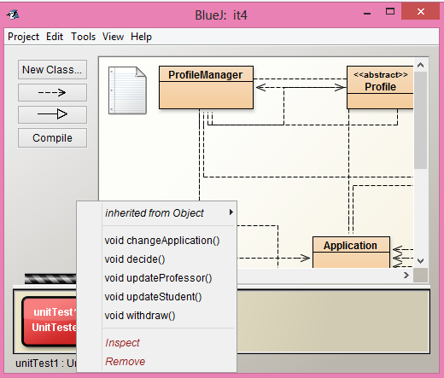
Each method will bring up a new window with text instructions in it, and may ask for user input. To enter input, simply type in on the keyboard, then press the return key. Note that the inputs must be realistic, as no field can be blank, and invalid inputs such as a 6 star rating, or a 7 digit student number( must follow format 100xxxxxx), will incur errors.
An alternate method of usage is to create an instance of ProfileManager, which will create an attached ApplicationManager. From here the user can specify commands such as creating and destroying profiles, as well retrieving them.
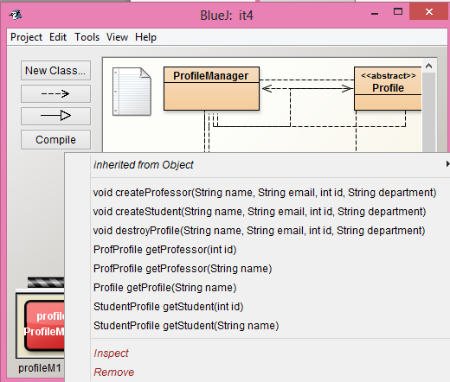
The IDE also allows the user to view internal objects, such as any object in the list of managed profiles, and then have those objects call methods. This is done through the "inspect" command, as shown below, which shows an empty list of profiles.
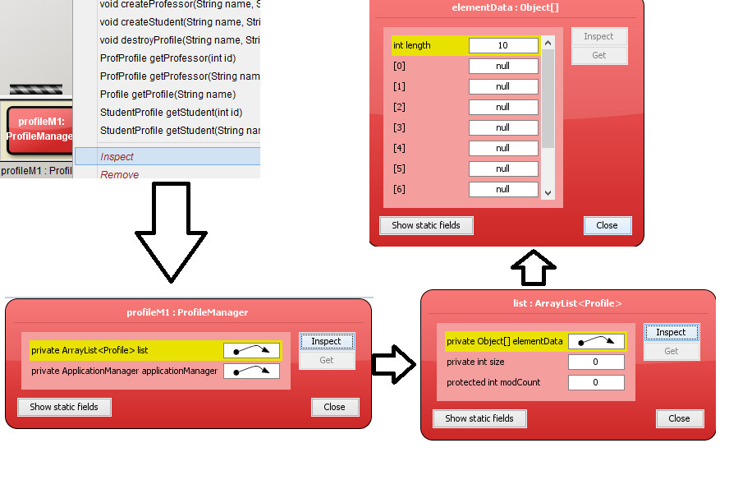
Rationale of System Changes
For the majority of the class implementations, the choices in the previous iteration reports were fine to implement. However, as is often the nature in theoretical programs that become actual, many unforseen issues arose, which made it necessary to introduce new methods, especially for accessing private variables. It also became necessary to introduce new methods to account for the other missing sub-systems, which were not implemented, or else the system would not work.
The decision to make a seperate class for comments, ratings, and CV references was made to allow additional info , such as date and author, to be properly formatted and displayed in a visually pleasing manner.
Other than these minor changes, the system was the same as theorized, with the exception of the "Classes" for the ApplicationManager and ProfileManager, which were included to both make clear which sub-systems were being implemented, and to show how their interaction would work in a complete system .

