AI in Risk Management and Fraud Detection

P.Jaycee Immaculate
I M.Sc. Computer Science
PG Department of Computer Science
A.P.C.Mahalaxmi College For Women
Thoothukudi, Tamil Nadu, India
jayceeimmaculate@gmail.com

Abstract
In the current digital business environment, commercial businesses are experiencing growing difficulties in financial risk management and fraudulent activity detection. The increasing number of online transactions, digital payments, and financial operations makes it difficult for traditional risk management approaches to be effective and efficient. In this scenario, Artificial Intelligence (AI) provides useful assistance to commercial businesses by improving the analysis of large amounts of financial and transactional data. From a commercial business point of view, AI assists in the detection of risk patterns, transaction behavior, and suspicious activities at an early stage. By continuously learning from historical and real-time data, AI systems increase accuracy in fraudulent activity detection. The deployment of AI also enhances internal control systems, reduces financial losses, and improves efficiency. Moreover, accurate fraudulent activity detection increases customer trust and protects the reputation of an organization. In summary, the deployment of AI in risk management and fraudulent activity detection helps to promote safe financial practices, enhanced business sustainability, and growth in a technology-driven commercial environment.

Keywords:Artificial Intelligence, Business Sustainability, Financial Risk Control, Fraud Identification, Smart Data Usage, Transaction Monitoring…

1. Introduction
In recent years, due to the rapid increase of digital businesses and financial transactions, there are various types of financial risks and fraudulent activities that are being encouraged. Nowadays, businesses conduct their operations in a very competitive environment that is largely technological. It is important to note that even small types of financial irregularities can cause big losses to the businesses, making it very challenging to handle these issues by applying the conventional risk management and fraud detection mechanisms that largely involve manual checking of data.
Artificial Intelligence (AI) has proved to be an effective tool in addressing some of these challenges in the commerce and finance industries. Through the utilization of tools like machine learning and data analytics in pattern recognition, Artificial Intelligence enables businesses to process large data sets in finance in a more efficient and accurate manner. When considered in relation to commerce, Artificial Intelligence can be useful in risk assessment, internal controls, and decision-making. Therefore, the incorporation of Artificial Intelligence in managing risks and fraud is helpful in reducing financial losses and promoting sustainability in conducting business.

2. Background and Related Works
Due to the prevalence of digital financial services today, classical approaches to managing financial risks and preventing fraud are becoming obsolete. This necessitates a move towards research studies that address the applications of Artificial Intelligence in these fields. A number of recent research studies discuss the applications of machine learning and predictive analytics in enhanced financial risk assessment and timely fraud detection using these approaches. A study by Kacheru et al. (2025) discussed how AI can improve predictive analytics and fraud detection systems.
The research of Majumder (2024), which is based in the field of banking, reveals that subtle patterns of risks can be identified via artificial intelligence methods and can provide enhanced credit risk evaluation beyond human evaluations. Other research carried out in Indian financial institutions revealed that machine learning techniques, like Support Vector Machines and decision trees, aid in detecting suspicious transactions in meeting financial standards.
At the same time, through systematic literature reviews the following facts are to be pointed out: AI-based computational methods such as anomaly detection and neural networks are employed for the detection of financial frauds through the most commonly employed methods such as artificial neural networks to analyze the transaction behavior. These facts cater to the proposed notion of how AI not only improves the rate of accuracy in the detection of frauds but also helps organizations to become stronger against various schemes of fraudulent activities.

3. Methodology
The following research will follow a descriptive and analytical approach, through which the role of Artificial Intelligence can be discussed in risk management and fraud detection from a commerce perspective. The primary source of information is secondary data collected from research journals, academic articles, reports, and good online publications published on the topic of AI applications in finance and business risk management. The primary focus has been on developing an understanding of how AI-based techniques, like machine learning, predictive analytics, and transaction monitoring, contribute to the identification of financial risks and fraudulent activities. The review of existing models and frameworks discussed in earlier studies has been done in terms of their applicability to commercial organizations. The qualitative analysis approach has been performed on the data collected to determine common trends, benefits, and limitations of AI usage in financial risk management. The methodology developed tends to be quite helpful in conceptual understanding of AI-based risk management practices and their influence on fraud prevention in modern business realms.

4. Role of Artificial Intelligence in Risk Management
Artificial Intelligence has emerged as an important tool in strengthening risk management practices in commercial organizations. As digital transactions have increased manifold, along with a boost in complex business operations, traditional risk management approaches lack the ability to portray their efficiency in risk identification on time. This is the challenge AI responds to, as it permits automated analysis of huge volumes of financial and transactional data with better accuracy and at faster rates. By using machine learning algorithms and predictive analytics, AI helps organizations identify risk patterns, assess potential financial threats, and support informed decision-making.
From a commerce perspective, the use of AI enhances financial risk assessment through its analysis of behavior of customer, past transactions, and market trends. Predictive models help business enterprises anticipate their future risks by recourse to preventive actions instead of corrective actions after losses have already been incurred. Continuous risk monitoring supported by AI also enables organizations to respond promptly to evolving conditions of risk. In summary, AI makes proactive risk management data-driven, ensuring better financial stability and increased operational efficiency in recent business environments

4.1 Proposed AI-Based Solution for Risk Management and Fraud Detection
The proposed solution is based on the adoption of an AI-based risk management and fraud detection solution in various commercial organizations. This solution uses machine learning and predictive analytics to continually monitor financial transactions and recognize unusual or suspicious patterns. It effectively uses the power of data to learn from historical data or ongoing data to evaluate the risk of fraud, enabling the detection of possible fraud in its early stages.
From the business point of view, the application of this AI-oriented method helps reduce the need to rely on human verification, avoids making financial losses, and enhances the current internal control environment. Identifying financial fraud helps the organization take timely corrective actions and build customer confidence. The suggested solution facilitates the processing of risk, aids sound business decisions, and enhances safe and sound financial practices in the tech-savvy business environment.

Figure 1. AI-Based Risk Management Flowchart
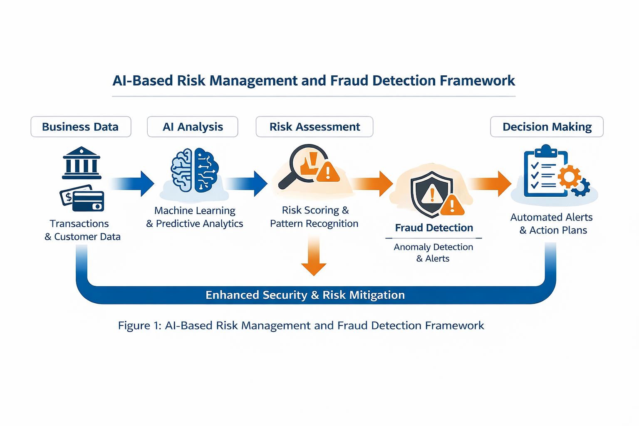
Figure 1 shows an AI-based framework used in commercial organizations for conducting risk management and fraud detection. This discusses how to analyze the financial data by using machine learning-based techniques for risk level assessment and detection of suspect activities. The system generates automated alerts that will support timely managerial decisions; this will help the businesses to reduce fraud, improve internal controls, and finally maintain secure financial operations.

4.2 Benefits of AI-Based Risk Management and Fraud Detection
The implementation of AI systems to manage risks and detect fraud is advantageous to commercial organizations. The first advantage is that the implementation leads to greater accuracy in verifying risks and fraud. This is because AI systems process huge amounts of information without the possibility of error. The risk of loss is also mitigated as AI systems detect any inconsistencies early enough.

Table 1. Comparison of Traditional and AI-Based Risk Management Approaches
Aspect | Traditional Risk Management | AI-Based Risk Management
Data handling | Limited and manual analysis | Large-scale automated data analysis
Risk identification | Reactive and time-consuming | Proactive and real-time
Fraud detection | Rule-based and less flexible | Pattern-based and adaptive
Accuracy level | Moderate | High
Operational efficieny | Low | Improved
Decision-making support | Delayed | Faster and data-driven

Table 1 gives some insight into the fundamental differences between traditional and AI risk management methods use cases. Comparing the two reveals that AI has the advantage in accuracy, quicker risk identification, and better efficiency. AI helps in the analysis and subsequently in the detection of fraud, thus enhancing risk handling in business organizations.
Operational efficiency is also enhanced by the ability to minimize reliance on manual checks. In this regard, the role of AI is to increase the number of employees who participate in strategic decision-making. Risks handled using AI: In business management, an effective way of handling risks involves the strengthening of internal control systems. There is also the aspect of regulatory compliance. Another aspect is the role played by efficient fraud detection in enhancing customer confidence. In one way or another, the use of AI leads to cost reduction and the long-term sustainability of a business in a competitive environment.

4.3 Challenges and Limitations
Although the advantages of the AI-based risk management systems and the efficiency of the systems in the detection of fraudulent activities have been established, there are challenges that affect the adoption of the systems by business organizations, despite the benefits associated with the systems. Firstly, the expensive nature of the AI systems could act as a significant challenge to the adoption of the systems, particularly to small and medium-sized businesses. The efficiency of the risk management systems also relies on the availability of enough data.
Similarly, another limitation in the implementation or use of AI would be the absence of skilled individuals who are able to efficiently design, supervise, and/or interpret AI-based systems that can be used in managing risks as well as in fraud detection. There are concerns regarding ethical variables, including data privacy, security, and bias, which create limitations of trust as well as transparency. Moreover, an over-reliance on AI can limit human capabilities in particular decisional conditions.

4.4 Managerial Implications
The adoption of AI-based systems for the purpose of risk management and fraud detection is a significant event that will have considerable implications for the manager of a commercial enterprise. Because AI possesses the ability to deliver timely and precise information on risks, the manager could make decisions that could result from the utilization of AI-generated information on risks. In this sense, the manager could take preventive measures against potential financial risks.

From the manager's point of view, AI is beneficial in the improvement of internal control mechanisms and ensuring regulatory compliance. Managers can effectively manage their resources by reducing the use of manual monitoring techniques and shifting their attention to effective risk planning strategies. Further, AI can help managers ensure the trust of the firm's customers through effective and secure financial operations. Therefore, AI allows managers to align the strategies of managing risks with the goals of the business and achieve efficiency in the operations of the business for the purposes of sustainable development amidst the business environment that is competitive and driven by technologies.

5. Conclusion and Future Scope
This paper underlines the ever-increasing significance of Artificial Intelligence in enhancing the processes of risk management and fraud detection within business entities. As explained in the article, the analysis proves the capability of Artificial Intelligence to not only speed up the procedures of risk detection but also improve the precision of fraud detection and decision-making through the processes of management.
However, despite the benefits associated with the use of AI, there remain a number of challenges to address these risks and challenges as well. In the future, further research aims to explore the development of more transparent models for the use of AI to increase the level of trust. There is also the possibility for further research to move into the future and explore the possibility of combining AI with other technological concepts like blockchain to control fraud risks. All in all, in the future, the increased use of AI is bound to play a crucial role in the promotion and sustenance of safer business practices.
This study concludes that AI-based risk management and fraud detection systems play a crucial role in strengthening financial control, improving decision-making, and enhancing organizational trust. In the future, the adoption of explainable AI, integration with emerging technologies, and expansion across diverse commercial sectors can further improve transparency, efficiency, and sustainability in risk management practices.

References

- Albrecht, W. S., Albrecht, C. O., Albrecht, C. C., & Zimbelman, M. F. (2016). Fraud Examination. Cengage Learning.
- Bhasin, M. (2015). An empirical investigation of the role of computer-based fraud detection tools. International Journal of Accounting and Financial Reporting, 5(1), 55–79.
- Deloitte. (2021). AI in Risk Management: Transforming the Future of Risk. Deloitte Insights.
- Kshetri, N. (2018). Artificial intelligence in finance: Uses, challenges, and ethical concerns. IEEE Computer, 51(9), 40–47.
- PwC. (2020). Risk Management in the Age of Artificial Intelligence. PricewaterhouseCoopers Report.
- Ryman-Tubb, N., Krause, P., & Garn, W. (2018). How Artificial Intelligence and Machine Learning Research Impacts Payment Card Fraud Detection. Journal of Financial Crime, 25(2), 423–436.
- Sutton, S. G., Holt, M., & Arnold, V. (2016). The reports of management accountants: Moving toward artificial intelligence. Journal of Accounting Literature, 36, 67–80.
- World Economic Forum. (2020). Global Technology Governance: AI and Financial Risk Management. WEF White Paper.
- Yoon, K., Hoogduin, L., & Zhang, L. (2015). Big data as complementary audit evidence. Accounting Horizons, 29(2), 431–438.
- Zarsky, T. (2016). The trouble with algorithmic decisions: An analytic road map to examine efficiency and fairness in automated and opaque decision making. Science, Technology, & Human Values, 41(1), 118–132.

