AgroShield AI: A Silent Smart Crop Protection System

Vikashini S T¹ Gowri M¹ Maheswari M¹ Jaycee Immaculate P¹
¹ Department of Computer Science
II M.Sc. Computer Science
A.P.C.Mahalaxmi College For Women,
Thoothukudi, Tamil Nadu, India
Academic Year: 2026 – 2027
Guide / Mentor:
Dr.S.Sankaravadivu
Assistant Professor
Department of Chemistry.

Abstract
Agriculture plays a vital role in ensuring food security; however, farmers continue to face significant crop losses due to uncontrolled wild animal intrusions, pest attacks, and the late detection of plant diseases. In severely affected regions, crop losses can reach up to 50–60%, while conventional protection methods such as electric fencing and chemical deterrents are often expensive, labor-intensive, and harmful to both humans and wildlife. These challenges particularly affect smallholder farmers, home gardeners, and urban terrace gardeners, creating a need for an affordable, intelligent, and sustainable crop protection solution. To address these issues, AgroShield AI: A Silent Smart Crop Protection System, developed by Team Lady Launchers 2.0, introduces an innovative Product-Service System (PSS) that integrates an owl-shaped smart hardware device with a dedicated mobile application and web dashboard. The proposed system leverages Artificial Intelligence (AI), the Internet of Things (IoT), and TinyML running on an ESP32 microcontroller to provide real-time animal identification and intelligent crop monitoring. Unlike conventional motion detection systems, AgroShield AI distinguishes between different animal species, such as wild boars, monkeys, and elephants, as well as humans, and activates species-specific ultrasonic sound waves to safely deter intruders without causing physical harm. In addition to animal protection, the device continuously monitors environmental conditions through soil moisture, temperature, humidity, and other sensors while incorporating an AI-powered plant disease detection module that recommends suitable organic treatments. Designed as an affordable solution for small-scale farmers and urban gardeners, AgroShield AI combines intelligent monitoring, real-time alerts, cloud connectivity, and sustainable farming practices into a single integrated platform. By replacing hazardous traditional methods with ethical, AI-driven crop protection and proactive plant health management, the proposed system aims to improve agricultural productivity, enhance urban food security, and promote environmentally responsible coexistence between humans and wildlife.
Keywords: Artificial Intelligence, Internet of Things, TinyML, Smart Agriculture, Crop Protection, ESP32, Plant Disease Detection, Sustainable Farming, Product-Service System.

TABLE OF CONTENTS

S.NO | TOPICS
1. | Introduction
2. | Evidence & Market Research
3. | Proposed Solution - AgroShield AI
4. | System Design & Working Mechanism
5. | Implementation & Feasibility
6. | Business & Market Strategy
7. | Social & Economic Impact
8. | Conclusion & Future Scope
1. INTRODUCTION

1.1 Problem Statement
The agricultural sector faces a critical challenge as farmers lose significant portions of their crops to uncontrolled animal intrusion and the late detection of leaf diseases. Traditional crop protection methods, such as electric fencing or chemical deterrents, are often prohibitively expensive, labor-intensive, and unsafe for both humans and wildlife. Furthermore, these existing solutions are frequently ineffective at providing real-time alerts or multi-functional monitoring. There is an urgent need for a smart, affordable, and eco-friendly solution that can proactively protect crops while simultaneously monitoring plant health to prevent losses from disease.

1.2 Problem Validation
Research and field studies highlight the severity of human-animal conflict in agriculture:
- Widespread Impact: In surveyed areas, 57% of participants reported frequent wild pig conflicts, and over 90% considered wildlife a major risk to their agricultural livelihood.
- Economic Losses: In severely affected regions, farmers face 50–60% crop loss, which significantly reduces their income and lowers overall agricultural productivity.
- Primary Threats: Data indicates that wild boars are the most destructive animals, followed by cattle and monkeys.
- Geographic Risk: Crop damage is highest in farms adjacent to forest areas, particularly in the Western and Eastern Ghats of Tamil Nadu.
- Compensation Trends: In Tamil Nadu, the financial compensation required for crop damage caused by wildlife has recorded its highest figures in ten years, underscored by the fact that payouts for crop loss often exceed those for human casualties. This intensity of conflict is reportedly forcing some farmers to retreat from agriculture entirely.

1.3 Target Sector
The primary focus of this project is the Agriculture sector, specifically addressing the needs of those most vulnerable to crop loss. The target audience includes:
- Smallholder and Medium-scale Farmers: Those who require affordable technology to protect their primary source of income.
- Plantation and Orchard Owners: Large-scale growers who face significant risks from larger wildlife intrusions.
- Farmers Near Forest Borders: Individuals operating in high-risk zones where human-animal conflict is most frequent.
- Urban and Home Gardeners: A growing segment of terrace, balcony, and boutique organic growers who need to protect their crops from local pests and birds.
- Institutional Stakeholders: Government agriculture and forest departments, as well as Farmer Producer Organizations (FPOs) looking for sustainable co-existence models.

2. EVIDENCE & MARKET RESEARCH
2.1 Impact Analysis & Economic Evidence
The economic toll of human-wildlife conflict has reached unprecedented levels, particularly in Tamil Nadu.
- Rising Compensation Costs: In the 2023-24 period, Tamil Nadu recorded its highest crop damage figures in ten years. Notably, the financial compensation paid for crop loss due to wildlife is now significantly higher than that paid for human casualties, injuries, and property damage combined.
- Farmers Retreating from Agriculture: Investigative reports indicate that increasing conflict is forcing many farmers to abandon cash crops like maize, pulses, vegetables, and groundnut because the risks are too high. In some regions, up to 62% of farmers have reduced their cultivation area due to these persistent threats.
- Government Response: The crisis is severe enough that the Ministry of Agriculture has officially recognized crop loss from wild animal attacks as a fifth add-on risk category under the Pradhan Mantri Fasal Bima Yojana (PMFBY) starting in 2026.

2.2 Field Study & Research Data
Extensive surveys were conducted to validate the problem across various agricultural zones:
- Survey Participants: Research included a survey of 1,460 villagers in the Eastern and Western Ghats, interviews with 120 farmers in the Nilgiris, and a survey of 128 farmers in various Tamil Nadu forest ranges.
- Key Findings:
  - 90%+ of farmers consider wildlife a major agricultural risk.
  - 57% reported frequent conflicts specifically with wild pigs.
  - Crop losses in the most severely affected areas range between 50% and 60%.
- Top 10 Affected Districts (Tamil Nadu): The districts facing the highest annual crop damage from wild animals are Tiruppur (highest), followed by Erode, Coimbatore, Tiruvannamalai, Kancheepuram, Chengalpattu, Krishnagiri, Madurai, Namakkal, and Tiruchirappalli.
- Crops at Risk: Data shows that Vegetables are the most frequently damaged crop, followed by groundnut, millets, maize, paddy, and bananas.

2.3 Market Segmentation & Target Audience
The market for AgroShield AI is divided into three primary categories:
- TAM (Total Addressable Market): All farmers across India.
- SAM (Serviceable Addressable Market): Farmers specifically located in wildlife-prone areas.
- SOM (Serviceable Obtainable Market): Farmers in Tamil Nadu during the initial pilot phase.
- Ideal Customer Profile: The target customer is typically 25–65 years old, falls into the low-to-middle income bracket, and operates a farm or plantation near forest borders. They are smartphone users who are increasingly willing to adopt smart farming technologies to protect their livelihood.

2.4 Competitor Analysis & Pricing
AgroShield AI is positioned as a superior, more affordable alternative to current market solutions:
- Current Alternatives: Farmers currently use traditional solar owl decoys (priced between ₹4,000–₹10,000) or electric fencing (costing upwards of ₹89,000).
- The Advantage: Unlike competitors, AgroShield AI provides AI-based animal identification rather than just motion detection. It is the only solution in its class to offer species-specific ultrasonic deterrence, real-time mobile alerts, plant disease diagnostics, and soil moisture monitoring in a single device.
- Value Proposition: Priced at ₹1499, AgroShield AI is significantly more cost-effective while offering a broader range of features that traditional repellents lack.

3. PROPOSED SOLUTION - AGROSHIELD AI
3.1 System Overview
AgroShield AI is designed as a comprehensive Product-Service System (PSS) that bridges the gap between physical deterrents and digital monitoring. The solution consists of two primary integrated components:
- Product (Hardware): An AI-powered Smart Owl Device equipped with an ESP32 controller, various environmental sensors (Soil Moisture, DHT22, PIR, Ultrasonic, Microphone), and mechanical components like a servo motor and piezo speaker.
- Service (Software): A Flutter-based mobile application and web dashboard that provide AI predictions, real-time monitoring, push notifications, and detailed crop protection recommendations.

3.2 Innovation & Technology Integration
The project utilizes a sophisticated technology stack to ensure autonomous and accurate operation:
- Edge AI (TinyML): The system runs TinyML on an ESP32 embedded controller to perform real-time animal classification directly on the device. This allows the system to identify specific species—such as wild boars, monkeys, deer, cattle, or elephants—rather than just detecting generic movement.
- Intelligent Multi-Sensor Monitoring: The device uses a combination of PIR sensors for motion detection and KY-037 microphones for acoustic analysis to confirm threats. HC-SR04 ultrasonic sensors are used for precise distance measurement to target intruders effectively.
- IoT & Cloud Computing: Data is synchronized with a Cloud-Based Management system, allowing farmers to receive instant alerts and view detection history from anywhere.
- Closed-Loop Deterrence: Upon identifying an animal, the device uses a 360° servo motor to orient itself toward the threat and triggers a piezo ultrasonic speaker to emit a targeted frequency.

3.3 Unique Value Proposition (UVP)
AgroShield AI offers several distinct advantages that set it apart from traditional agricultural security measures:
- Species-Specific Response: The system is not a one-size-fits-all alarm; it generates customized ultrasonic frequencies based on the specific animal detected, maximizing the effectiveness of the deterrent.
- "It's Me" Human Filter: A smart verification feature identifies the farmer, ensuring that deterrence mechanisms are bypassed when the authorized owner is present, thereby preventing false alerts.
- Multi-Functional Monitoring: It is an all-in-one tool that provides AI plant disease diagnostics (allowing farmers to photograph leaves for early detection) and real-time soil moisture monitoring alongside its protection features.
- Ethical & Eco-Friendly Design: The system replaces hazardous methods like electric fencing and chemical poisons with 100% safe, non-harmful ultrasonic waves. It is solar-powered, silent to humans, and designed to foster a workable model of coexistence between farmers and wildlife.

4. SYSTEM DESIGN & WORKING MECHANISM
The design of AgroShield AI integrates advanced hardware components with a cloud-linked software ecosystem to provide a seamless crop protection experience.

4.1 Design Architecture
The AgroShield AI Smart Owl Device is designed using a biomimetic architecture, inspired by the natural appearance and behavior of an owl to provide an effective and eco-friendly crop protection solution. The realistic owl-shaped enclosure acts as a visual deterrent to birds and small animals while serving as a protective housing for the embedded electronic components. The external body is designed with an aerodynamic profile and textured surface, enabling the device to blend naturally into agricultural environments while maintaining durability under outdoor conditions.
The device incorporates a 360-degree rotating head mechanism powered by a servo motor, allowing realistic directional movement that mimics the natural behavior of an owl. This dynamic motion enhances the deterrence capability and improves monitoring of the surrounding area. Passive airflow channels are integrated into the enclosure to facilitate natural ventilation and heat dissipation, ensuring stable operation of the internal electronic components during continuous use.
The body structure is engineered to provide balanced weight distribution, mechanical stability, and resistance to environmental factors such as wind and light rain. The wings and tail are designed to improve structural balance and support the overall stability of the device when installed in gardens or agricultural fields. The reinforced base provides secure mounting and minimizes vibrations during operation.
Internally, the enclosure follows a modular architecture that efficiently accommodates the ESP32 microcontroller, ultrasonic sensor, PIR motion sensor, soil moisture sensor, temperature and humidity sensor, microphone, speaker, communication module, servo motor, and power management circuitry. This organized internal layout simplifies maintenance, enhances system reliability, and allows future hardware expansion without significant structural modifications.
The overall design architecture focuses on durability, intelligent functionality, ease of deployment, and environmental adaptability. By integrating biomimetic design principles with Artificial Intelligence, IoT, and embedded systems, AgroShield AI provides a compact, reliable, and sustainable smart crop protection solution specifically designed for home gardens, kitchen gardens, terrace gardens, and small-scale farming applications.

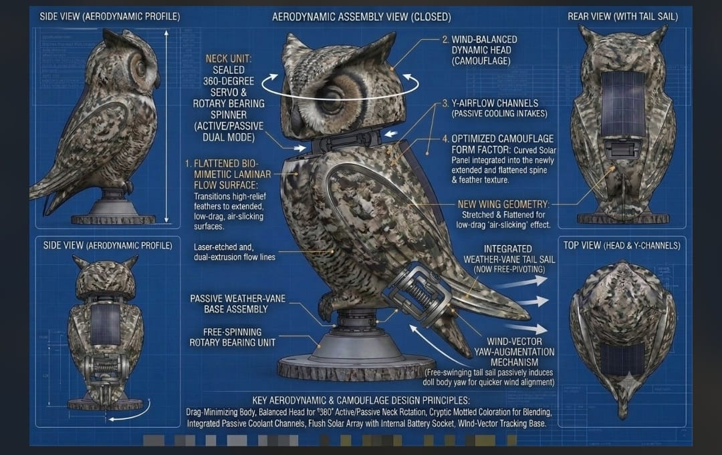
Figure 3.1: Design Architecture of AgroShield AI – Owl-Shaped Smart Crop Protection Device

4.2 Hardware Components & Architecture
The physical unit is a Smart Owl Device designed for outdoor durability and efficient electronic integration. The core hardware architecture includes:
- Central Processing: An ESP32 Embedded Controller integrated with TinyML to perform on-device AI animal classification.
- Detection Sensors:
  - PIR Sensor: Used for initial motion detection of warm-bodied intruders.
  - HC-SR04 Ultrasonic Sensor: Positioned in the owl’s "eyes" for precise distance measurement to target intruders.
  - KY-037 Microphone: Placed in the "mouth" to capture animal sounds for acoustic classification.
- Environmental Sensors: Includes a Soil Moisture Sensor for ground analysis and a DHT22 Sensor for real-time temperature and humidity monitoring.
- Mechanical Actuators:
  - 360° Servo Motor: Allows for horizontal head rotation to track and face the detected intruder.
  - Piezo Ultrasonic Speaker: Acts as the repellent by emitting species-specific frequencies.
- Power System: A Solar Panel mounted on the device coupled with a 5V Battery Pack ensures continuous, eco-friendly operation.
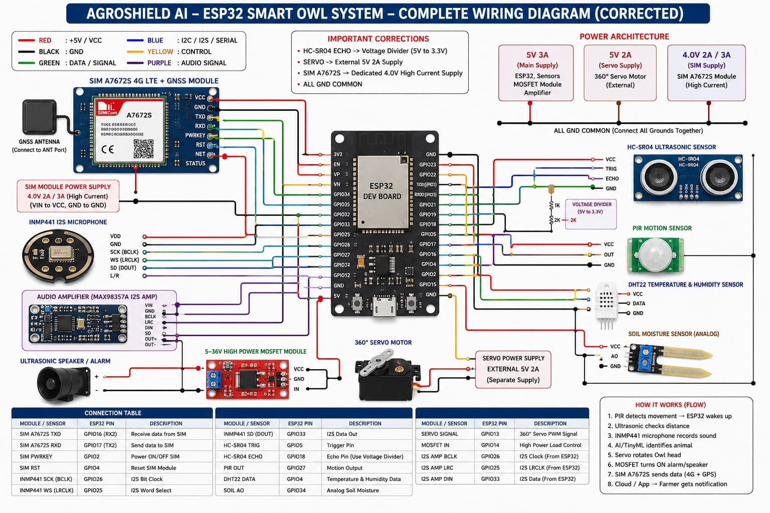
Figure 4.2: Hardware Architecture and Wiring Diagram of the AgroShield AI Smart Crop Protection System

4.2 Software Architecture
The service layer of the system consists of a Flutter-based mobile application and a comprehensive Web Dashboard.
- AI Diagnostics: A dedicated module for AI Plant Disease Diagnostics allows farmers to upload photos for early blight detection and receive organic treatment recommendations.
- Cloud Connectivity: All detection history and sensor data (such as soil moisture percentages) are stored in a Cloud-Based Data Management system for long-term analytics.
- Real-Time Alerts: The system pushes instant notifications to the user's smartphone regarding animal intrusions or critical environmental thresholds, such as low soil moisture.

4.3 Working Process Flow
The system follows a logical 10-step sequence to ensure accurate and ethical deterrence:
- Motion Detection: The PIR sensor identifies a warm-bodied movement.
- Distance Measurement: The HC-SR04 sensor determines how far the intruder is from the crops.
- Acoustic Capture: The KY-037 microphone captures the specific sound profile of the intruder.
- Edge AI Processing: The ESP32 with TinyML processes the sensor data to identify the entity.
- Classification: The AI categorizes the intruder (e.g., Human, Wild Boar, Monkey, Deer, Cow, or Elephant).
- Verification Logic:
  - If Human: The mobile app sends a notification asking "Is this you?". If the user confirms, the system remains silent; otherwise, it enters intruder mode.
  - If Animal: The system bypasses human verification and proceeds to deterrence.
- Targeted Orientation: The 360° Servo motor rotates the head to face the animal.
- Active Deterrence: The Piezo speaker generates a frequency specific to that animal species to encourage it to leave safely without physical harm.
- Cloud Logging: The detection event is recorded in the cloud.
- Farmer Reporting: The user receives a detailed report and real-time notification of the successful deterrence event.

5. IMPLEMENTATION & FEASIBILITY
5.1 Product Development Roadmap
The implementation follows a structured Product Development Engine Pipeline consisting of eight critical phases:
- Resource Collection: Procurement of hardware including ESP32, sensors, solar panels, and batteries. This stage also involves gathering audio datasets for various pests (rats, crows, pigeons) and researching 3D modeling files for the device exterior.
- Exterior Prototyping: Designing and 3D printing the exterior owl shell, incorporating alignment tabs and mounting zones for durability and ease of assembly.
- Hardware Assembly: Physical assembly of components, including routing internal wiring, connecting sensors to the ESP32 board, and fitting the solar power system.
- Software Development: Programming the baseline firmware logic and developing the local web dashboard architecture, including the "wireless bypass" function for authorized users.
- Hardware & Software Integration: Flashing the code onto the assembled hardware and ensuring that the sensors, servo, and buzzer trigger correctly in a closed-loop system.
- Testing & Model Training: Collecting real-world pest audio to train the Edge Impulse TinyML audio model, which is then deployed onto the ESP32 to fine-tune the species-specific ultrasonic frequencies.
- Beta Testing & App Rollout: Deploying initial units in real terrace gardens to test weatherproofing and technical performance, while launching the app to trial users for analytical monitoring.
- Market Launch: Scaling production for a full retail launch at the ₹1499 price point, pushing the mobile app to app stores, and offering premium software modules.

5.2 Prototype & MVP Status
The project has moved past the ideation phase into a designed prototype status. The Minimum Viable Product (MVP) is defined by its core functionality:
- Core Edge AI: On-device animal classification.
- Closed-Loop Deterrence: Automated tracking and ultrasonic response.
- Free Trial Dashboard: Initial software interface for users to monitor their crops.

5.3 Technical & Economic Feasibility
The launch of AgroShield AI is considered highly feasible due to several strategic factors:
- Low-Cost Components: The hardware and software components used are incredibly low-cost, with an estimated total production cost of ~₹900 per unit (₹600 for hardware and ₹300 for software development).
- Resource Availability: All necessary parts are readily available in bulk wholesale markets across India, ensuring a stable supply chain for scaling.
- Hyper-Lean Software Overhead: The system is designed for efficiency, requiring minimal computational power and keeping operational expenses low (estimated at ₹150 to ₹200 per user/month).

6. BUSINESS & MARKET STRATEGY
6.1 Market Segmentation & Target Audience
The market strategy is focused on identifying high-risk agricultural zones and specialized gardening segments:
- TAM (Total Addressable Market): All farmers across India.
- SAM (Serviceable Addressable Market): Farmers specifically located in wildlife-prone areas.
- SOM (Serviceable Obtainable Market): Farmers in Tamil Nadu during the initial pilot phase.
- Target Customers: Smallholder and medium-scale farmers, plantation and orchard owners, Farmer Producer Organizations (FPOs), and government departments.
- Urban Segment: Boutique small-scale organic growers, urban terrace hobbyists, and balcony gardeners who need overnight protection for crops.
- Ideal Customer Profile: Farmers aged 25–65 in rural or semi-rural locations (especially near forests) who are smartphone users willing to adopt smart farming technologies.

6.2 Pricing Strategy & Competitor Analysis
AgroShield AI employs a Value-Based Prestige Pricing model to disrupt the current market.
- Competitive Pricing: The retail price for the physical device is set at ₹1,499 per unit, which is significantly more accessible than traditional solar owl decoys (₹4,000–₹10,378) or electric fencing systems (upwards of ₹89,000).
- Competitive Advantage: Unlike existing alternatives that only offer basic motion detection, AgroShield AI provides a multi-functional solution including AI animal identification, species-specific responses, real-time mobile alerts, plant disease diagnostics, and soil monitoring.

6.3 Revenue Streams
The business model utilizes a diversified approach to ensure long-term sustainability:
- Direct Product Sales: One-time purchase of the hardware unit for ₹1,499.
- SaaS Subscription Tiers (Pro Plans): Recurring revenue from premium AI modules:
  - Premium ML Pest Identification: ₹150/month or ₹1,800/year.
  - AI Plant Disease Diagnostic Module: ₹200/month or ₹2,400/year.
  - AI Soil Monitoring Module: ₹150/month or ₹1,800/year.
  - Bundled Pro Plan: All modules offered at a discounted rate of ~₹5,000/year.
- In-App Advertising: Targeted advertising for agricultural products to supplement operational costs.

6.4 Business Viability & Financial Projections
The project is designed for high profitability through lean manufacturing and low overhead:
- Production Costs: Total development cost is estimated at ~₹900 per unit (comprised of ₹600 for hardware and ₹300 for software).
- Hardware Profit Margin: The system generates approximately ₹499 to ₹500 net profit per unit on hardware sales alone.
- Operating Expenses: Monthly operational costs of ₹150–₹200 per user are intended to be fully covered by the premium SaaS subscription tiers.
- Initial Launch Projection: A modest first-batch run of 100 units is projected to generate ₹1,49,900 in gross revenue, resulting in an expected net profit of ₹49,900.

7. SOCIAL & ECONOMIC IMPACT
7.1 Urban Food Security
AgroShield AI plays a vital role in supporting the growing movement of urban agriculture. By providing a dedicated solution for rooftop and terrace gardens, the system:
- Protects urban harvests from local pests and birds during overnight hours.
- Encourages sustainable local food production, ensuring that urban and boutique organic growers can successfully harvest what they plant without the threat of unexpected loss.

7.2 Proactive Financial Relief
The system offers a proactive alternative to traditional reactive measures like insurance claims:
- Preventing Losses: It is designed to save boutique and small-scale growers from devastating crop losses before they occur, which is more effective than seeking compensation after the damage is done.
- Bypassing Complexity: By preventing the intrusion entirely, farmers can avoid the complex and often lengthy insurance claim processes typically associated with agricultural damage.
- Income Stability: By reducing the 50–60% crop loss often seen in high-conflict areas, the system directly contributes to increasing and stabilizing the income of vulnerable farming families.

7.3 Ethical Deterrence & Wildlife Safety
One of the most significant social contributions of this project is the promotion of a non-violent model of human-animal coexistence:
- Safe Alternatives: AgroShield AI is designed to replace cruel and hazardous methods, such as physical poisons or dangerous high-voltage electric fencing, which can be fatal to wildlife and domestic animals.
- Non-Harmful Technology: The system uses 100% safe AI-generated ultrasonic sound waves that deter animals without causing them any physical harm or lasting injury.
- Eco-Friendly Operation: Being solar-powered and silent to humans, the device provides an environmentally sustainable security solution that respects the local ecosystem.

7.4 Contribution to Sustainable Farming
Overall, the implementation of AgroShield AI fosters more resilient agricultural practices by:
- Enhancing Productivity: Lowering the risks associated with wildlife and disease leads to higher overall agricultural productivity.
- Promoting Innovation: Bringing Edge AI and IoT technologies to smallholder farmers helps bridge the technological divide in rural sectors.
- Supporting Global Goals: By securing harvests and protecting biodiversity, the project aligns with broader goals for global food security and sustainable farming.

Conclusion
AgroShield AI represents a significant advancement in sustainable agriculture, offering an affordable, eco-friendly, and multi-functional solution to the persistent problems of crop loss and human-wildlife conflict. By integrating Edge AI (TinyML) with IoT, the system moves beyond generic motion detection to provide species-specific deterrence, ensuring that animals are repelled safely and ethically without the need for dangerous electric fences or poisons.
The project successfully demonstrates that high-technology solutions can be delivered at a low cost (₹1499), making smart farming accessible to smallholder farmers and urban gardeners alike. Beyond simple protection, the inclusion of soil monitoring and AI-powered disease diagnostics transforms the device into a comprehensive farm management tool. Ultimately, AgroShield AI empowers farmers to proactively secure their livelihoods, enhances urban food security, and fosters a workable model of coexistence between humans and nature.

Future Scope
The roadmap for AgroShield AI extends from its current prototype phase into a scalable commercial enterprise with several key areas for expansion:
- Market Expansion: Following the initial pilot phase in Tamil Nadu (SOM), the project aims to scale its reach to farmers across all wildlife-prone areas in India (SAM) and eventually the entire national agricultural market (TAM).
- Production Scaling: The next phase of the Development Roadmap involves moving from 3D-printed prototypes to large-scale manufacturing to meet retail demand.
- Enhanced AI Capabilities: Future iterations will focus on training more sophisticated TinyML models by collecting broader datasets for additional pest species and a wider variety of plant diseases.
- Software Ecosystem Growth: The project plans to launch a full suite of SaaS subscription tiers, offering premium modules for advanced pest identification, professional-grade disease diagnostics, and predictive soil analytics.
- App Store Integration: A primary goal is the official rollout of the Flutter mobile application on major app stores, providing users with a seamless, cloud-connected dashboard for real-time monitoring and historical reporting.
- Institutional Partnerships: There is potential for future collaboration with government agriculture and forest departments to implement the system as a standard tool for human-wildlife conflict mitigation.

