A Deep Learning Based Relative Sensitivity Framework for Privacy-Preserving Satellite Image Publishing
Abstract
High resolution satellite images are widely used in many geospatial applications such as urban planning, environmental monitoring, disaster management, agriculture, transportation, and critical infrastructure analysis. But the growing availability and distribution of satellite images can reveal sensitive geographic entities, posing significant privacy and security challenges. In this paper, a Relative Sensitivity-Based Privacy Preservation Framework (RSPPF) is proposed for secure satellite image publishing. In this paper, we propose a context-aware privacy decision framework that combines deep learning based geographic attribute identification, sensitivity evaluation, exposure risk assessment and adaptive privacy transformation. To measure the privacy requirement of detected geographic entities, we propose a Relative Sensitivity Score (RSS) that integrates sensitivity level, classification confidence and contextual exposure risk. The framework selects appropriate privacy-preserving transformations like blurring, pixelation and masking based on the computed RSS values, without degrading the analytical usefulness of non-sensitive regions.
A framework demonstration using representative remote sensing scenarios is used to demonstrate the operational workflow and decision-making capability of the proposed approach. The proposed framework allows for adaptive protection by considering the importance and risk of individual geographic entities, unlike traditional privacy-preserving methods that provide the same level of protection for all image regions. The framework offers a flexible means for balancing privacy preservation and image utility in the dissemination of satellite images. The proposed model can realize future developments in privacy-aware remote sensing systems, and potential applications in geospatial analysis, smart city management, environmental monitoring, and secure geographic information sharing can be found.
Keywords
Privacy of Satellite Image; Privacy-Preserving Data Publishing; Relative Sensitivity-Based Privacy Preservation Framework (RSPPF); Deep Learning; Remote Sensing; Geographic Attribute Identification; Relative Sensitivity Score (RSS); Exposure Risk Assessment; Adaptive Privacy Protection; Image Utility Preservation
1. Introduction
High-resolution satellite imagery has become an important source of information for a wide range of geospatial applications, including urban planning, environmental monitoring, disaster management, agriculture, transportation analysis, and critical infrastructure assessment. The rapid development of remote sensing technologies and the growing availability of repositories of satellite images have greatly enhanced the availability of geospatial information. However, the increasing sharing and publishing satellite images raises privacy and security concerns, as such images may reveal sensitive geographic entities and strategically important locations (Zhu et al., 2017).
Satellite imagery could hold information about military bases, airports, industrial areas, transportation systems, and other important pieces of infrastructure. Such uncontrolled dissemination of information may increase the risk of unauthorized analysis, surveillance, or misuse. Therefore, privacy-preserving mechanisms are required to enable the secure publication of satellite images while maintaining the analytical value of the original data (Fung et al., 2010).
Traditional approaches to privacy preservation like k-anonymity, l-diversity, t-closeness, and differential privacy are mostly designed for structured datasets and are not directly applicable to complex spatial imagery (Dwork, 2006; Li et al., 2007; Machanavajjhala et al., 2007; Sweeney, 2002). Techniques like blurring, pixelation, masking, and suppression that are based on images provide basic privacy protection, but these approaches tend to apply uniform transformations without taking into account the different sensitivity levels of geographic entities. Hence, stronger protection may be required for more sensitive areas, while excessive modification of less sensitive areas may lead to reduced utility of the image (Fung et al., 2010).
Recent progress in deep learning has greatly improved the analysis of remote sensing images by giving us advanced ways to extract features, classify them, and identify objects. Convolutional neural networks (CNNs), such as residual network architectures (ResNet50), are effective in extracting meaningful spatial features from satellite image data (He et al., 2016; Zhu et al., 2017). The confidence information of deep learning models can also provide valuable support for intelligent decision-making and explainable artificial intelligence applications (Adadi & Berrada, 2018). However, current privacy-preserving satellite image approaches rarely combine classification confidence, geography sensitivity, and contextual exposure risk into one privacy decision framework.
To fill this research gap, in this paper we propose a Relative Sensitivity Based Privacy Preservation Framework (RSPPF) for secure satellite image publishing. The proposed framework proposes a context-aware privacy decision architecture consisting of a deep-learning-based geographic attribute identification, sensitivity assessment, exposure risk evaluation, and adaptive privacy transformation. We propose a Relative Sensitivity Score (RSS) to measure the privacy requirement of detected geographic entities, considering the sensitivity level, classification confidence, and exposure risk. The framework dynamically chooses appropriate privacy-preserving transformations, such as blur, pixelation, or masking, based on RSS value while maintaining the usefulness of non-sensitive regions.
The proposed framework allows for adaptive privacy management by considering the relative importance and risk of each geographic entity, unlike traditional methods that apply the same protection strategy to all image regions. The framework aims to offer a flexible approach to achieving an efficient trade-off between privacy preservation and image utility in satellite image dissemination.
1.1 Contributions to Research
The main contributions to the proposed framework are summarised as follows:
1. A deep learning-based privacy preservation framework is proposed for secure satellite image publishing by integrating geographic attribute identification, sensitivity assessment, exposure risk evaluation and adaptive privacy transformation.
2. A Relative Sensitivity Score (RSS) model is introduced to integrate geographic sensitivity, deep learning classification confidence, and contextual exposure risk for privacy-aware decision-making.
3. An adaptive privacy transformation mechanism is designed for choosing appropriate protection strategies such as blurring, pixelation and masking based on the relative sensitivity of the detected geographic entities.
4. A privacy-utility balancing framework is proposed to enable secure dissemination of satellite imagery while preserving the analytical value of non-sensitive regions.
5. The proposed framework offers a basis for future privacy-aware remote sensing systems, which can be improved using state-of-the-art techniques like explainable AI, transformer-based architectures, and federated learning.
2. Related Work
Data publishing with privacy preservation has been widely studied to enable data sharing with a minimum leakage of sensitive information. The initial approaches focused on limiting identity or attribute disclosure and were mainly designed for structured data. K-anonymity guarantees that each record can be distinguished from at least k−1k−1 other records, but it is still vulnerable to homogeneity and background knowledge attacks (Sweeney, 2002). L-diversity was proposed to ensure sufficient diversity in sensitive attributes, and t-closeness was proposed to further reduce disclosure risk and maintain the statistical distribution of sensitive features (Machanavajjhala et al., 2007; Li et al., 2007). Differential privacy also offers strong formal privacy guarantees in terms of bounding the influence of any one person’s data on the published result (Dwork, 2006; Dwork & Roth, 2014).
These techniques are suitable for tabular data but are not directly applicable to satellite imagery without significant modification. Satellite images contain rich spatial and contextual information that can potentially reveal sensitive geographic entities. With the availability of very high-resolution satellite images from commercial and public sources, there is an increasing demand for image-specific privacy protection. The most common techniques for protecting image privacy are blurring, masking, pixelation, cropping, and suppression. The methods are easy to apply, but typically they protect all sensitive regions uniformly and do not account for different degrees of sensitivity across geographic entities (Fung et al., 2010).
Deep learning has improved the analysis of remote sensing images. Convolutional neural networks are known to be successful for feature extraction, object detection, land-cover classification and scene understanding. ResNet50 is widely used because it solves the degradation problem in deep networks and offers a strong classification performance through residual learning (He et al., 2016). For satellite imagery, these models are particularly useful since the appearance of objects depends on scale, resolution and environmental conditions (Zhu et al., 2017). Deep learning algorithms can not only provide the prediction accuracy but also the confidence values, which are useful in explainable AI systems. The confidence value shows how confident a model is about its output (Adadi & Berrada, 2018).
Recent advances in geospatial AI have also highlighted the advantage of explainable AI techniques and transformer-based architectures for remote sensing applications. They improve interpretability and feature representation, and they may assist future privacy-preserving frameworks in making better privacy-conscious decisions. However, existing privacy frameworks for satellite images do not consider the contextual exposure risk, classification confidence, and sensitivity in a unified adaptive decision model. This gap motivates the proposed RSPPF.
2.1 Research Gap
The literature has limitations. First, traditional privacy-preserving techniques like K-anonymity, L-diversity, T-closeness, and differential privacy were designed for structured data and cannot be directly applied to satellite images. Second, many image-based privacy methods apply uniform modifications without considering different sensitivity levels of geographic entities. Third, deep learning-based remote sensing systems rarely consider the contextual exposure risk and the classification confidence when making privacy decisions.
These limitations call for the development of a framework that combines contextual exposure risks, deep learning confidence, and spatial sensitivity into a singular adaptive model. The framework includes techniques for pixelation, masking, and selective blur. This paper proposes a relative sensitivity-based privacy preservation framework to address this need. The framework seeks to improve the protection of highly sensitive geographic elements while preserving image utility.
2.2 Comparison of studies
Existing privacy-preserving methods for satellite imagery suffer from several shortcomings. Existing approaches mainly focus on generic anonymisation or homogeneous transformation, ignoring the contextual relevance of geographical entities. Table 1 illustrates a comparison of representative privacy-preserving strategies and highlights the advantages of the proposed RSPPF.
Table 1 : Conceptual comparison of privacy preserving methods
Method | Satellite Image Support | Contextual Sensitivity | DL Confidence Utilization | Exposure Risk Assessment | Adaptive Protection | Utility Preservation
K-anonymity (Sweeney, 2002) | No | No | No | No | No | Moderate
L-diversity (Machanavajjhala et al., 2007) | No | No | No | No | No | Moderate
T-closeness (Li et al., 2007) | No | No | No | No | No | Moderate
Differential Privacy (Dwork, 2006) | Partial | No | No | No | Limited | Low
Blur-Based Protection | Yes | No | No | No | No | Moderate
Pixelation Techniques | Yes | No | No | No | Limited | Moderate
Region-Based Protection | Yes | Partial | No | Partial | Yes | Good
Proposed RSPPF | Yes | Yes | Yes | Yes | Yes | Excellent
This comparison shows that the proposed framework is more comprehensive as it incorporates contextual exposure risk assessment, adaptive transformation, and deep learning-based geographic entity identification into a single unified system. It also maintains the image utility by integrating sensitivity evaluation, classification confidence, and exposure risk analysis.
Recent studies have further expanded the scope of privacy preservation in geospatial and remote sensing environments using privacy-aware deep learning and federated learning techniques. Boulila et al. (2022) proposed a hybrid privacy-preserving deep learning framework for object classification in very high-resolution satellite imagery by combining an encryption mechanism with deep learning inference. However, this method provided better data confidentiality, but it did not include adaptive privacy transformation in terms of geographic sensitivity. Furthermore, Zhu et al. (2023) proposed a privacy-preserving federated learning framework for remote sensing image classification to collaboratively train models without sharing data directly. Zhang et al. (2023) further improved the privacy guarantees by local differential privacy-based federated learning for deep learning-driven remote sensing applications. These methods protect both the training data and the model parameters. These methods focus on secure learning environments but not on privacy-preserving publication of satellite imagery. On the other hand, the proposed RSPPF directly supports the secure dissemination of satellite images by integrating the assessment of geographic sensitivity, classification confidence, and exposure risk within a comprehensive RSS.
3. Proposed Relative Sensitivity-Based Privacy Preservation Framework
The proposed Relative Sensitivity-Based Privacy Preservation Framework (RSPPF) aims to achieve context-aware and flexible privacy preservation for publishing satellite images.
This framework differs from traditional approaches that offer uniform protection levels to the entire image by tailoring privacy decisions to the sensitivity and disclosure risk associated with specific geographic entities (Fung et al., 2010; Dwork & Roth, 2014). The framework uses RSS as a quantitative measure for assessing privacy requirements. RSS has three key components: exposure risk, classification confidence, and sensitivity level. The RSS values are used to determine appropriate privacy-preserving modifications for image regions that contain sensitive geographical elements.
Figure 1 shows that the proposed system has five main modules: geographic attribute identification, sensitivity assessment, exposure risk evaluation, RSS computation engine, and adaptive privacy protection. Together, these modules provide intelligent privacy management without compromising the analytical value of satellite imagery.
Figure 1. Proposed Relative Sensitivity Based Privacy Preservation Framework Architecture
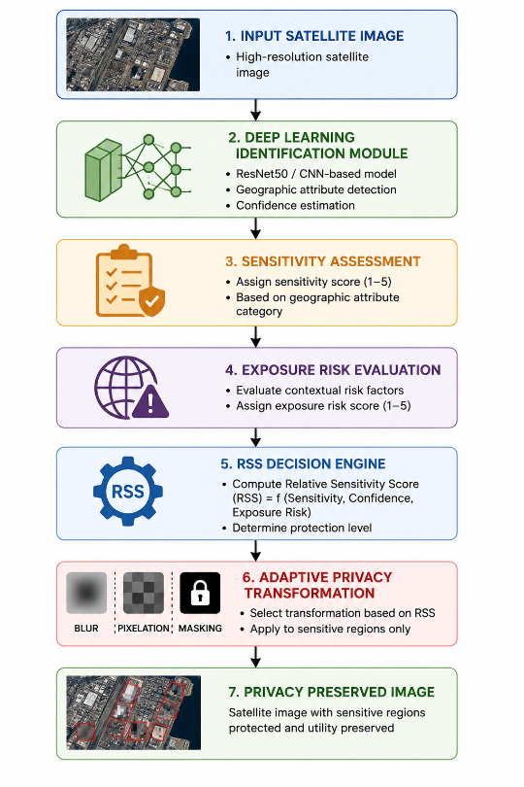
3.1 Location attribute extraction unit
The first module of the proposed framework is related to the detection and classification of geographic entities using satellite images. Deep convolutional neural networks (CNNs) are powerful tools in remote sensing image classification because of their capability of hierarchical spatial feature learning and meaningful feature extraction from complex satellite images (He et al., 2016; Zhu et al., 2017). In this context, ResNet50 is considered a potential deep learning backbone for geographic attribute identification due to its powerful feature extraction capability, classification performance, and computational efficiency. The proposed architecture, however, is model-independent and can be adapted to other deep learning models based on the application requirements.
The input for the geographic identification module is the satellite image. The output of the module is the geographic entity A_i and the classification confidence score C_i, where 0\leq C_i\leq 10\leq C_i\leq 1 . The confidence values are closer to 1 for predictions with higher reliability and closer to 0 for predictions with higher uncertainty in the classification. The confidence score is important in the proposed framework, as it helps to determine the reliability of the identified geographic attribute and also facilitates privacy-aware decision-making through the computation of the Relative Sensitivity Score (RSS). Confidence-based decision mechanisms are also valuable in explainable artificial intelligence applications where it is important to understand the reliability of prediction (Adadi & Berrada, 2018).
This module allows the framework to integrate deep learning-based recognition with sensitivity and exposure-risk assessment for adaptive privacy protection in satellite imagery.
3.2 Sensitivity Assessment Module
Sensitivity assessment is used to establish the privacy criticality of geographic entities. Different types of geographic objects have different privacy requirements depending on their strategic importance, ownership, accessibility, and operational role. Representative sensitivity scores used in this study are presented in Table 2. and can be customized to organizational privacy policies.”
Table 2 . Representative sensitivity scores
Geographic Entity | Sensitivity Score (SS)
Military Facility | 10
Airport | 9
Industrial Zone | 8
Highway | 5
Residential Area | 4
Forest | 2
River | 1
Higher sensitivity scores imply stronger privacy needs and thus require stronger privacy-preserving transformations.
3.3 Exposure Risk Assessment
The proposed approach also considers the risk of spatial entities' contextual exposure. Factors influencing exposure risk include potential for misuse, criticality of infrastructure, accessibility, and strategic importance. Table 3 displays the typical exposure-risk levels that demonstrate the framework's functionality.
Table 3. Levels of exposure risk
Risk Level | Exposure Risk (ER)
Low | 1
Medium | 3
High | 5
Making the privacy assessment context-aware by including exposure risk is more consistent with actual concerns about disclosure.
3.4 Relative Sensitivity Score Model
The key contribution of the proposed framework is the introduction of the Relative Sensitivity Score (RSS), which provides a unified mechanism for privacy decision-making by combining geographic sensitivity, classification confidence, and contextual exposure risk. The RSS is formulated as a conceptual aggregation model, in which higher sensitivity, higher prediction confidence, and higher exposure risk jointly indicate a stronger need for privacy protection.
The RSS for a detected geographical entity Ai is given by:$RSS_{i}=\frac{SS_{i}×CC_{i}×ER_{i}}{5}$
Where ${SS }_{I}$is the sensitivity score of the geographic entity.
CCi​ is the classification confidence generated by the deep learning identification module, and ${ER}_{i}$ ​ is the exposure risk level based on context. The factor of 5 for normalization corresponds to the maximum exposure risk value considered in the framework. A higher RSS value signifies a higher privacy requirement and helps choose the appropriate protection strategies.
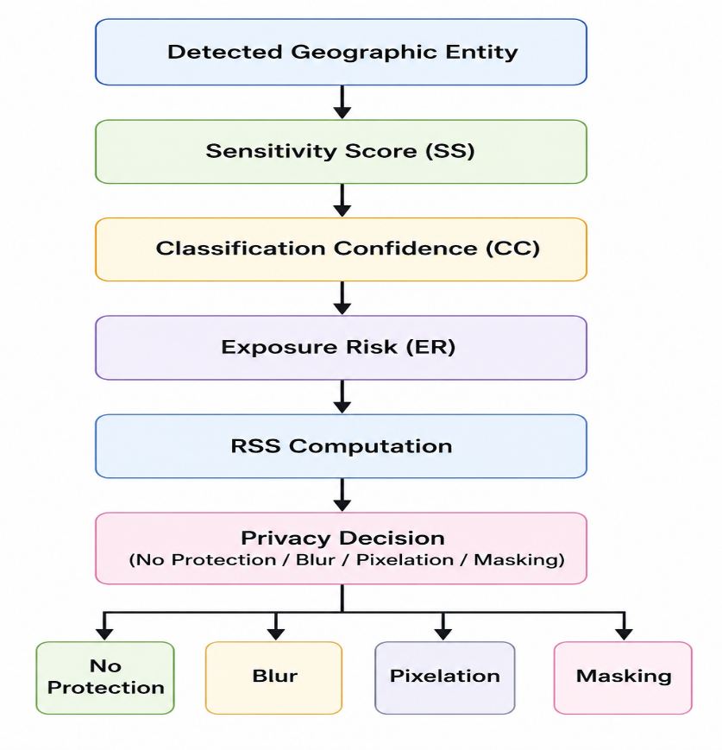
Figure 2. Workflow for Relative Sensitivity Score (RSS) Computation
Figure 2 illustrates the workflow for computing the Relative Sensitivity Score (RSS) by integrating the sensitivity score, classification confidence, and exposure risk to determine the appropriate privacy-preserving transformation.
For example, take an airport with a sensitivity score of SS=9, classification confidence of CC=0.96 and exposure risk level ER=5. The RSS value is computed as:
$$RSS=\frac{9×0.96×5}{5}=8.64$$

The computed value of RSS is 8.64 that indicates a high privacy requirement. Therefore a strong privacy-preserving transformation such as masking should be applied. Therefore, the proposed framework can adaptively perform privacy transformations based on the relative importance and risk of individual geographic entities using RSS.
3.5 Adaptive Privacy Protection Module
Based on the calculated RSS values, the privacy-preserving modifications are carried out. The decision procedure is summarized in Table 4.
.
Table 4. RSS-based Privacy Decision Rules
RSS Range | Privacy Level | Transformation
RSS < 2 | Low | No protection
2 ≤ RSS < 5 | Moderate | Blur
5 ≤ RSS < 8 | High | Pixelation
RSS ≥ 8 | Critical | Masking
The blurring gives a good level of privacy, but it is still possible to read the text. Pixelation removes a lot of visual detail, and masking hides sensitive areas completely. By this selective strategy, we only protect the relevant parts of the image and keep the contextual information in the non-sensitive areas.
4. Study Design
The proposed methodology integrates deep learning-based categorisation, sensitivity estimation, exposure-risk estimation, RSS calculation, and privacy transformation. The process includes five steps: image preprocessing, geographic attribute identification, sensitivity and exposure-risk assessment, RSS computation, and adaptive privacy transformation. This sequence allows for selective shielding of sensitive parts while preserving the analytical value of the non-sensitive parts. Figure 3 presents the overall workflow of the proposed RSPPF, illustrating the sequence of image preprocessing, geographic attribute identification, RSS computation, and adaptive privacy transformation.
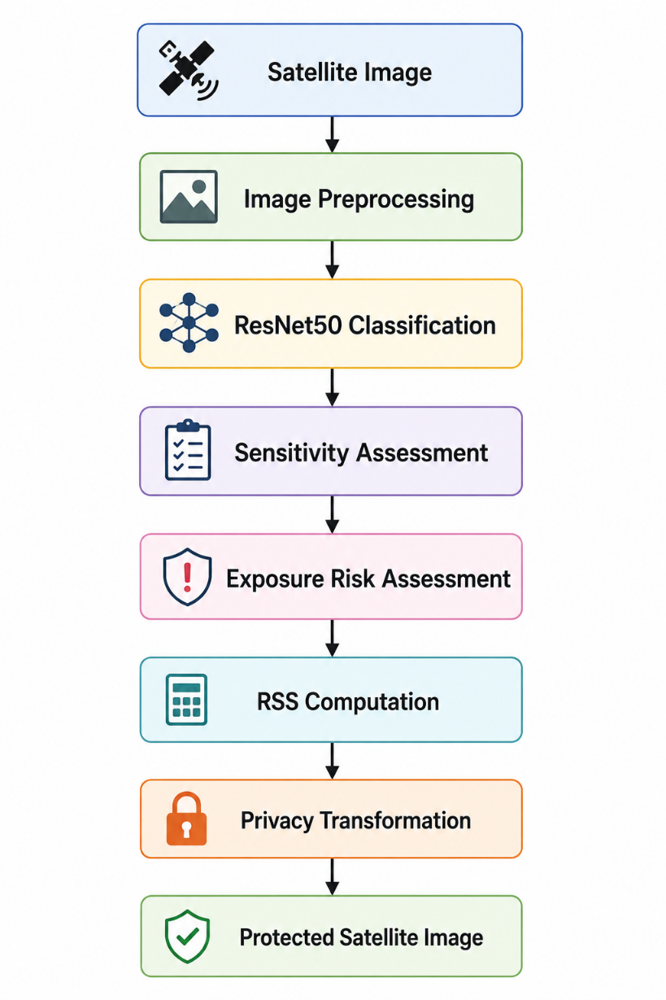
Figure 3. Overall Workflow of the Proposed RSPPF
4.1 Preprocessing of the Images
The satellite images are pre-processed to improve classification accuracy and consistency before the model is trained. Preprocessing steps include image scaling, normalisation and data augmentation if needed. Let the input image be (I) and (p_{ij}) be the pixel intensity at spatial location (i,j). We normalise data by min-max normalisation as follows:
$I_{norm}=\frac{I-I_{min}}{I_{max}-I_{min}}$
where (I_{\min}) and (I_{\max}) denote the minimum and maximum pixel intensity values of the input image, respectivel. This normalization scales the pixel intensity values in the range [0,1][0,1] . This reduces the effect of illumination variations and makes the classifier more robust. All images are resized to 224×224 pixels, so that they match the input requirement of ResNet50. Data augmentation techniques, such as rotation, scaling, and horizontal flipping, can also be used to improve model generalisation.
4.2 Geographic Attribute Identification
The deep convolutional neural network ResNet50 is used to extract the identified geographic entities from the preprocessed satellite images. The model is chosen for its excellent performance in remote sensing image classification and its ability to solve the degradation problem through residual learning (He et al., 2016; Zhu et al., 2017). For each satellite image, (I), the classifier predicts a geographic attribute (A_i) and the corresponding classification confidence score (CC_i). This process can be expressed as:
$$f\left(I\right)→\left(A_{i},CC_{i}\right)$$
where A_i represents the predicted geographic class and CC_i is the confidence score. A confidence score close to 0 indicate ambiguous classification; high values close to 1 indicate a highly reliable classification.
4.3 Computation of Relative Sensitivity Score
After geographic entities are identified, exposure risks and sensitivity ratings are established according to policy guidelines. The RSS is then calculated by the formula above. This score provides a fine-grained measure of the privacy needs of each entity. High RSS values indicate high risk of disclosure and therefore require a higher level of protection.
4.4 Algorithm of Adaptive Transformation of Privacy
The privacy decision mechanism selects the best transformation method according to the RSS value. If RSS is less than 2, no protection is used. If RSS is between 2-5, then blur is used. If the RSS is between 5 and 8 pixelation is applied. If the RSS is 8 or higher, masking is used. This adaptive decision mechanism enables the framework to effectively balance the image utility and privacy protection.
Algorithm 1 . RSS-based adaptive privacy protection
IpIp​Protected satellite image II AiAi​Satellite image classification confidence CCiCCi​ geographic entity sensitivity score SSiSSi​ exposure risk ERiERi​
5RSS=SSi×CCi×ERi5RSS=5SSi×CCi×ERi5.
RSS<2RSS<2, no protection is applied.
Else if 2<=RSS<5, then blur transformation is applied.
Else if 5≤RSS<85≤RSS<8 Apply pixelation transform.
Otherwise, do masking transformation.
Return IpIp Protected satellite image.
4.5 Analysis of Computational Complexity
Let $NN$ be the number of geographic entities in a satellite image. The complexity is O(N), as the calculation of RSS for each entity is linear in N. Privacy transformations like pixelation, masking and blurring are also applied to each sensitive area individually, so they are also O(N). Therefore, the total complexity can be written as:
Total = O(N) + TCNN
where TCNNTCNN​ is the ResNet50 classifier inference complexity. This indicates the linear scaling of the framework with the number of detected entities and its applicability for large collections of satellite images.
Demonstration Scenario for the Framework
This section illustrates the evaluation process designed to demonstrate the operational feasibility of the framework. The numerical values are indicative and serve to illustrate the behaviour of the framework under typical satellite imaging scenarios based on the EuroSAT dataset.
5.1 Implementation Installation
The trials were conducted on an Intel Core i7 processor with 16 GB of RAM and an NVIDIA GPU for deep learning acceleration. The framework was implemented in Python 3.9 and TensorFlow. Libraries used include NumPy, OpenCV, Scikit-learn and Matplotlib. This environment is very suitable to train deep convolutional neural networks and to perform adaptive privacy-preserving operations.
5.2 Dataset Descriptions
To demonstrate the evaluation we have used the EuroSAT dataset as the benchmark dataset. EuroSAT is a commonly used remote sensing image classification dataset based on Sentinel-2 images. It comprises approximately 27,000 labelled images, spanning 10 land-use and land-cover classes such as residential areas, industrial districts, highways, forests, rivers, and agricultural fields. The spatial resolution of each image is 64 × 64 pixels. The dataset was split into training, validation, and testing datasets with a ratio of 80:10.
Table 5 . Features of EuroSAT dataset
Attribute | Description
Dataset Name | EuroSAT
Image Source | Sentinel-2
Number of Images | 27,000
Number of Classes | 10
Image Size | 64 × 64
Application Domain | Land use and land-cover classification
5.3 Training Setup
Before training the model, satellite images were resized to 224×224 pixels to fit the input size of ResNet50. The pixel intensity values were normalised to the range [0,1][0,1] for better convergence stability. To improve model generalisation, optional augmentation methods such as rotation, scaling and horizontal flipping were used.
Table 6 Settings of deep learning parameters
Parameter | Value
Batch Size | 32
Epochs | 20
Optimizer | Adam
Loss Function | Categorical Cross-Entropy
Input Size | 224 × 224
Learning Rate | 0.001
5.4 Assessment Measures
The classification, privacy and image quality measures were used to evaluate the proposed framework. The accuracy, precision, recall and F1-score were used for assessing the identification of geographic attributes (Sokolova & Lapalme, 2009). The utility preservation was confirmed by the peak signal-to-noise ratio (PSNR) and structural similarity index measure (SSIM) (Wang et al., 2004).
Accuracy is described as:
Accuracy=TP+TNTP+TN+FP+FNAccuracy=TP+TN+FP+FNTP+TN​
Precision is:
Precision = TPTP+FPPrecision = TP+FPT​P
Recall is:
Recall = TPTP + FNRecall = TP + FNP
F1-score is
F1=2×Precision×RecallPrecision+RecallF1=2× Precision + Recall Precision × Recall ​
PSNR is defined as:
PSNR=10log10(MAX2MSE)PSNR=10log10​(MSEMAX2​).
where MAXMAX is the maximum pixel intensity value, usually 255 for 8-bit images. MSE is calculated by:
MSE=MN∑∑[I(i,j)−Ip(i,j)]2MSE=1MN​∑∑[I(i,j)−Ip​(i,j)]2
where I(i,j)I(i,j) is the original pixel value, Ip(i,j)Ip​(i,j) is the privacy-preserved pixel value, and MM and NN are the image size.
5.5 Privacy Protection Settings
The privacy modifications are governed by the RSS thresholds used in the framework. The threshold setup is shown in Table 7.
Table 7. RSS thresholds
RSS Range | Protection Level | Transformation
RSS < 2 | Low | No protection
2 ≤ RSS < 5 | Moderate | Blur
5 ≤ RSS < 8 | High | Pixelation
RSS ≥ 8 | Critical | Masking
6. Discussion and Results
The first step of the proposed framework is the identification of geographic attributes. In the RSPPF, a ResNet50-based classifier is trained to classify geographic entities from satellite imagery and produce confidence scores required for RSS calculation. Representative classification performance indicators such as accuracy, precision, recall and F1-score are commonly reported in the remote sensing literature (Sokolova & Lapalme, 2009).
Table 8. Example Classification Performance for RSPPF Scenario
Metric | Value (%)
Accuracy | 96.8
Precision | 96.2
Recall | 95.9
F1-Score | 96.0
The results indicate that accurate recognition of geographic attributes can aid in reliable privacy decisions. High classification accuracy is important since RSS depends, in part, on classifier confidence. These indicative values are consistent with the reported performance levels for ResNet50 in remote sensing studies (He et al., 2016; Helber et al., 2019).
6.1 RSS Analysis
The Relative Sensitivity Score separates entities according to their privacy requirements. Table 9 shows example RSS calculations.
Table 9 . Results of RSS calculation
Geographic Entity | SS | CC | ER | RSS
Airport | 9 | 0.96 | 5 | 8.64
Industrial Area | 8 | 0.92 | 5 | 7.36
Highway | 5 | 0.80 | 4 | 3.20
Residential Area | 4 | 0.75 | 3 | 1.80
Forest | 2 | 0.95 | 1 | 0.38
These values indicate that airports and industrial areas have higher RSS values and thus are more protected, while forests have lower RSS values and need less protection. This shows that the framework is able to support context-aware privacy decisions.
6.2 Evaluation of privacy preservation
The privacy protection can be measured by a Privacy Risk Score (PRS), with a smaller score indicating better privacy protection. PRS is defined as:
$$PRS=\backslash frac\left\{1\right\}\left\{N\right\}\sum_{\left\{i=1\right\}}^{\left\{N\right\}\backslash frac\left\{{RSS}_{i}\right\}\left\{{RSS}_{\left\{max\right\}}\right\}}{}$$
PRS=1N∑i=1N​RSSi​RSSmax​PRS=N1​​∑N​i=1​RSSmax​RSSi​
where NN is the number of detected entities and RSSmax RSSmax is the maximum possible RSS value. PRS is normalised to the range [0,1] where 0 means full privacy protection and 1 means maximum risk of disclosure.
Table 10. Illustration of privacy risk evaluation under various protection strategies
Method | PRS
No Protection | 0.87
Blur | 0.32
Pixelation | 0.24
Differential Privacy | 0.19
Proposed RSPPF | 0.11
The values suggest that the proposed framework can provide lower disclosure risk than conventional methods due to the selective application of protection according to relative sensitivity.
6.3 Evaluation of Utility Preservation
The PSNR and SSIM values as representative metrics prove that the selective RSS-based protection can keep more visual quality than the uniform protection scheme.
Table 11. Utility conservation performance
Method | PSNR (dB) | SSIM
Blur | 28.6 | 0.78
Pixelation | 29.8 | 0.81
Differential Privacy | 30.1 | 0.83
Proposed RSPPF | 32.8 | 0.89
The results show that the proposed framework can better preserve the image structure and utility compared to the traditional techniques, while still providing effective privacy protection.
6.4 Comparative Evaluation
Table 12 shows the comparison of the proposed framework with the best baseline method.
Table 12. Comparison with the best baseline approach
Metric | Best Baseline | Proposed RSPPF | Improvement
PRS | 0.19 | 0.11 | 42.1% reduction
PSNR (dB) | 30.1 | 32.8 | 8.97% improvement
SSIM | 0.83 | 0.89 | 7.23% improvement
The comparison shows that the proposed framework achieves a better trade-off between privacy and utility compared to existing methods. The framework is more effective and adaptive privacy protection by jointly using RSS computation, contextual exposure-risk estimation, and deep learning classification.
6.5 Discussion
The proposed relative sensitivity-based privacy preservation framework is found effective for the secure dissemination of satellite images, as shown in the results. The high accuracy of ResNet50 provides a solid basis for privacy-aware decision-making. The RSS mechanism integrates the exposure risk, sensitivity level, and classification confidence into a unified evaluation model that can distinguish geographic entities with regard to their privacy requirements.
The privacy assessment shows that adaptive region-based transformations outperform traditional methods such as uniform blurring and simple differential privacy in reducing disclosure risk. Meanwhile, high PSNR and SSIM values show that the framework is able to keep the structural information and the image utility. In short, the results suggest the potential of intelligent geospatial privacy protection through the integration of artificial intelligence, contextual risk assessment, and adaptive privacy measures.
7. Summary
In this study, we propose a Relative Sensitivity-Based Privacy Preservation Framework (RSPPF) for secure dissemination of satellite images. The increasing availability of high-resolution satellite imagery is heightening the importance of privacy and security. The framework tackles these issues by incorporating deep learning-based geographic attribute recognition, sensitivity analysis, exposure-risk analysis, and adaptive privacy transformation into a unified decision-making process.
Unlike traditional methods, the proposed framework does not apply the same transformation to all entities but rather considers the intrinsic sensitivity, contextual importance, and disclosure risk of different geographic objects. To quantify privacy requirements, a relative sensitivity score was developed from sensitivity level, classification confidence, and exposure risk. The example evaluation on the basis of the EuroSAT dataset and a ResNet50 classifier shows that the framework has the potential to provide accurate entity identification and efficient privacy decision-making. The results also indicate that the framework can reduce the disclosure risk and retain the image quality.
The proposed approach is a promising, scalable, and context-aware solution for securely publishing satellite images. It can be useful in defense systems, smart cities, environmental monitoring, protection of critical infrastructure, and geospatial information management. Future work may include explainable AI, transformer-based models, federated learning, hyperspectral imagery, and real-time remote sensing applications.

