### WSS 1x4 100GHz 间隔偶数波模块软件接口

### Revision History

|  |  |  |  |  |
| --- | --- | --- | --- | --- |
| **Rev.** | **Date** | **Revision History** | **Originated by** | **Signed by** |
| 1.0 | 2014-11-21 | First release | Liuzhenwen |  |
| 1.1 | 2014-11-28 | 增加维护接口 | Xiexi |  |
| 1.2 | 2014-12-01 | 增加命令说明，  删除不需要的0x42命令，  增加0x54命令 | Xiexi |  |
| 1.3 | 2015-2-05 | 修改errorcode寄存器定义  删除0x03命令，查询版本使用0xaa命令 | Xiexi |  |
|  |  |  |  |  |
|  |  |  |  |  |

##### **波长和和通道的对应关系如下：**

偶波对应关系：

|  |  |  |
| --- | --- | --- |
| **Channel plan** | **Frequency (THz)** | **Wavelength**  **(nm)** |
| 48 | 196.2 | 1527.994 |
| 47 | 196.1 | 1528.773 |
| 46 | 196.0 | 1529.553 |
| 45 | 195.9 | 1530.334 |
| 44 | 195.8 | 1531.116 |
| 43 | 195.7 | 1531.898 |
| 42 | 195.6 | 1532.681 |
| 41 | 195.5 | 1533.465 |
| 40 | 195.4 | 1534.25 |
| 39 | 195.3 | 1535.036 |
| 38 | 195.2 | 1535.822 |
| 37 | 195.1 | 1536.609 |
| 36 | 195.0 | 1537.397 |
| 35 | 194.9 | 1538.186 |
| 34 | 194.8 | 1538.976 |
| 33 | 194.7 | 1539.766 |
| 32 | 194.6 | 1540.557 |
| 31 | 194.5 | 1541.349 |
| 30 | 194.4 | 1542.142 |
| 29 | 194.3 | 1542.936 |
| 28 | 194.2 | 1543.73 |
| 27 | 194.1 | 1544.526 |
| 26 | 194.0 | 1545.322 |
| 25 | 193.9 | 1546.119 |
| 24 | 193.8 | 1546.917 |
| 23 | 193.7 | 1547.715 |
| 22 | 193.6 | 1548.515 |
| 21 | 193.5 | 1549.315 |
| 20 | 193.4 | 1550.116 |
| 19 | 193.3 | 1550.918 |
| 18 | 193.2 | 1551.721 |
| 17 | 193.1 | 1552.524 |
| 16 | 193.0 | 1553.329 |
| 15 | 192.9 | 1554.134 |
| 14 | 192.8 | 1554.94 |
| 13 | 192.7 | 1555.747 |
| 12 | 192.6 | 1556.555 |
| 11 | 192.5 | 1557.363 |
| 10 | 192.4 | 1558.173 |
| 9 | 192.3 | 1558.983 |
| 8 | 192.2 | 1559.794 |
| 7 | 192.1 | 1560.606 |
| 6 | 192.0 | 1561.419 |
| 5 | 191.9 | 1562.233 |
| 4 | 191.8 | 1563.047 |
| 3 | 191.7 | 1563.863 |
| 2 | 191.6 | 1564.679 |
| 1 | 191.5 | 1565.496 |

**2、命令格式和具体命令如下：**

##### Serial Communication Port Setting

Three wire RS-232 serial port with no handshake, 8 data bits, 1 stop bit, no parity bit. Baud rate is 115.2kb/s default or set by command.

##### Command/Response Format

Serial communication of the module works in slave mode: it only responds to valid commands from host processor and never initiates communications

**Command Structure**

|  |  |  |  |  |  |  |
| --- | --- | --- | --- | --- | --- | --- |
| Byte | 1 | 2 | 3 |  | N+2 | N+3 |
| *Description* | Code | Data Length (N) | D1 | … | DN | Checksum |

**Response Structure**

|  |  |  |  |  |  |  |
| --- | --- | --- | --- | --- | --- | --- |
| Byte | 1 | 2 | 3 |  | N+2 | N+3 |
| *Description* | Status | Data Length (N) | D1 | … | DN | Checksum |

**Command/Response Definition**

|  |  |
| --- | --- |
| *Byte* | *Description* |
| Code | Command Code as defined in Command Code Table |
| Status | Communication Status:  0x00 ⎯ Success, Bit-0 ⎯ Checksum Error, Bit-1 ⎯ Syntax Error |
| Data Length | Number of Data Bytes |
| Dn, n = 1~N | Data |
| Checksum | Communication Error Check (Sum of all bytes, including checksum byte, is zero) |

# Command Code Table

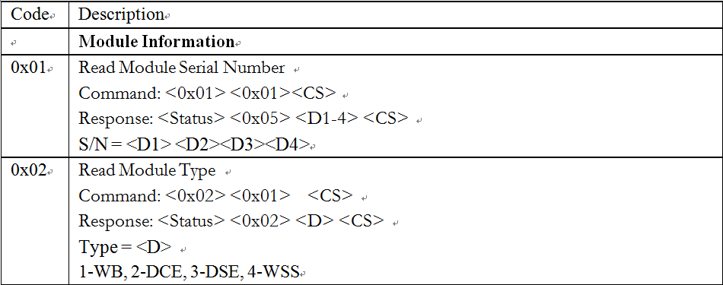

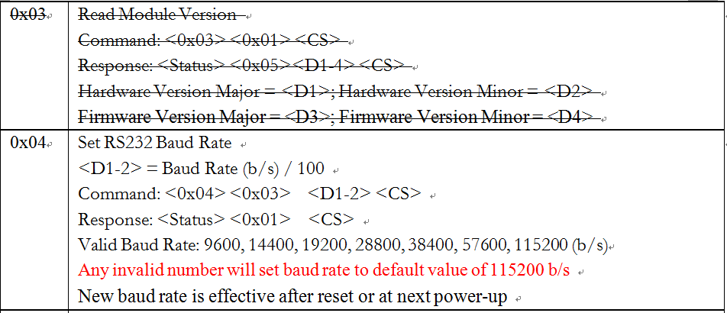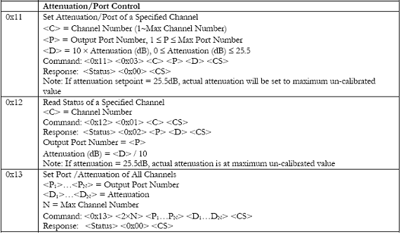





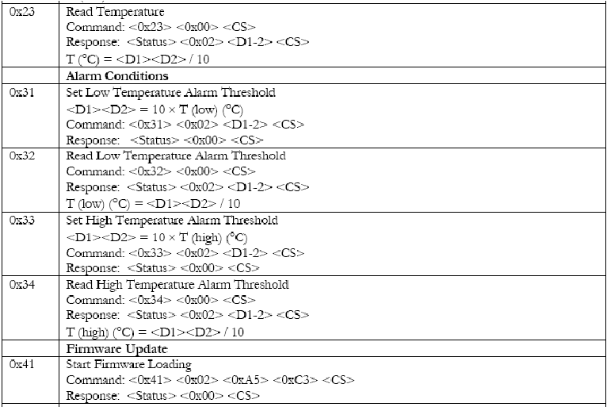

|  |  |
| --- | --- |
| 0x43 | Switch to New Firmware  Command: <0x43> <0x00> <CS>  Response: <Status> <0x00> <CS> |
| 0x54 | Load New Firmware  Command: <0x54> <0x10> <D1-16> <CS>  Response: <Status> <0x00> <CS>  Continue Sending new firmware data file in 16 byte groups. Fill in zeros if the last group has less than 16 bytes |

|  |  |
| --- | --- |
| 0xaa | Manufacture ID  Command:<0xaa><00><cs>  Response : <Status> <0x8> <name1> <name2> <HardWare Version Major> < HardWare Version Minor > < FirmWare Version Major > < FirmWare Version Minor >< band type > < odd or even type ><CS>  name1=ID1 ID1 is a fixed number defined by HuaWei to identify the different vender(厂家ID，具体见厂家ID文档)  name2= ID2 ID2 is a fixed number defined by HuaWei to identify the different vender. (模块并口串口识别ID，并口0x40，串口0x31)  band type: C_BAND=1  odd or even type: CBAND_ODD=1, CBAND_ALL=0, CBAND_EVEN=2(WSS模块支持的波段，如支持的是偶数波，则为2) |
| 0x50 | GET:VOLTAGE  Command:<0x50><Voltage Index><cs>  Response : <Status> <0x8> < standardH > < standardL> < maxH > < maxL>< min H > < minL>< curH > < curL><CS>  StandardVol(0.1V)= < standardH > < standardL>/10  maxVol(0.1V)= < maxH > < maxL >/10  minVol(0.1V)= < min H > < minL >/10  curVol(0.1V)= < curH > < curL >/10 |
| 0x51 | GET: CURRENT  Command:<0x51><Current Index><cs>  Response : <Status> <0x8> < standardH > < standardL> < maxH > < maxL>< min H > < minL>< curH > < curL><CS>  StandardCur(mA)= < standardH > < standardL>  maxCur (mA)= < maxH > < maxL >  minCur (mA)= < min H > < minL >  curCur(mA)= < curH > < curL > |
| 0x52 | GET:ERRCODE  Command:<0x52><ErrorCode Index><cs>  Response : <Status> <0x4> < ErrorCodeH1 > < ErrorCodeH2 > < ErrorCodeL1 > < ErrorCodeL2 ><CS>  ErrorCode = < ErrorCodeH1 > < ErrorCodeH2 > < ErrorCodeL1 > < ErrorCodeL2 >  Note：  1 refers to current recoverable (by hard pin reset) ERRCODE  2 refers to history recoverable (by hard pin reset)ERRCODE  3 refer to current unrecoverable (by hard pin reset) ERRCODE  4 refer to history unrecoverable (by hard pin reset) ERRCODE  ErrorCode = < ErrorCodeH1 > < ErrorCodeH2 > < ErrorCodeL1 > < ErrorCodeL2 >  Get every bit in errorcode at table below(若不支持，则填0) |
| 0x53 | GET:ERRLOG  Command:<0x53><0><cs>  Response : <Status><0x11>  <ResetCountH ><ResetCountL >  <LastResetType >< ResetTimestampH><ResetTimestampL>  < TempErr >< TempErrTimestampH>< TempErrTimestampL>  < ChipErr >< ChipErrTimestampH >< ChipErr TimestampL>  <ChipErr >< CurrentErrTimestampH>< CurrentErrTimestampL>  < VolErr >< VolErrTimestampH>< VolErrTimestampL>  <CS>  (若不支持，则填0) |

3、在微程序升级的时候分为三步：

在向模块发送命令0x41且得到正确回复之后, 大板向模块通过0x54命令发送firmware数据帧，每条0x54命令模块接收后都按照0x54命令格式要求进行回复。 发送完所有数据后，大板向模块下发0x43命令，切换到新的firmware。在整个升级过程中所有配置（通道配置到光口以及衰减值）都与升级前一样，保持不变。

4、通道设置穿通后，可调衰减范围为0～150(单位0.1db)。默认为150

软复位模块，要求配置保持不变，各通道衰减值保持，无抖动。

硬复位模块前，大板下发0x15命令，设置模块要保存的值，然后硬复位模块，模块启动后单板下发0x17命令模块恢复配置。

5、模块上电后复位起来后, 不要主动上报信息给大板,如logo初始化信息等. 模块正常工作时也不要主动上报信息.

6、Max Channel Number为48. 对于列出的1~48通道, 要求所有通道都可以按照命令要求进行查询设置. 但对1～6波和47，48通道光指标不做要求。

7、光模块自动识别微程序，不是自己厂家模块的微程序，上报升级失败；

8、任何情况下微程序升级失败，不能导致模块失效，不能影响业务。