*VN RU and DS values after each write in the corresponding components*

0 Write(s)

|  |  |  |  |
| --- | --- | --- | --- |
| Server | VN | RU | DS |
| A | 1 | 8 | A |
| B | 1 | 8 | A |
| C | 1 | 8 | A |
| D | 1 | 8 | A |
| E | 1 | 8 | A |
| F | 1 | 8 | A |
| G | 1 | 8 | A |
| H | 1 | 8 | A |

1 Write(s)

|  |  |  |  |
| --- | --- | --- | --- |
| Server | VN | RU | DS |
| A | 2 | 8 | A |
| B | 2 | 8 | A |
| C | 2 | 8 | A |
| D | 2 | 8 | A |
| E | 2 | 8 | A |
| F | 2 | 8 | A |
| G | 2 | 8 | A |
| H | 2 | 8 | A |

2 Write(s)

|  |  |  |  |
| --- | --- | --- | --- |
| Server | VN | RU | DS |
| A | 3 | 8 | A |
| B | 3 | 8 | A |
| C | 3 | 8 | A |
| D | 3 | 8 | A |
| E | 3 | 8 | A |
| F | 3 | 8 | A |
| G | 3 | 8 | A |
| H | 3 | 8 | A |

3 Write(s)

|  |  |  |  |
| --- | --- | --- | --- |
| Server | VN | RU | DS |
| A | 4 | 4 | A |
| B | 4 | 4 | A |
| C | 4 | 4 | A |
| D | 4 | 4 | A |
| E | 3 | 8 | E |
| F | 3 | 8 | E |
| G | 3 | 8 | E |
| H | 3 | 8 | E |

4 Write(s)

|  |  |  |  |
| --- | --- | --- | --- |
| Server | VN | RU | DS |
| A | 5 | 4 | A |
| B | 5 | 4 | A |
| C | 5 | 4 | A |
| D | 5 | 4 | A |
| E | 3 | 8 | E |
| F | 3 | 8 | E |
| G | 3 | 8 | E |
| H | 3 | 8 | E |

5 Write(s)

|  |  |  |  |
| --- | --- | --- | --- |
| Server | VN | RU | DS |
| A | 5 | 4 | _ |
| B | 6 | 3 | _ |
| C | 6 | 3 | _ |
| D | 6 | 3 | _ |
| E | 3 | 8 | _ |
| F | 3 | 8 | _ |
| G | 3 | 8 | _ |
| H | 3 | 8 | _ |

6 Write(s)

|  |  |  |  |
| --- | --- | --- | --- |
| Server | VN | RU | DS |
| A | 5 | 4 | _ |
| B | 7 | 3 | _ |
| C | 7 | 3 | _ |
| D | 7 | 3 | _ |
| E | 3 | 8 | _ |
| F | 3 | 8 | _ |
| G | 3 | 8 | _ |
| H | 3 | 8 | _ |

7 Write(s)

|  |  |  |  |
| --- | --- | --- | --- |
| Server | VN | RU | DS |
| A | 5 | 4 | _ |
| B | 8 | 6 | B |
| C | 8 | 6 | B |
| D | 8 | 6 | B |
| E | 8 | 6 | B |
| F | 8 | 6 | B |
| G | 8 | 6 | B |
| H | 3 | 8 | _ |

8 Write(s)

|  |  |  |  |
| --- | --- | --- | --- |
| Server | VN | RU | DS |
| A | 5 | 4 | _ |
| B | 9 | 6 | B |
| C | 9 | 6 | B |
| D | 9 | 6 | B |
| E | 9 | 6 | B |
| F | 9 | 6 | B |
| G | 9 | 6 | B |
| H | 3 | 8 | _ |

*Images of Output for Each Server*

Server A Server B

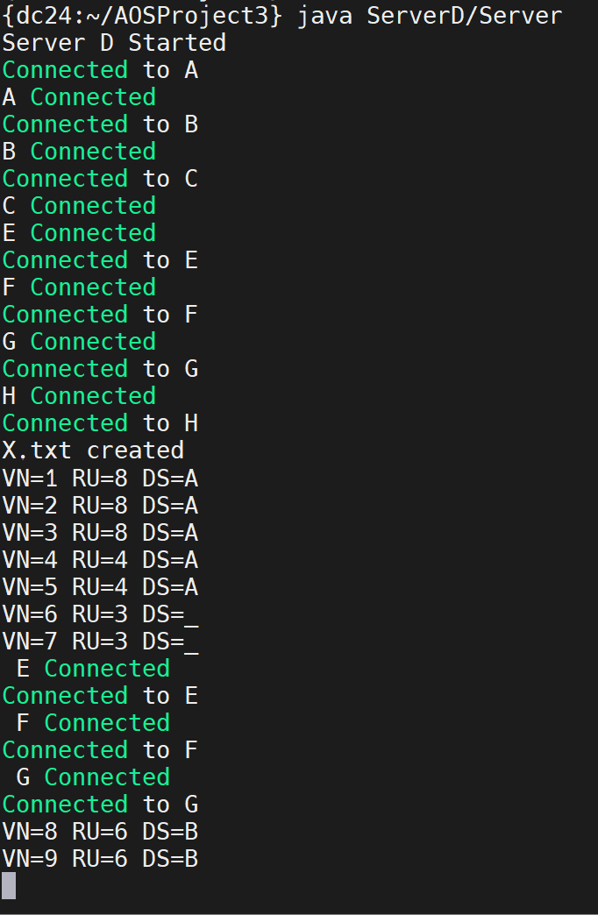Server C Server D

Server E Server F

Server G Server H

