Backup sharePoint list to Windows SQL Server
Contents
Prerequisite​​​ 1
Prepare windows OS (Like Windows Server 2016 Datacenter) 1
Install standalone Windows SQL server 1
Deploy Windows SQL Server 3
Initial import with current data (Excel) from SharePoint 4
Main steps 9
Manual: Run the script to backup data from SharePoint site to SQL server 9
Task Scheduler: Run the script to backup data from SharePoint site to SQL server 9

Prerequisite​​​

Prepare windows OS (Like Windows Server 2016 Datacenter)
- OS location: \\products\PUBLIC\PRODUCTS\ISO\OS\Windows Server 2016 Standard and Datacenter
- Need to install .net3.5: Dism /online /enable-feature /featurename:NetFX3 /featurename:NetFx3ServerFeatures /source:D:\sources\sxs

Install standalone Windows SQL server
- App location: \\products\PUBLIC\PRODUCTS\Applications\Server\SQL Server 2016
- Install JDK from http://download.oracle.com/otn-pub/java/jdk/8u144-b01/090f390dda5b47b9b721c7dfaa008135/jdk-8u144-windows-x64.exe
- Install standalone SQL Server only with Database Engine Services
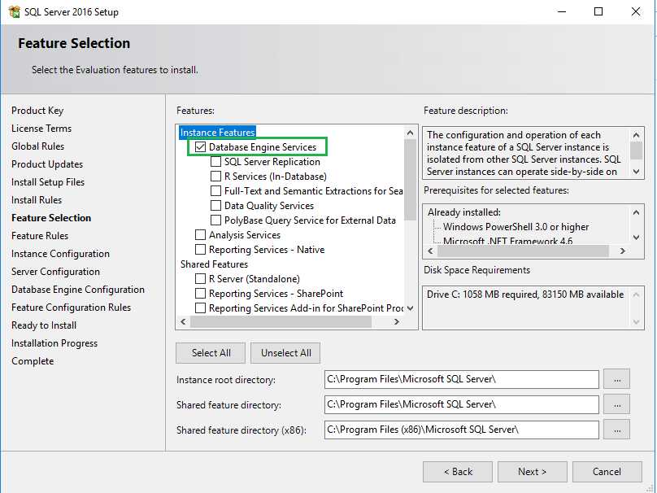
- Create one instance named as “spbackup”
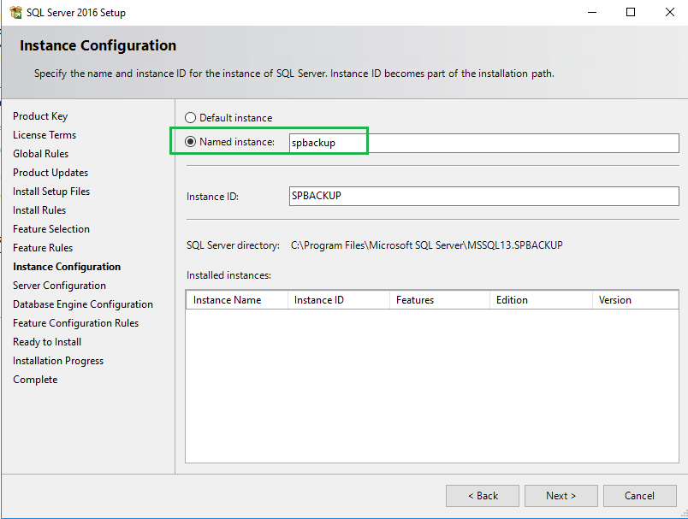
- Select the Mixed Mode and set the password as “07Apples”
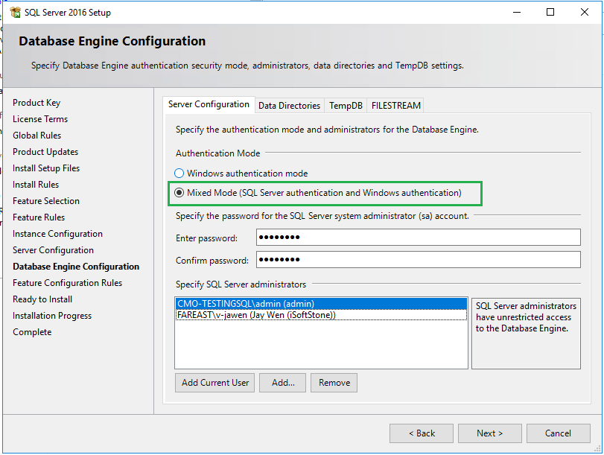

Deploy Windows SQL Server
- Configure SQL server for remoting connection: https://www.sqlshack.com/how-to-connect-to-a-remote-sql-server/
- On Server/client (optional for remoting) machine, install SSMS from https://docs.microsoft.com/en-us/sql/ssms/download-sql-server-management-studio-ssms
- Connect SQL server through SSMS by Windows Authentication on server machine.
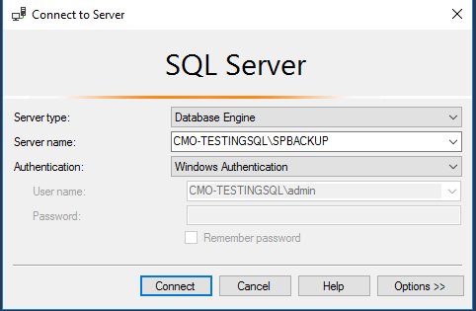
- Create new login (spremote\07Apples) with SQL Server Authentication
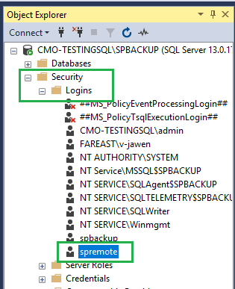
- On client machine (option), connect SQL server through SSMS using spremote\07Apples with SQL Server Authentication
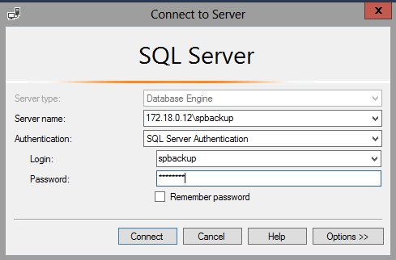
- Create one database named “splist”
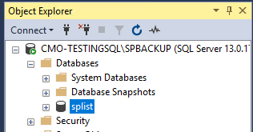

Initial import with current data (Excel) from SharePoint
- Install Office2016(excel+ tools): \\products\PUBLIC\PRODUCTS\Applications\User\Office_2016\MSI\64-bit\Office_Professional_2016
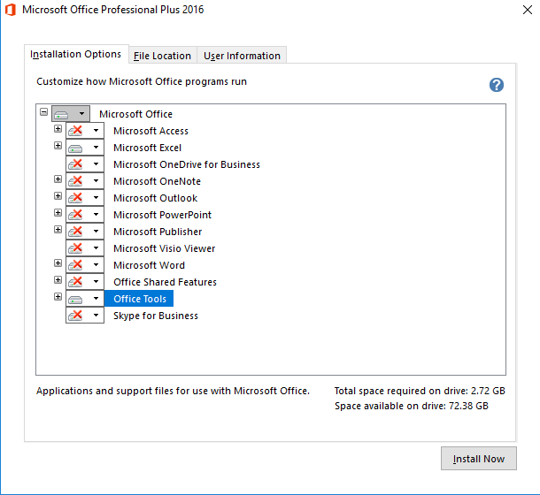
- Log in Excel with the account who can access to SharePoint site
- Install Microsoft Office Access database engine 2007: https://www.microsoft.com/en-US/download/details.aspx?id=23734
- Clone https://github.com/jayclover/spbackup to local
- Double click query.iqy in folder spbackup to generate one excel (e.g. listDataCSV.xlsx)
- Open SQL Server I/E Wizard for database splist
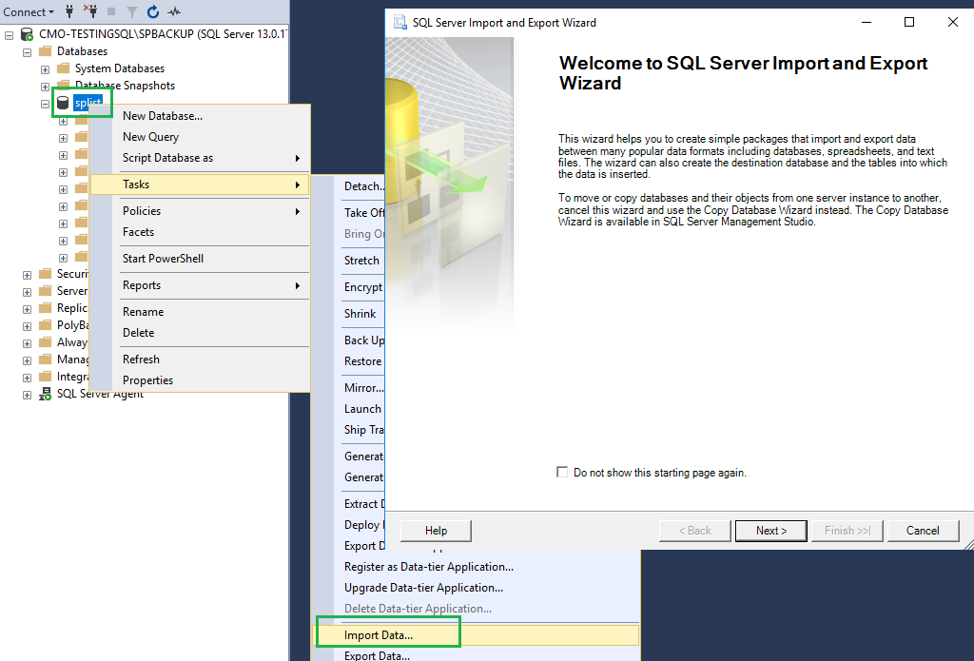
- Select Microsoft Excel with the generated listDataCSV.xlsx on “Choose a Data Source” page
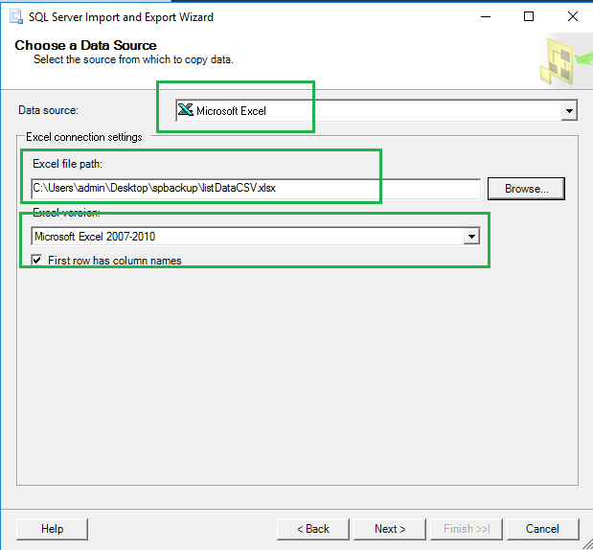
- On “Choose a Destination” page, select option as below
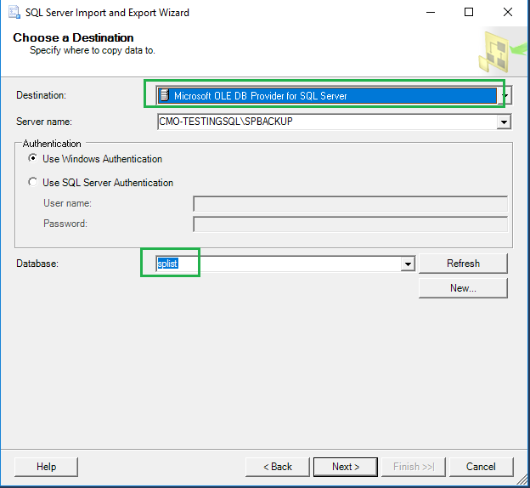
- On “Specify Table Copy or Query” page and finish the wizard with default settings in next steps
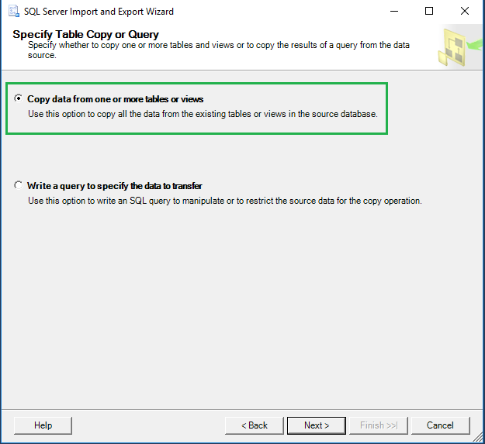
- The table is created and rename it as sptable
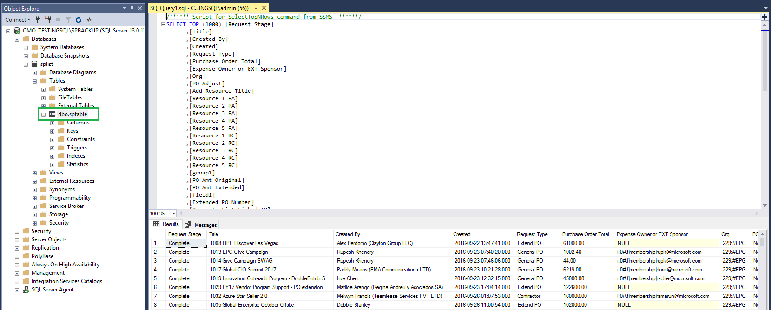

Main steps

Manual: Run the script to backup data from SharePoint site to SQL server
- Clone https://github.com/jayclover/spbackup to local
- Open powershell and turn to the directory for the local folder spbackup.
- Run .\cvsImportToSQL.ps1 "172.18.0.12\spbackup" "splist" "dbo.sptable"
- 172.18.0.12\spbackup : sqlserver ID\instant Name
- splist : database name
- dbo.sptable : table name

Task Scheduler: Run the script to backup data from SharePoint site to SQL server
- Clone https://github.com/jayclover/spbackup to local
- Edit spBackup.bat with current directory path for folder spbackup and save it and update the powershell command like we do the manual way
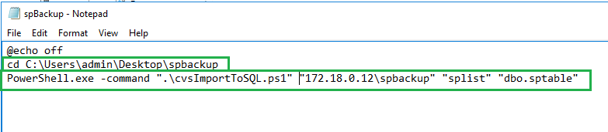
- Open Task Scheduler
- Create task named as spbackup
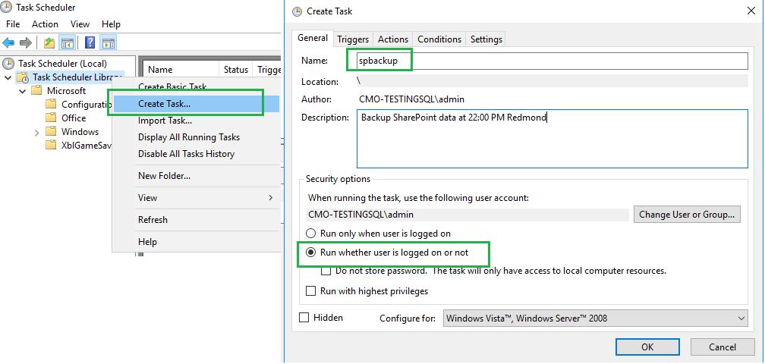
- Set it as daily task scheduler triggering it at 10:00 PM Redmond time
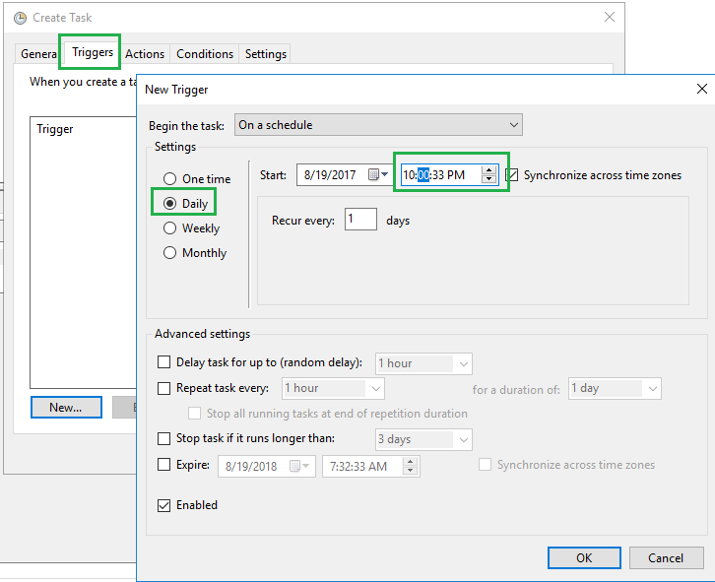
- Set the action and save this task scheduler.
