GOMOVE: A Smart Transportation Companion

A User Interface Design Presented to

The College of Computing and Information Sciences
NORTHWEST SAMAR STATE UNIVERSITY
Calbayog City

In Partial Fulfillment of the Requirements for the Course IT101: Introduction to Human, Computer, and Interaction

Submitted by:
CHELSEA MAGBOJOS
VALENTINE FRITZ N. YGRUBAY
JOHN BENJAMIN MONTERON

Submitted to:
CERILO C. DELA TONGA
Instructor

OCTOBER 2, 2026

- TITLE: GOMOVE: A Smart Transportation Companion

- PROPRONENT(S):
  - CHELSEA M. MAGBOJOS
  - VALENTINE FRITZ N. YGRUBAY
  - JOHN BENJAMIN MONTERON

- PROJECT RATIONALE:

Transportation is an important part of our daily lives, especially for students, workers, and other people who need to travel to different places. However, traffic, long waiting times, and limited transportation options can make traveling stressful and time-consuming. In the Philippines, traffic is a common problem, especially in busy areas. Because of this, commuters sometimes have difficulty arriving at their destinations on time. Having a transportation service that is fast, convenient, and easy to access can help lessen these challenges. With the help of technology, transportation has become more convenient. Mobile applications allow people to book rides using their phones, making it easier to find transportation without spending too much time waiting. In this project, GOMOVE is introduced as a convenient transportation application for commuters. It aims to make booking rides easier and help people travel to their destinations more conveniently. Through this project, we want to show how technology can provide a simple and practical solution to everyday transportation problems.

- OBJECTIVES

The main objective of GOMOVE is to provide a convenient and accessible transportation service for commuters. Specifically, this project aims to:

1. Provide convenient transportation for people who need to travel to different destinations.
2.Help commuters save time by making ride booking easier and faster.
3.Reduce the difficulty of finding transportation, especially in busy areas.
4.Use technology to improve commuting through an easy-to-use mobile application. 5.Provide a practical transportation option that can help make everyday travel more manageable.

- USER PERSONAS

1.Liza Marquez – Passenger
- Age: 23
- Background: Lives and travels around Calbayog City needs daily transport.
- Needs: Quick & easy booking; clear fare rates; real-time updates on arrival.
- Goals: Book a ride easily; set destination; track driver; arrive safely.
- Pain Points: Long waits; hard to find available rides; fare prices not clear.

2.Carlo Dela Cruz – Rider / Driver
  - Age: 36
  - Background: Full-time transport provider serving Calbayog City.
  - Needs: Get booking requests; clear pickup & drop-off details; simple navigation.
  - Goals: Accept rides; find passengers easily; complete trips; track daily earnings.
  - Pain Points: Hard to locate passengers; confusing multiple bookings; inconsistent ride requests.

- DESIGN

LOGO
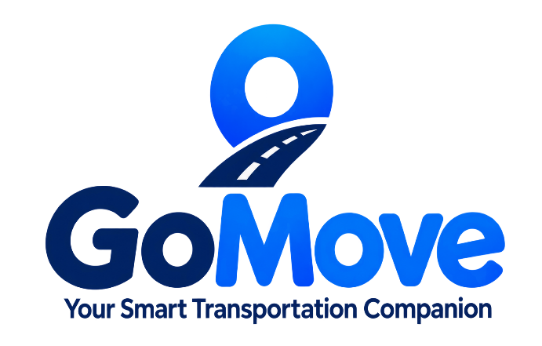

Figure 1. GOMOVE Logo Design

The logo consists of three main elements:
1. Location Pin: Blue marker shape representing navigation, destination, and real-time tracking.
2. Road Path Running: through the pin, symbolizing the journey, safe travel, and connectivity across Calbayog City.
3. Name & Typography : "GoMove" in bold modern font; "Go" in deep navy, "Move" in bright blue conveying energy, movement, and accessibility.

Below the graphic, the tagline "Your Smart Transportation Companion" appears in clean gray text, highlighting the app’s purpose: to make travel easier and smarter for everyone.

COLOR PALETTE

#0D47A1– Deep Navy blue
#1A79D5 – Bright Blue
#378D41– Green
#FFFFFF – White
#F5F4F4 – Light Gray

Figure 2. GOMOVE Color Palette

USER INTERFACE DESIGN AND MANUAL

GO MOVE is a mobile transportation application designed to make commuting easier, faster, and more convenient. The app allows users to easily find available transportation services, view routes and destinations, and request or book rides using their mobile devices. By providing essential transportation information and real-time updates, Go Move helps passengers plan their trips efficiently while providing a convenient way to connect with drivers and transportation services.

Getting Started Start-up
To start, the splash screen will appear after clicking the mobile application.

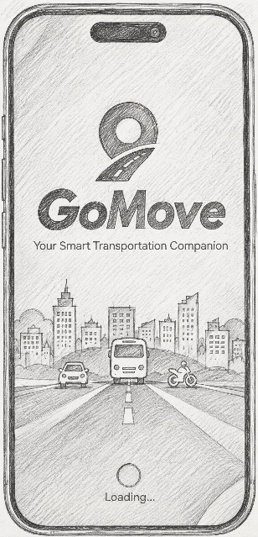

Figure 3. Splash Screen

Login Form
the user can login to enter into the main page.

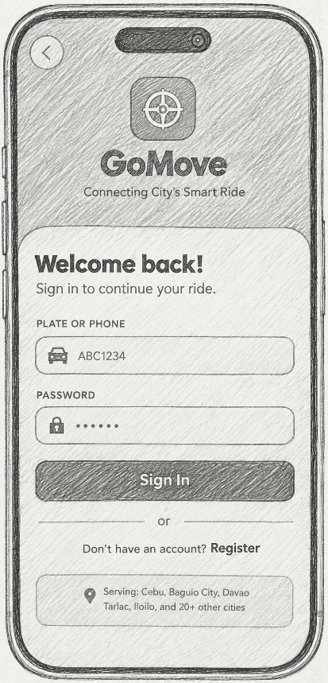
Figure 4. Login Form

Registration Form
The user can register after login, the user unable to login if the account isn’t exist.

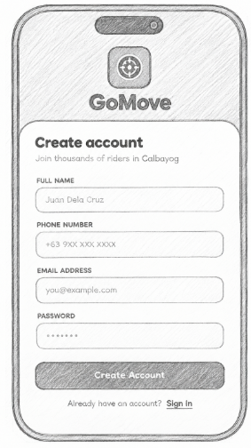
Figure 5. Registration Form

Passenger Dashboard
The Passenger Dashboard provides users with a simple interface to book rides, view available transportation options, track their current trip, and manage their ride history and account details.
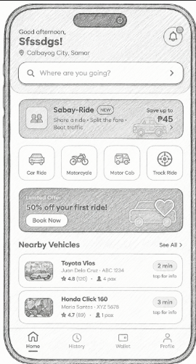
Figure 6. Passenger Dashboard

Track Ride
The passenger dashboard displays the ongoing ride, route map, estimated arrival time, driver details, fare, location, and options to call, chat, or share the trip.
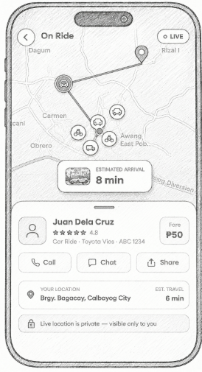
Figure 7. Track Ride

Sabay Ride
A The Sabay-Ride dashboard shows available carpool rides with pickup and destination fields, popular routes, driver and vehicle details, fare-sharing savings, departure times, and options to join each ride.
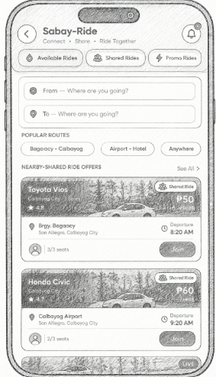
Figure 8. Sabay Ride

Overview Confirmation
The Join Sabay-Ride screen summarizes the selected carpool trip, showing the vehicle and driver, pickup and drop-off details, co-passengers, fare breakdown, savings, and a button to confirm the booking.
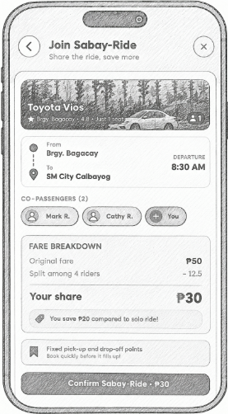
Figure 9. Overview Confirmation

Book a Ride
The Book a Ride screen allows passengers to select a destination, confirm their pickup point, add an optional purok, choose quick destinations, and view available routes on the map.
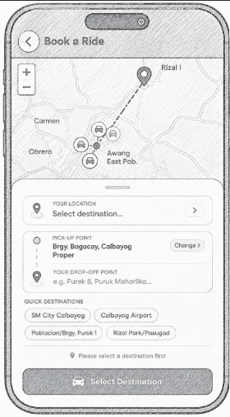

Figure 10. Book A Ride

History
The Ride History screen displays completed trips with their vehicle types, routes, dates and times, fares, and trip status.

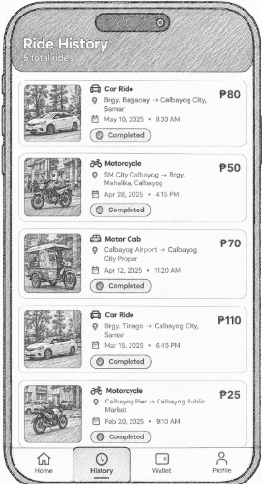

Figure 11. History

Wallet
The My Wallet screen shows the user’s available balance, top-up and send options, payment methods, and a list of recent wallet transactions with their amounts and dates.
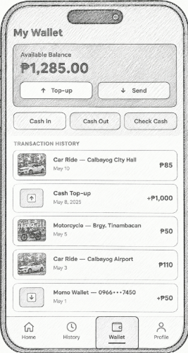
Figure 12. Wallet

Profile
The Profile screen displays the user’s account information, ride statistics and rating, along with options for editing the profile, notifications, privacy and security, help, app ratings, and terms of service.
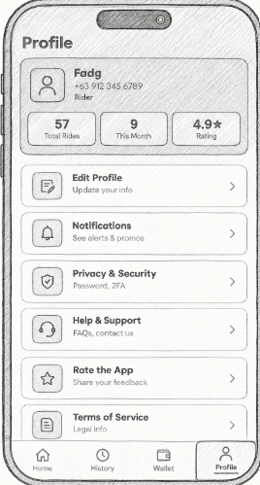
Figure 13. Profile

Rider Login

The Driver Portal screen provides a sign-in form for drivers, including email and password fields, a driver registration option, and demo login credentials.
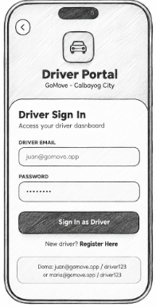
Figure 14. Driver Login
Rider Register
Rider can register the account and choose type of vehicle
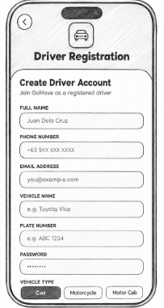
Figure 15. Rider Registration

Rider Dashboard
The Driver Bookings dashboard displays the driver’s online status, vehicle details, trip statistics, and incoming ride requests with passenger information, routes, fares, and options to accept or decline bookings.
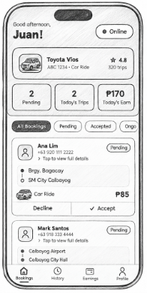
Figure 16. Rider Dashboard
Trip History
The Trip History screen shows completed driver trips with passenger names, routes, travel times, fares, and arrival status.
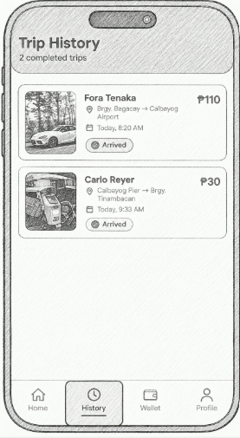
Figure 17. Trip history
Earnings
The Earnings screen summarizes the driver’s daily earnings, trips, average fare, rating, weekly overview, and total earnings for the week and month.
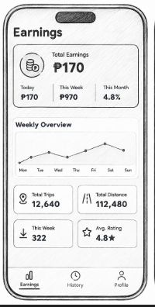
Figure 18. Earnings
Driver Profile
The Driver Profile screen displays the driver’s personal information, trip statistics, rating, vehicle details, and options for managing licenses and documents, notifications, and support.
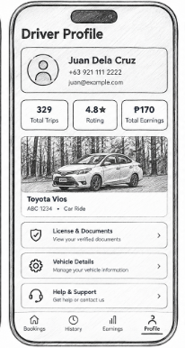
Figure 19. Driver Profile

