Project: Creditworthiness – Jean Paul Barddal

**Dear reviewer, please see the Jupyter Notebook that is located in the same repo as this report. There you will see the code I wrote to obtained the results presented here.**

## Step 1: Business and Data Understanding

*Provide an explanation of the key decisions that need to be made. (250 word limit)*

### Key Decisions:

1. What decisions needs to be made? The primary goal of this project is to determine whether a customer qualifies or not to a loan.
2. What data is needed to inform those decisions? This is one of those cases where more data usually may lead to better insights onto whether customers should be trusted to pay their loans in due time. Initially, the bank provided us with a fair amount of attributes, that seem to encompass financial, work-related and housing regarding each customer. A detailed analysis will take place to determine if we have redundant and irrelevant data that should be removed, and otherwise, it will be used to train our predictive model.
3. What kind of model (Continuous, Binary, Non-Binary, Time-Series) do we need to use to help make these decisions? As stated in the project description, the manager is concerned to divide customers into two segments (classes): creditworthy and non-creditworthy. Therefore, we’re dealing with a binary classification problem. Also, since we don’t have a lot of historical data, I don’t like the idea of working as a time-series (such as a data stream), since we don’t have enough data to back up the claim that we might have concept drifts.

## Step 2: Building the Training Set

*Build your training set given the data provided to you. The data has been cleaned up for you already so you shouldn’t* ***need to convert any data fields to the appropriate data types.***

*Here are some guidelines to help guide your data cleanup:*

* *For numerical data fields, are there any fields that highly-correlate with each other? The correlation should be at least .70 to be considered “high”. OK*
* *Are there any missing data for each of the data fields? Fields with a lot of missing data should be removed OK*
* *Are there only a few values in a subset of your data field? Does the data field look very uniform (there is only one value for the entire field?). This is called “low variability” and you should remove fields that have low variability. Refer to the "Tips" section to find examples of data fields with low-variability. OK*
* *Your clean data set should have 14 columns where the Average of Age Years should be 36 (rounded up) OK*

***Note:****For the sake of consistency in the data cleanup process, impute data using the average of the entire data field instead of removing a few data points. (100 word limit) OK*

***Note****: For students using software other than Alteryx, please format each variable as:*

|  |  |
| --- | --- |
| **Variable** | **Data Type** |
| Credit-Application-Result | String |
| Account-Balance | String |
| Duration-of-Credit-Month | Double |
| Payment-Status-of-Previous-Credit | String |
| Purpose | String |
| Credit-Amount | Double |
| Value-Savings-Stocks | String |
| Length-of-current-employment | String |
| Instalment-per-cent | Double |
| Guarantors | String |
| Duration-in-Current-address | Double |
| Most-valuable-available-asset | Double |
| Age-years | Double |
| Concurrent-Credits | String |
| Type-of-apartment | Double |
| No-of-Credits-at-this-Bank | String |
| Occupation | Double |
| No-of-dependents | Double |
| Telephone | Double |
| Foreign-Worker | Double |

*To achieve consistent results reviewers expect.*

*Answer this question:*

1. In your cleanup process, which fields did you remove or impute? Please justify why you removed or imputed these fields. Visualizations are encouraged.

* My strategy to remove attributes with a lot of missing data is simple: remove all attributes with more than 50% of the inputs are missing. In practice, this removed only one feature: Duration-in-Current-address.
* All of the remainder numeric attributes are imputed used the mean of the existing values.
* Both ‘Concurrent-Credits’ and ‘Occupation’ had a single value in the dataset (zero variability), and thus, were removed.
* All of the remaining string attributes are “dummified”, and that’s why I didn’t end up having the so-desired 14 attributes.
* All of the attributes that were originally binary and that were “dummified”, ended up showing a 1.0 correlation. This makes perfect sense since when is assumes the 0 value the other will definitely assume the value 1 and vice-versa. In this case, one of dummy variables was removed.

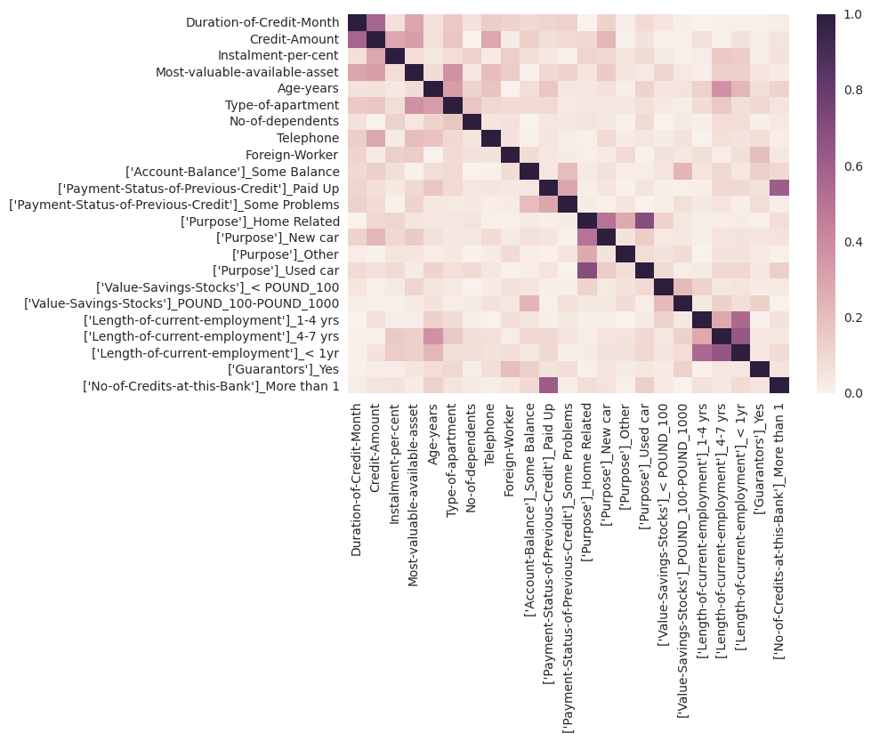

*Correlation matrix for the cleaned data set*

## Step 3: Train your Classification Models

*First, create your Estimation and Validation samples where 70% of your dataset should go to Estimation and 30% of your entire dataset should be reserved for Validation. Set the Random Seed to 1. (PLEASE SEE JUPYTER NOTEBOOK)*

*Create all of the following models: Logistic Regression, Decision Tree, Forest Model, Boosted Model*

*Answer these questions for* ***each model*** *you created:*

1. Which predictor variables are significant or the most important? Please show the p-values or variable importance charts for all of your predictor variables.
2. Validate your model against the Validation set. What was the overall percent accuracy? Show the confusion matrix. Are there any bias seen in the model’s predictions?

*You should have four sets of questions answered. (500 word limit)*

|  |  |  |  |  |  |
| --- | --- | --- | --- | --- | --- |
| *Topic* | | *Logistic Regression (SGD)* | *Decision Tree (DT)* | *Random Forest (RF)* | *AdaBoost* |
| *Variables and their importance* | 'Duration-of-Credit-Month'  'Credit-Amount'  'Instalment-per-cent'  'Most-valuable-available-asset'  'Age-years'  'Type-of-apartment'  'No-of-dependents'  'Telephone'  'Foreign-Worker'  "['Account-Balance']_Some Balance"  "['Payment-Status-of-Previous-Credit']_Paid Up"  "['Payment-Status-of-Previous-Credit']_Some Problems"  "['Purpose']_Home Related"  "['Purpose']_New car"  "['Purpose']_Used car"  "['Value-Savings-Stocks']_< POUND_100"  "['Value-Savings-Stocks']_POUND_100-POUND_1000"  "['Length-of-current-employment']_1-4 yrs"  "['Length-of-current-employment']_4-7 yrs"  "['Length-of-current-employment']_< 1yr" "['Guarantors']_Yes"  "['No-of-Credits-at-this-Bank']_More than 1" | *(Coefficients)* -2.52430815e+03  -9.17913239e+03  -1.12939417e+03  -7.68511593e+02  -1.68012249e+04  -8.78833209e+02  -4.46896036e+02  -6.24532536e+02  -4.88032909e+02  -5.81525804e+02  -1.96335079e+02  1.04712042e+02  -1.32759910e+02  -8.97531788e+01  -2.01944652e+02  -7.47943156e+01  -2.41211668e+02  -1.86985789e+02  -2.00074794e+02  -6.73148841e+01  4.64549865e-14  -2.09424084e+02 | 0.16950927  0.15454865  0.0626407  0.03603877  0.01430606  0.02760201  0.04347272  0.070645  0.0206735  0.06973498  0.01015279  0.04541578  0.0054984  0.02232738  0.01736574  0.02829426  0.05508371  0.  0.05226637  0.01215715  0.02489821  0.05290309 | 0.14149577  0.18203614  0.05751052  0.05963953  0.13598257  0.03447001  0.03026593  0.02873362  0.00646169  0.05471218  0.02640761  0.03976519  0.02473753  0.00976493  0.01711388  0.01621354  0.03044906  0.0157295  0.01886583  0.02562918  0.01560408  0.02484277 | 0.14  0.2  0.04  0.  0.14  0.  0.08  0.  0.  0.08  0.  0.1  0.04  0.06  0.  0.02  0.02  0.02  0.  0.06  0.  0. |
| *Accuracy obtained* | | *70.30%* | *69.69%* | ***79.39%*** | *75.15%* |

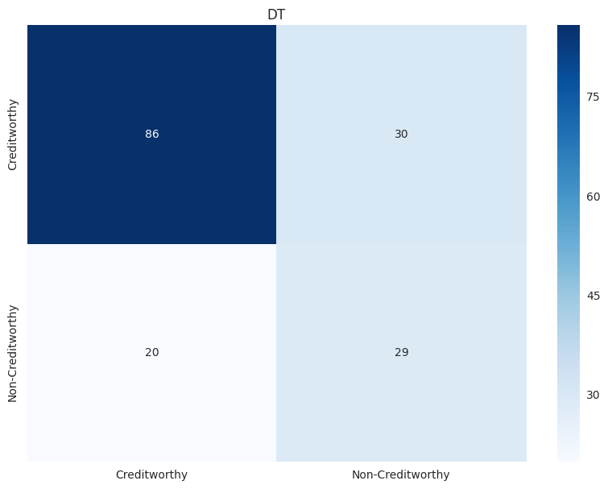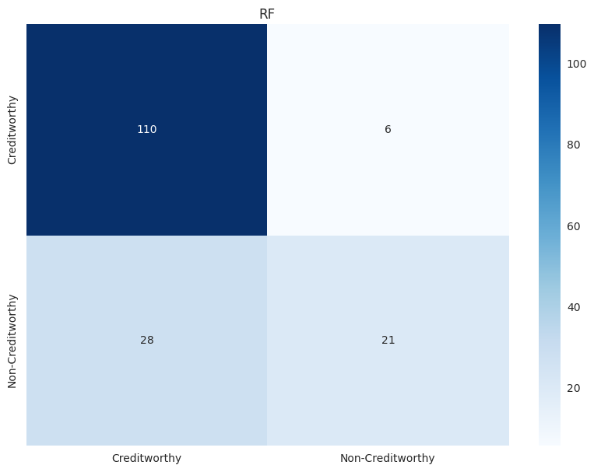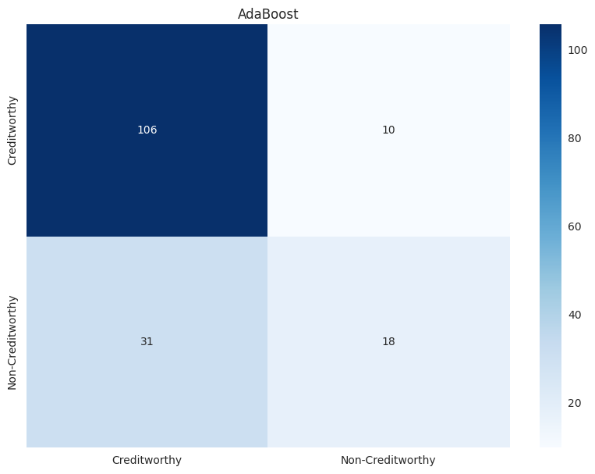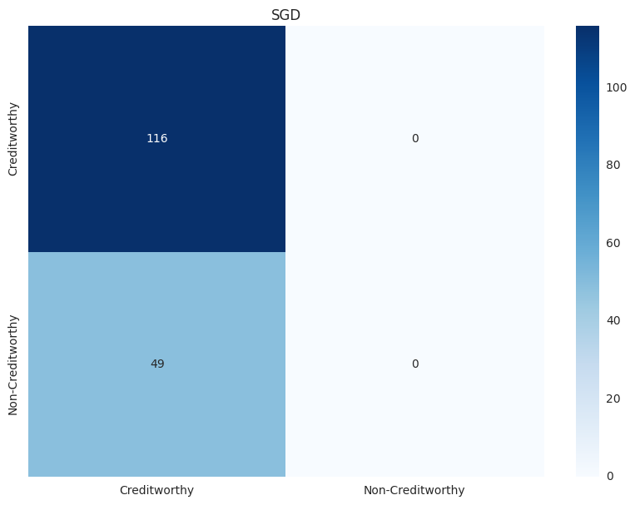

## Step 4: Writeup

*Decide on the best model and score your new customers. For reviewing consistency, if Score_Creditworthy is greater than Score_NonCreditworthy, the person should be labeled as “Creditworthy”*

*Write a brief report on how you came up with your classification model and write down how many of the new customers would qualify for a loan. (250 word limit)*

*Answer these questions:*

1. Which model did you choose to use? Please justify your decision using only the following techniques:
   1. Overall Accuracy against your Validation set
   2. Accuracies within “Creditworthy” and “Non-Creditworthy” segments
   3. ROC graph
   4. Bias in the Confusion Matrices

If we analyze the results presented in the table and confusion matrices above, we will see that all classifiers have problems with predicting the minority class (non-creditworthy customers). This shows that all classifiers are strongly biased towards this class, being SGD the extreme case, where all the instances in the validation set were classified as creditworthy. Naively, I would suggest going with the most accurate model (Random Forests), since it is able to correctly classify a few non-creditworthy customers. The validation is critical and should be performed with specialists, since the bank manager is the one that will be able to tell if the risk of providing loans for non-trustworthy customers surpasses more restrictive models, such as the decision tree, which is able to correctly predict more non-trustworthy customers.

**Note**: Remember that your boss only cares about prediction accuracy for Credityworth and Non-Creditworthy segments.

1. How many individuals are creditworthy?

Assuming the Random Forest classifier: the number of creditworthy customers in the validation set is 431 and non-creditworthy is 69.

Before you Submit

Please check your answers against the requirements of the project dictated by the [rubric](https://review.udacity.com/#!/rubrics/265/view) here. Reviewers will use this rubric to grade your project.