|  |
| --- |
| Railway Technologies Laboratory |
| Baseline Testing |
| The document summarizes latest Creep-Creepage tests done with Virginia Tech Roller Rig as a means of validation |

|  |
| --- |
| Mehdi Ahmadian (Ph.D), Jay Dixit, Karan Kothari  4-22-2017 |

Contents

Current Testing and Methodology 2

# Current Testing and Methodology

The objective of current testing is to establish baselines for the performance of the Virginia Tech Roller Rig (VTRR). The basic expectation from VTRR is to determine Creep forces while accurately controlling creepages and boundary conditions such as Vertical Load, Angle of Attack, Cant Angle and Lateral Displacement. Keeping this in mind, we designed the following experiments to establish a standard testing and data analysis scheme. The objective is to generate results that are *repeatable* and *reliable.*

## Design of Experiments

The following design of experiment ensures the following points to remove any additional sources of variability:

1. Uniformity of surface conditions at the contact interface
2. Uniformity of boundary conditions
3. Uniformity of terrain characteristics
4. Uniformity of data collection process

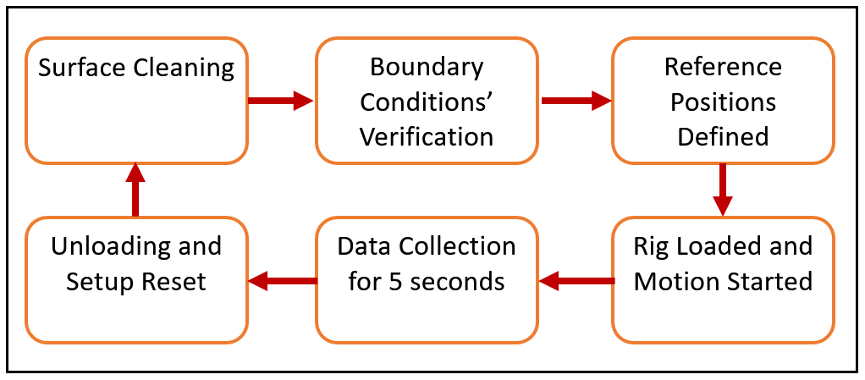

We now look at each individual step

### Surface Cleaning - *Ensuring constant surface conditions*

The effect of a third body significantly affects the creep forces at the contact interface. VTRR has two steel wheels rotating against each other at a pre-defined creepage and vertical load. A machining action is thus inevitable and the resulting debris could significantly affect the contact patch behavior thereby introducing a new variable. In order to eliminate that, the wheel and roller surfaces were constantly monitored and cleaned.

### Boundary Conditions’ Verification – *Ensuring constant boundary conditions*

VTRR has six actuators that control Angle of Attack, Cant Angle, Lateral displacement and Vertical Loading. Any deviations in these parameters causes a change in creep-creepage behaviour at the contact patch. Angle of Attack, Cant angles and Lateral Displacement are verified by external sensors which are independent of the actuator feedback. Vertical loading is verified by the force measuring system.

### Reference Position Definition – *Ensuring constant tread and terrain conditions*

Every machined surface has imperfections to some degree such as dents, notches, ovality etc. These imperfections are further aggravated over time especially in cases like VTRR with continuous wear happening due to the machining action. We define same starting and ending points for our servo motion so that the contact interface sees the same terrain over the course of testing. We also define a fixed retraction point for the vertical actuators.

### Loading of Rig and Start of Test

Once the initialization steps are complete, the wheel and roller velocities for the desired creepage is entered in the motion console. Vertical load is applied and the motion is started. All actuators are active and applying forces/moments.

### Data Collection

Constant test data size is necessary for batch post processing of the data. The data collection thus is programmed to cease after five seconds.

## Data Post Processing

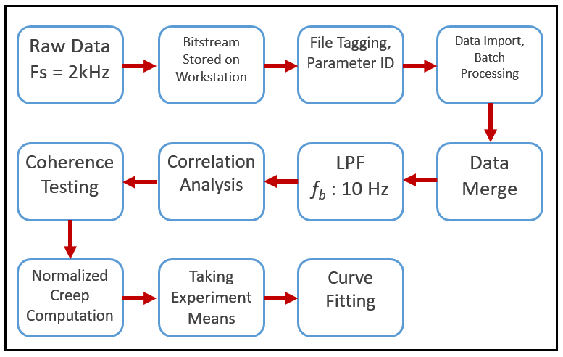

### Raw Data Collection

The following table shows the type of data that is queried and the data type:

|  |  |
| --- | --- |
| Query | Data Type |
| Longitudinal Forces | Integer value from -32768 to +32767 |
| Vertical Forces | Integer value from -32768 to +32767 |
| Commanded Wheel Velocity | Integer Value from -220 to + 220 |
| Actual Wheel Velocity | Integer Value from -220 to + 220 |
| Actual Roller Velocity | Integer Value from -220 to + 220 |

This data comes in the form of a stream of bits from sensors and serial connectors interface the data with SynqNET. SynqNET also provides the interface for the workstation to read and send data or commands over to actuators and sensors. The incoming bitstream (ones and zeros) is stored in a volatile cache memory.

### Data storage, File Tagging and Parameter extraction

The bitstream in the cache memory is then stored on the workstation in the form of a text file. The file is appropriately named and a separate journal notes the testing parameters that resulted in the data. This raw data is then processed by a MATLAB code which converts the numbers in the text file into data sets like forces and velocities with appropriate human identifiable units.