CSC15S Lab1 – Linux Setup and VIM Practice
Total: 100pts (due date see Blackboard)
What to turn in: Upload the following file to Assignment 1 in Blackboard.
(1) CSC15SLab1.docx (with all questions completed)
Part I. VM … VM …
[20 pts. Estimated time to complete: 15 minutes]
For Dr. Evil’s classes, all students will have the same lab environment. This is accomplished using the same virtual machine (VM) by everybody. The OS for this class is a 32-bit¹ Light Linux Ubuntu 18.04, which takes about 10GB of your hard drive space. Your first job is to get the VM installed. At the end of this job, we expect a screenshot like the following:
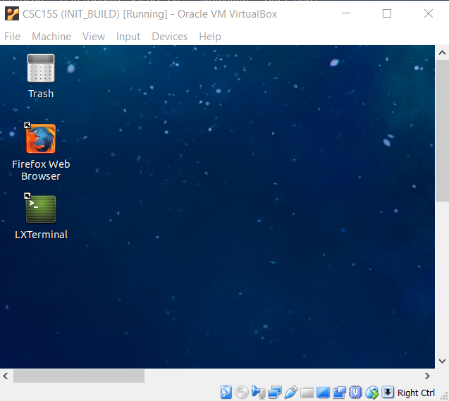
Please follow the steps below to get your VM set up:
(1) Download CSC15S.ova from Blackboard -> CSC15S->DOWNLOADS. [Estimate: 2 minutes using campus network]
(2) Download and install the latest version of Oracle VirtualBox [Estimate: 5 minutes using campus network]
(3) Start Oracle VirtualBox -> Files -> Import Appliance and import CSC15S.ova [Estimate: 5 minutes]
(4) Take a snapshot and name it as INIT_CSC15S. (This is for recovering the image if the system crashes) [Estimate: 1 minute]
(5) Now boot into the system and answer the following questions. The password for csc15s is “goodyear”.
Q1. How many seconds does it take to boot? (From the time you click “Start” on VM to the time you see the login page) (10 pts)
14.42
Q2. Please paste below a screenshot to prove that you have taken the initial snapshot [10 pts]
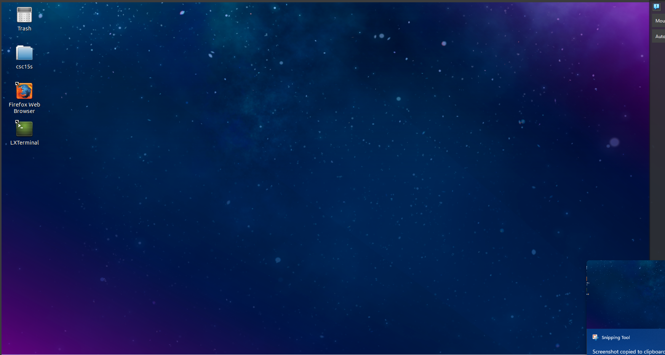
Continue to the NEXT Section “Performance Tuning” if you find that it takes more than 20 seconds to boot, or if you’d like to earn 20 bonus points.

THIS SECTION IS OPTIONAL
Optional/Bonus Section. Performance Tuning (When Your VM is Slow)
[Estimated time to complete: 60 minutes. Bonus Points: 20pts]
The VM can be optimized. You can apply the following approaches one by one and report the improvement of the speed-up. In many cases, if one approach does not work (you can restore the INITIAL snapshot you’ve taken in the previous step).
-------------------------------------------------------------- Worksheet -------------------------------------------------------------------------------------------
Your hardware config: CPU: __12th Gen Intel(R) Core(TM) i3-12100F_____ cores, _____3.30____ GHZ, RAM: ___8.00_____ GB.
Hard-drive: ___476___ GB, SSD Drive? ____y__ (Y/N)
Optimization | Boot-Time  (in seconds) | Does it Freeze System? (Y/N)
O1: Enable Intel Vt-x support
(1) Reboot your host OS into UEFI/BIOS and enable the Intel Vt-X (or AMD-v) support. (Google “how to boot into UEFI” in your OS.
(2) Go to the setting of the CSC15S VM and System->Processor->Acceleration and tick on the Vt features (for some OS, like some models of MacOS, you’ll have to tick them off)
O2: Install Guest Addition
(1) Reboot your VM in VirtualBox
(2) VirtualBox: Device -> Install Guest Addition
(3) Click the “LXTerminal” on desktop to bring up a terminal
(4) cd /media/csc15s/VBox_GAs_some_number
(5) sudo ./VBoxLinuxAdditions.run
type password: goodyear
(6) Once reporting success, type “exit”
(7) Reboot and measure the boot time
Usually, installation of Guest Addition (if effective) will allow you to view screen with max resolution of your computer
O3: assign more cores
Go to settings of CSC15S VM: System -> Processor
O4: enable graphics acceleration
Go to settings of CSC15S VM: Display -> tick enable 3D and 2D accelerations (sometimes your hardware/OS will not allow 2D optimization).
Display -> increase the video memory from 16MB to 64MB or 128MB (this is needed especially when you have a 4k screen)

Q1. Please make sure that the above worksheet is completely filled out
Q2. What is your VM boot time after all optimizations are applied? ___________ seconds

------------------------- THE ABOVE SECTION IS OPTIONAL -------------------------------------------------------
*** Please visit Dr. Evil’s office hour by Thursday 09/13 if your laptop’s VM boot time still > 20 seconds. Failure to get the issues resolved by 09/14 will directly result in UW (Unofficial Withdrawal) from this class.

Part 2. Be a VIM Pro? – Play NetHack First!
[30 pts. Estimated time to complete: 30 minutes]
Believe it or not: this practice might be the #1 factor that decides if you will be a great software developer. It is not a sufficient condition, but a necessary condition! 80% of time a developer is awake (s)he might be using an editor, and most of it is spent on navigation. It is extremely important that you do it efficiently.
The key is to do the navigation without using a mouse or the arrow keys which are located far away from the center of the keyboard. The key combination “hjkl” thus becomes a natural solution to replace arrow keys in vim.
In this practice, you will use a very well known UNIX game Nethack to practice your VIM navigation keys. To prove your success you have to provide five screenshots as shown below:
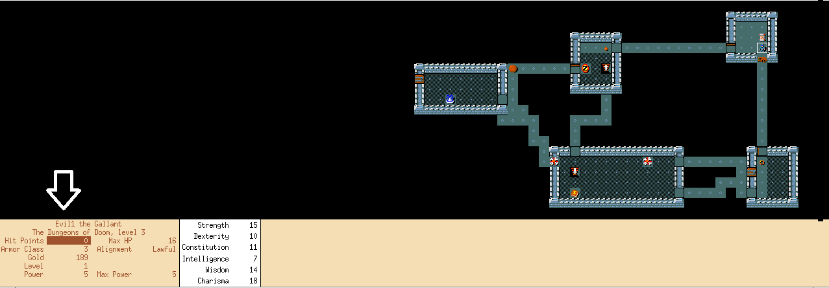
Please follow the steps listed below to start the game. Type the following command in the terminal to start the game:
xnethack -u Evil1
Note that “Evil1” appears as the user name in the game (see the WHITE arrow in the above screenshot). You will need to play the game five times. Each time, using a different user name (Evil1, … Evil5). Note you will have to replace “Evil” with your real first name such as Mike1, Mike2, …, Mike5.
Our requirement is very simple: use the “hjkl” keys to explore as much as possible on the random map. The minimal requirement is that you need to explore at least 5 rooms in each round.

-------------------------------------------------------------- Worksheet -------------------------------------------------------------------------------------------
Q1. To prove your success, please paste the 5 screenshots (one for each run of the game). [30 pts]
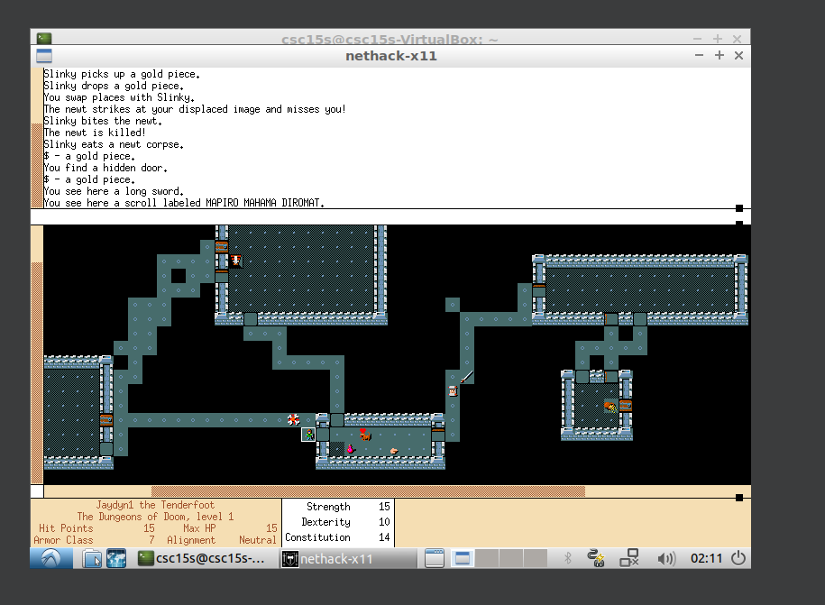
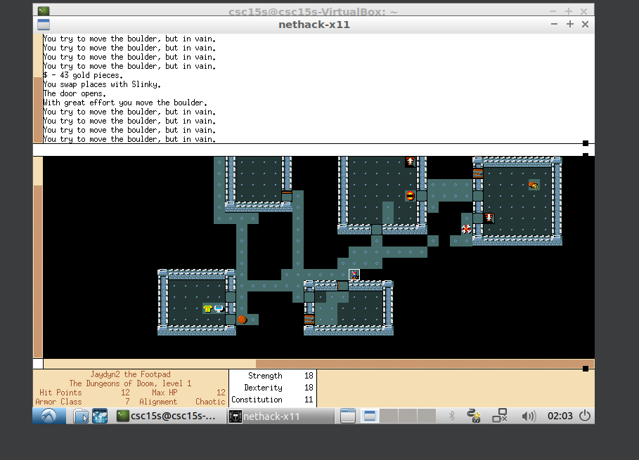
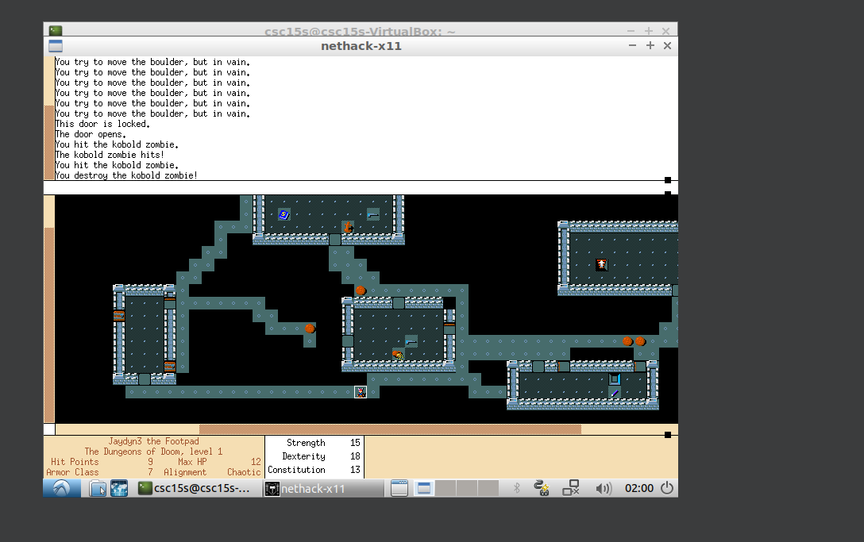
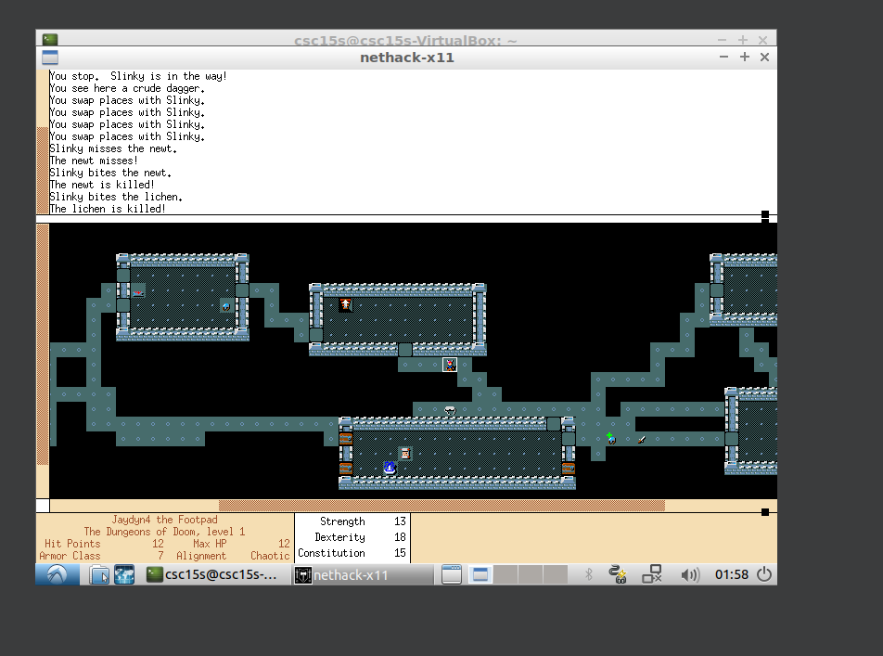
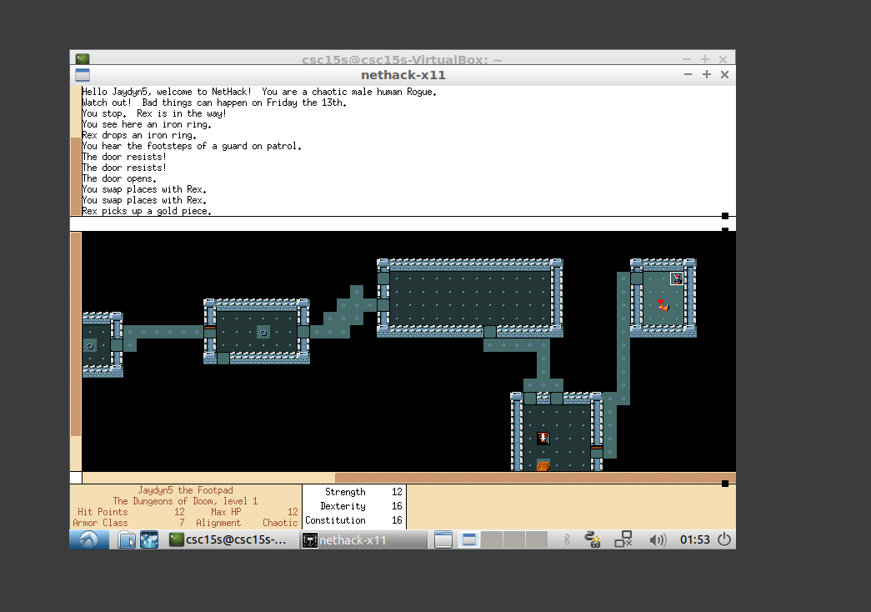

Part 3. VIMTUTOR!
[50 pts. Estimated time to complete: 60 minutes]
Our plan is to finish the first two tutorials of the vimtutor, which teaches you some of the essential commands of VIM. Start a terminal and type “vimtutor” you should be able to see a screen like the following. Please follow the instructors carefully and finish the first two lessons. This will take about 40 minutes to one hour of your time.
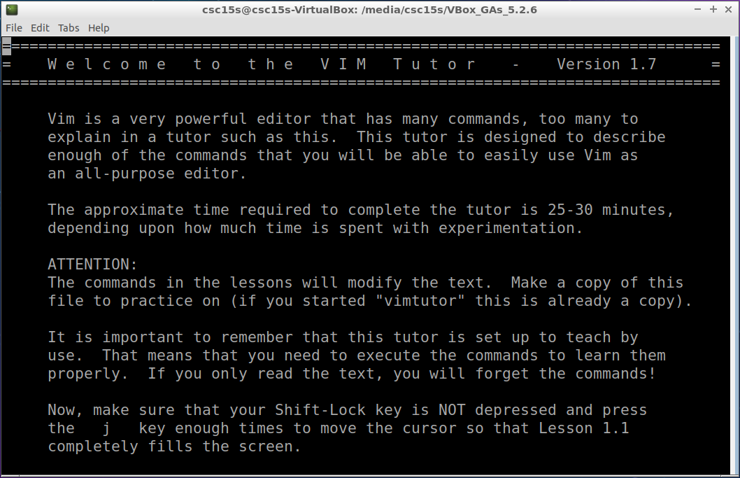
Once you finish the vimtutor, please visit vimgenius and test your knowledge! Follow the instructions in the figure below and please finish the first two quizzes.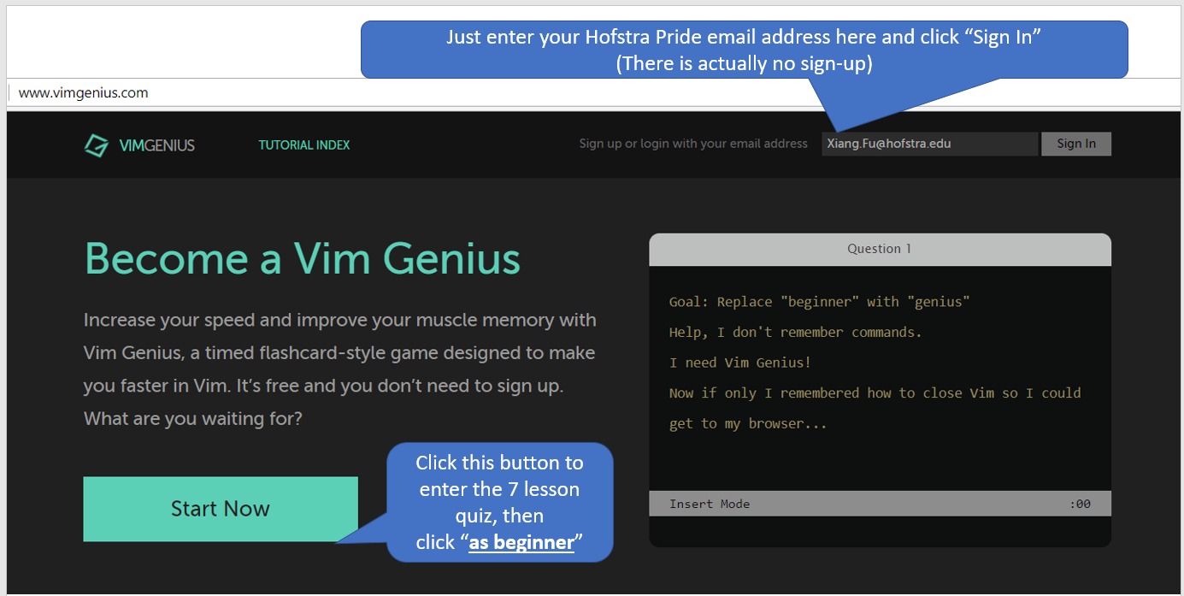

-------------------------------------------------------------- Worksheet -------------------------------------------------------------------------------------------
Q1. To prove your success, please paste a screenshot like the following [50 pts].
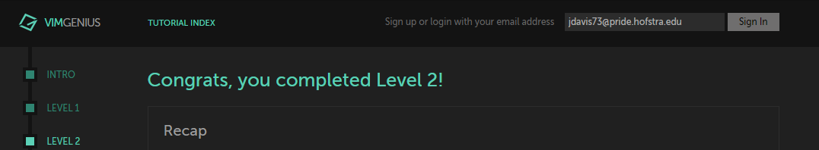
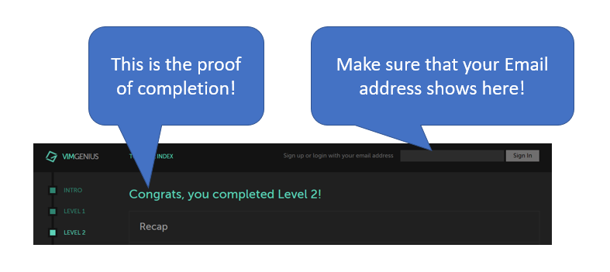

Why 32-bit instead of 64-bit? This is to make sure the lowest hardware would be required.

