CSC215 Lab10 – Remote Buffer Overflow
Total: 100pts
@Copyright Dr. Xiang Fu
What to turn in: CSC215Lab10.docx
Note: the folder used for this lab is ~/-Desktop/csc215/lec22_bo2 in the Ubuntu image. You also need BT5 for this lab.
(1) Repeat the success of attack on peercast3. Paste the success screenshot below. [20pt, 20 minutes]
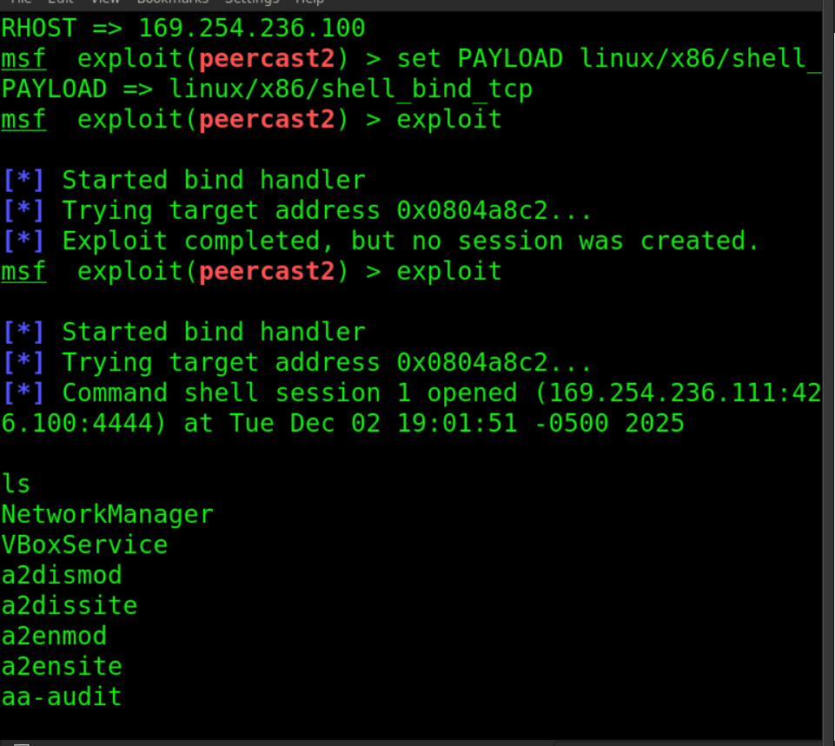

(2) Shell code exploration. [25pt, 25 minutes]
(2.a) List the absolute file path of the linux/x86/shell_bind_tcp payload below (hint: it is a single stage payload) [5pt]

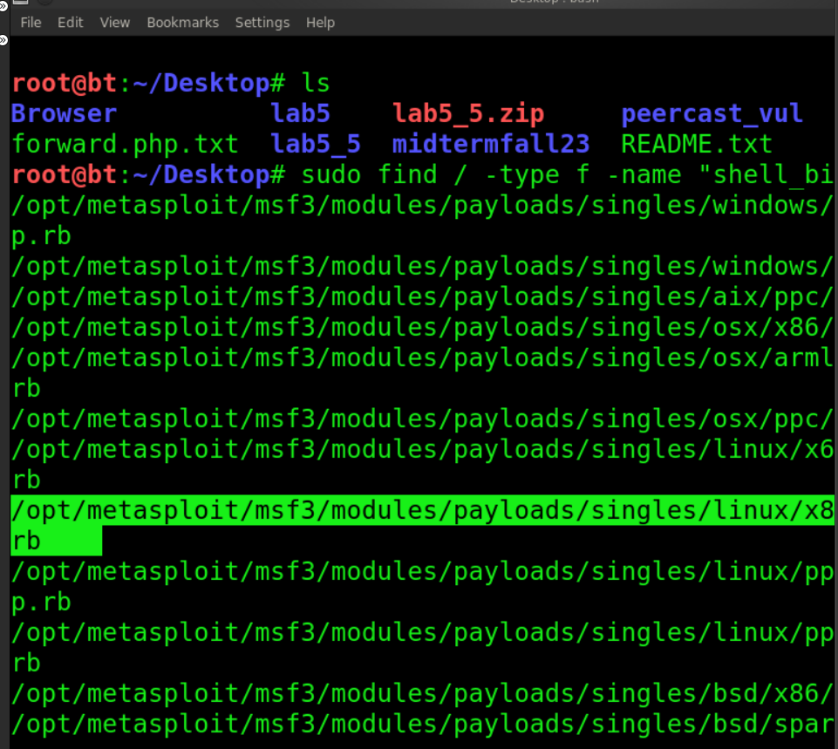
/opt/metasploit/msf3/payloads/single/linux/x86/shell_bind_tcp.rb
(2.b) Explain the logic of shell_bind_tcp. You should concentrate on the INT 80 calls (read the lecture notes on where to find Linux system calls by INT 80 service code). [20pt]
The file exists to serve as a sent payload, it is a single. The payload consists of assembly instructions . Payload opens a TCP port on victim machine. Wait for connection, spawns /bin/sh attached to socket, everything done using raw x86 Linux syscalls.
Purpose...
Create socket: 0x66 (socketcall->socket)
Bind socket: 0x66 (socketcall->bind)
Listen: 0x66 (socketcall->listen)
Accept: 0x66 (socketcall->accept)
Redirect file descriptors: 63 (dup2)
Execute shell: 11 (execve)
0x2c6b934
(3) Use GDB to trace into the shell code. Set a breakpoint at the address of the “JMP ESP” instruction in peercast3. (e.g., if you want to set a breakpoint at 0x80000000, you can use command b *0x80000000 in GDB). Explain if you have seen the same code as shown in (2.b) Paste a screenshot of the REAL SHELLCODE (not the self-extraction) that you have found. [20pt]
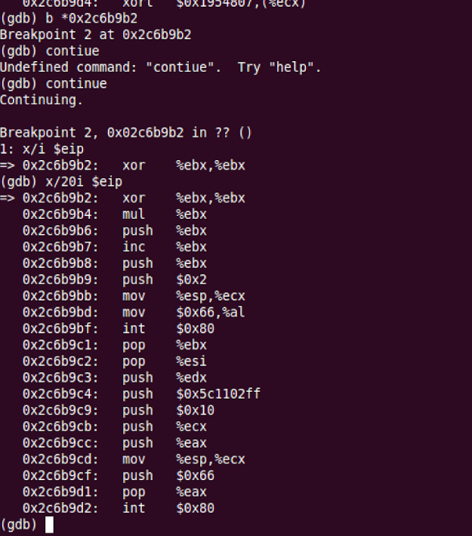
No we don’t find the same code
(4) Debugger Assisted Analysis. [35pt]. Now with the help of the debugger, you can supply a detailed report of the shell_bind_tcp shell code. Your report should include the values of the parameters (and their semantics) for each of the INT 80 interrupts in the shell code.

INT 0x80 #1 – socket(AF_INET, SOCK_STREAM, 0)
At the first int 0x80:
- EAX = 0x66 → sys_socketcall
- EBX = 0x1 → sub-function SYS_SOCKET
- ECX = esp → points to [2, 1, 0]
Semantics: socket(AF_INET=2, SOCK_STREAM=1, protocol=0).
Return: EAX = sockfd (saved for later calls).

INT 0x80 #2 – bind(sockfd, &addr, 16)
Before the second interrupt the shellcode builds a sockaddr_in on the stack:
- sin_family = AF_INET (2)
- sin_port = htons(4444) (=0x115c)
- sin_addr = INADDR_ANY (0)
At the second int 0x80:
- EAX = 0x66
- EBX = 0x2 → SYS_BIND
- ECX = ptr → [sockfd, &sockaddr_in, 16]
Semantics: bind(sockfd, (struct sockaddr *)&addr, 16) so the socket listens on TCP port 4444 on all interfaces.

INT 0x80 #3 – listen(sockfd, 0)
The shellcode reuses the arg array and sets a backlog value.
At the third int 0x80:
- EAX = 0x66
- EBX = 0x4 → SYS_LISTEN
- ECX = ptr → [sockfd, 0]
Semantics: listen(sockfd, backlog=0) (minimal backlog, just enough for this shell).

INT 0x80 #4 – accept(sockfd, NULL, NULL)
At the fourth interrupt:
- EAX = 0x66
- EBX = 0x5 → SYS_ACCEPT
- ECX = ptr → [sockfd, NULL, NULL]
Semantics: newfd = accept(sockfd, NULL, NULL).
Return: EAX = newfd, the connected client socket; the shell now talks over this descriptor.

INT 0x80 #5–#7 – dup2(newfd, 2), dup2(newfd, 1), dup2(newfd, 0)
A small loop calls dup2 three times.
For each int 0x80 in the loop:
- EAX = 0x3f → sys_dup2
- EBX = newfd (the accepted socket)
- ECX = 2, then 1, then 0
Semantics:
dup2(newfd, 2); // stderr → socket
dup2(newfd, 1); // stdout → socket
dup2(newfd, 0); // stdin → socket
After this, all standard I/O of the upcoming shell goes through the TCP connection.

INT 0x80 #8 – execve("/bin/sh", ["/bin/sh", NULL], NULL)
At the final int 0x80:
- EAX = 0x0b → sys_execve
- EBX = ptr → string "/bin/sh"
- ECX = ptr → argv array [ptr_to_"/bin/sh", 0]
- EDX = 0 → envp = NULL
Semantics: execve("/bin/sh", argv, NULL).
This replaces the current process with /bin/sh, giving a bind shell on port 4444.

