CSC215 Lab11 – Format String Attack
What to turn in: CSC215Lab12.docx
Note: the files used for this lab are located in ~/Desktop/csc215/lectures/lec24_format_str_lab in the Ubuntu image.

1. Format String Attack [100pt]
(1) Type “make” to compile fmtstr.cc. Craft a string to feed into fmtstr so that it prints out the RETURN ADDRESS of the main() function (i.e., where main() would jump to when it completes). You can use GDB to assist your analysis. Paste the screenshot below to prove your success. (hint: you might need a lot of %p’s, the number of %p depends on the size of the temp array). [30pt, 10 minutes]
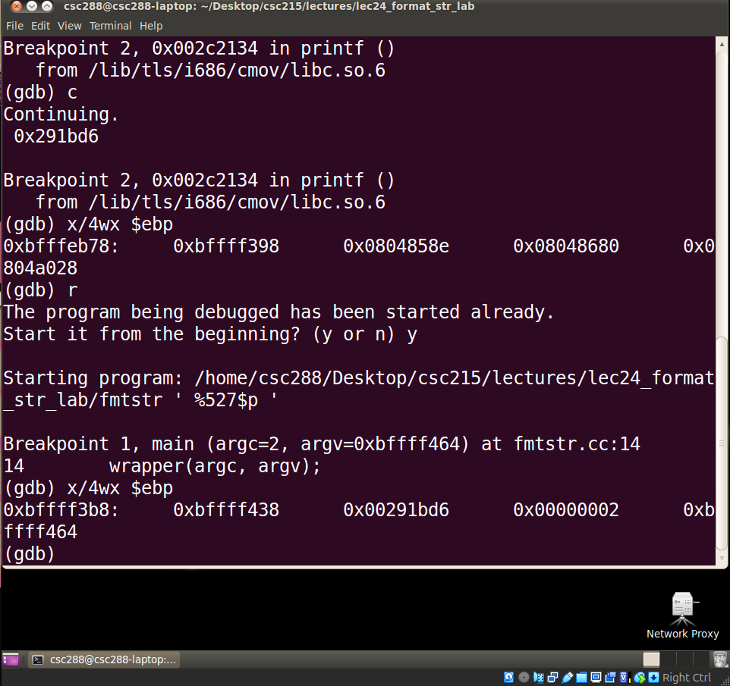
(2) Replicate the success of writing value “0xAAAABBBB” into global variable Canary. Paste your screenshot below. [40pt, 20minutes]
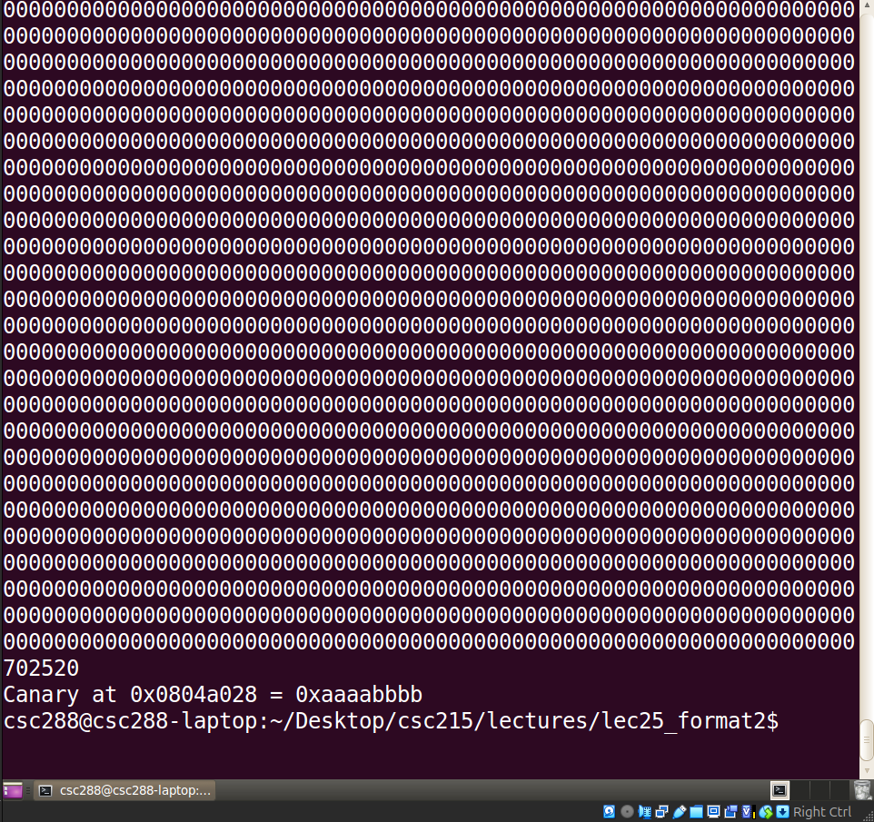
(3) Now write value “0x20201010” into global variable Canary. Paste your screenshot below. [20pt, 20 minutes]
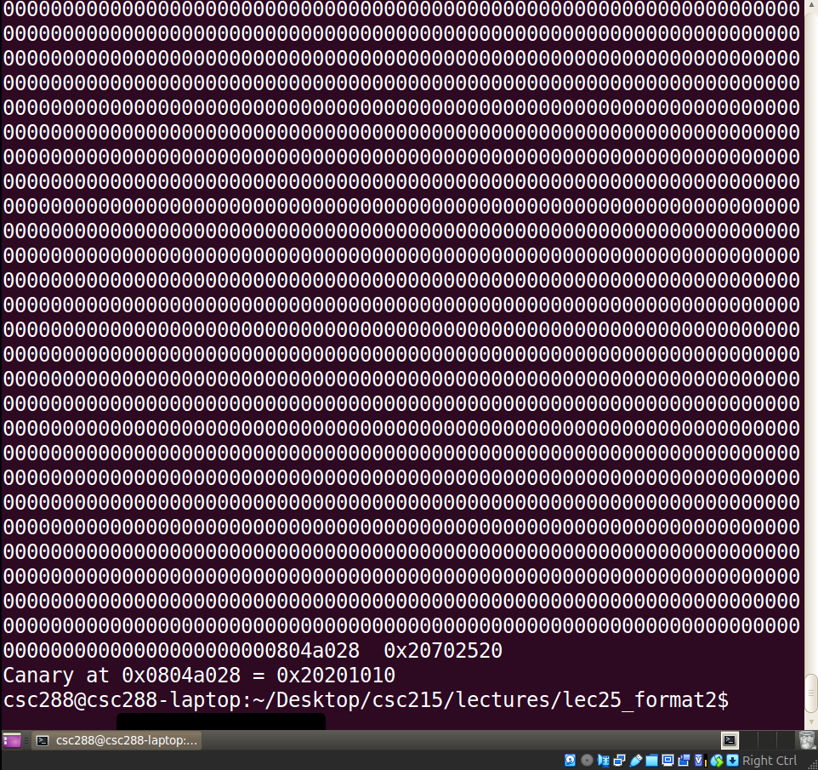
(4) A security consulting firm proposes to develop a product “PatchMe”. The tool takes a binary executable as the input, and modifies its .text segment to defeat format string attacks. Describe how you would implement this tool. [10pt, 15 minutes]
A tool like PatchMe would operate as a post-compilation binary rewriter that scans the executable’s .text segment for potentially vulnerable uses of formatting functions such as printf, sprintf, and related libc calls. The tool would parse the binary, identify call sites, and analyze the calling convention to determine whether a format string argument is a static constant or a runtime-supplied value. Whenever it detects an unsafe pattern such as a function call where the format string originates from user-controlled memory—the tool would rewrite the machine code to insert a protective wrapper. This wrapper could enforce a safe default format string (e.g., "%s"), validate the string at runtime, or reroute calls through hardened library stubs that reject dangerous format specifiers like %n. The rewriting process would require disassembly of the affected blocks, patching relative call offsets, and reconstructing the control flow to ensure correctness. By modifying the .text segment in this targeted way, PatchMe strengthens legacy binaries against format-string vulnerabilities without requiring source code or recompilation.

