CSC215 Lab4 – Web App Security and Intro to Ruby
Total: 100pt
@Copyright Dr. Xiang Fu. All Rights Reserved
What to turn in: Zip all related file in lab4.zip. [note: all related files in /var/www/vul of the Ubuntu image]. The zip file should include the following:
(a) CSC215Lab4.docx with your answer to each question typed.
(b) hack.py
(c) new_myexec.c
(d) ruby1.rb
(e) ruby2.rb
(f) ruby3.rb
(g) ruby4.rb and a.html
1. Web Application Vulnerability [20pt]
Attack http://169.254.236.100/vul/bad1.html manually. Paste the screenshot below to demonstrate your success.
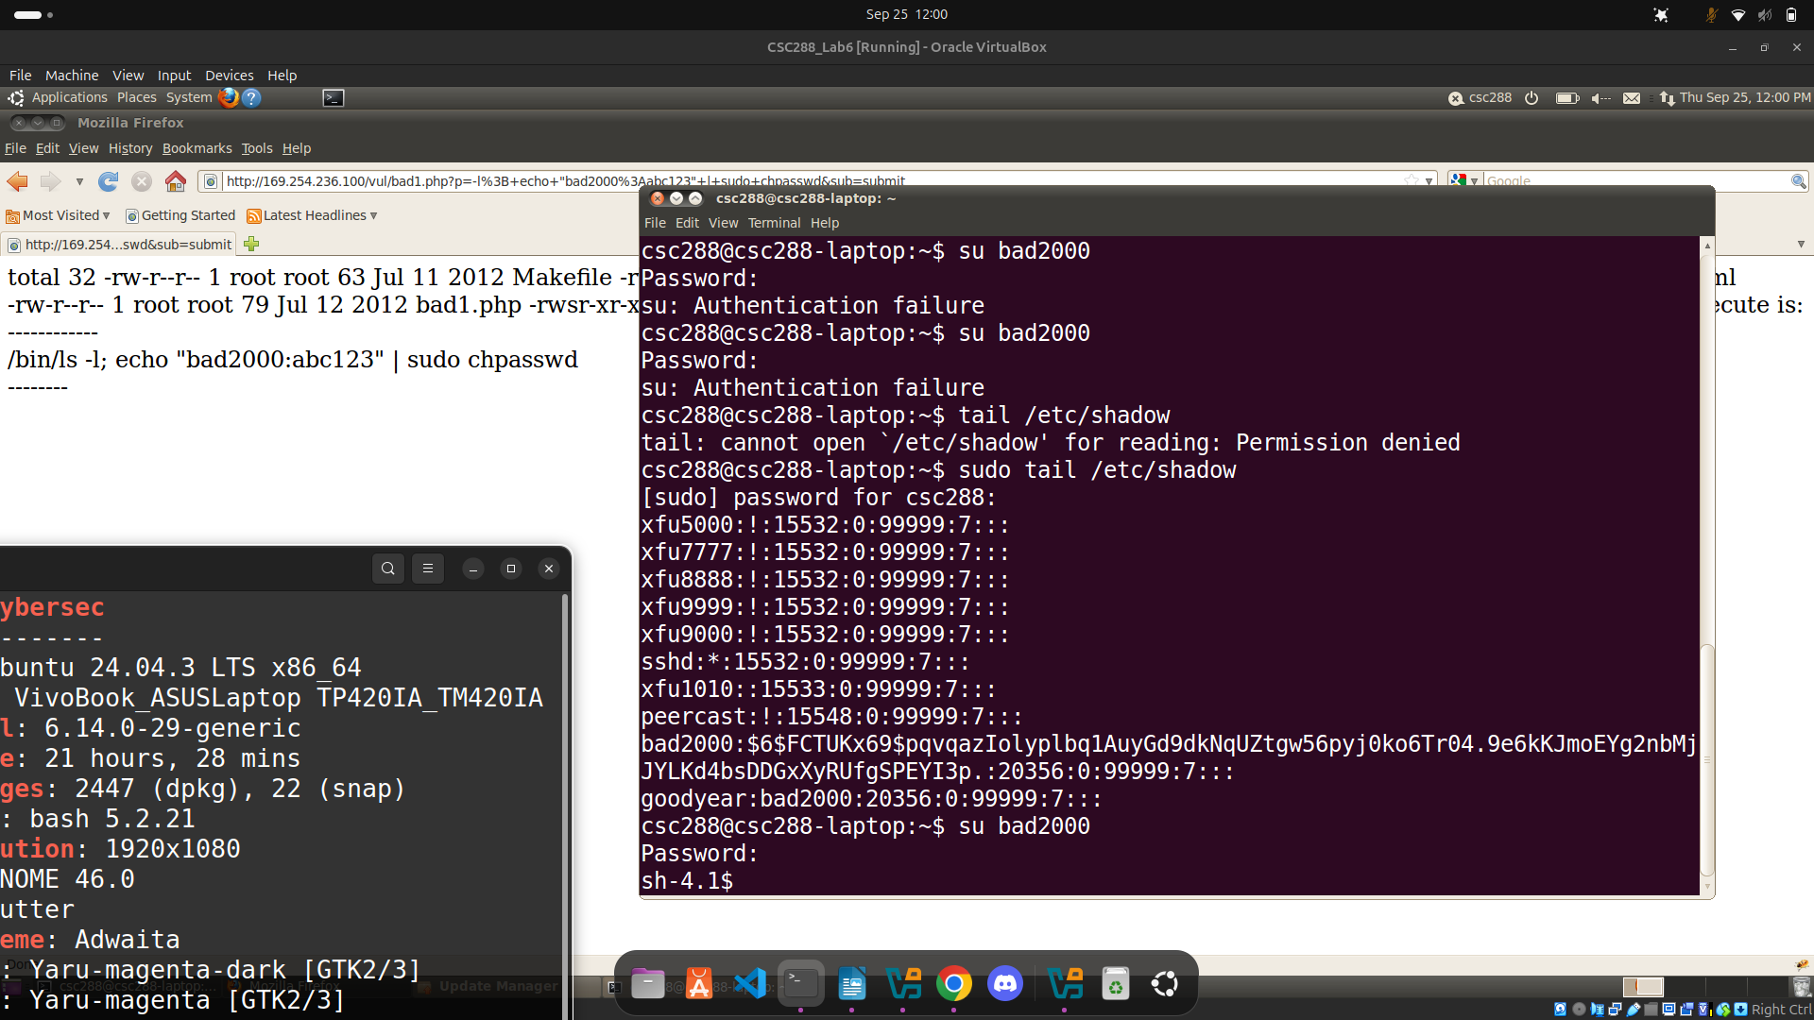
2. Replay Attacking Using Netcat [10pt]
Write a simple Python script named “hack.py” that replays the above attack using netcat. Our requirement is that your script can create 10 user account at a time. Paste the screenshot below to prove your success (show the contents of /etc/passwd).
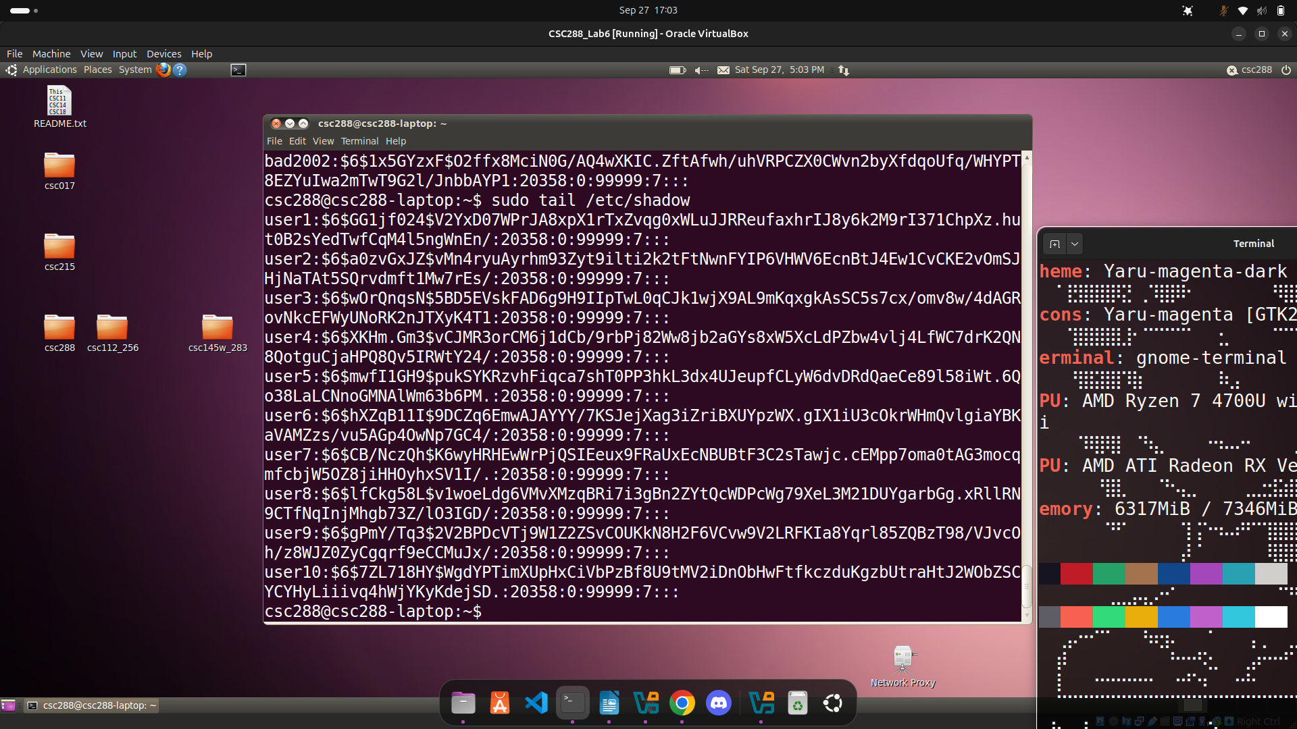
3. Defense [20pt]
Now patch the myexec.c source and make it robust against command injection attack. Submit your file as “new_myexec.c”. Paste the screenshot of failed attack.
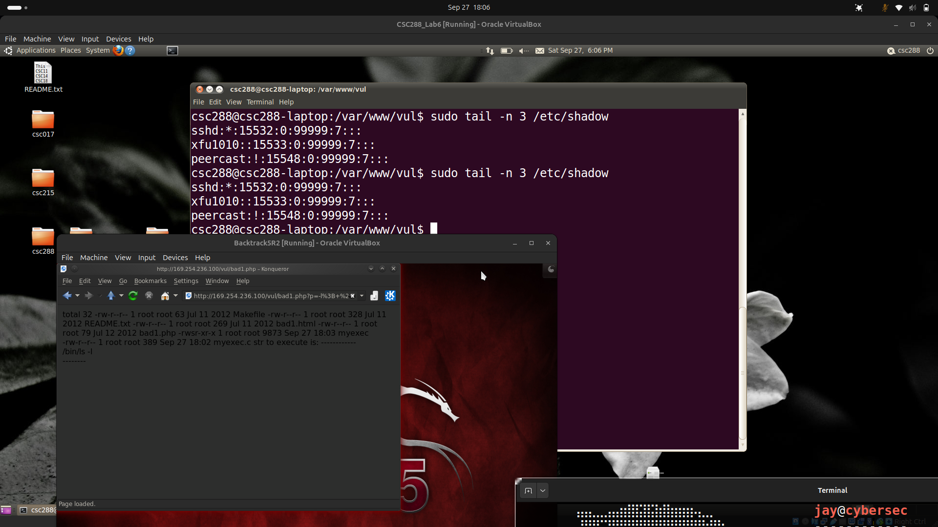
4. Ruby Practice [50pt]
(a) [save as ruby1.rb] Print the first 100 odd numbers [10pt]
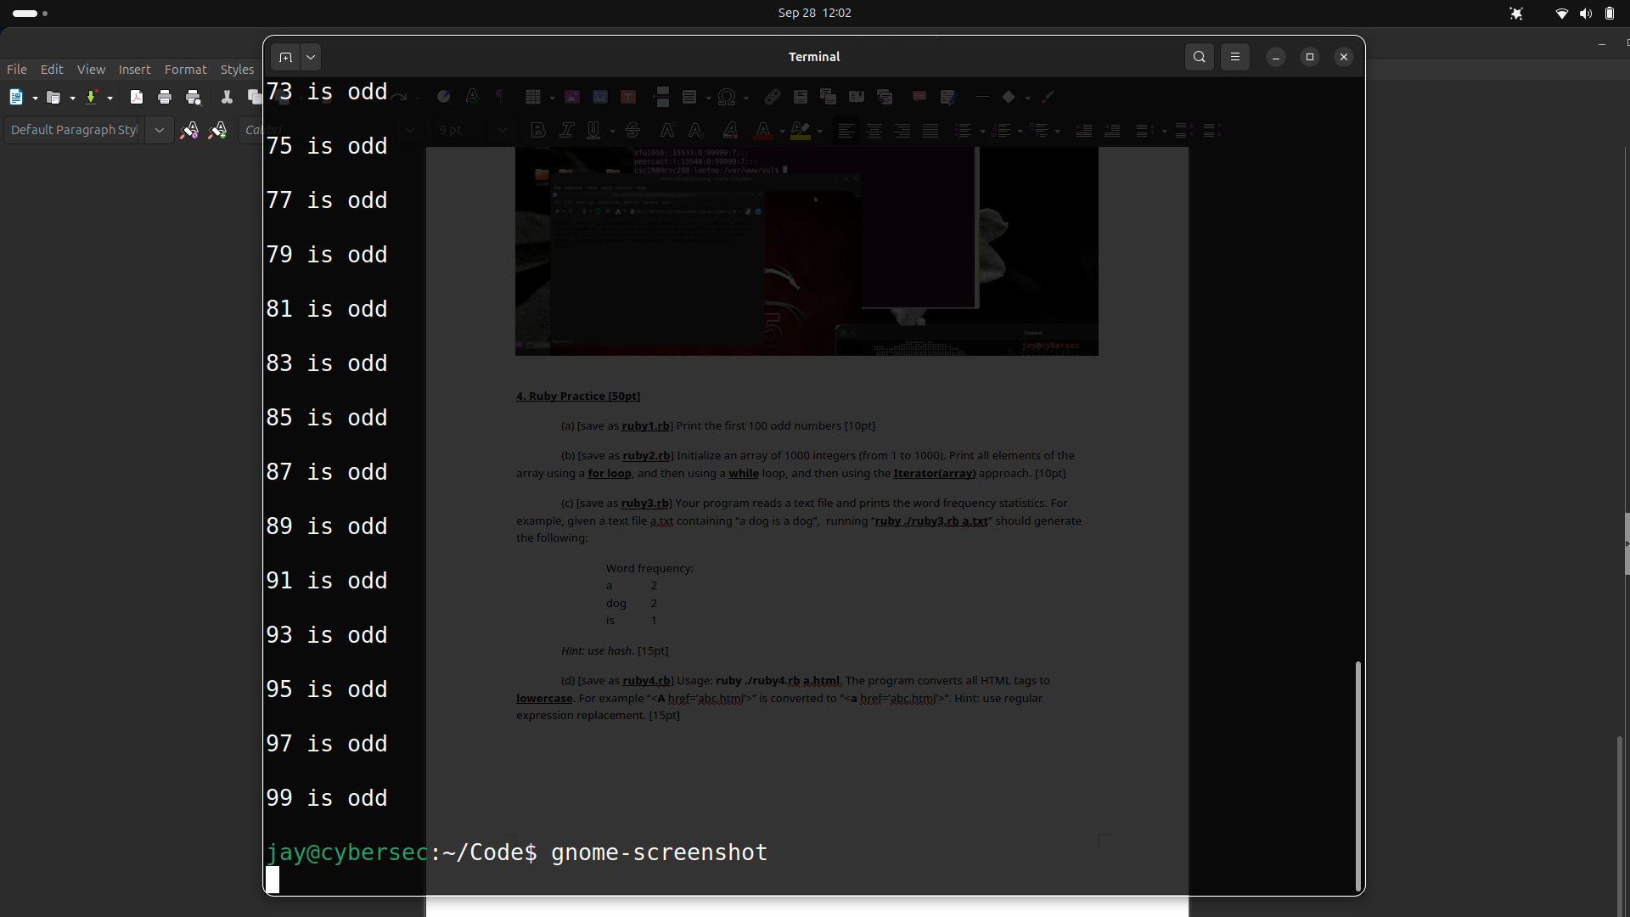
(b) [save as ruby2.rb] Initialize an array of 1000 integers (from 1 to 1000). Print all elements of the array using a for loop, and then using a while loop, and then using the Iterator(array) approach. [10pt]
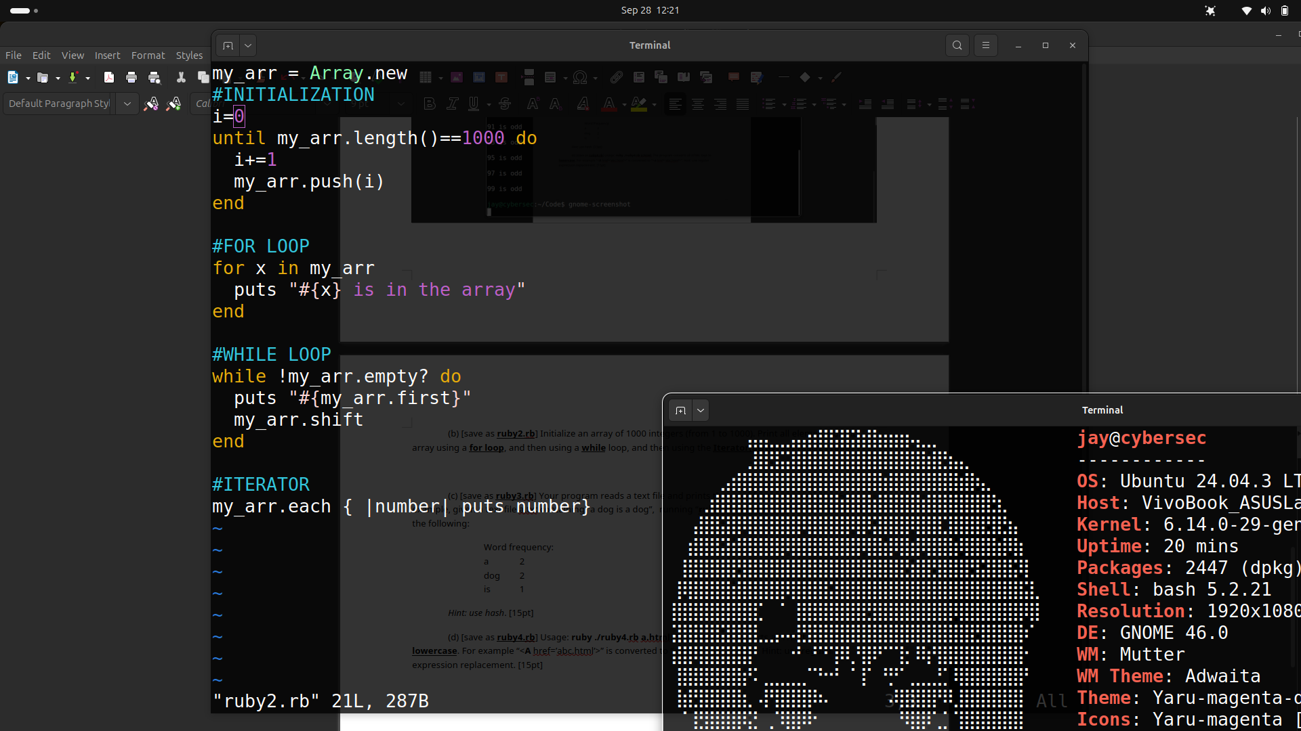
(c) [save as ruby3.rb] Your program reads a text file and prints the word frequency statistics. For example, given a text file a.txt containing “a dog is a dog”, running “ruby ./ruby3.rb a.txt” should generate the following:
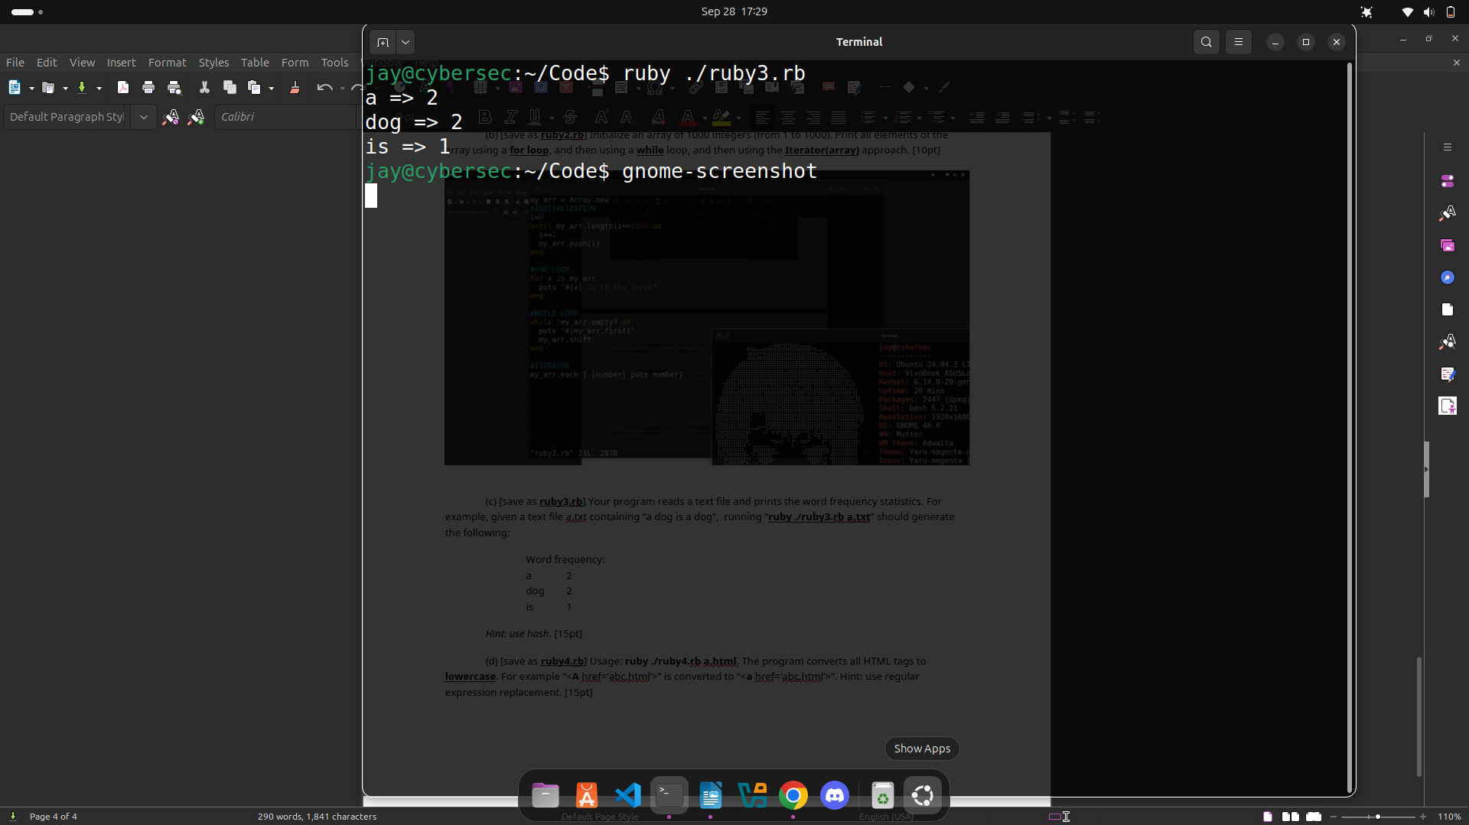
Word frequency:
a 2
dog 2
is 1
Hint: use hash. [15pt]
(d) [save as ruby4.rb] Usage: ruby ./ruby4.rb a.html. The program converts all HTML tags to lowercase. For example “<A href=’abc.html’>” is converted to “<a href=’abc.html’>”. Hint: use regular expression replacement. [15pt]
