CSC215 Lab5 – Metasploit Practice 3
Total: 200pts
@Copyright Dr. Xiang Fu. All Rights Reserved.
What to turn in: Zip all related file in lab5.zip. The zip should include the following files:
(1) csc215Lab5.docx with all your answers typed and screenshots pasted.
(2) php_cmd_inj.rb.

Part I. 100pts
Hint: There are two approaches to find out the Metasploit API information.
(1) read developer_guide.pdf (using xpdf) located at /opt/metasploit/msf3/documentation
(2) search the use of API calls in source code. Use “find ./ -type f –exec grep –H ‘keyword’ {} \;” in /opt/megasploit/msf3/modules or /opt/megasploit/msf3/lib.

1. PHP_Eval Exploit Practice [40pt]
Repeat experiment with PHP_Eval and http://169.254.236.100/vul2/eval.html. Establish a remote shell session using the bind_perl payload. Paste your success screenshot below.
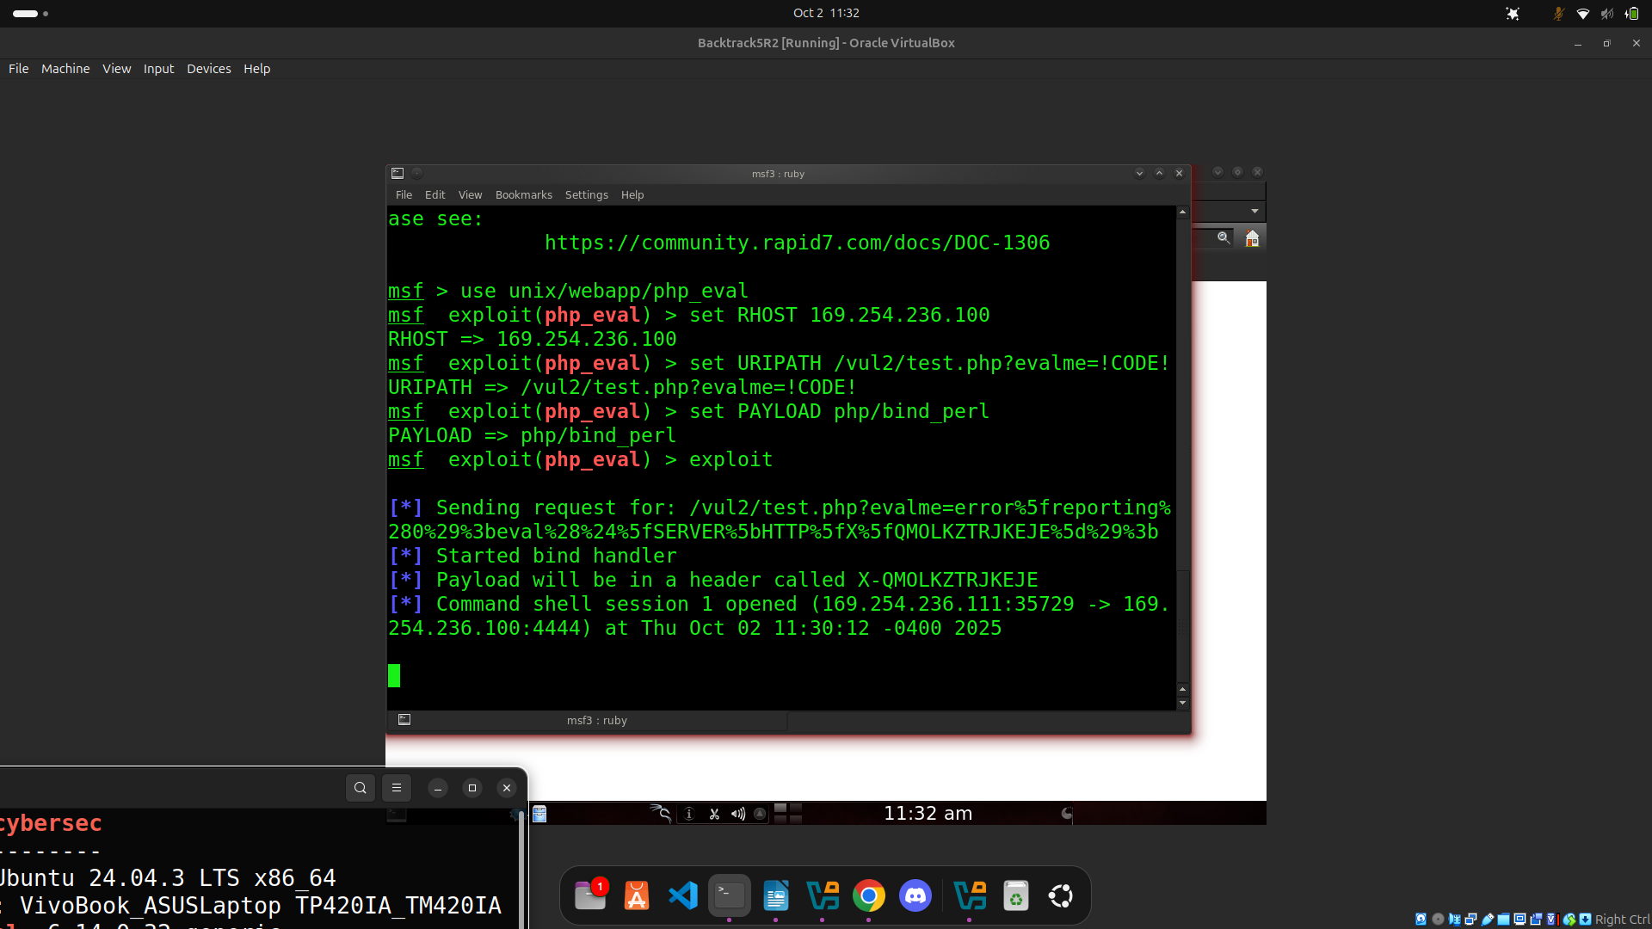
2. Code Comprehension [60pt]
Read /opt/Metasploit/msf3/modules/exploits/unix/webapp/php_eval.rb. Insert the commands for debugging and answer the following questions below:
(1) What is the meaning of the “%q{“at line 25? [2pt]
No strings good, no escape patterns; constant string across multiple lines
(2) What does “space=>8190” mean at line 40? [2pt]
It is the max URL length for some old versions of apache accordign to http://www.boutell.com/newfaq/misc/urllength.html
Max payload size is 8190 bytes

(3) What is the meaning of “BadChars” at line 45? [2pt]
Quotes are escaped by PHP’s magic_quotes_gpc in a default install

(4) What is the meaning of “ConnectionType” and “find” at line 48? [4pt]
ConnectionType is a parameter inside a metasploit module that specifies how the session should handle the payload’s network connection once the exploit succeeds
Find means session need original socket of payload
(5)* List at least 5 ConnectionTypes and brief describe their meanings. (hint: use search command find ./ -type f –exec grep -H ConnectionType {} \; to search for the occurrence of “ConnectionType” in source code. To find out the semantics of each ConnectionType, e.g., ‘bind’, use command find ./ -type f –exec grep –H “’bind’” {} \; (note: you need the single quotes around the bind keyword.) [10pt]
find – reuse the existing socket.. payload/exploit expects to use original network socket that delivered payload (like a HTTP request) used for web/PHP-style shells
bind – target listens, attack connects; payload binds a listener on the target machine (open port on the victim)
reverse – payload connects back to you (connect-back) payload makes outbound connection from the target to handler (LHOST:LPORT)
none/noconn – no network expected; module/payload doesn’t create or require a new network socket
tunnel – session is routed/tunneled through existing channel

(6) Use debugger to determine the value of datastore[‘URIPATH] at line 65. [3pt]
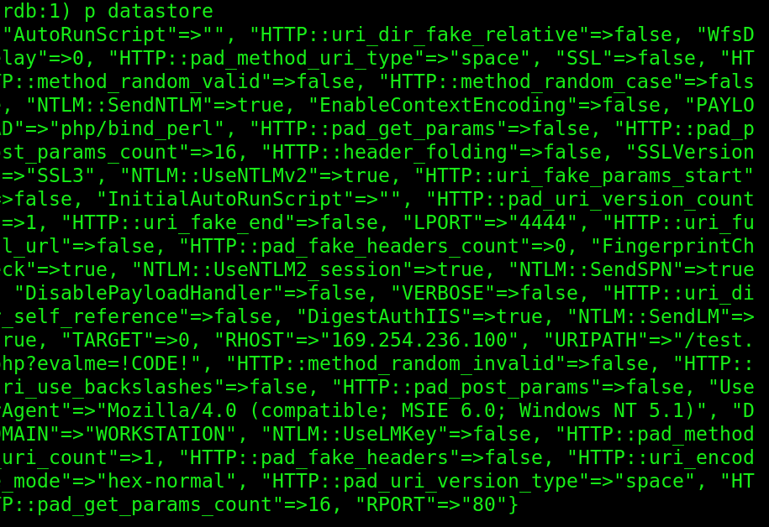
(7) Explain the meaning of the gsub operation at line 65. [4pt]
It is removing everything from the first ? Onward in the string.. the regex /\?. */ breaks down as: \? → literal question mark, .* is zero of any character, until end of string. A question mark and everything that follows it.
(8) Use debugger to find out the value of headername at line 81. (paste the screenshot below). [4pt]
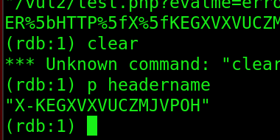

(9) Use debugger to find out the value of stub at line 82. [2pt]
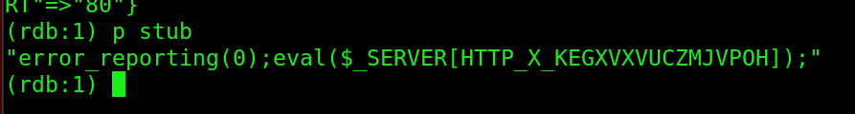
(10) Use debugger to find out the value of uri at line 84. [2pt]
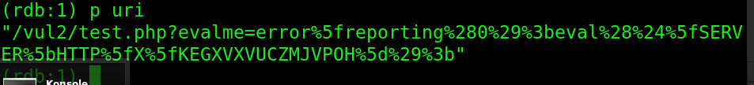
(11) Explain why there are many “%” symbols appearing in uri (after line 84 is executed). [2pt]
It isn’t safe to send certain characters through a query string, so it must be done via its ASCII character, hence the % symbol.
(12) Prove that the statements between 91 and 94 (i.e., “headers => {headername=… connection=…}”) are working by Wireshark. Paste the screenshot below and explain briefly. [10pt]
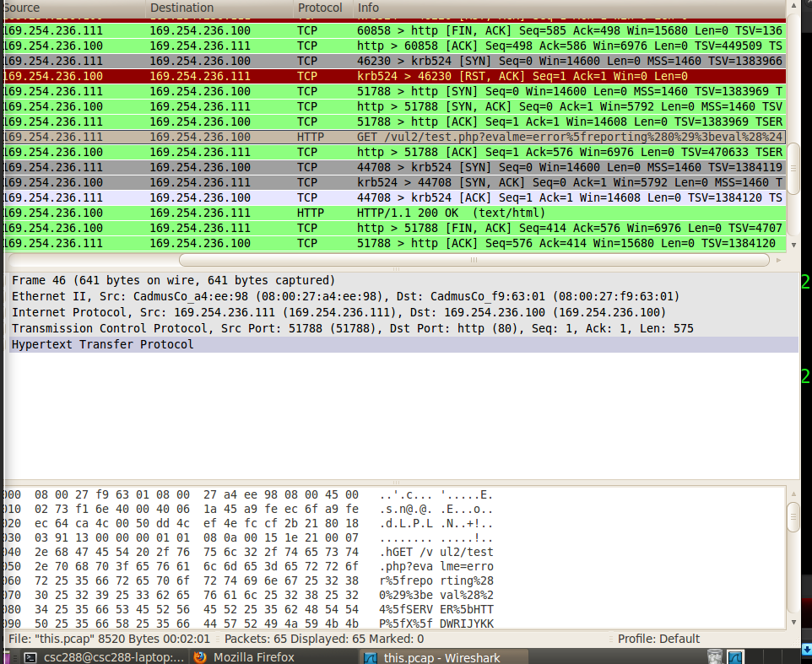
It’s working by wireshark because it was able to capture the HTTP get from backtrack.
(13) Use debugger to trace into the handler function at line 100. Hint: use t “step” command. What is the absolute path of the ruby file that contains handler()? [2pt]
/opt/metasploit/msf3/lib/msf/core/exploit/http/client.rb:207
(14) If we change the connection type from “find” to “bind”, will it change the handler being called? Explain [3pt]
No it wont affect the handler being called a It simply calls the same handler() entry point, but the behavior inside that handler will branch based on the connection type.
(15) Use debugger to trace into the handler function and describe its logic [8pt]
If no socket is provided, then try the global one.. if the parent claims the socket associated wit hthe HTTP client, then it rips the socket out from under the HTTP client.
The signature handlr accepts an option socket nsock. None passed, tries to use HTTP client’s socket.
Uses global HTTP client socket when none provided
If caller didn’t supply socket (nsock is nil) this object has client object, it sets nsock to self.client.conn (HTTP client’s connection). Default to client’s socket
Calls parent handler and checks result.. calls super(nsock) storing the return value in rv. If rv==handler::claimed (meaning the parent handler successfully claimed/took ownership of that connection)< and theres a client object, and the socket just handled nsock is the same socket object stored on self.client.conn, then it sets self.client.conn=nil
returns parents handler.
-------------------------------------------------------------- BONUS Question [50pt]--------------------------------------------------------------------------
Continue your debugging efforts and submit a 2-page report (with proper screenshots) which describes how a session (the communication for supporting the remote shell) is created.
Hint: you will eventually trace into handle_connection(). Then you need to find out who starts a connection to port 4444. To accomplish the goal, use Wireshark to assist your analysis. When stepping through exploit_driver, watch the traffic captured by Wireshark.
BONUS IS DONE ON SEPERATE PDF.. YES I UPLOADED IS

Part II. 100pt
1. [80pt] Develop another exploit named “php_cmd_inj.rb” which can spawn a remote session on the following vulnerable web app:
http://169.254.236.100/vul/bad1.php.
The payload to use is /opt/metasploit/msf3/modules/payloads/singles/cmd/unix/bind_perl. Paste screenshots of the entire attack process to prove your success.
Hint: use Wireshark to analyze the data payload during the exploit development.
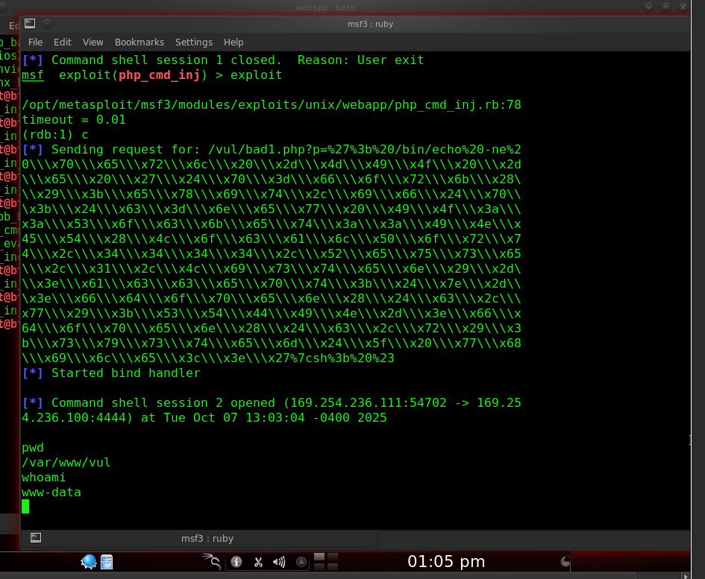
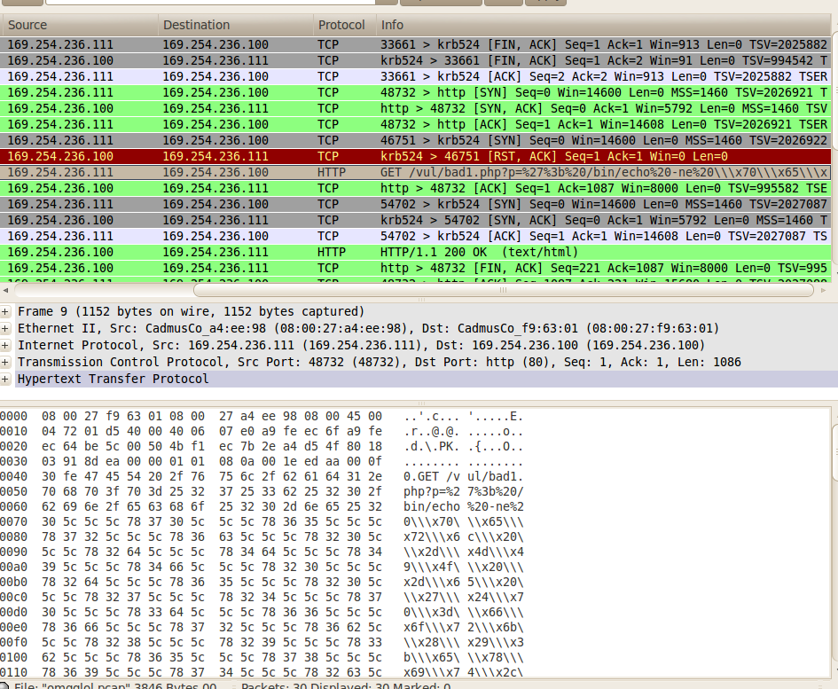
2. [20pt] As the metasploit framework is publicly available to hackers, the daily updates of metasploit allow a hacker to easily incorporate latest attacks and launch them against a vulnerable system (if the system administrator is lazy enough not to apply patches daily). Propose the design of an automatic hardening tool, which takes the daily updates of metasploit, and automatically enhances the firewall to defeat zero-day attacks. You have to describe some technical details and make the proposal technically feasible.
A way to combat this is by monitoring metasploit for its updates (with cron job, that touches a stamp file when new commits/modules appear). Use that trigger so an automation or AI componenet fetches the live update and checks for new or zero day exploit information. Analyze the changes, and generate defensive artifacts (firewall rules, IDS signatures, rate limits). Then automatically push hardening updates to the firewall/IDS, with safeguards, perhaps human approval for a high risk block.

