CSC215 Lab6 – C Pointer and GDB
Total: 100pts
@Copyright Dr. Xiang Fu. All Rights Reserved.
What to turn in: a zip file containing the following:
(1) CSC215Lab6.docx
(2) Problem1.cc
Note: the files needed for this lab are located in ~/Desktop/csc215/lectures/lec14_c_lab in the Ubuntu image.

1. Printf [30pt]
[1. Submit as Problem1.cc 10pt, 5 minutes] Write a simple C program which prints out integers from -65536 to 65535 in hexadecimal format. Each hex number should have 8 digits, a sample output is listed below:+
0 0x00000000
1 0x00000001
2 0x00000002
…

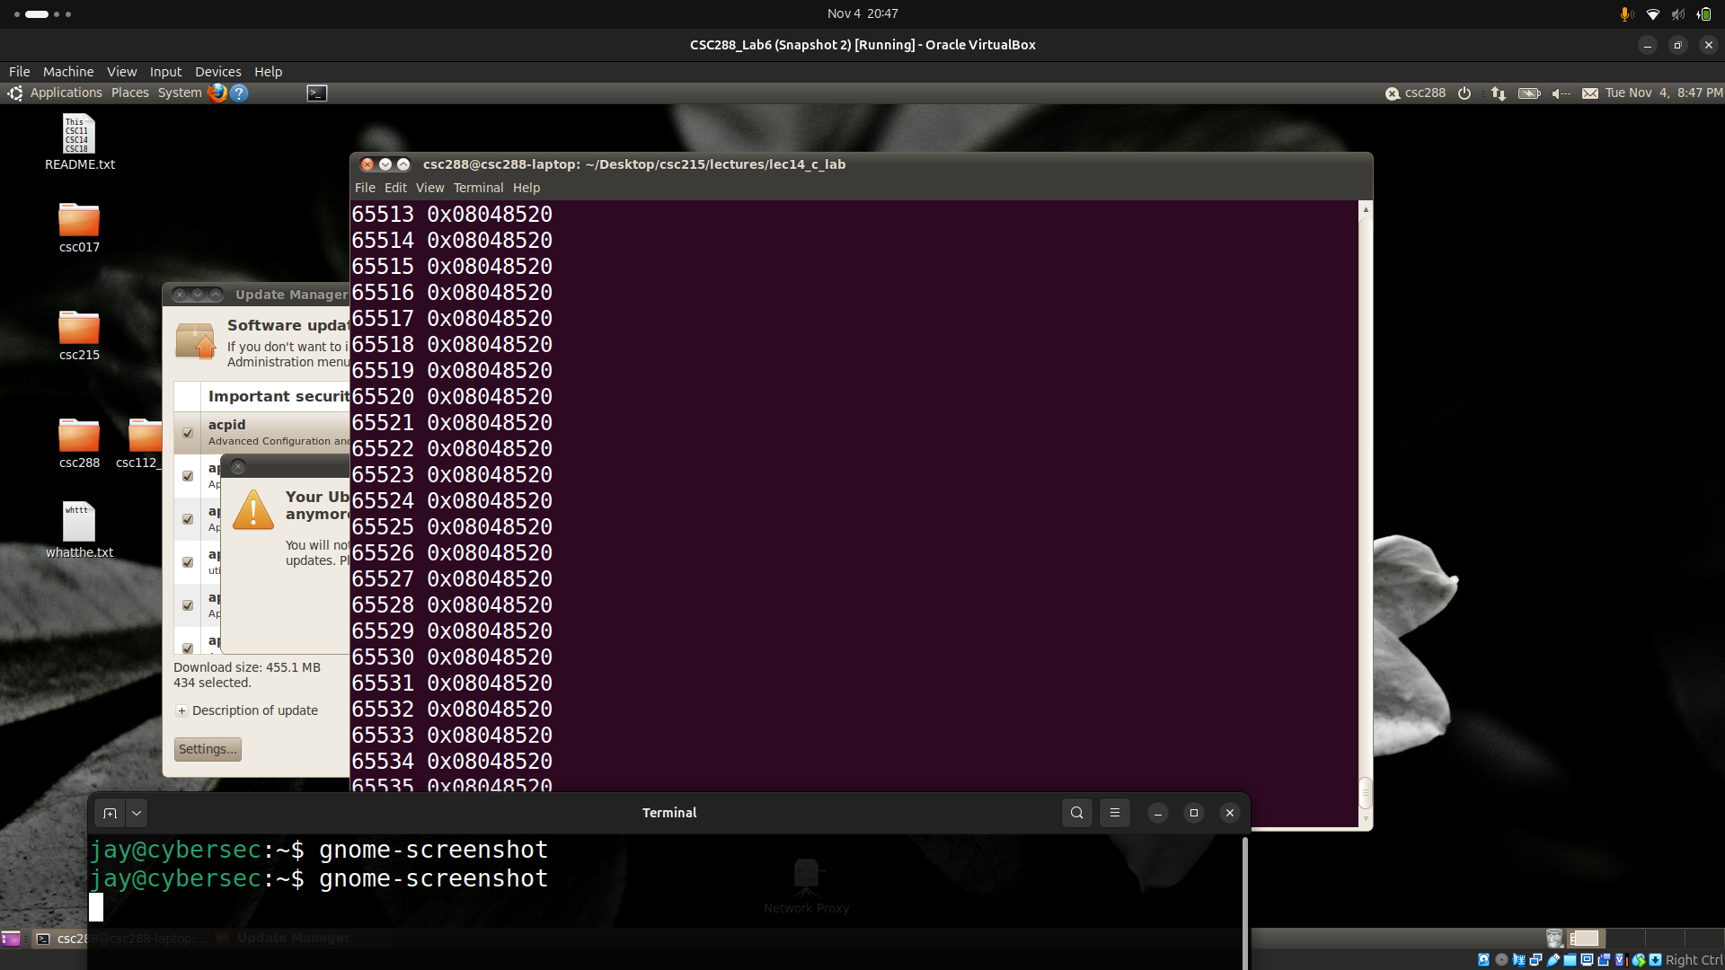
[2. 20pt, 5 minutes] Finish the setvar.cc (one line missing) so that at the end of the program, the value of “n” is 200.
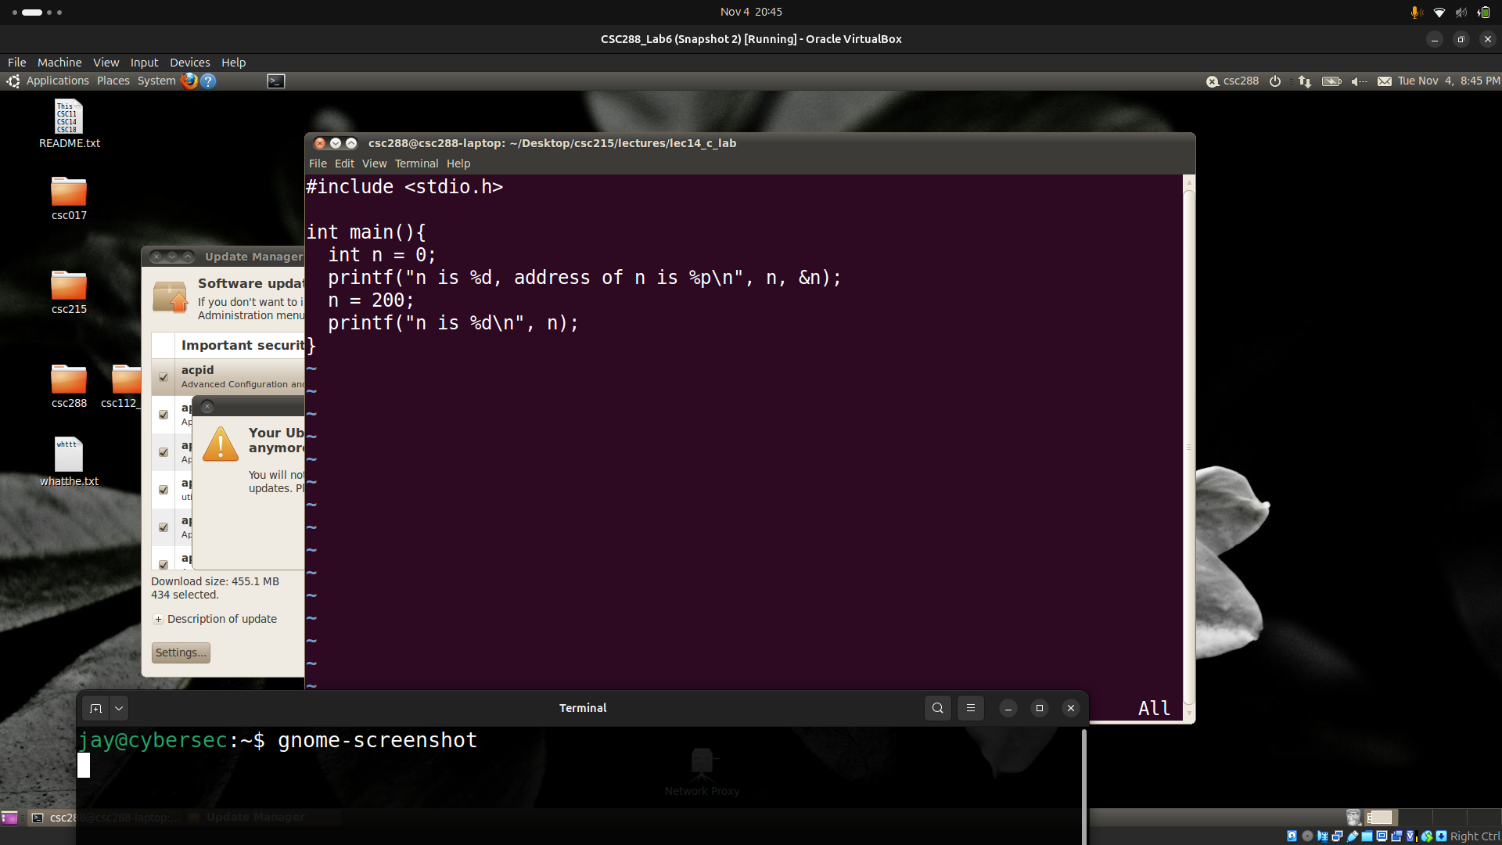
2. C Language Pointers [30pt]
[1. 15pt, 8 minutes] Try answering the following questions without running the program below:
#include <stdio.h>
int main(){
int a = 1;
int b = 2;
int *p = &a;
int **q = &p;
printf("a is located at %p\n", &a);
printf("b is located at %p\n", &b);
}

//the output of the above program is
a is located at 0xbfcfc04c

b is located at 0xbfcfc048

[a] What is the value of &p? __________0xbfcfc044_________________
[b] What is the value of &q? __________0xbfcfc040_________________
[c] What is the value of q? _______________0xbfcfc044_____________
[2. 15pt, 8 minutes] Complete the above program (pointer1.cc) so that you could print out the values of &p, &q, and q. Now answer the questions again. You can use GDB to find out the answer.
a _______1______________ b _______2________________ &p _______0xbffff3c4__________________
&q _____0xbffff3x0_______________ q ________0xbffff3c4_______________

3. GDB Practice [40pt]
Use GDB to trace into bubble_sort.cc and answer the following questions without modifying the source code.
[1. 10 pt, 5 minutes] what is the value of i and j when the program reaches line 8 and the value of arr[4] is 5?
_________________1,3___________________________________________
[2. 15 pt, 8 minutes] re-run the program and stop at line 20 (before the call of sort). Find out the following using GDB (all in hex):
a _______1______ b _____2_________ c ______3__________ d ________________4_____
&a ____0xbffff3bc_______ &b _____0xbffff3b8________ & c_____0xbffff3b4__________ &d _________0xbffff3b0___________
beginning address of arr __________0xbffff398___________________
value of the EIP register _____0x80485ac_________________________
[3. 15pt, 8 minutes] List the assembly instructions that correspond to line 8 “arr[j] = arr[j-1]”.
