CSC215 Lab7 – Assembly Language
Total: 100pt
@Copyright Dr. Xiang Fu. All rights reserved.
What to turn in: Submit lab7.zip, which contains the following:
(1) CSC215Lab7.docx
(2) cat.cc
Note: the files needed for this lab are located in ~/Desktop/csc215/lectures/lec16_assembly_practice in the Ubuntu image.
In the lec16_ assembly_practice folder, you can find a simple C program which executes “/bin/ls” as an external program. The source code is shown as below:
1 #include <stdio.h>
2 #include <unistd.h>
3 #include <sys/types.h>

4 int main(){
5 char *args[] = {"/bin/ls", "-l", NULL};
6 char *envs[] = {NULL};
7 execve("/bin/ls", args, envs);
8 }
Read the Unix system manual about execve and answer the following questions. (hint: “google man execve”).
1. What does execve do? [5pt]
Execve essentially executes a linux command through the C language in a script. The man page shows that it executes the program pointed to by filename. Filename must be either a binary executable or a script starting with a line of the form:
! interpreter [optional-arg]
2. What is the args parameter used for? [5pt]
Args parameter is used as an array to provide pathway to your binary you wish to execute, -l to display the list, and null to elucidate the end of a line. Essentially, to provide a pathway to your binary in which you want to execute as an array.
3. Why does the args array end with a NULL? [5pt]
It ends with NULL to explain that it’s the end; integer 0 means end; NULL.
4. Create another C program which uses execve to print out the contents of /etc/passwd. (hint: use “/bin/cat”). Save your C program as cat.cc. Note: do NOT modify the original ls.cc. [15pt]
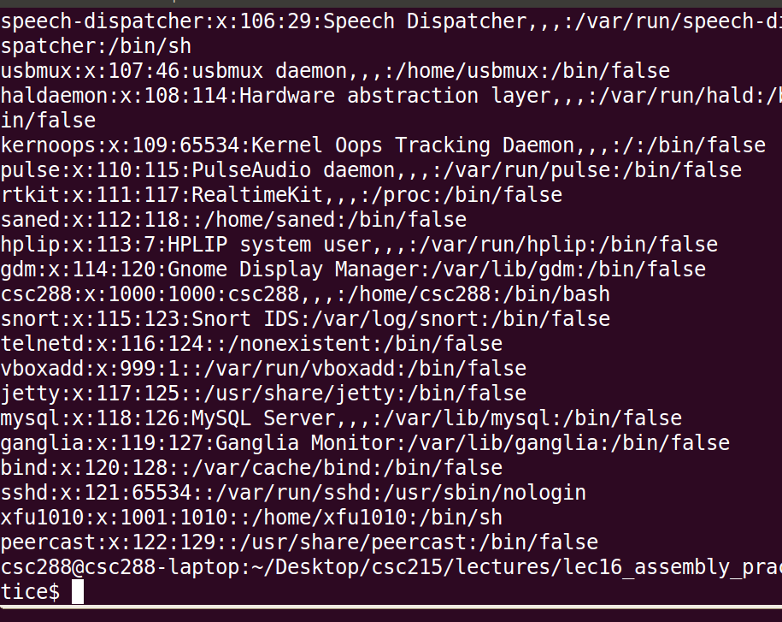
5. Now compile ls.cc using static linking – g++ ls.cc –o ls –static –g. The following is the assembly of the main function. The following questions will ask you to correlate each statement in ls.cc with the assembly instructions below. You can use GDB to assist your analysis.
(gdb) x/16i $eip
=> 0x8048259 <main+9>: movl $0x80ae448,0x10(%esp)
#include <stdio.h>
#include <unistd.h>
#include <sys/types.h>

int main(){
char *args[] = {"/bin/ls", "-l", NULL};
char *envs[] = {NULL};
execve("/bin/ls", args, envs);
}
0x8048261 <main+17>: movl $0x80ae450,0x14(%esp)
0x8048269 <main+25>: movl $0x0,0x18(%esp)
0x8048271 <main+33>: movl $0x0,0x1c(%esp)
0x8048279 <main+41>: lea 0x1c(%esp),%eax
0x804827d <main+45>: mov %eax,0x8(%esp)
0x8048281 <main+49>: lea 0x10(%esp),%eax
0x8048285 <main+53>: mov %eax,0x4(%esp)
0x8048289 <main+57>: movl $0x80ae448,(%esp)
0x8048290 <main+64>: call 0x805cb20 <execve>
0x8048295 <main+69>: mov $0x0,%eax
0x804829a <main+74>: leave
0x804829b <main+75>: ret
(5.a) In the above figure, which corresponds to the beginning address of const string “/bin/ls”? [10pt]
(a) 0x80ae448 (b) 0x80ae450 (c) 0x10(%esp) (d) 0x14(%esp)
(5.b) In the above figure, which corresponds to the beginning address of const string “-l”? [10pt]
(a) 0x80ae448 (b) 0x80ae450 (c) 0x10(%esp) (d) 0x14(%esp)
(5.c) List the assembly instructions that correspond to statement “char *args[] = {"/bin/ls", "-l", NULL};”. [10pt]
________0x08048259 <+9>: movl $0x80ae448,0x10(%esp)
0x08048261 <+17>: movl $0x80ae450,0x14(%esp)
0x08048269 <+25>: movl $0x0,0x18(%esp)________________________________________________
________________________________________________________
________________________________________________________
(5.d) Assume that the program is stopped by debugger at 0x8048261 (and the instruction movl $0x80ae450, 0x14(%esp) has not been executed yet). If the address of args is 0xbffff024. What is the current value of register ESP? [10pt]
________________0xbffff014________________________________________________
(5.e) Follow the instructions in Lecture 15, and take the machine code of th e main() function of ls.cc and express it in the form of a C language char array (e.g., char *arr = “\xba\x06…”). Paste your char array below. [30pt]

