CSC215 Lab8 – Practice on Manipulating Stack
Total: 100pt
@Copyright Dr. Xiang Fu. All Rights Reserved.
What to turn in: CSC215Lab8.docx
Note: all the files needed for this lab are located at ~/Desktop/csc215/lectures/lec18_stack_practice in the Ubuntu image.
1. Stack Frame [30pt] (10 minutes)
Compile fib.cc using command: g++ fib.cc –o fib –g –fno-stack-protector
Answer the following questions using GDB. Set a breakpoint at line 9 (“return z”) and find out the following data when GDB first stops at line 9.
n ______2___________ x _____1__________ y ______1________ z ____2____________________
&n _______0xbffff380_________ &x ____0xbffff364_________ &y ____0xbffff368________ &z ________0xbffff36c________________
EIP _____0x80484d5____________ EBP ______0xbffff378_________ ESP _____0xbffff350____________
value of previous EBP ______0xbffff3a8____________________
value of Return Address (where to jump when fib() finishes) _______0x08048b5________
Draw the stack frame diagram (e.g., using PPT), with all of the above information included. Paste your diagram below.
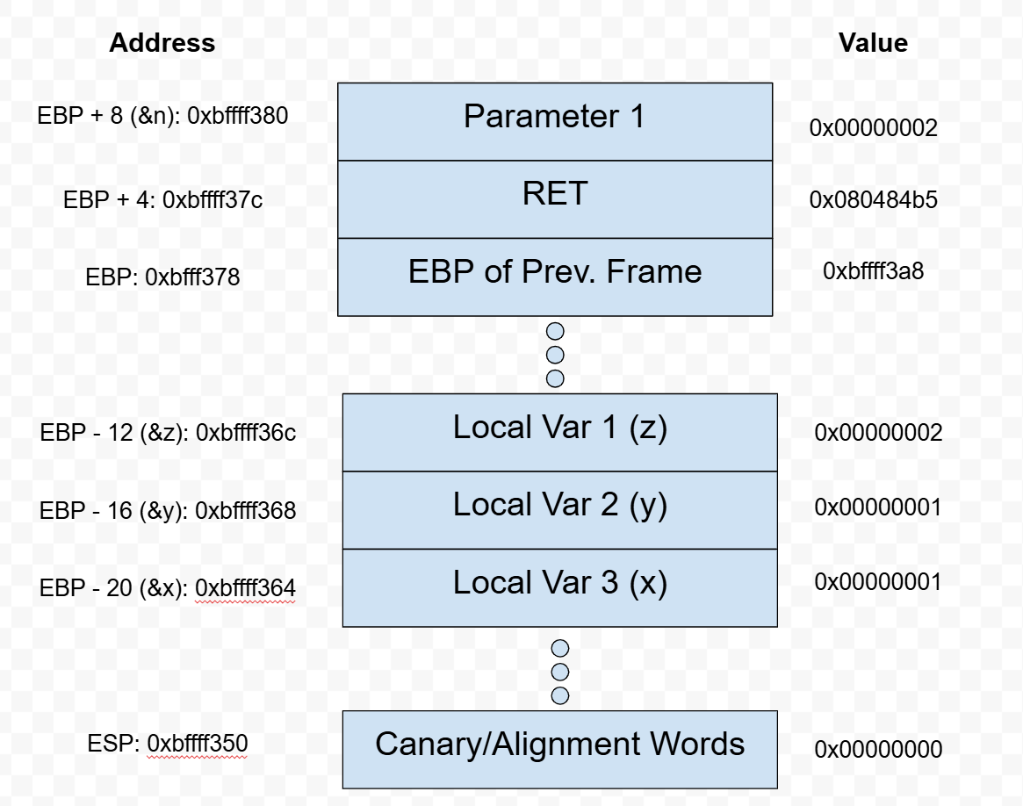
2. Use the perl approach to attack meet.cc so that when the program crashes, it is about to return (to 0x41414141).
Use GDB memory and register dump to show your success
(e.g., show the stack dump and current instruction to execute). [40pt] (estimate: 10 minutes)
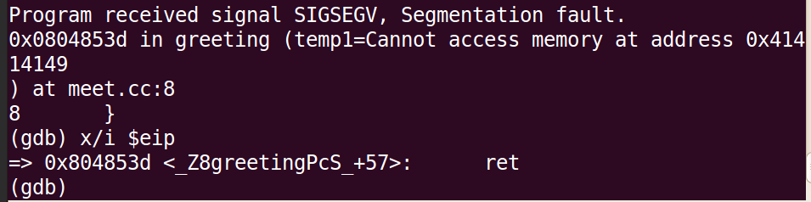

3. Use the perl approach to attack meet.cc so that the program will end up in an infinite loop of calling greeting(), in another word, you would see the output like the following. (hint: make sure to get the attack string size right). [30pt]
hello U����� U�����
hello U����� U�����
hello U����� U�����
hello U����� U�����
hello U����� U�����
hello U����� U�����
hello U����� U�����
hello U����� U�����
hello U����� U�����
