**Practical 02:**

**Aim:**

Creating ordered & unordered lists in HTML using <ol>, <ul> & <li> tags.

**Code (Ordered List):**

|  |
| --- |
| <!DOCTYPE html>  <html>  <head>  <title>Practical 02</title>  </head>  <body bgcolor="yellow">  <h1>Lists in HTML</h1>  <h2>Ordered list</h2>  <h3>Programming languages</h3>  **<ol type="A" start="A">**  **<li>**Java**</li>**  **<li>**Python**</li>**  **<li>**Swift**</li>**  **<li>**C++**</li>**  **<li>**JavaScript**</li>**  **</ol>**  <h3>Operating systems</h3>  <ol type="1" start="1">  <li>Windows</li>  <li>MacOS</li>  <li>Linux</li>  <li>Android</li>  <li>iOS</li>  </ol>  <h3>Linux tools</h3>  <ol type="I" start="I">  <li>Wireshark</li>  <li>Nikto</li>  <li>NMap</li>  <li>BurpSuite</li>  <li>Metasploit</li>  </ol>  </body>  </html> |

**Code (Unordered List):**

|  |
| --- |
| <!DOCTYPE html>  <html>  <head>  <title>Practical 02</title>  </head>  <body bgcolor="orange">  <h1>Lists in HTML</h1>  <h2>Unordered list</h2>  <h3>Mobile manufacturers</h3>  **<ul type="circle">**  **<li>**Apple**</li>**  **<li>**Samsung**</li>**  **<li>**OPPO**</li>**  **<li>**Nokia**</li>**  **<li>**Vivo**</li>**  **</ul>**  <h3>Laptop manufacturers</h3>  <ul type="square">  <li>Lenovo</li>  <li>Apple</li>  <li>ASUS</li>  <li>Samsung</li>  <li>HP</li>  <li>Dell</li>  </ul>  <h3>Camera manufacturers</h3>  <ul type="disk">  <li>Canon</li>  <li>Nikon</li>  <li>Sony</li>  <li>Panasonic</li>  </ul>  </body>  </html> |

**Output (Ordered List):**

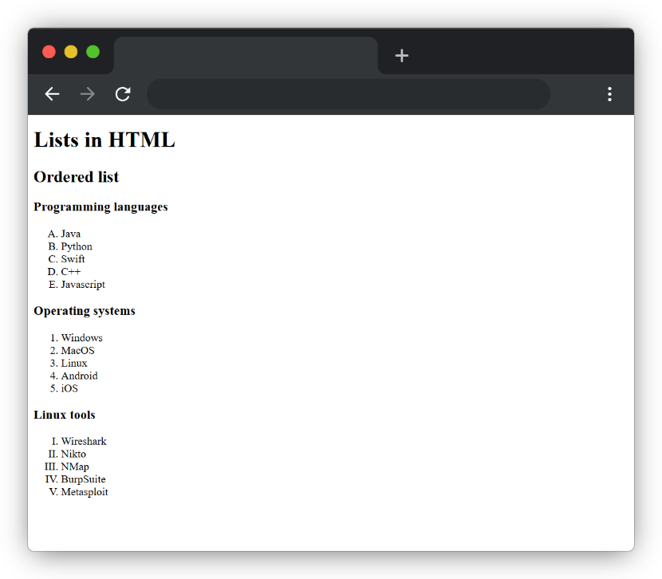

**Output (Unordered List):**

