Bot Detection Using Mouse Movement Analysis
Machine Learning Project Report

1. Abstract
This report presents a machine learning system for detecting automated bots based on mouse movement patterns. The system uses a Long Short-Term Memory (LSTM) neural network trained on the DelBot-Mouse dataset, which contains timestamped mouse event sequences from both human users and four types of scripted bots. The trained model is deployed as a Flask web application where users trace a circular path on a canvas, and the model returns a real-time Human/Bot confidence score.

2. Objective
The primary objective of this project is to distinguish between human and automated bot mouse movements using temporal sequence modelling. Specifically, the goals are:
- Train a binary classifier on raw mouse event sequences (timestamp, event type, x, y coordinates).
- Deploy the model in an interactive web interface where live mouse movements are analysed in real time.
- Output a confidence score (Human % and Bot %) rather than a hard binary label, to account for uncertainty.

3. Dataset

3.1 Source
The project uses the DelBot-Mouse dataset, a publicly available benchmark dataset for bot detection research. The dataset contains mouse movement recordings collected during a circular tracing task.

3.2 Categories
Category | Description
circles_human_pc1 / pc2 | Human participants tracing a circle on a PC
circles_bot_pynput | Bot using pynput library — mechanical, regular intervals
circles_bot_pyhm | Slightly humanised pynput bot
circles_bot_naturalmousemotion | Bot mimicking natural curves
circles_bot_gan | GAN-generated human-like trajectories

3.3 Class Distribution
The dataset is imbalanced with approximately a 3:1 bot-to-human ratio. This imbalance was addressed during training using class weights, which penalise misclassification of the minority (human) class more heavily.
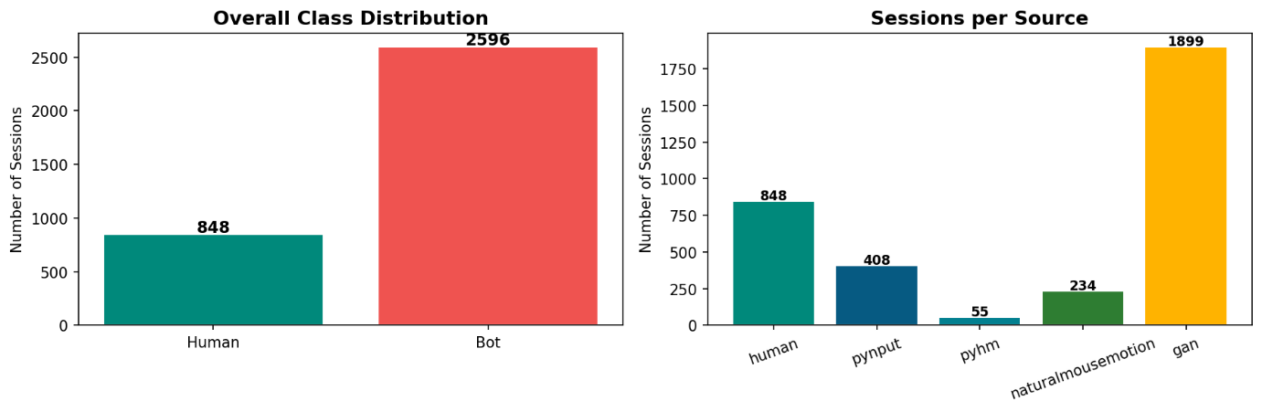
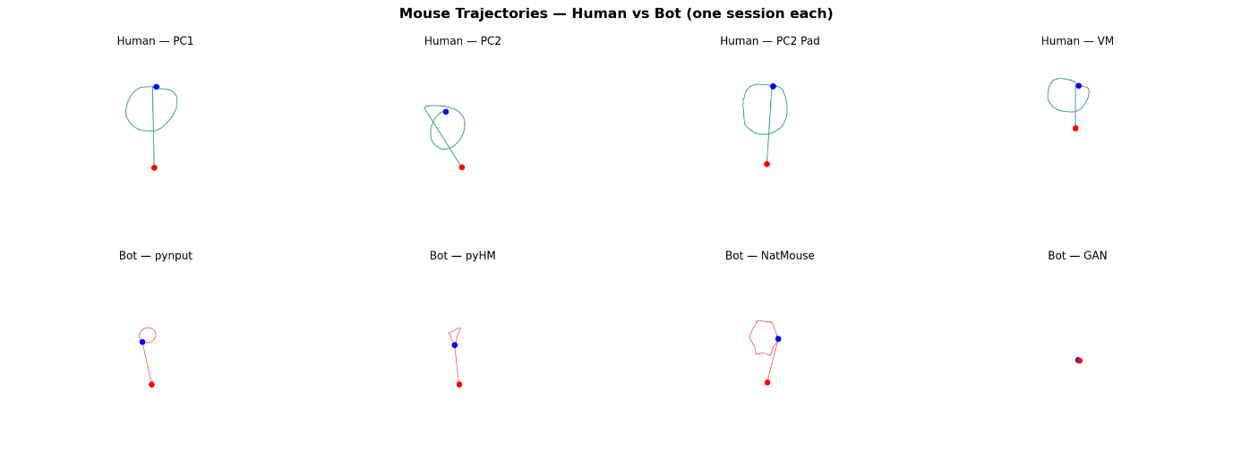
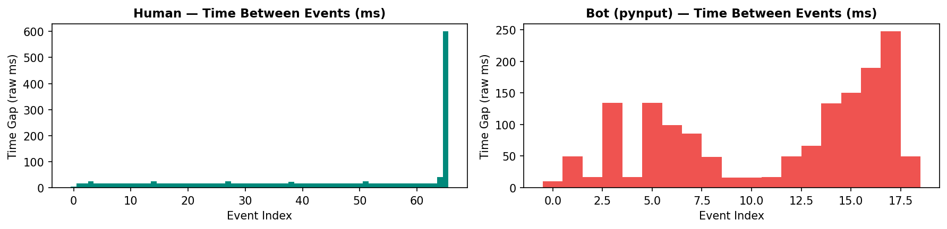

4. Methodology

4.1 Preprocessing
Each session file is a CSV containing timestamped mouse events (move, click, release) with (x, y) screen coordinates. The following preprocessing steps were applied:
- Event type encoding: move → 0, click → 1, release → 2.
- Temporal normalisation: timestamps scaled to [0, 1] within each session.
- Spatial normalisation: x and y coordinates divided by canvas width and height respectively.
- Sequence truncation / zero-padding to a fixed length of MAX_LEN = 200 events.
- Final input shape per sample: (200, 4) — 200 timesteps, 4 features.
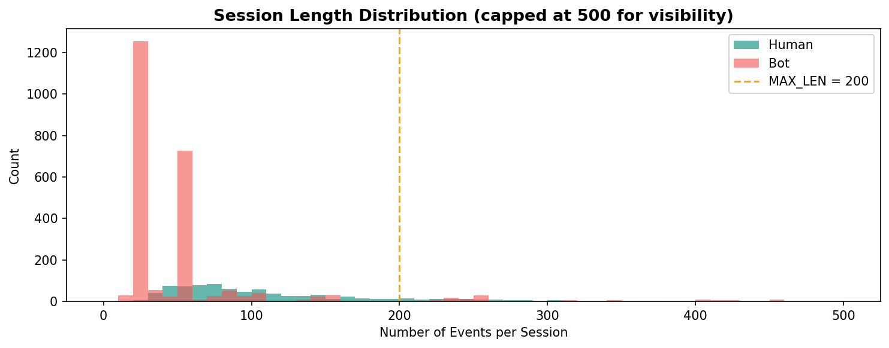

4.2 Model Architecture
A Bidirectional LSTM (BiLSTM) network was used to capture temporal dependencies in both forward and backward directions. The architecture consists of:
Layer | Configuration
Input | Shape (200, 4)
GaussianNoise | σ = 0.01 (regularisation)
Bidirectional LSTM | 64 units, return_sequences=True
Bidirectional LSTM | 32 units
Dense | 32 units, ReLU activation, L2 regularisation
Dropout | Rate = 0.4
Output Dense | 1 unit, Sigmoid activation (P(bot))

4.3 Training
- Optimiser: Adam with learning rate 1e-3.
- Loss: Binary cross-entropy with label smoothing (0.1) to prevent overconfidence.
- Class weights applied to compensate for bot/human imbalance.
- Early stopping on val_loss with patience = 15; best weights restored.
- Training ran for 20 epochs; best model checkpoint was at epoch 5.
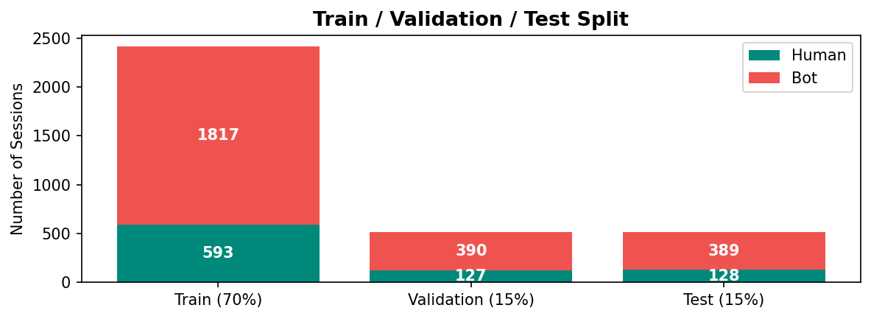

5. Results

5.1 Evaluation Metrics
Metric | Value
Validation AUC | 0.8784
Test AUC | 0.8712
Precision (Bot class) | 0.9881
Recall (Bot class) | 0.64
Train / Val Loss | 0.444 / 0.854
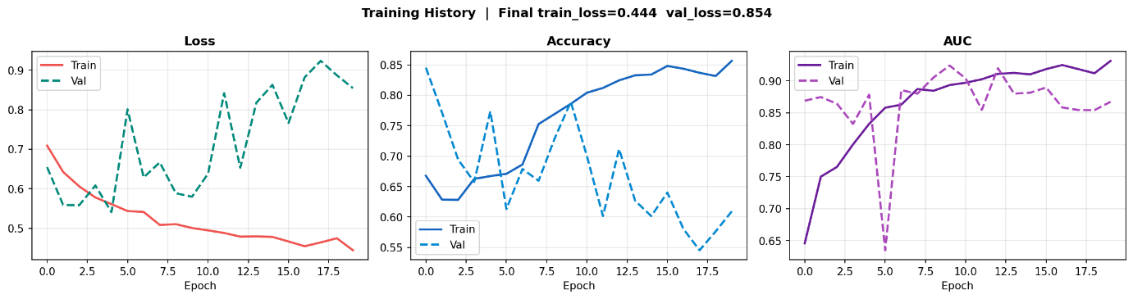

5.2 Confusion Matrix Summary
On the test set: 125 humans correctly classified as human, 250 bots correctly classified as bot, 3 humans misclassified as bot, 139 bots misclassified as human. The high precision (98.8%) reflects that when the model predicts bot, it is almost always correct. The lower recall (64%) means the model is conservative — it prefers to classify ambiguous cases as human.
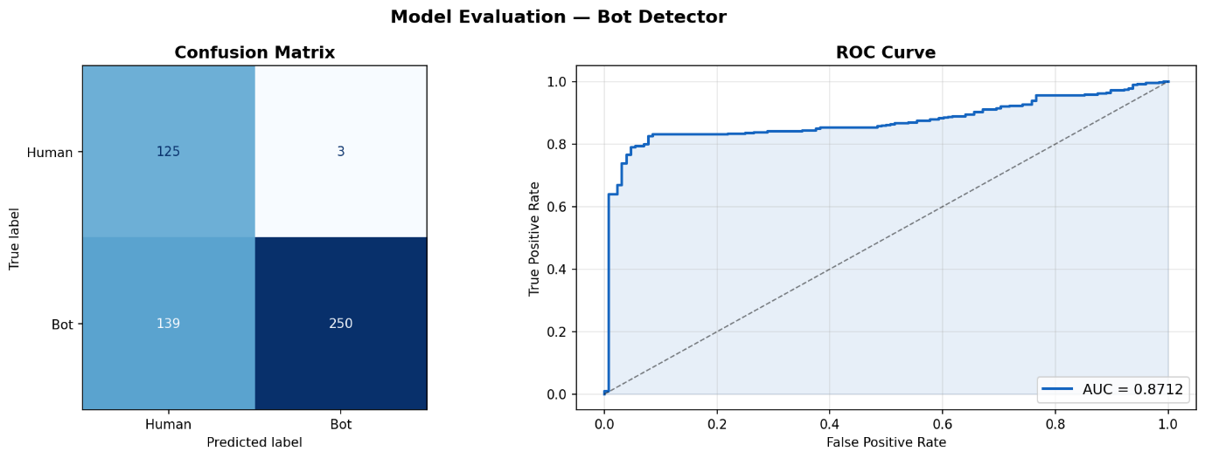

5.3 Confidence Distribution
The prediction confidence distribution (P(Bot)) shows two distinct clusters: human sessions concentrate around P(Bot) = 0.2–0.35 and bot sessions span a wider range from 0.4 to 0.9, with the 0.5 decision boundary providing reasonable separation.
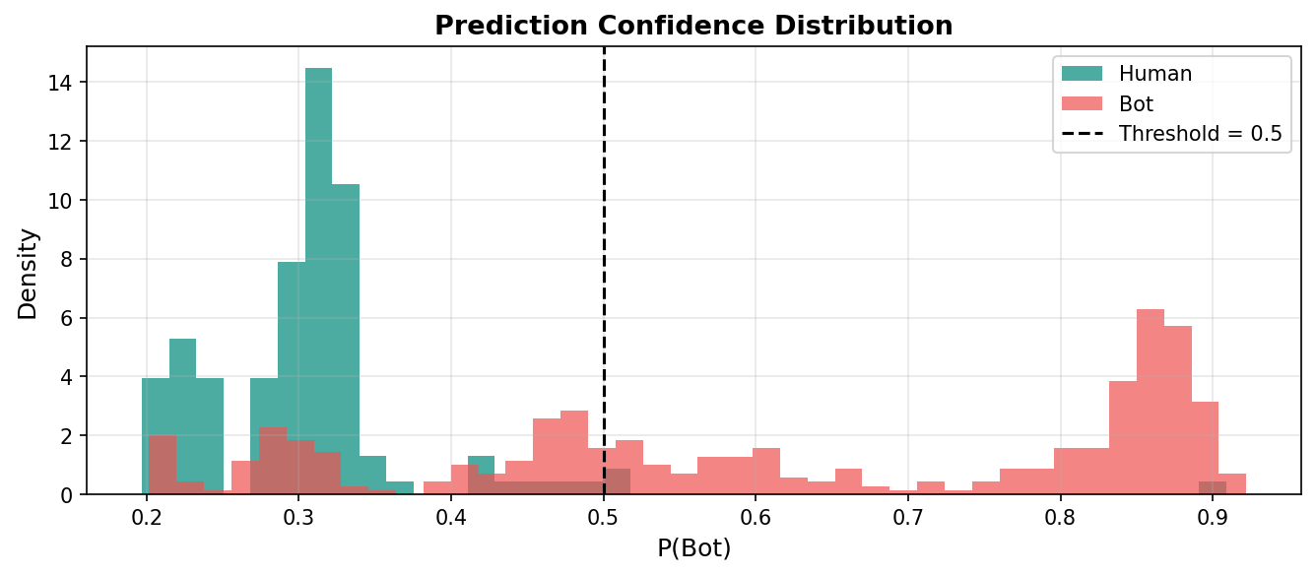

6. Demo Application

6.1 Architecture
The demo is a Flask web application (app.py). The frontend is a single-page HTML/JavaScript interface served by Flask. The backend runs the trained Keras model and exposes a /predict endpoint.

6.2 User Flow
- The user opens http://localhost:5000 in a browser.
- A dashed circle is displayed on a canvas. A glowing blue dot orbits the circle continuously.
- The user traces the dot with their mouse. 200 mouse events are collected automatically.
- Events are sent as JSON to the /predict endpoint.
- The backend preprocesses the sequence (same pipeline as training) and runs inference.
- The result is displayed as Human % and Bot % with an animated confidence bar.

6.3 Preprocessing Consistency
It is critical that the preprocessing in app.py exactly mirrors the training pipeline. This is ensured by using the same normalisation logic, the same MAX_LEN = 200, and the same 4-feature encoding. Mismatch between training and inference preprocessing is a common source of deployment failure and was explicitly verified in this project.
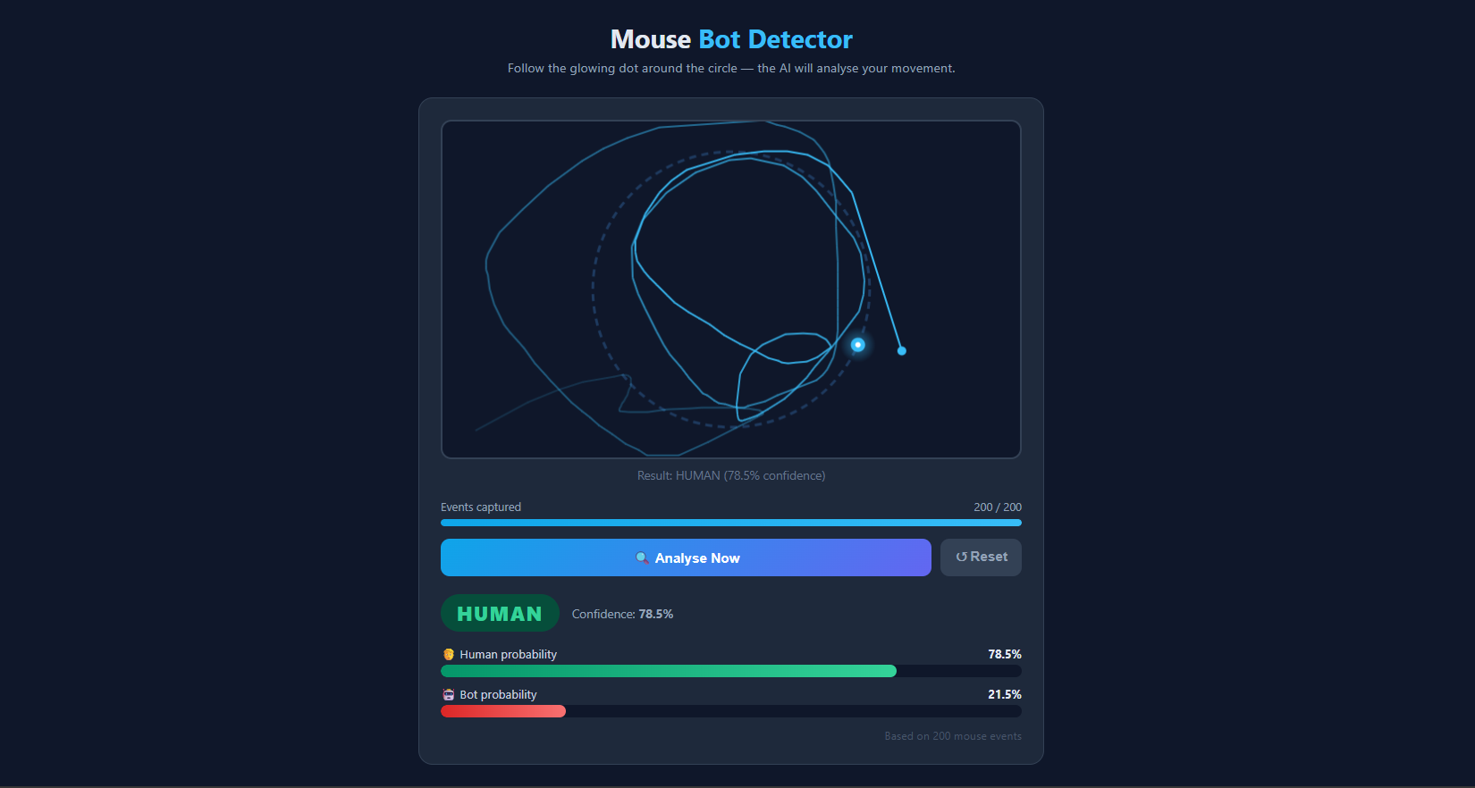

7. Limitations
- The model was trained on a specific circular tracing task. Free-form mouse movements on arbitrary pages are out of distribution and may produce less reliable results.
- Recall on the bot class is 64%, meaning ~36% of bots are classified as human. Sophisticated bots (GAN-based, NaturalMouseMotion) are the hardest to detect.
- The dataset is collected from a controlled desktop environment. Mobile or touchpad inputs may behave differently.
- The model outputs a single confidence score and does not identify which specific bot type is most likely.

8. Potential Applications
- CAPTCHA replacement: Passive bot detection during normal user interaction, requiring no user action beyond natural mouse movement.
- Web security: Integration into login flows to flag suspicious automated access attempts.
- Ad fraud detection: Identifying bot-driven clicks on digital advertisements.
- User analytics: Distinguishing real users from scrapers or crawlers in web traffic data.
- Research: Baseline for studying increasingly human-like bot behaviour (GAN-generated movements).

9. Conclusion
This project demonstrates that mouse movement sequences contain measurable temporal and spatial patterns that differentiate human users from automated bots. A BiLSTM model trained on the DelBot-Mouse dataset achieves a test AUC of 0.8712 and a bot-class precision of 98.8%, confirming that the approach is viable for practical bot detection. The live Flask demo successfully runs inference on real-time mouse events, making the system end-to-end deployable. Future work could focus on training-task alignment, improved recall through threshold tuning, and expanding to multi-class classification across the four bot subtypes.

References
[1] DelBot-Mouse Dataset — [add citation/URL here]
[2] Hochreiter, S. & Schmidhuber, J. (1997). Long Short-Term Memory. Neural Computation.
[3] TensorFlow / Keras Documentation — https://www.tensorflow.org
[4] Flask Documentation — https://flask.palletsprojects.com

