**---Tweet APP---**

**Name:- Jaydatt Dhorsinge**

**Emp.Id:- 841771**

* In this appication I have implemented OpenApi(Swagger) dependency to execute the flow and test the functionality.
* Added the globle exeception handling with custom exception.
* For the request and response used DTO model classed to avoid the sesitive details populating to UI like Password , DOB etc.
* Used Stream and lambda expression.

**OpenAPI Access url** :- [**http://localhost:9191/swagger-ui/index.html**](http://localhost:9191/swagger-ui/index.html)

* LoginController :-

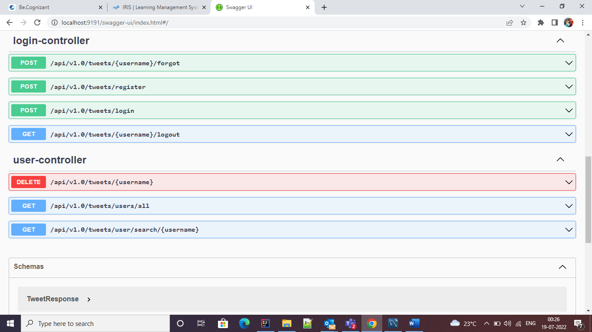

* Login API :-

This is how proper exception will throw to user in Response. If provide the wrong username and password.

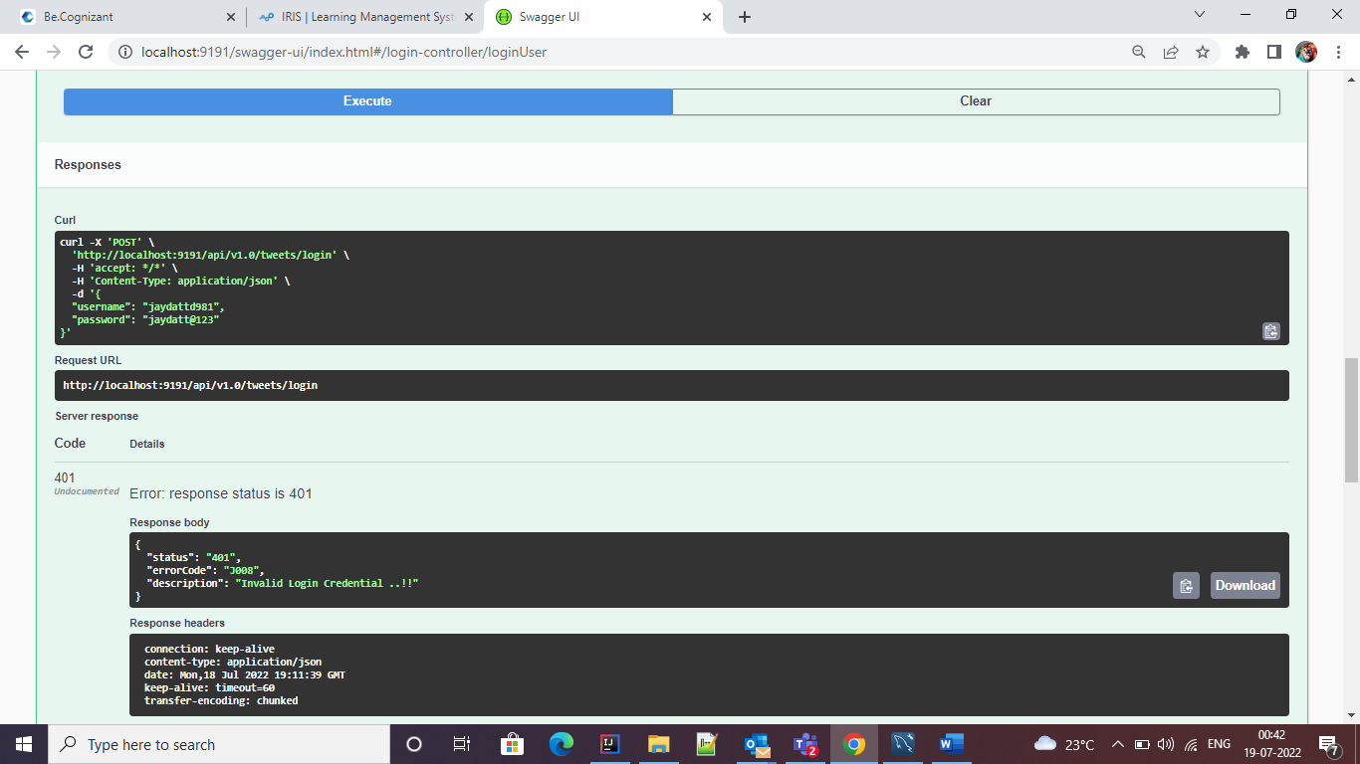

Other API :-

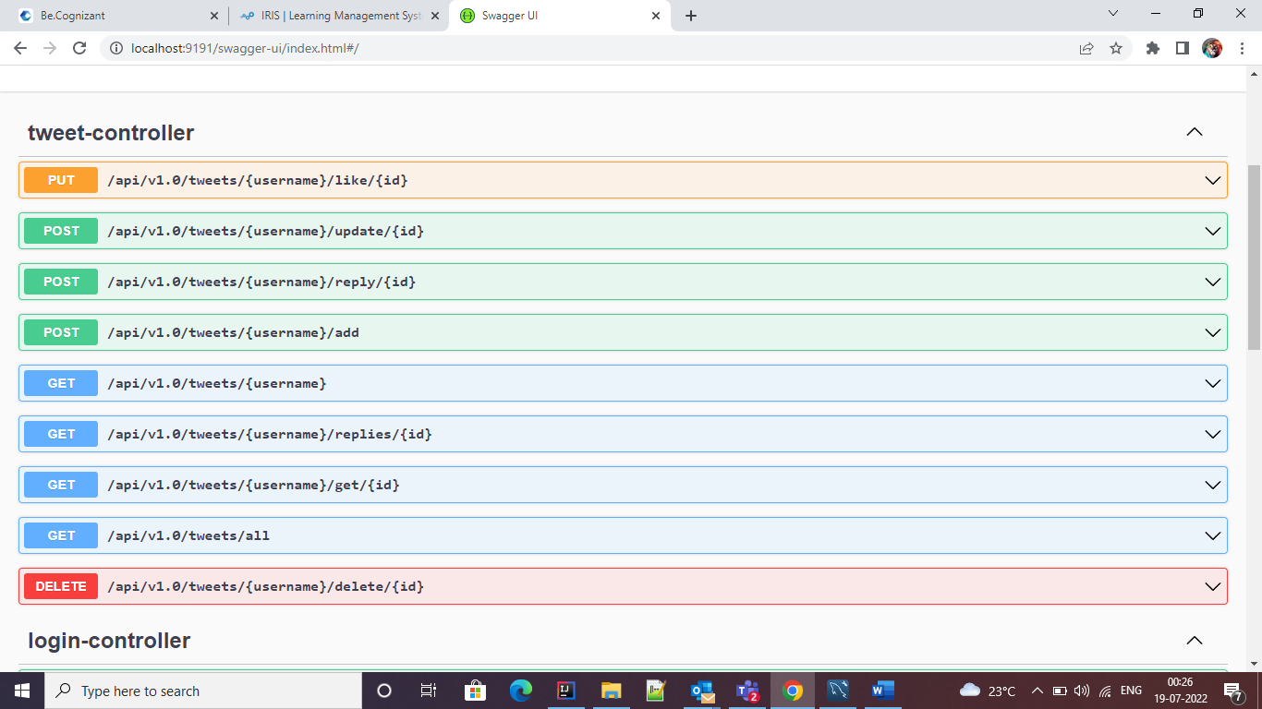

* Schemas:-

